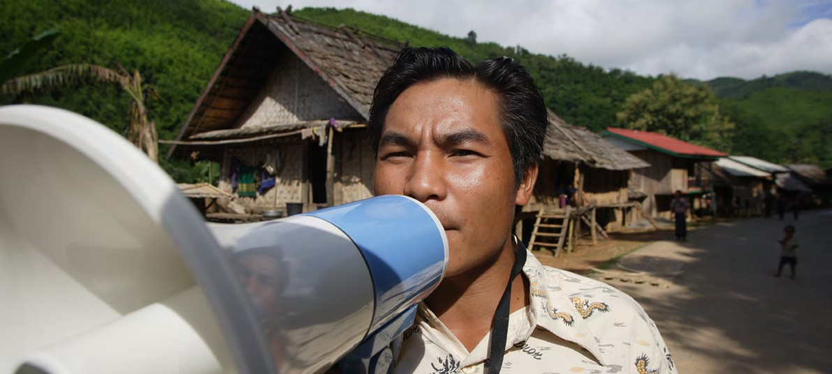
MODULE 4.6 – HANDOUT 4: IDENTIFYING THEMES ON WORD
TRAINING PACKAGE FOR USING SOCIAL SCIENCE IN COMMUNITY ENGAGEMENT AND/OR COMMUNICATIONS ACTIVITIES

Key informant interview
Research topic: Adolescent health
Location: Bagara, Fara Village
Participant: Fara Village Chief (FC)
Scroll down for coding book extract which explains codes
Gender influences social position;
Gender influences access to food

Education influences access to food

Gender influences social position

Education influences access to food

Education influences social position

FC: Boys in Fara sit for their class 8 exam. All boys are then circumcised after the class 8 exam. In this area, when a boy gets circumcised a few things change; one, the boy can no longer enter the mother’s kitchen, you start shying away from your mother, you cannot tell your mother directly that you are hungry, you don’t show your weakness.
SNB
GI
RM
GD
PE
E
EAB
GI
GI
GI
SNB
EAB
Res: So, what do these boys do for food?
FC: Some of them will be lucky to go to high school, so when you go to school you get your food there. If not, you have to find and make the food yourself.
You end up thinking like a big person because you build a smaller house [for the boys]; this means you are separating them, the mind now adjusts, and you start walking with the other older boys and you are not as dependent on the parents as before.
Res: What about the girls?
FC: For the girls, even if they don’t go to school, we don’t build a different house for them. They just get a room next to the mother, where she will have her things. The girl is very protected, even boy visitors are not allowed. But for the boys they are allowed to have their own guests, nobody restricts them. The girls are protected so that they don’t get pregnant. Many homesteads they rear dogs to keep men away.
But mentally, the 12, 13, 14-year-old adolescent boys and girl already have a mentality that they are adults. But according to the law of Kenya adulthood is at 18.
Res: And for this adolescent age group, when it comes to getting healthy food, what challenges do they have?
FC: It depends whether they are attached to the parents or separated. If the child is attached to the parents, they eat whatever food is provided at home. When they are separated from the parents, that is when it beomes a challenge. Especially if they fail to access secondary school.
Res: And what do they do if they don’t go to school?
FC: They will look for places to work. Most people prefer them because you pay them what you want because they are children, they are so many, an adult you will negotiate, but the adolescent they are children, so you give them a lot of work for very small money.

IDENTIFYING THEMES ON WORD
TRAINING PACKAGE FOR USING SOCIAL SCIENCE IN COMMUNITY ENGAGEMENT AND/OR COMMUNICATIONS ACTIVITIES

Theme: Gender influences access to healthy food for adolescents in rural Kenya

FC: Boys in Fara sit for their class 8 exam. All boys are then circumcised after the class 8 exam. In this area, when a boy gets circumcised a few things change; one, the boy can no longer enter the mother’s kitchen, you start shying away from your mother, you cannot tell your mother directly that you are hungry, you don’t show your weakness.
SNB
GI

Theme: Education influences access to healthy food for adolescents in rural Kenya

Res: So, what do these boys do for food?
FC: Some of them will be lucky to go to high school, so when you go to school you get your food there. If not, you have to find and make the food yourself.
EAB

Res: And for this adolescent age group, when it comes to getting healthy food, what challenges do they have?
FC: It depends whether they are attached to the parents or separated. If the child is attached to the parents, they eat whatever food is provided at home. When they are separated from the parents, that is when it becomes a challenge. Especially if they fail to access secondary school.
SNB
EAB

Theme: Gender influences social position for adolescents in rural Kenya

FC: Boys in Fara sit for their class 8 exam. All boys are then circumcised after the class 8 exam. In this area, when a boy gets circumcised a few things change; one, the boy can no longer enter the mother’s kitchen, you start shying away from your mother, you cannot tell your mother directly that you are hungry, you don’t show your weakness.
SNB
GI

FC: For the girls, even if they don’t go to school, we don’t build a different house for them. They just get a room next to the mother, where she will have her things. The girl is very protected, even boy visitors are not allowed. But for the boys they are allowed to have their own guests, nobody restricts them. The girls are protected so that they don’t get pregnant. Many homesteads they rear dogs to keep men away.
GD
GI

Theme: Education influences social position for adolescents in rural Kenya

Res: And what do they do if they don’t go to school?
PE
FC: They will look for places to work. Most people prefer them because you pay them what you want because they are children, they are so many, an adult you will negotiate, but the adolescent they are children, so you give them a lot of work for very small money.
E

Fictionalized – to be adapted.

