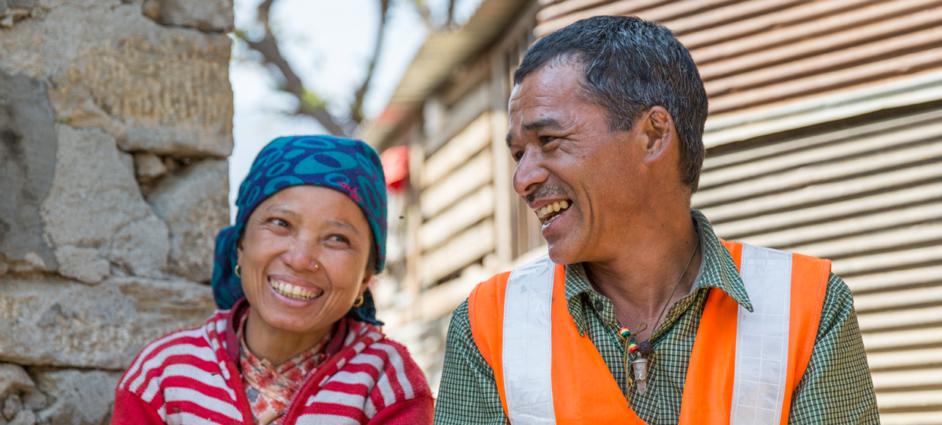

**TRAINING PACKAGE FOR USING SOCIAL SCIENCE IN COMMUNITY ENGAGEMENT AND/OR COMMUNICATIONS ACTIVITIES**

**SESSION 2.1:** Understanding context, vulnerability   
and inequality in public health and humanitarian emergencies

SESSION CONTENT

**Learning approach:** Real-time presentation, individual and group exercises, case examples

**Delivery mode:** Online and offline, 100 minutes approx.

**Summary:** This session introduces the idea that it is important to understand broad social context in order to understand vulnerability and inequality. It also highlights the importance of recognizing the strengths and resiliencies of affected communities, to better design and implement emergency response.

**Learning outcomes:**

* Understand the importance of advocacy to increase the use of social science in community engagement   
  and/or communication activities in a humanitarian/emergency response
* Know the key stakeholders to advocate with and how best to advocate among different groups
* Consider the important steps to advocate for funding social science research

FACILITATING THE SESSION

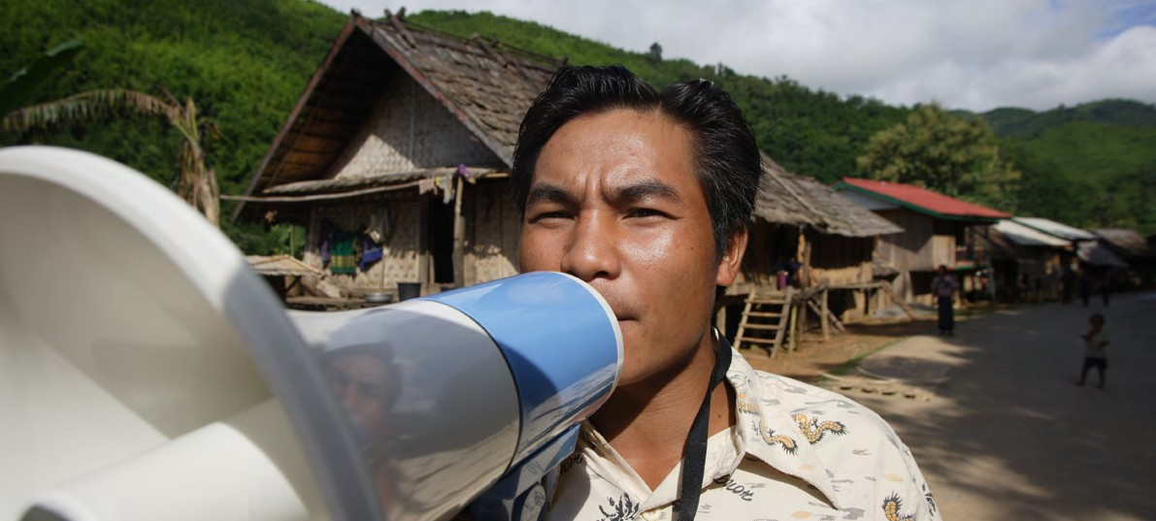

**TRAINING PACKAGE FOR USING SOCIAL SCIENCE IN COMMUNITY ENGAGEMENT AND/OR COMMUNICATIONS ACTIVITIES**

Introduction: (5 minutes total)

Talk through session summary and learning outcomes.

Position this session in the question flow below.

1. How to ensure that this information goes back to communities? To inform community-level actions and decision-making of the broader response?
2. What methodology and tools should be used to collect and analyse this information?
3. How to track the information used to ensure that it effectively contributes to operational and strategic priorities?
4. Who can collect this information?
5. Does this information already exist? Is there a related needs assessment or study?
6. What information is needed?

**DATA TO ACTION:**

Key questions in social science research

1. Who needs this information?
2. How to ensure that the information is used to make operational and/or strategic decisions?

Vulnerability and social difference (30 minutes total)

|  |  |
| --- | --- |
|  | Question to participants (10 minutes):  What does ‘vulnerability’ mean to you?  Who tends to be most vulnerable during a crisis?  What causes vulnerability?  Online: Invite the participants to write the answers in the chat function and summarize  Offline: Ask two or three participants to share their thoughts on each question |

**Vulnerability** – can be defined as the characteristics of individuals, households or groups that put them at risk of physical or mental harm, and/or of being unable to meet their basic needs (definition adapted by SSHAP from Wisner et al. 2004).

Vulnerability is usually created more by social circumstances than by physical/biological characteristics. For instance, women are not vulnerable just because they are women, but because of socially or culturally determined gender roles which can limit their ability to access resources or make decisions. Gender roles – like all social and cultural constructs – can vary considerably between different settings.

For another example, some households or communities are more vulnerable during disasters due to poverty. Poverty is likely the result of (pre-disaster) social, economic and political factors in the place where they live. Vulnerability during emergencies is also exacerbated by pre-existing inequalities. These pre-existing inequalities are often deepened during crises – including when emergency responses are poorly designed and do not take vulnerabilities into account.

**Social difference** – this refers to the aspects of social difference between people, households and groups. Depending on the setting, some aspects of social difference may mean that some people are more vulnerable than others during a crisis. Some examples include gender, race or ethnicity, religion, etc.

|  |  |
| --- | --- |
|  | Brainstorm (10 minutes):  Discuss with participants the ‘dimensions of vulnerability’ identified by researchers in the Rohingya refugee camps in Cox’s Bazar (see PowerPoint). In this discussion, highlight not just vulnerability and social difference, but what risks people are actually vulnerable to, some of which are also illustrated in the graphic. For instance, young girls are at risk of child marriage; unregistered people are at risk of not being able to access resources, etc. |

|  |  |
| --- | --- |
|  | Case example (15 minutes total):  Discuss with participants the ‘dimensions of vulnerability’ identified by researchers in the Rohingya refugee camps in Cox’s Bazar (see PowerPoint). In this discussion, highlight not just vulnerability and social difference, but what risks people are actually vulnerable to, some of which are also illustrated in the graphic. For instance, young girls are at risk of child marriage; unregistered people are at risk of not being able to access resources, etc.. |

Drivers of vulnerability: the role of context (15 minutes total)

|  |  |
| --- | --- |
|  | Question to participants (5 minutes):  What do we mean by context?  Online: Invite the participants to write the answers in the chat function and summarize  Offline: Ask two or three participants to share their thoughts on each question |

**Context:** describe the different aspects of a place that are important for it to be fully understood. There are many examples of features in a context, such as geography, climate, infrastructure, culture, systems of government, language, livelihoods, religion and dominant ideas, etc.

It is important to understand context to understand vulnerabilities during (and following) a crisis. There are three principal connected areas of ‘context’ to consider: political economy, historic legacies, and cultural and social drivers.

**Political economy** – This helps us to understand who has power and resources in a place – both formal and informal power – and who is excluded or marginalized in a specific context, and why. ‘Marginalized’ people are those who are powerless in their society or group. Their marginalized status is often not just because of local factors, but also national and global political and economic processes that can lead to poverty, inequality, and unjust distribution of resources between different social groups.

**Historic factors/legacies** – These are closely related to political economy, but emphasize historical factors and experiences which may continue to shape vulnerabilities and inequalities; examples are colonial exploitation, and conflicts. Ethnic divisions, for instance, may be rooted in divisions encouraged by former colonial powers who were exploiting divide and rule tactics, or from historical conflicts which persist into the modern day.

**Cultural and social drivers** – These refer to cultural and social norms and practices which can shape vulnerability in different ways. Women, for instance, may be expected to care for sick family members which might put them at higher risk of infectious disease during an epidemic. Other examples might include cultural or social taboos which lead to discrimination against certain groups such as religious minorities or certain types of workers (e.g. waste pickers).

Assessment of broad political, economic and historical circumstances can highlight how whole populations or communities – of an entire region or ethnic group for example – may be more vulnerable than other populations or communities. More detailed analyses can reveal power differentials and inequalities within communities and households. Taking stock of political economies alongside an analysis of cultural and social norms and practices, you can get a good sense of who may be more vulnerable in a crisis, and why.

|  |  |
| --- | --- |
|  | Small group discussion (5 minutes)  Share an example of how aspects of political economy, historic factors or cultural and social drivers in your context (or a context you have worked in) have impacted vulnerability and inequalities. How might these different drivers relate to one another?  Online: Invite the participants to write the answers in the chat function and summarize  Offline: Ask two or three participants to share their thoughts on each question |

Resilience (15 minutes total)

|  |  |
| --- | --- |
|  | Question to participants (5 minutes):  What does ‘resilience’ in the setting of a humanitarian emergency mean to you?  Online: Invite the participants to write the answers in the chat function and summarize  Offline: Ask two or three participants to share their thoughts on each question |

**Community resilience** is a term often used in disaster management and humanitarian response to refer to the extent which communities can prepare for and respond to crises. It is important for responders not to frame affected communities only as vulnerable, passive recipients of aid. Communities and community members are actually often the first responders to a crisis, and they should be recognized for having valuable experience, knowledge, networks, skills and practices.

Responders must acknowledge and take stock of a community’s strengths and assets, and build on these existing capacities and forms of resilience. Critically, programmes must still acknowledge that these groups can face stark inequalities and injustices. Efforts to build resilience should emphasize both what can be done to support community action in the immediate stage of an emergency, as well as integrate more long-term objectives for resilience building for social justice.

An example comes from the Rohingya refugee camps in Cox’s Bazar, when a response action may have omitted local organization among a vulnerable social group. Humanitarian responders had set up ‘safe spaces’ for women and girls. An anthropologist (a type of social science researcher) doing research in the camp later learned that women were already self-organizing taleems, or gatherings organized around prayer. The taleems provided a sense of belonging, safety and hope, and a space in which they could relate to one another, give advice, and share. That is, they were setting up their own safe spaces. The researcher found that women were more comfortable in these informal spaces, than in those set up by the response

|  |  |
| --- | --- |
|  | Question to participants (5 minutes):  How can responders best support community resilience in humanitarian settings?  Online: Invite the participants to write the answers in the chat function and summarize  Offline: Take answers from the room |

Responders can support community resilience in humanitarian settings in several ways:

* Continually assess communities’ strengths and resources
* Ask directly how communities themselves are addressing, or would like to address, issues related to the emergency
* Provide resources and support to community action rather than duplicating their efforts, or even damaging their organizing
* Monitor for gaps in community responses – there may be vulnerable groups that are being excluded from informal responses. How can they be helped?

Context analysis for humanitarian emergencies (30 minutes total)

|  |  |
| --- | --- |
|  | Question to participants (5 minutes):  Consider the content of the session so far and how this applies to your work. Why is it important for emergency responders to have an understanding of context, vulnerability & resilience?  Online: Invite the participants to write the answers in the chat function and summarize  Offline: Take answers from the room |

Context analysis is a social science research method which can support responses to be better able to address the needs of vulnerable groups, and build upon community resilience, in both the immediate and long term. This might entail:

1. Foresee – being aware of context can help responders foresee or predict who may be more vulnerable in a given situation
2. Investigate – being aware of context can help responders understand what kinds of questions they need to be asking to find out who is vulnerable
3. Lessen its impact – being aware of context can help responders design and implement programmes that look out for vulnerability, either by reducing it or stopping it from worsening and ensuring that no one is left behind
4. Build on – being aware of context can help responders recognize and build on community resources and strengths, which can contribute to making communities more resilient in the long run, and therefore may reduce vulnerabilities

|  |  |
| --- | --- |
|  | Case study: Individual or group exercise (20 minutes)  Think of a public health or humanitarian emergency you are familiar with:   * Who was/is particularly vulnerable during that crisis? In what ways? * Are there social groups you think might have been/might be vulnerable that have not been recognized? * What are some of the drivers that may have led to this vulnerability? (e.g. refer back to Level 1 and Level 2 drivers of behaviour from the Behavioural Drivers Model, Session 1.1) * Are there examples of resilience within affected communities, and even vulnerable groups, that responders have/could have built upon? * How might have you designed an aspect of response (community engagement, contact tracing, treatment, etc.) differently to ensure no one is left behind?   If session attendees are not familiar with any, emergency options to discuss can include the West and Central African Ebola epidemics, the Rohingya refugee crisis in Cox’s Bazar, the Zika epidemic in South America, the Nepalese earthquake, the Haiti earthquake, the COVID-19 pandemic in a specific country context ,etc.  Ask one or two groups to report back in plenary) |

Wrap-up/summary (5 minutes)

* Contextual knowledge is of critical importance during a humanitarian emergency.
* It is important to understand the broader social context of a setting in order to understand issues of vulnerability and inequality. Vulnerability is usually created more by social circumstances than by physical/biological characteristics.
* While understanding vulnerability, responders should also look to community resilience. Communities and community members are actually often the first responders to a crisis, and have valuable experience, knowledge, networks, skills and practices. Responders can support community resilience in humanitarian settings in several ways.
* Context analysis is a social science research method which can support responses to be better able to address the needs of vulnerable groups, and build upon community resilience, in both the immediate and long term.

ACKNOWLEDGEMENTS:

Megan Schmidt-Sane and Tabitha Hrynick (IDS) developed the content of this module.   
It was reviewed by Theresa Jones and Olivia Tulloch (Anthrologica).