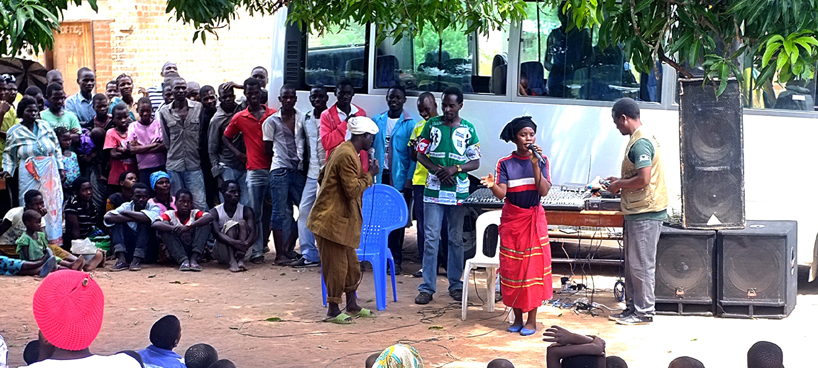

**TRAINING PACKAGE FOR USING SOCIAL SCIENCE IN COMMUNITY ENGAGEMENT AND/OR COMMUNICATIONS ACTIVITIES**

**SESSION 4.10:** Community feedback mechanism: Consolidation and analysis

SESSION CONTENT

**Learning approach:** Real-time presentation, individual and group exercises, case examples

**Delivery mode:** Online and offline, 115 minutes approx.

**Essential sessions to have completed before this session:** 1.1, 4.1, 4.4, 4.6, 4.9

**Summary:** This session focuses on the application of qualitative approaches to manage a community feedback mechanism. It describes community feedback consolidation, prioritisation and analysis using examples from the Red Cross. This session links the IFRC Community Feedback Kit to the social science operational research context.

**Learning outcomes:**

* Become familiar with open and structured feedback data and how it is analyzed
* Become familiar with methods to organise and analyse community feedback
* Understand when feedback is of a critical or sensitive nature

FACILITATING THE SESSION



**TRAINING PACKAGE FOR USING SOCIAL SCIENCE IN COMMUNITY ENGAGEMENT AND/OR COMMUNICATIONS ACTIVITIES**

Introduction: (5 minutes total)

Talk through session summary and learning outcomes.

Position this session in the question flow. Explain that this module mainly addresses question area 4 and 5,   
but we will touch on 1, 2, 3 and 6.

1. How to ensure that this information goes back to communities? To inform community-level actions and decision-making of the broader response?
2. What methodology and tools should be used to collect and analyse this information?
3. How to track the information used to ensure that it effectively contributes to operational and strategic priorities?
4. Who can collect this information?
5. Does this information already exist? Is there a related needs assessment or study?
6. What information is needed?

**DATA TO ACTION:**

Key questions in social science research

1. Who needs this information?
2. How to ensure that the information is used to make operational and/or strategic decisions?

Note: Content in this session has been adapted from the [IFRC Feedback Kit](https://docs.google.com/document/d/1PJNUfW8Cr2u8Ew8pK_1fKYJOtqGlxrLZRso9DpyiZ8w/edit?usp=sharing) (Overview).

Recap from Session 4.9: Community feedback & feedback mechanisms   
(10 minutes total)

Community feedback is simply any information shared by members of the community we are working for and interacting with.

* Feedback could be about anything, but we are usually interested in community members’ experiences with the activities we are conducting, the current situation of the community, or other topics relevant to our work, such as health beliefs.
* It is communities’ right to share their feedback with us, and our responsibility to manage and handle it appropriately.
* Community feedback data are owned by the community and, at the end of the day, are used by the community to trigger actions within it.
* Community members may share insights that include questions, suggestions, observations, beliefs, perceptions, concerns and statements of thanks.
* These insights could be shared in different ways: formally or informally, in a structured or unstructured way, directly or indirectly.
* Feedback could be proactively collected, or reactively received when community members wish to share.
* Feedback could be positive, neutral or negative.

A community feedback mechanism is a way to systematically and regularly listen to and act on what community members share with us, especially while they are receiving support. A community feedback mechanism is organized in a cycle of collecting, making sense of, acknowledging and acting on what’s shared by community members. The system includes different ways (channels) for collecting/receiving feedback, tools for managing, analysing and sharing feedback, and processes to act on the data and inform communities about actions taken.

Community feedback is an essential part of an emergency response, including risk communication and community engagement . By recognising, respecting and valuing local knowledge, community feedback mechanisms are an opportunity to build and maintain trust with communities and accountability to them. Organisations have an obligation to listen to community members and respect their right to give feedback.

|  |  |
| --- | --- |
|  | **Case example: DRC Red Cross collecting community feedback for Ebola response and volcanic eruption**  During the Ebola response in the East of the Democratic Republic of Congo (DRC), which started in 2018 and lasted for more than two years, Red Cross volunteers conducted a range of activities. They shared information about the virus, ways to protect yourself, and the response activities with community members. They conducted household visits, discussions with community groups, interactive radio shows, and more. During these activities, the volunteers received lots of feedback from community members, which they recorded using paper forms. All data were entered into an Excel database, coded and analysed on a regular basis. The findings were shared and discussed with local government-led risk communication commissions and Ebola response leaders as well as regional and global partners, to inform strategic discussions and decisions. The feedback data helped the Red Cross operation to respond to community concerns and suggestions in real-time, which built trust and acceptance for health interventions. This method has since been used in several contexts, including more recent emergencies such as the response to the volcanic eruption in Goma, DRC, a population movement response, and has also been integrated into the IFRC Community Epidemics and Pandemics Preparedness Programme (CP3). For more on the feedback mechanism in DRC, visit [Global Health: Science and Practice](https://www.ghspjournal.org/content/9/2/332). |

We can break down the community feedback cycle into six steps:

1. Design of a feedback mechanism
2. Collection & initial response
3. Consolidation & prioritisation
4. Analysis
5. Sharing & taking action
6. Closing the loop

Figure 1 below visualizes the 6 steps of the Community Feedback cycle. In this session, we will cover steps 3 and 4, consolidation and prioritisation, and analysis. For more information on steps 5 and 6, see Session 7.2.

Figure 1: The Community Feedback Cycle

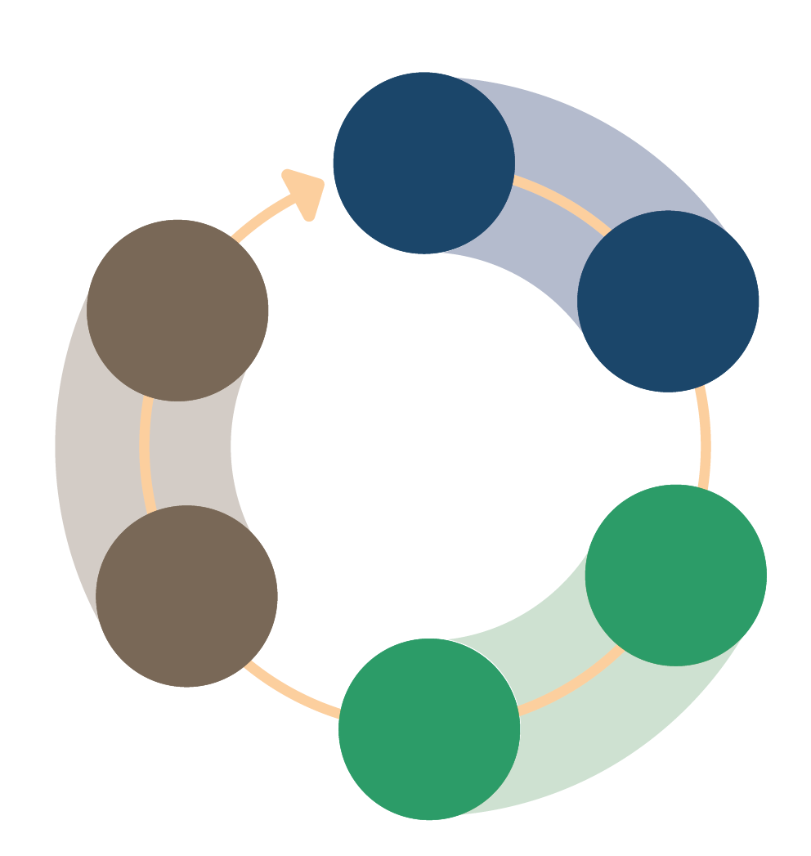

1.

Design

2.

Data collection & initial response

3.

Consolidation &

prioritisation

4.

Analysis

5.

Sharing   
&  
taking action

6.

Closing   
the loop

Step 3: Consolidating, reviewing and prioritising community feedback data  
(30 minutes total)

Refer to Session 4.9 for Steps 1-2

Consolidation & prioritisation: Some feedback comments might be addressed immediately; others might have to be escalated to program teams or leadership. Once feedback has been recorded, you need to sort and treat the different types of feedback according to the nature of the feedback (level of sensitivity or criticality).

|  |  |
| --- | --- |
|  | Brainstorm (10 minutes):  What does sensitive or critical feedback mean? Why would it need to be escalated to program teams or leadership quickly?  Online: Invite the participants to write the answers in the chat function and summarize  Offline: Collect answers from the group  Three different types of feedback:  Sensitive Feedback – Any information that can put the person sharing it or other people linked to it at risk and needs to be handled with care.[1]   * This can involve serious allegations related to breaches of national or international law, or human rights law concerning the protection (safety, dignity, and rights) of affected populations, or any violation of the Humanitarian Code of Conduct or safeguarding policies.[2] Sensitive feedback can be received as any type of feedback, such as a report, a question, or a suggestion as it depends on the specific situation if it puts a person at risk if shared with others.   Critical feedback – Any feedback that requires urgent/timely follow-up but is not sensitive in nature.   * These can include issues like the delivery of spoiled food, potential security risks, signs of an outbreak of disease, or new rumours in the community that might directly threaten upcoming programming. Critical feedback comments need to be shared immediately with the person in the best position to address the comment.   Routine feedback – Any feedback that does not require an urgent response and can be incorporated into routine feedback collection, analysis, action, and response cycles.   * These can include feedback about general levels of satisfaction with program activities, recommendations to improve future programming, general updates on changes in the operational context, etc. Routine feedback still needs to be responded to in the sense that all feedback requires “closing the loop”, but there is more time to consolidate it, analyse it, share it, and respond to it alongside other feedback data. |

A) Consolidate the feedback

After collecting community feedback data, it needs to be gathered and processed so it can be analyzed and used. How you do this can vary depending on the feedback channels and complexity of your mechanism. It’s important to consolidate the feedback as soon as you can after collection.

Examples:

* Type feedback into a logbook or common database
* Discuss feedback verbally in a meeting
* Write up notes and data collection forms

**A few helpful tips:**

Translating community feedback data

Ideally we want to keep feedback in its original language. If you must translate raw data, include a glossary of terms to reduce the risk of context and meaning being lost in translation.

Data management

Save raw data for future analyses, in-depth questions and accountability.

B) Review and clean the feedback

After consolidating the feedback, the next step is to review and clean the data. A best practice is to work with a teammate who has a fresh perspective.

Key questions to ask when reviewing data are:

* Are the feedback comments clear? Is it clear what the feedback provider was saying?
* Was all sensitive feedback was classified as such?
* Are there any duplicates in the data?
* Were the right categories and answer options used? Are there any inconsistencies?
* Is there any information missing?
* If a sampling strategy was used, was it followed?

Bring back any patterns in data quality issues to the feedback collectors so they can improve. Let them know there will be regular spot checks.

For more detailed instructions on data cleaning, see the IFRC Feedback Kit: ‘4. How to listen and respond to open community feedback: Section IV Feedback Referral and Analysis - Consolidate and clean data’ and ‘5. How to Use Perception Surveys in a Feedback Mechanism: Section IV Consolidation and prioritization – 4.2 Cleaning and Quality Assurance’.

C) Prioritise and make referrals where necessary

Based on your feedback mechanism design and referral framework, flag any feedback that is critical (meaning that it’s urgent and needs specific follow-up) and refer to the responsible person(s). Note when and how and referrals were made.

Sensitive feedback will be handled according to processes outlined by your organization. Sensitive feedback should be flagged as soon as it is collected, before consolidation.

For more on sensitive feedback, see Module 6 on ‘How to Handle Sensitive Feedback’ in the IFRC Feedback Kit.

|  |  |
| --- | --- |
|  | Question to participants (10 minutes):  What could be some examples of critical community feedback data (feedback that needs urgent follow-up or referral)?  Online: Invite the participants to write the answers in the chat function and summarize  Offline: Ask two or three participants to share their answers |

* Health and safety issues like spoiled food or security threats
* New “rumours” or beliefs that undermine upcoming programming
* Signs of a disease outbreak

**REMINDER:**

Sensitive community feedback is different from critical feedback. Sensitive feedback can put people who shared it at risk and can involve any serious allegations related to breaches of laws or violations of human rights, the humanitarian Code of Conduct or safeguarding policies. Examples of sensitive feedback would be experiences of sexual exploitation or abuse, or reports of corruption. Sensitive feedback are always handled separately to reduce the risk of harm for the person sharing the feedback.

**”**

We heard there will be an attack   
on the hospital tomorrow.

**“**

The vaccine will kill us in 5 years.

**“**

**”**

Your vaccine causes abortion in pregnant women.

**“**

**”**

My neighbour   
got sick after attending your event.

**“**

**”**

Step 4: Analysing community feedback (60 minutes total)

Analysis: Feedback needs to be analysed for immediate action and understanding of longer-term trends. Analysing means you group the feedback comments to identify the main topics that community members shared with you and see if there are differences in the feedback shared by specific groups of people or changes over time. You also compare the findings with other information sources to understand the bigger picture.

The main steps for analysing feedback data are:

1. Compile – gather all the feedback data you want to analyse
2. Identify themes – See which topics stand out
3. Disaggregate – See if there are differences between locations, demographic groups, and feedback channels
4. Identify changes – See if the data have changed
5. Triangulate – See if other information sources confirm your findings and provide more insights

An important tool for analysing feedback are codes. Codes are key words or short phrases that we assign to feedback phrases that help us organise the feedback, understand the main themes and topics within it, and keep track of all the information so we don’t get overwhelmed. Having a coding system is important in feedback mechanisms because our data collection and analyses are ongoing. See Session 4.6 for additional details on coding. See **Worksheet 1** for a template coding framework for community feedback.

|  |  |
| --- | --- |
|  | Question to participants (5 minutes):  What are some tools or means that you could use to code your feedback data?  Online: Invite the participants to write the answers in the chat function and summarize  Offline: Ask two or three participants to share their answers |

Coding can be done in various ways, including:

* Hand-writing the codes beside text in hand-written forms or logs
* Using post-its, flipchart posters, or chalk on a board to organise and group statements relating to different topics
* Using a table in a word processing program and placing codes in a column next to each feedback comment
* Adding all comments to an Excel spreadsheetand adding the codes in separate columns. Using “dropdown menus” can facilitate the coding process
* Use qualitative data analysis software (e.g., Nvivo, MaxQDA)
* Using machine learning to automatically assign codes to different feedback comments

When you are coding, you will need to list the codes in a coding framework. If you have a lot of codes, it might help to categorise these codes. See what makes sense based on your data collection tools. It’s also important to define your codes in a codebook, to help you keep track and so others can also understand and apply the codes.

A coding framework presents the hierarchy of codes and how they are grouped into categories under the different types of feedback.

*A small extract from a community feedback coding framework as an example:*

|  |
| --- |
| Questions  Questions about response activities  Questions about distributions  Questions about selection criteria  Questions about how to register for support  **TYPE OF FEEDBACK** |
| **CATEGORY** |
| **CODE** |

A codebook describes the different types, categories and codes and explains how to use them. It is the reference document for everyone using the coding frame and ensures everyone codes the data the same way.

*A codebook for community feedback data can be structured like the following:*

|  |  |  |  |  |
| --- | --- | --- | --- | --- |
| Code | Description (inclusion and exclusion criteria) | Example feedback comments | Last changed | Comments |
| Questions about distributions | Any question relating to distributions, e.g., the time or location of the distribution | * When will the next distribution take place? * How will we be informed about the timing of the next distribution? * Is the next distribution happening at the same site? | Introduced on 03.11.2021 | Do not code questions about how to register for support, this is coded under the separate code “questions about how to register for support” |

|  |  |
| --- | --- |
|  | Group exercise (10 minutes):  One way to organize feedback is by type. “Types” of feedback include:  **Questions** – Can show what communities need to know and help you to identify information gaps.  Example: How can I keep my family safe?  **Suggestions or requests** – Can tell you what communities think needs to be done about specific issues and what you could do better or differently.  Example: We want to be consulted before you decide what will be done.  **Observations, beliefs, and perceptions** – Can show how communities understand and analyse their situation. This includes beliefs that may be labelled as “rumours”, superstitions or gossip. Note that these labels can be stigmatising.  Examples: People in our communities don’t want to be vaccinated; Ebola is caused by witchcraft.  **Encouragement and praise** – Can tell you what communities appreciate and think should be continued, confirming if you are moving in the right direction.  Example: Thanks for visiting us and discussing with us.  **Report of concerns or incidents** – These are comments about specific issues which might need to be handled on an individual basis.  Example: I have not received my cash transfer for this month.  Question for the group:  What “type” does each of these feedback statements belong to?   * Where can I register for receiving assistance? (answer: questions) * The earthquake is a revenge of the gods. (answer: observations, beliefs and perceptions) * The latrines in our sector are broken and need to be fixed. (answer: report of concerns or incidents) * We love the radio shows, keep up the good work! (answer: encouragement and praise) * You should provide us with face masks. (answer: suggestions or requests)   Online: Invite the participants to share their answers in the chat function or in a poll and summarize  Offline: Collect answers from the group and discuss |

For more detailed analysis steps for open feedback data, see Sessions 4.4 and 4.6. For structured feedback like perception surveys, see Sessions 4.3, 4.5 and 4.7. See also Module 4 on ‘How to Listen and Respond to Open Feedback Data’, and Module 5 on ‘How to Use Perception Surveys in a Feedback Mechanism’ in the IFRC Feedback Kit.

Different approaches for analysis can include:

* Looking at specific topics or feedback cases like an event or emerging issue in the community
* Compile feedback from different locations or from different channels
* Stakeholder-driven or community-led analysis

Once results are analysed, ensure that community feedback findings are included in broader analyses and triangulated with other social science data (refer to Session 4.8).

Analytical framework

An analytical framework is a way to organise information about key areas of an issue or emergency. It supports planning and strategising, collaboration, triangulation of various data sources, and gives an overview of the information available. An analytical framework categorises all the available information and helps foster collaboration across different teams and breaks down silos to increase effectiveness. Community feedback codes can map onto the analytical framework. It’s important for an analytical framework to be updated regularly to include emerging and existing community feedback topics.

Saturation

When analysing community feedback, you may start to hear the same message many times. This could be a sign of saturation, which a point in the qualitative research process when gathering and analysing more data doesn’t lead to any new insights. When you reach this point, it’s important to revisit your data collection strategy with your team of data collectors to decide if you can scale back your data collection, or if there are data collection or quality issues (such as biases or errors).

|  |  |
| --- | --- |
|  | Group exercise (15 minutes):  Explore the [Template Coding Framework and Codebook](https://docs.google.com/spreadsheets/d/1CSy6kTUed47r864FNp4j4prAyZhS6kkf?rtpof=true&authuser=evaelisabeth.erlach%40gmail.com&usp=drive_fs) (**Worksheet 1**) from the IFRC Feedback Kit together. From the template codebook sheet, pick one type of feedback (e.g. question; suggestions or requests; observations, perceptions or beliefs; encouragement and praise; report of a concerns or incidents). Discuss the feedback categories, codes and examples with your partner.  Online: Invite the participants to share the findings in the chat function and summarize  Offline: Collect answers from the group and discuss |

*For advanced community feedback analysis, get the support of someone with a technical background in community feedback mechanisms*

Completing the community feedback cycle (5 minutes total)

*The final two steps (Steps 5-6) of the community feedback cycle are covered in Session 7.2.*

Sharing & taking action:The most essential step of the feedback cycle is gathering together to discuss what you have been hearing, what it means, and what you can do to address it. To facilitate this process, you need to share and discuss the findings with those who are in the position to act on the feedback. This includes internal discussions, external discussions (with peers and others) and, importantly, meetings with the community.

Closing the loop: To close the feedback cycle, you document the agreed action points and provide updates on what has been done with the feedback to the community.

FURTHER RESOURCES

* [IFRC Feedback Kit](https://docs.google.com/document/d/1PJNUfW8Cr2u8Ew8pK_1fKYJOtqGlxrLZRso9DpyiZ8w/edit?usp=sharing) (Overview)
* [How to build or adapt a coding framework](https://docs.google.com/document/d/1G3x-yQCgmtW8nbzhxcmIEwV0pNyAVrvf/edit?usp=sharing&ouid=109473232721131860036&rtpof=true&sd=true)
* [A template coding framework](https://docs.google.com/spreadsheets/d/1CSy6kTUed47r864FNp4j4prAyZhS6kkf?rtpof=true&authuser=evaelisabeth.erlach%40gmail.com&usp=drive_fs) (can be used as a starting point for coding community feedback, see also **Worksheet 1)**
* [Example coding frameworks for Ebola, COVID-19 and other diseases](https://drive.google.com/drive/folders/1VsfR3ByxtmauvRkyMAEyWquSRn2hpBQ1?usp=sharing)
* [An example analytical framework for community feedback](https://docs.google.com/spreadsheets/d/10mp4MFCizRsG3M3IuzPI_0SEYStCD25Y?rtpof=true&authuser=evaelisabeth.erlach%40gmail.com&usp=drive_fs)

FOR MORE DETAILED INFORMATION COMMUNITY FEEDBACK (IN GENERAL) –

* [Using Community Feedback to Guide the COVID-19 Response in Sub-Saharan Africa: Red Cross and Red Crescent Approach and Lessons Learned from Ebola](https://www.liebertpub.com/doi/10.1089/hs.2020.0195?url_ver=Z39.88-2003&rfr_id=ori:rid:crossref.org&rfr_dat=cr_pub%20%200pubmed)
* [New Mixed Methods Approach for Monitoring Community Perceptions of Ebola and Response Efforts in the Democratic Republic of the Congo](https://www.ghspjournal.org/content/9/2/332)
* [A Red Cross Red Crescent Guide to Community Engagement and Accountability](https://communityengagementhub.org/wp-content/uploads/sites/2/2019/06/20211020_CEAGuidelines_NEW1.pdf)
* IFRC’s [COVID-19 Community Feedback Kit](https://communityengagementhub.org/resource/covid-19-community-feedback-kit/), which provides a list of tools and guidance actors need to set up mechanisms for systematically listening and responding to communities

.

Wrap-up/summary (5 minutes)

* **Community feedback** is simply any information shared by members of the community we are working for and interacting with. A community feedback mechanism systematically collects feedback.
* Some feedback is of a sensitive or critical nature and needs to be addressed immediately or escalated to program teams or leadership.
* To ensure high quality of feedback, data collection teams must also know if there are any issues in their processes.
* This is why quick consolidation of feedback, either into a database or verbally at a meeting, is important.
* Reviewing and cleaning data to check if it’s complete and clear is the next step.
* Prioritising feedback and making referrals where necessary is a key step for accountability.
* Feedback analysis must involve community members.
* Main steps for analysis are:
* Compile
* Identify themes
* Disaggregate
* Identify changes
* Triangulate
* Codes are a tool to help us organize feedback. Codes are organised using a coding framework and codebook.
* Analytical frameworks help with strategic organisation of information, across teams in an organisation or response.
* Communication between analysts and data collectors is important to keep the volume of data usable but manageable.

ACKNOWLEDGEMENTS:

This session was developed by Vivienne Walz (IFRC), Ombretta Baggio (IFRC) and Eva Erlach (IFRC) and is based on materials developed by CDA Collaborative Learning and IFRC. It was reviewed by Elisabeth Ganter Restrepo (IFRC) and Ginger Johnson (Collective Service).

1. Inter-Agency Standing Committee (2021). Data Responsibility in Humanitarian Contexts. Operational Guidance, p.30.
2. Danish Refugee Council (forthcoming). Community Feedback and Complaint Response Mechanism, p. 19.