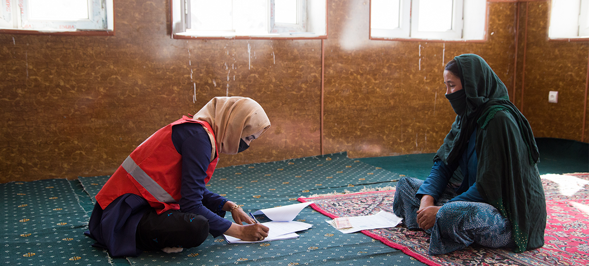

**TRAINING PACKAGE FOR USING SOCIAL SCIENCE IN COMMUNITY ENGAGEMENT AND/OR COMMUNICATIONS ACTIVITIES**

**SESSION 4.4:** Qualitative data collection methods: In-depth interviews, observations, and focus group discussions

SESSION CONTENT

**Learning approach:** Real-time presentation, individual and group exercises, case examples

**Delivery mode:** Online and offline, 140 minutes approx.

**Essential sessions to have completed before this session:** 4.1

**Summary:** This session focuses on qualitative approaches to collecting data that is relevant to community engagement and/or communications activities. Specifically, it covers in-depth interviews, structured and informal observations and focus group discussions.

**Learning outcomes:**

* Become familiar with the range of different qualitative data collection tools that can be useful for community engagement and/communications activities
* Be able to apply certain qualitative data collection methods
* Become familiar with different rapid qualitative methodologies

FACILITATING THE SESSION

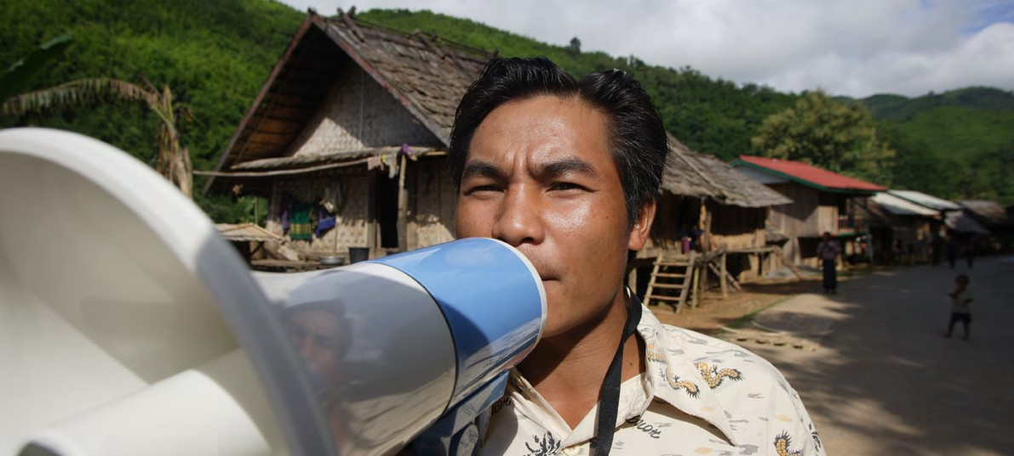

**TRAINING PACKAGE FOR USING SOCIAL SCIENCE IN COMMUNITY ENGAGEMENT AND/OR COMMUNICATIONS ACTIVITIES**

Introduction: (5 minutes total)

Talk through session summary and learning outcomes.

Position this session in the question flow. Explain that this module mainly addresses question area 5, but may touch upon other questions.

1. How to ensure that this information goes back to communities? To inform community-level actions and decision-making of the broader response?
2. What methodology and tools should be used to collect and analyse this information?
3. How to track the information used to ensure that it effectively contributes to operational and strategic priorities?
4. Who can collect this information?
5. Does this information already exist? Is there a related needs assessment or study?
6. What information is needed?

**DATA TO ACTION:**

Key questions in social science research

1. Who needs this information?
2. How to ensure that the information is used to make operational and/or strategic decisions?

Qualitative Methods (15 minutes total)

|  |  |
| --- | --- |
|  | Question to participants (5 minutes):  What do we mean by qualitative methods?  If participants have completed session 4.2 explain that this is a recap  Online: Invite the participants to write the answers in the chat function and summarize  Offline: Ask two or three participants to share their answers |

Qualitative methods are used to understand ‘the why and the how’ – why do people behave in a certain way, how do they perceive the situation and what are their priorities and capacities. These methods are important to get an in-depth understanding of underlying social and behavioural drivers (for example, why do some people not want to be treated in an Ebola treatment centre or avoid being treated there; why do people trust some information sources more than others during a conflict; why do people prefer certain types of COVID-19 vaccines over others, etc.?)

Qualitative approaches

* Not based on numbers
* Generally use interviews, focus groups discussions and observations
* Exploratory: looking at factors such as cultural expectations, gender roles, ethnic and religious implications and individual feelings
* Usually use a smaller sample size than quantitative approaches
* Methods provide results that are usually rich and detailed, offering many ideas and concepts to inform programming

|  |  |
| --- | --- |
|  | Question to participants (5 minutes):  Why are qualitative methods important to community engagement and/or communications activities?  Online: Invite the participants to write the answers in the chat function and summarize  Offline: Ask two or three participants to share their answers |

Qualitative methods are critical as they:

* Allow an understanding of why and how affected people and communities cope with and are impacted by an emergency
* Give us an opportunity to listen to people
* Help to start a dialogue/conversation with people affected by an emergency situation
* Can help to build relationships, acceptance and trust among crisis-affected populations
* Help to identify local resilience mechanisms for responding to crisis which can be supported (i.e. building on existing structures instead of creating new and unsustainable ones)

As for any operational social science research, it is important to systematically involve communities in the research cycle. This means involving them in the research design (e.g. what are their priority research questions?), the roll-out and analysis of data, and also discussing with them key findings and specific recommendations for improvement.

These principles are all central to community engagement and/or communications activities.

Qualitative data collection techniques and tools (30 minutes total)

|  |  |
| --- | --- |
|  | Question to participants (5 minutes):  Which techniques and tools can be used to collect qualitative data?  Online: Invite the participants to write the answers in the chat function and summarize  Offline: Ask two or three participants to share their answers |

There are many different techniques and tools that can be used to collect qualitative data which are relevant to community engagement and/or communications activities.

These are just some examples of tools that can be used:

Figure 1: Qualitative methods that can be helpful for community engagement and/or communications activities to design and deliver high-quality and locally appropriate approaches and strategies



FOCUS GROUP   
DISCUSSION

OBSERVATION

KEY INFORMATION INTERVIEW

TRANSECT /   
OBSERVATORY WALK

SOCIAL NETWORK MAPPING

COMMUNITY RESOURCE   
AND RISK MAPPING

MEDIA / SOCIAL   
MEDIA MONITORING

|  |  |
| --- | --- |
|  | Question to participants (5 minutes):  Which techniques and tools have you used in your work?  Online: Use a poll outlining the different tools and invite the participants to vote  Offline: Invite the participants to share their experience in plenary and highlight in colours those tools participants are most familiar with  Optional: Consider – for both online and offline training delivery – facilitating a brief discussion on which tools the participants find easy to use and why other tools are less commonly used or are more difficult to use |

These are a selection of some of the most common techniques and tools. They can be used alone or together, but it is important to select the most appropriate tools depending on the situation, the kind of information you need, the type of human resources available to collect data, and who you want to engage.

Key informant interviews (KIIs), semi-structured interviews (SSIs) or in-depth interviews (IDIs) are conducted with people who can provide detailed information about the topic you want to know more on. They use a set of predefined questions or a topic guide covering the area of interest. They allow interviewees/key informants to provide both first-hand experiences and personal opinions. Key informant interviews can be a helpful method when seeking information on sensitive issues that are difficult to discuss in a wider group. They are also suitable when engaging vulnerable individuals who are difficult to reach and/or who require extra time to build trust on a one-to-one level. You might face both of these scenarios in your work. KIIs can be conducted with a range of people – in practice it often starts off with visible community leaders to better understand the situation, begin to identify social dynamics, vulnerabilities and risks, etc., but can then be expanded to include other members of the community who can share information to help answer your research question. KIIs are normally conducted at the beginning of a project to inform the design of activities or at the end as a tool for evaluation. However, they can be conducted on an ongoing basis to inform the roll-out of activities.

Observations can include different approaches:

* Household-level observations using a checklist (e.g. Does the family cover the water storage container? Is soap available?)
* Exploratory observation walks or transect walks using a topic guide. These types of observation are often conducted with people from the community including representatives from specific population groups (e.g. adolescents, minority groups, women). They can help the researcher to collect information, for example on popular gathering places, existing infrastructure, and accessibility to services such as health structures.
* Ethnographic observations involve taking detailed notes to document participants' ongoing behaviour in a natural situation. This allows for a thorough record of what people say and do in a given situation and can provide direct information on their actions and behaviours – e.g. what nurses say and do during vaccination clinics.

|  |  |
| --- | --- |
|  | Question to participants (5 minutes):  Why might it be useful to combine interviews with observations?  Online: Invite the participants to write the answers in the chat function and summarize  Offline: Ask one or two participants to share their answers |

Observation can be used to verify information collected verbally from participants – is what they say they do actually what they do? For example, household-level observations could help to determine if soap is available at home close to the latrines/toilet facilities to understand if people are able to wash their hands with soap at critical times. Or, for example, if a health worker describes in a key informant interview that she/he provides detailed information on vaccine side effects to patients, then additional observations would help verify this.

It is important to understand that self-reported behaviours can differ widely from actual behaviours. For example, COVID-19 survey data can indicate a high percentage of people wearing masks, whereas observed behaviour in public spaces may indicate low levels of mask wearing. When a person knows what the socially desirable response is (e.g. mask wearing) they are more likely to report themselves as following the desired behaviour, especially for remote-based data collection methods where there is no opportunity to observe behaviours.

Transect/observatory walk is a common method used to observe and talk in person (or as a team) about things of local importance. The team/researcher selects, with the help of the community, key informants (could be representatives of vulnerable population groups, adolescents, women, formal community leaders, etc.) to walk with them through the area (for example village and surroundings) using a topic guide to record the observations and discussion. It involves observing, asking, listening, discussing, learning about different ranges/zones and seeking opportunities for greater inclusion and accessibility of vulnerable groups.

Focus group discussions(FGDs) involve in-depth discussion with a group of people about a certain topic. Again, these are based on a predefined list of questions or a topic guide covering the area of interest. FGDs generally include 8–10 people. It is important to ask: who is in the group and will this selection of participants lead to open sharing and dialogue? (e.g. should men and women be in the same group in this setting?, should health facility supervisors and more junior health workers be included in the same session?) It is important to ensure that you actively include vulnerable groups such as persons with disabilities, migrants and the elderly, and consider doing separate FGDs with them. This method allows for members of the group to agree or disagree, which gives insight into the range of ideas and opinions and levels of agreement and consistency. This is important as many of the issues that community engagement and/or communications activities address involve a range of beliefs, attitudes and related actions, all of which should be understood – e.g. contraception use.

Social network **mapping** is a creative research method used to visualize key influencers and key information sources through a drawing (e.g. on a large paper sheet, chalkboard or through drawing in the ground/mud). The different sizes of circles represent key influencers and key information sources – a larger circle can indicate a key influencer or information source that is considered more important than those in smaller circles. Their proximity to the centre of the map can illustrate how accessible and/or influential they are to the individual or the group. This can help identify crucial actors, modalities and routes for community engagement and/or communications activities. Some tools that can be referred to can be found [here](https://sswm.info/es/sswm-solutions-bop-markets/improving-water-and-sanitation-services-provided-public-institutions-2/venn-diagrams).

Figure 2: Social network of Rachel Kiambu for seeking maternal and child health care



An example of key influencers and key information sources relating to antenatal care (fictional).

Note that the hospital is considered to be important, but is in fact less accessible to Rachel than other influencers/information sources. The traditional birth attendant, Mrs Jaynee, is also much closer to her than the hospital. This is helpful to know. Social network maps can also be created on a group/community level.

Community resource and risk mapping is a creative research method that recognizes that the local population holds accurate knowledge of their local environment. It is used to visualize the resources and risks in a community related to the crisis, depicted through either drawing or other visual representation (moulding, drawing in ground/mud). Resources and risks can include people, places or services (formal and informal). This should be done with a diverse group of community members, which includes groups that are more likely to be marginalized (see sessions 2.1 and 4.1 for more guidance). This participatory process can help to engage the participants and wider local community in decision-making and community action (e.g. location of a vaccination/treatment centre, inclusion of specific households for specific assistance) and is a powerful tool to allow remote and marginalized population groups to represent themselves, bringing in their local knowledge and perspectives. It can also be repeated over time to monitor and evaluate changes at community level. Some tools that can be referred to can be found [here](https://ifrcgo.org/ecv-toolkit/action/community-mapping/Actions%20-%202%20-%20Community%20mapping.pdf).

Figure 3: Map created by adolescents aged 13–16 years in reference to a question about waterborne disease risks, and also resources that can be engaged for prevention activities



The resources in this map include the hospital, the farm and the cattle. The risks include the latrines and the ‘pub’. The church, school and markets were described as both risks (for disease spread) and resources (for information dissemination).

Media and social media monitoringis a rich source of information for community engagement and/or communications activities. Radio, television, social media and online news are popular formats for dissemination of local news, but can also expose people to dangerous misinformation. This content, both factual and non-factual, can change community beliefs and behaviours on issues like vaccines and stigmas. Media monitoring is also crucial to understanding changing narratives and sentiments that may ‘go viral’ and rapidly shift environmental conditions.

High-quality media monitoring requires some technical knowledge, research and analytical thinking. It usually has these three elements:

1. Understanding the media landscape (e.g. what are popular local radio stations and social media influencers). Local field research and online research can help develop a media landscape.
2. Monitoring popular media platforms, using tools like Meltwater, Talkwalker, WHO EARS, and/or Google News.
3. Analysing monitored content to determine important narratives and rumours, whether content is locally relevant, and the extent to which content may require community engagement or other responses.

*To use this specific method, get the support of someone with a technical background in media and social media monitoring*

Key informant interviews (40 minutes total)

|  |  |
| --- | --- |
|  | Group exercise (10 minutes)  Review CDC’s [Implementation Guide for KIIs and Listening Sessions](https://www.cdc.gov/vaccines/covid-19/vaccinate-with-confidence/rca-guide/downloads/CDC_RCA_Guide_2021_Tools_AppendixB_KIIInterviews-ListeningSessions-508.pdf). Take 5 minutes to read pages 2 and 3 in particular.  As discussed, qualitative methods can help to start a dialogue/conversation with crisis-affected communities who may be experiencing the worst situation of their lives. They can help to build relationships, acceptance and trust. Let’s think now about using qualitative methods in your work – what do you think are important things to consider when using these methods with communities affected by a crisis?  Online: Invite the participants to write the answers in the chat function and summarize  Offline: Ask participants to turn to their neighbour to discuss and then take two or three answers |

To consider:

* Be a good listener: be patient, focus on the person speaking, do not interrupt
* ‘Talk less, listen more’
* Start off with an easy question to help informants settle into the interviews.
* Ask for an example
* Let the interviewee lead
* You are in charge, BUT the informant should lead the interview.
* He or she should be speaking most of the time during the interview – the interview is about them, not you
* Use open ended questions, encourage people to speak and expand on the subject
* Example: ‘People do not want the vaccine because they are badly influenced’. Open-ended question as a response: ‘What makes you say that? Tell me more…’
* Avoid leading questions:
* These are worded in such a way as to influence the participant’s response; they lead the participant along a certain line of thinking
* PROBE to get more detailed information from people
* Follow-up questions are VERY important – this is where we get the really interesting data. Think about peeling an onion. Use active probes to summarize and confirm what an informant has said. *‘*Tell me more about______.’ ‘So, you said that _________ are major problems in your community. What other problems exist here?’
* Write detailed notes beyond what people say, including what you observe during the interview

|  |  |
| --- | --- |
|  | Question to participants (5 minutes):  Which are leading questions?   1. How do you feel about the devastation caused to your community after the earthquake? 2. How bad was the devastation caused to your community after the earthquake? 3. What fears do you have when your baby continues to suffer from diarrhoea (for several days)? 4. How do you feel when your baby continues to suffer from diarrhoea (for several days)? |

Explain:

2 and 3 are leading. Discuss why (emphasize the influencing nature of words such as ‘bad’ and ‘fear’).

|  |  |
| --- | --- |
|  | Question to participants (5 minutes):  Change these questions to be non-leading:   1. Don’t you think that being a survivor of flooding is difficult? 2. It is important to respect physical distancing measures, but sometimes it can be difficult, don’t you think?   Online: Invite the participants to write the answers in the chat function and summarize  Offline: Ask one or two participants to share their answers |

Non-leading questions can include:

1. How has life been for you since the flooding?
2. How do you feel about wearing a mask in public settings?

|  |  |
| --- | --- |
|  | Group exercise (15 minutes)  Abbas/Amira is a 23-year-old Syrian refugee living in Turin, Italy.[1] National data suggests that males and females between 20 and 30 have the lowest COVID-19 vaccination rates.  The interviewer is working for the organization ActRelief who want to understand:   * The different perceptions this age group have about the COVID-19 vaccination – do they believe it works, what they think about any side-effects, etc. * Informational barriers to accessing the service – do they know where to get the vaccination, etc. * Logistical barriers to them accessing this service – transportation costs, etc.   Abbas/Amira has good knowledge of the vaccination and believes that it works. They have slight concerns about side effects, and have heard some confusing stories from friends and neighbours about the long-term effects of being vaccinated. Abbas/Amira doesn’t have direct access to information about where to get the vaccination, but they do have access to the internet. Abbas/Amira works long hours at a local restaurant to support their family.   1. Find a partner (if online pair participants in a breakout room) 2. Pick a role – interviewer, respondent 3. Interview for five minutes 4. Swap 5. Topic: COVID-19 vaccine acceptance among migrant groups in Italy   Collect the reflections of two groups on their experiences of the exercise. What went well? What was difficult? |

Observations (20 minutes total)

Observations involve:

* Observing people as they engage in activities that would probably occur in much the same way if you were not present
* Engaging in the activities taking place yourself to better understand the local perspective
* Identifying and developing relationships with stakeholders – who should either be involved in, or aware of the research – and with gatekeepers, who are needed to gain access to certain places or people important to the research

|  |  |
| --- | --- |
|  | Brainstorm (5 minutes):  Imagine a scenario in your work with communities that in-depth observation might help inform (e.g. at-home water treatment processes). What exactly might you need to observe?  Online/Offline: Take answers from the room/chat-box |

What might you observe?

* The daily lives and activities of specific groups of people, e.g. pregnant women
* Specific events
* Informal conversations (e.g. people’s body language, moods, or attitudes) and other interactions among participants
* People’s physical condition
* The general environment (e.g. housing, properties, livestock, assets)
* Whether people from different groups have different coping mechanisms or access to support
* If possible, power dynamics within the community and who has influence over who
* The state of public services, sanitation systems, and infrastructure (e.g. schools, water points, health posts)

|  |  |
| --- | --- |
|  | Question to participants (5 minutes):  What are important steps when conducting an observation?  Online: Invite the participants to write the answers in the chat function and summarize  Offline: Ask one or two participants to share their answers |

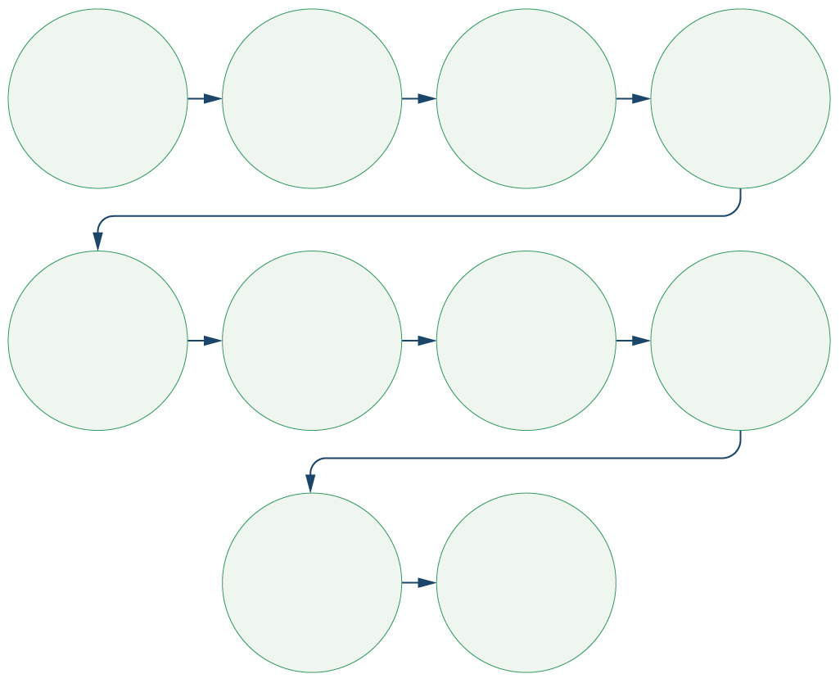

Determine the purpose of the observation

Determine the population(s) to be observed

Consider the accessibility of the population(s) - how will you reach them?

Investigate possible sites for observation

Select the site(s), time(s) of day, and date(s)

Decide how field   
staff will divide up or pair off to cover all sites most effectively (if more than one)

Consider how you will present yourself (appearance)

Plan how and if you will take notes during the observation activity

Conduct   
observation

Schedule time soon after observation to read and expand your notes

Tips for taking detailed observation notes

Begin each entry with the date, time, place, and type of data collection event.

Leave space on the page for expanding your notes, or plan to expand them on a separate page.

Take notes strategically. It is usually practical to make only brief notes during data collection. Direct quotes can be especially hard to write down accurately. Rather than try to document every detail or quote, write down key words and phrases that will trigger your memory when you expand notes.

Use shorthand. Because you will expand and write/type up your notes soon after you write them, it does not matter if you are the only person who can understand your shorthand system. Use abbreviations and acronyms to quickly note what is happening and being said.

Cover a range of observations. For example, even if your question relates to specific events (e.g. food distributions) you should be documenting informal conversations; people’s body language, moods or attitudes; the general environment; interactions among participants; ambiance; and other information that could be relevant.

Arrive early and leave late. If observing a time-bound event (e.g. something which happens at the same time each day/week) arrive early to document the above types of activities before the event takes place, and be one of the last to leave the event for the same reasons. Some of the most interesting/important observations may occur during these periods.

Consider using present tense to increase the level of detail you capture.

Observations can also be more structured, in a checklist format, which is helpful if you have a number of data collectors and you have specific aspects you want to capture. See **Handouts 1 & 2** for examples of observation guides. See **Handout 3** for an example of an unstructured way of recording detailed field notes.

Focus group discussions (15 minutes total)

|  |  |
| --- | --- |
|  | Question to participants (5 minutes):  FGDs are helpful when we want to see the range of ideas and opinions and levels of agreement and consistency about a topic. What specific issues in your work with communities might best be addressed through this method?  Online: Invite the participants to write the answers in the chat function and summarize  Offline: Ask one or two participants to share their answers |

In addition to the top tips already described for interviews and observations, there are some additional issues to consider when conducting an FGD:

* Setting a number of ground rules together with the FGD participants, including:
* All responses are valid – there are no right or wrong answers
* Respect the opinions of others even if you don’t agree
* Speak as openly as you feel comfortable; it is okay to abstain from topics
* Help protect other people’s privacy by not discussing details outside the group
* Balance participation across the group by asking: ‘Who else has something to say?’ or ‘I would like to hear more from...’. Do not let one or two people dominate the conversation. Also, keep in mind that the ultimate purpose of an FGD is to hear how the group collectively discuss and debate the issue of concern. The role of the researcher here is to moderate (not lead) the discussion, so make sure the discussion stays on topic, and that as many members of the group as possible have a chance to contribute to the conversation.
* When dealing with dominant people you can say ‘I can feel you have a lot of information to share about this topic. What about, we meet right after this discussion so we can get more details? / ‘I think it would be great if you could see my colleague here who would be delighted to have a specific discussion with you on this.’
* If discussion goes too far off topic, redirect it: ‘These are important and interesting points. However, we need to bring the discussion back to our main focus on....’
* For sensitive topics, e.g. sexual violence, do not ask participants to speak of individual experiences in a group setting. Instead, you can ask questions in such a way that you are asking people to speak about how they think members of their community/local area experience the issue or topic of concern.

|  |  |
| --- | --- |
|  | Question to participants (5 minutes):  What are important steps when conducting an FGD?  Online: Invite the participants to write the answers in the chat function and summarize  Offline: Ask one or two participants to share their answers |

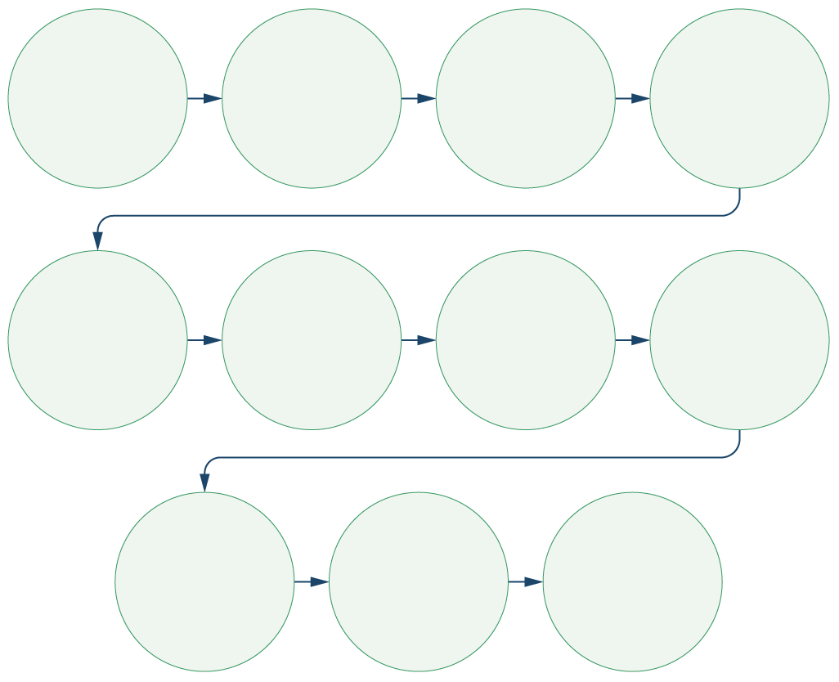

Plan the objective, discussion guide,   
and participants

Inform relevant actors: e.g. leaders and community members

Ensure the discussion space is accessible, and private

Test the questions

Introduce each   
other and explain   
the objective fof   
the study

Ask permission to record the session   
(if relevant)

Ensure confidentiality and that participation is voluntary   
(see ethics session)

Obtain informed consent verbally   
(see ethics session)

Open the discussion

Give the participant the opportunity   
to ask questions

Afterwards:   
Debrief with the team to fix errors or information gaps

Qualitative Research Methodologies (10 minutes total)

Whereas methods are research tools, methodologies are the overall research strategy and rationale.

We will conclude with an overview of qualitative research methodologies that might be helpful for you to know about.

Offline training – make sure the participants can leave with the URLs to further reading/tools

Rapid rural appraisal (RRA)[2]: Rapid exploratory study of a particular geographical area. This methodology is designed to establish an understanding of local conditions, problems and characteristics. It uses observation and semi-structured interviewing. It is usually carried out over a period of weeks, rather than years. A more detailed overview can be found [here](https://www.fao.org/3/w2352e/w2352e03.htm).

Community-led ethnography:Community-led ethnography opens up the research process to include community researchers. This approach involves professional social scientists providing training, implementation and analytical support to networks of community focal points to assist them in conducting ethnographic research in their communities. Community researchers can be community mobilizers, community health workers (CHW) or any other community group who has a stake in supporting outbreak support and preparedness efforts. See Box 1 for an example.

**BOX 1**



Community-led ethnography in Sierra Leone

An exploratory study was conducted in Sierra Leone’s Kambia District where a small group of community health workers were trained in introductory social science research and ethnographic research methods. These trainees were then supported to conduct research, analyse findings and propose adaptations to current public health strategies, including their own practice. This network of community researchers first explored vaccine confidence in border communities, contributing to the adaptation of community engagement and vaccine deployment strategies at district level. Following that, the community researchers recorded their communities’ experiences and perceptions of COVID-19, which formed the basis of weekly social science reports to the District’s COVID-19 Response Platform.

Participatory Action Research (PAR): Those affected by an issue prioritize the research questions and lead the research themselves – as researchers rather than as participants. They analyse the causes of problems, reflect on and prioritize actions, and monitor change to build shared learning. A more detailed overview of PAR and practical resources can be found [here](https://equinetafrica.org/sites/default/files/uploads/documents/PAR_Methods_Reader2014_for_web.pdf).

Community feedback: Using the example of IFRC’s community feedback process, Red Cross volunteers collect comments and questions that come to them during their routine community engagement activities. These are then transcribed in batches. Qualitative thematic analysis is applied to each batch. This is coded, usually in a standardized way, to enable changes in the information collected to be tracked over time.

You can also look through IFRC’s ‘Community Feedback Kit’ which is a list of tools and guidance actors need to set up mechanisms for systematically listening and responding to communities. More information and resources can be found [here](https://www.liebertpub.com/doi/10.1089/hs.2020.0195?url_ver=Z39.88-2003&rfr_id=ori%3Arid%3Acrossref.org&rfr_dat=cr_pub++0pubmed) and [here](https://communityengagementhub.org/resource/covid-19-community-feedback-kit/). Please also refer to upcoming Sessions 4.9 and 4.10.

*To best use these specific methodologies, get the support of someone with a technical background in social science research*

**FOR ADVANCED-LEVEL PARTICIPANTS:**



For information on other qualitative methodologies that can be used in time-sensitive settings, the Rapid Research Evaluation and Appraisal Lab (RREAL) have developed a decision-making tool that helps researchers to ask: What do you want your research to do?, and How do you want to do it? The decision-making tool then signposts to different qualitative methodologies that may be suitable. **Handout 4** illustrates this process and lists other qualitative methodologies that might be helpful to your work, including Rapid Assessment Procedures, Rapid Assessment Response and Evaluations, Rapid Qualitative Inquirys, Rapid Ethnographic Assessments and Participatory Rural Appraisals.

* [Rapid Assessment Procedure](https://archive.unu.edu/unupress/food2/UIN08E/UIN08E00.HTM) (RAP)
* [Rapid Assessment Response and Evaluation](https://jan.ucc.nau.edu/rtt/pdf%20format%20pubs/Trotter%202000%20pdf%20Pubs/RARE%20Methods%20Resource%20Guide%202000.pdf) (RARE)
* [Rapid Qualitative Inquiry](http://www.rapidqualitativeinquiry.com/2.html) (RQI)
* [Rapid Ethnographic Assessment](https://www.routledge.com/Rapid-Ethnographic-Assessments-A-Practical-Approach-and-Toolkit-For-Collaborative/Sangaramoorthy-Kroeger/p/book/9780367252298) (REA)
* [Participatory Rural Appraisal](https://sk.sagepub.com/books/participatory-rural-appraisal#:~:text=Participatory%20Rural%20Appraisal%3A%20Principles%2C%20Methods%20and%20Application%20outlines%20the%20application,organizational%20analysis%2C%20monitoring%20and%20evaluation.) (PRA)
* More information on these resources can be found on the RREAL website [here](https://www.rapidresearchandevaluation.com/) and [here](https://www.rapidresearchandevaluation.com/rreal-tracker).

Wrap-up/summary (5 minutes)

* Qualitative methods are used to understand ‘the why and the how’ – why do people behave in a certain way, how do they perceive the situation and what are their priorities and capacities.
* Qualitative methods are critical during an emergency response as they:
* Allow an understanding of why and how affected people and communities cope with and are impacted by an emergency;
* Give us an opportunity to listen to people; and
* Help to start a dialogue/conversation with people affected by an emergency situation.
* Key informant interviews or semi-structured interviewsare conductedwith people who can provide detailed information about the topic you want to know more on. They use a set of predefined list of questions or a topic guide covering the area of interest.
* Observations involve going into ‘real-life’ settings and taking detailed notes. They can be used to verify information collected verbally from participants – is what they say they do actually what they do?
* Focus group discussions involve in-depth discussion with a group of people about a certain topic. Again, these are based around a predefined list of questions or a topic guide covering the area of interest. Focus group discussions (FGDs) generally include 8–10 people.
* Other potentially helpful qualitative methodologies include RRA, community-led ethnography, PAR and community feedback.

ACKNOWLEDGEMENTS:

Theresa Jones (Anthrologica), Gefra Fulane (Anthrologica) and Ginger Johnson (Collective Service) developed the session content. It was reviewed by Megan Schmidt-Sane (IDS), Tabitha Hrynick (IDS) and Eva Niederberger (Anthrologica). Rhys O’Neill and David Cyprian (Rootwise) contributed content on media and social media analysis.

1. Fictional – can be adapted for context
2. For more information, please refer [here](http://www.fao.org/docrep/w3241e/w3241e09.htm).