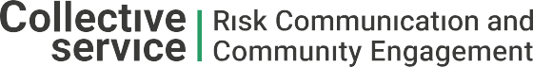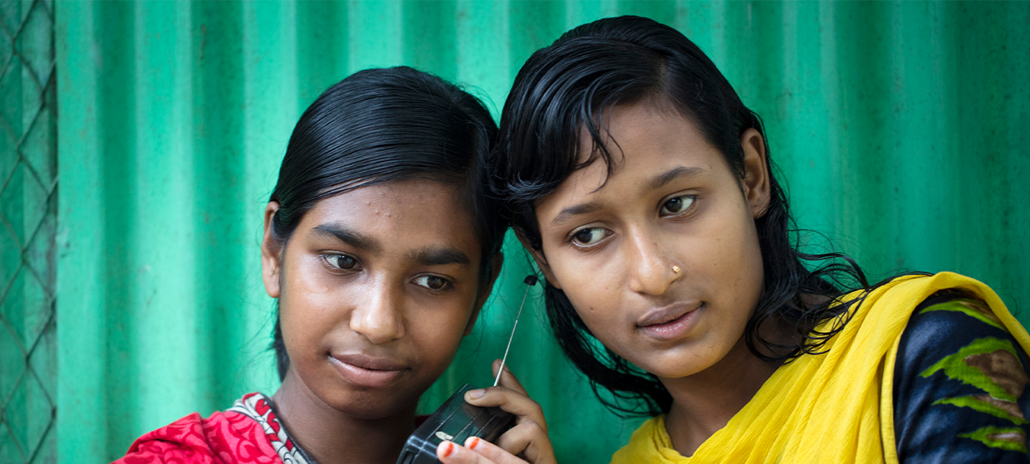

**TRAINING PACKAGE FOR USING SOCIAL SCIENCE IN COMMUNITY ENGAGEMENT AND/OR COMMUNICATIONS ACTIVITIES**

**SESSION 5.4:** Feeding back to communities and using findings to support community-level solutions and actions

SESSION CONTENT

**Learning approach:** Real-time presentation, individual and group exercises, case examples

**Delivery mode:** Online and offline, 100 minutes approx.

**Essential sessions to have completed before this session:** 5.3

**Summary:** This session describes the different approaches used to share research findings back with communities through a range of case examples. It explains what is needed to ensure this feedback supports the decision-making and action of communities affected by an emergency.

**Learning outcomes:**

* Understand the need to feed research findings back to communities and the many benefits of doing so
* Be able to design research processes that incorporate a plan to share findings back to communities in a way that supports community-level solutions and actions and addressing power differentials

FACILITATING THE SESSION

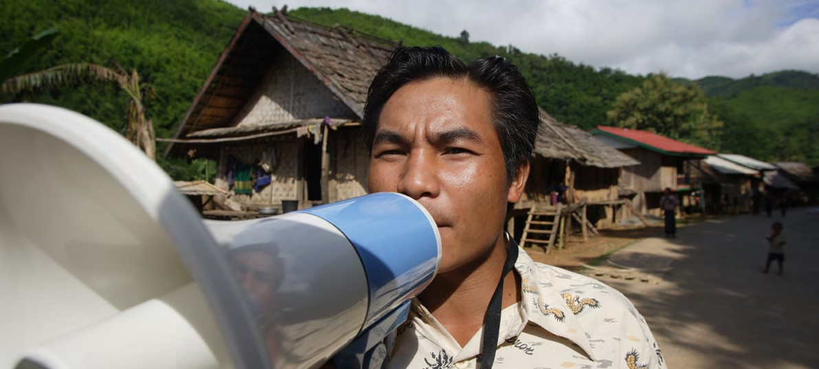

**TRAINING PACKAGE FOR USING SOCIAL SCIENCE IN COMMUNITY ENGAGEMENT AND/OR COMMUNICATIONS ACTIVITIES**

Introduction: (5 minutes total)

Talk through session summary and learning outcomes.

Position this module in the question flow.

1. How to ensure that this information goes back to communities? To inform community-level actions and decision-making of the broader response?
2. What methodology and tools should be used to collect and analyse this information?
3. How to track the information used to ensure that it effectively contributes to operational and strategic priorities?
4. Who can collect this information?
5. Does this information already exist? Is there a related needs assessment or study?
6. What information is needed?

**DATA TO ACTION:**

Key questions in social science research

1. Who needs this information?
2. How to ensure that the information is used to make operational and/or strategic decisions?

Feeding back to communities (25 minutes)

|  |  |
| --- | --- |
|  | Question to participants (5 minutes):  Why is it important to make sure communities engaged in research know about the findings from the research they have been involved in?  Online: Invite the participants to write the answers in the chat function and summarize  Offline: Ask two or three participants to share their thoughts |

In order to:

* Actively turn findings into actions or change that are realistic and acceptable to affected communities – so the actions actually work, and are supported by the communities
* Ensure the research informs and support community-level action which can address the emergency but also benefit the longer-term development of the area
* Increase communities’ knowledge and understanding of a topic area or issue
* Verify the findings of the research – to check they seem accurate and realistic to the people from which they were generated
* Have the opportunity to interpret more from the findings – a type of ‘shared sense-making’ – e.g. by asking ‘we found this … why do you think that might be?’
* Promote the active rather than passive role of communities, which can also positively contribute to more resilient communities because power has been shared
* Build trust and goodwill between researchers and participants, the emergency response and affected communities

Participants also generally want researchers to share the results of the work they have been involved in.

A key ethical principle discussed in Module 3.1 was that research participants should benefit from taking part in the research. People can feel a sense of satisfaction when contributing to research and they also want to teach their friends and family something afterwards. If research is designed to address priorities identified in the community (as discussed in Module 4.1 on localized research) then knowing the findings will be of clear benefit.

Feeding research back also does something to correct power imbalances between researchers and participants by making research less ‘extractive’.

|  |  |
| --- | --- |
|  | Question to participants (5 minutes):  What do we mean by ‘extractive’ research?  Online: Invite the participants to write the answers in the chat function and summarize  Offline: Ask two or three participants to share their thoughts |

Extractive’ research generally involves a researcher coming in, taking information from people, not sharing findings and then the outcomes of research having no benefit for the people involved. Community feedback processes are a good way to address this.

Even communities not involved in the research, but also coming from areas affected by the emergency, may benefit from knowing research findings.

It seems obvious that this is the ‘right thing to do’, so why doesn’t it happen?

|  |  |
| --- | --- |
|  | Question to participants (5 minutes):  What might be some of the barriers to feeding back findings of the research to communities?  Online: Invite the participants to write the answers in the chat function and summarize  Offline: Ask two or three participants to share their thoughts |

Reasons might include:

* Not enough time
* Not enough budget
* Researchers lacking knowledge about *how* to share feedback
* Concerns about whether participants will understand the results
* Fears about protecting confidentiality and/or anonymity of participants

How have organizations shared research findings? (30 minutes total)

|  |  |
| --- | --- |
|  | Case example  [Busara Center’s](https://medium.com/busara-center-blog/seen-but-not-heard-c70db0554926) research in their Nairobi lab has highlighted that participants want feedback on the work they have been involved in. Busara has an agenda for ethical and inclusive research in the Global South. As part of Busara's work with GSMA, Safaricom and the Kenya Forest Service, the Nairobi team conducted qualitative and quantitative research with members of Kenya's Community Forest Associations (CFAs). These CFAs help protect the forest, and the research focused on how to ease the burden of collecting data and reporting their efforts. To overcome the challenges of little time and budget, the research team trialled giving feedback to participants via low-cost SMS. They created the content of the SMS feedback by having phone calls with the 19 participants of the qualitative phase of the research to agree on what the messages should say.  The SMS read:  "In February you participated in our research on CFAs and forests in Kenya. Thank you for participating, your insights were very valuable to us! We have reported the following to Safaricom, KFS and other stakeholders: 1. The digital solution can provide more knowledge on conservation through training and information sharing. 2. More transparent and predictable financial incentives for dedicated CFA members can speed up tree-planting. Safaricom and KFS took this seriously and are considering the best solutions. Please share these findings at your next CFA meeting."  A follow-up survey was given to participants who both had and had not received the feedback. The researchers found that giving participants feedback made them significantly more likely to say they were treated respectfully and significantly less likely to say that they find it difficult to speak up in community meetings. It had no significant impact on likelihood to change something in their lives as a result of their findings, or their motivation to conserve the forest (motivation was already high).  *Questions for the group:*  What do you think about using SMS for feeding back research findings? What do you think about the message content?  How would you feel as a participant receiving this feedback?  Why do you think the feedback did not influence them to change something in their lives? |

|  |  |
| --- | --- |
|  | Case example  Oxfam and HelpAge have been undertaking research in refugee camps in Gambella, Ethiopia and in Malawi into the incontinence needs of older people. The research has been mainly qualitative and aimed to hear directly from older people their experience of incontinence, and to learn their recommendations for WASH and other humanitarian actors to better respond to the issue.  The research was planned around a series of ‘feedback loops’ to ensure that the research findings accurately reflected the information coming from older people. Qualitative data was gathered through the following methods:   1. Focus group discussions with older people who may or may not have incontinence 2. Household visits with people who have incontinence, either urinary or faecal or both 3. Key informant interviews with stakeholders from the health sector and community associations such as Refugee Council representatives and Older Person Association (OPA) members)   Once data had been collected through each method, the following steps were taken:   * The data was analysed to identify important themes, and themes were discussed with the research enumerators to ensure they had been captured accurately * Additions or changes were made to incorporate any missing or misrepresented information * A second set of FGDs were conducted with the same participants that had participated in the data collection stage * The findings were presented with opportunities for correction and discussion with older people, particularly focusing on the recommendation sections * A second set of household visits was also conducted with those who had participated in the research to share the findings and confirm their accuracy * A second round of analysis was conducted to incorporate any changes requested at this point * Finally, a workshop was held with sector key informants to which community stakeholders were also invited to provide an opportunity to present and discuss the findings, and to allow discussion and debate between NGOs and community representatives on possible actions to be taken on the research findings. Recommendations included: * Training for caregivers on how best to support older people, including those who were bed-bound, including psychological first aid training * More mobile health care support and home visits for people with incontinence and other health issues where access to hospitals and health centres is difficult or expensive * Psychosocial support provided at the household level rather than being centre-based as it is currently, for both those with incontinence and their caregivers * Training for OPA members on psychosocial support and care for bed-bound and incontinent people – the OPA members were very keen to be part of this in Ethiopia in particular and actively suggested that they take on regular visiting as part of their roles to support bed-bound individuals psychologically * For agencies to provide NFIs to support in managing incontinence, or to provide income-generating opportunities to allow families to earn money to be able to buy these items themselves   Questions for the group:  What do you think about this approach for feeding back research findings?  How would you feel as a participant?  What would be needed to build this into a piece of research? (e.g. timeline, budget, resources) |

In addition to those described above, there are other possible approaches to feeding research findings back to communities. Some might be participatory than others, and some may reach more people than others (i.e., more than just the participants).



Community Advisory   
Boards

Community action planning workshops

Educational sessions using findings

Community meetings

Radio/ Newspaper

Advisory structures in communities or ‘steering committees’ usually have representation from all key stakeholders and a range of community members. These should be established at the beginning of the research process and have defined terms of reference as to their purpose – e.g., to develop research questions, to comment on the research protocol, to give feedback on findings, etc. They should meet regularly, be available to speakers of all identified languages and give input at every stage of the research. They are also well placed to feed research findings back to the wider community. They are described in more detail in Session 4.1 on localized research.

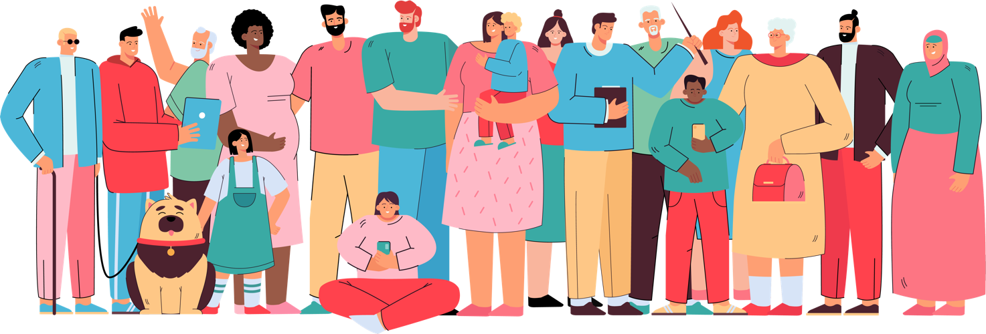

We will hear more about community action planning workshops later in the session.

|  |  |
| --- | --- |
|  | Question to participants (5 minutes):  Do you have any other suggestions of methods for feeding back research findings? Are there existing channels in your community engagement work that could be used? This may include creative or multimedia examples (e.g. film, dramas)  Online: Invite the participants to write the answers in the chat function and summarize  Offline: Ask two or three participants to share their thoughts |

Importantly, the method of feedback does not need to be the same as the method for data collection. Think about what fits your resources and what you have to say – e.g. can you use technology or media outlets? Also think about who needs to know the research findings? Is it important that the information reaches the wider community, beyond those who participated in the research?

Key takeaways to do this well include:

* Approach research with an expectation of continued engagement with participants
* Include results-sharing as a clear step in the research design, and make sure you have enough time and budget for it
* Translate findings into local languages and avoid overly scientific terms or ‘jargon’
* Use various channels and accessible products that ‘work’ in the local context

You can get feedback from participants during data collection in terms of what information would be helpful to share, how it can be shared, and with whom.

Informing community-level action and decision-making (35 minutes total)

Feeding research findings back to affected communities and using the findings to support community-level solutions and actions may require the research team to go one step further than just discussing the findings.

The case examples below show where more stages of feedback were done.

|  |  |
| --- | --- |
|  | Case example  The International Rescue Committee (IRC) supported a Participatory Action Research project in a West African community hard hit by the 2014-2016 Ebola outbreak. At the height of the outbreak in one informal settlement, the main hospital was temporarily closed. When it was reopened, pregnant women were observed to be avoiding using the hospital services for both antenatal care (ANC) and delivery. They were instead using traditional birth attendants (TBAs) within their local area, whom the government had previously banned from delivering babies.  At the request of a number of pregnant women, TBAs, local leaders and health workers, the research focused partly on building trust and communication in addition to understanding what was behind the reduced service uptake and what could be done to improve services.  After the data was collected and analysed, a workshop was held with representatives from all of the major groups (pregnant women, TBAs, local leaders and health workers) to discuss research findings. The main findings included that poor communication and interpersonal tensions between pregnant women and health workers, and between TBAs and health workers, was a major barrier to pregnant women using ANC and delivery services. The Ebola outbreak had had a significant psychological impact on people in the area, and contributed to these tensions. There were also newly introduced infection prevention and control procedures that limited space for patients, meaning they felt less willing to attend.  During the workshop, the group made an action plan. They listed different existing and potential community and hospital-level solutions and voted as a group on what the most important actions could be. This included forming a drama group which could educate other pregnant women about hospital services and educate health workers about how they would like to be communicated with. The TBAs agreed to hold meetings with health workers to discuss how referrals from community to hospital could go smoothly, and the health workers agreed to allow the TBAs to accompany women into the hospital if needed. The action planning process involved breaking down the different steps of the action (e.g., selecting drama group members, deciding topic, etc.) and identifying who exactly would be responsible for carrying it out and with what timeline. It also identified where action was needed by some actors who were not present – e.g. by government or donors, etc.  *Questions for the group:*  What do you think about this approach for feeding back research findings in a way that encourages community-level action?  How might we avoid placing too much burden on community members for change they cannot make – e.g. for hospital space to be increased, for new equipment for health workers, for better government recognition for TBAs?  For more information on Participatory Action Research, see [*here*](https://equinetafrica.org/sites/default/files/uploads/documents/PAR_Methods_Reader2014_for_web.pdf). |

Tips for going beyond providing feedback:

* Directly discussing action and change. Community action planning workshops, as described earlier, involve sitting down with research participants and/or members of the wider community to discuss exactly how the findings might translate to community change or action on priority needs. Community members then create an action plan to specify how this change will happen: what action is the responsibility of who, and when will it happen and with what support, etc.
* Making sure to build on existing solutions where possible, rather than replacing them with new solutions. This can undermine and disempower.
* What also helped in the case example presented above was that the research was designed to address the priorities of the community. When research has also been based on a community’s priorities, then it is more straightforward to support that community’s own decision-making and action.
* Being able to support community-level change also requires other earlier considerations by researchers in terms of how they design the study, including what questions they ask, and how they analyse and frame findings. Session 5.3 covers more on transforming data and evidence into actionable findings.

|  |  |
| --- | --- |
|  | Case example  In response to concerns about vaccine hesitancy and unknown health-seeking behaviours in Bwindi Impenetrable Forest and Kyamulibwa, southwest Uganda, the AViD project provided insight into the various local explanations and sources of knowledge regarding veterinary vaccination that affect its uptake in rural Ugandan communities. The project focused on how local knowledge about vaccines is constructed and communicated in two rural Ugandan cohorts, across 20 villages, through focus group discussions and semi-structured interviews with 92 individuals. The use of free listing (asking people to list all the items they can think of that relate to the topic) and rank ordering (asking people to order lists of items from the most important/significant to least) to learn common health-seeking behaviours enabled the research team to understand who communities turn to for health advice when asked about specific symptoms associated with emerging zoonotic diseases. Through interviews, the team was able to learn who community members would seek vaccines from and to provide them with information on their use, administration and storage, and whether negative experiences of using vaccines on livestock affects the uptake of vaccines in their keepers and associated family members.  The research team shared the findings at community meetings, using flipcharts to present the findings regarding vaccines, wildmeat consumption and health-seeking behaviours. These community feedback sessions were conducted in Bwindi with community leaders, community members and reformed poachers.  To detect outbreaks earlier and to increase veterinary interventions when needed, simple referral pathways for alternative health care providers were developed with local NGOs in both regions. These pathways are based on the language used and data provided by interviewed farmers, and took the format of an infographic (using images rather than text). This was done following previous experience of successfully developing infographics in these areas to engage community members, both literate and illiterate. They were designed to encourage alternative health care providers to refer cases to veterinary professionals if specific symptoms of a notifiable zoonotic or epizootic are presented to them. In return, they receive a small reward if diagnosis is confirmed and they can continue with their treatment, preserving their position and influence in their communities.  There are plans to share the referral pathway with the alternative health care providers, but this first requires ensuring local clinics, hospitals and veterinary practices are involved as well as alternative healers and drug providers, such as pharmacies. Long-term funding is also needed to make the referral pathway sustainable.  As highlighted in this case example, structural changes are often also needed alongside community-level action (in this case – referral pathways that also allow normal practices to continue). This means both levels need to be considered simultaneously. Change as a result of research requires an ‘enabling environment’ and Session 6.2 discusses in more detail what is required at the community level for this to occur.  Questions for the group:  Please share your experience or reflections on when higher-level structural change has needed to happen alongside community action.  How else would you communicate with non-verbal or illiterate community members? |

|  |  |
| --- | --- |
|  | Group exercise (5 minutes):  Break the group into small groups of three. Building on case examples from Sessions 1.1 and 5.2:  You are a researcher supporting the organization/programme ACTRelief, which aims to assist conflict-affected population groups in the northeast of Bagara. The population faces several challenges including food insecurity, limited livelihood opportunities and a lack of information on available services.  You were deployed to urgently conduct an analysis of the context and develop activities for ACTRelief, and other NGOs and government actors for them to effectively communicate with the affected population and engage communities and relevant stakeholders with the aim to reduce waterborne disease.  Data set summary:  Key themes and sub-themes to emerge from qualitative assessment (key informant interviews and focus group discussions with community members) were:  Waterborne diseases:   * Perception that cholera does not exist in the country, that is it something else causing the disease and deaths, including divine sign from God * Shame and stigmatization of the people who had cholera, including rejection by their own communities, sometimes leading to violent attacks on the affected persons. * Misunderstanding on the purpose and use of household chlorine and medicines that could be used to treat cholera   Priorities of the community members interviewed:   * Lack of livelihood opportunities was perceived by male participants as the most important issue * Female participants raised the concern that men who were not working were drinking excessive amounts of alcohol   Trust in service providers:   * NGO actors are generally trusted * ACTRelief had a recent incident whereby food relief was delivered late, and this had not been communicated to all community members, so there is some dissatisfaction with these services * Government actors are perceived as doing little to support, but when information is given, it is generally believed   Key influencers at community level:   * Local leadership was reported to be influential, although not always the most trusted * Church leaders and other figures from the local Baptist Church networks are both influential and trusted * For the Muslim minority, Imams play a trusted role in provision of information   Preferred communication channels for information from service providers:   * Women – radio, face-to-face/door-to-door * Men – radio, market announcements * Older population groups – radio, market announcements * Youth – market announcements * Marginalized Tia ethnic group – face-to-face/door-to-door   Hygiene KAP survey results:   * Relatively high coverage of latrines (approx. 70%) * Low coverage and use of improved latrines; the majority do not have hand-washing facilities * Low prevalence of hand-washing with soap in adults and children * Drinking water sources not protected * Water from water vendors not clean * Water is not stored or drawn safely at home * Children’s faeces are not seen as dangerous * Leftover food not reheated thoroughly, and fruits are not washed before eating * Fruit juices and ice-lollies use contaminated water * Poor hygiene among food sellers / cooks * Food is not prepared hygienically for communal gatherings * Failure to wash hands with soap following the preparation of a cholera victim’s corpse leads to further transmission * People are scared to disclose sickness or death because of associated stigma * Indiscriminate refuse disposal creates breeding grounds for flies * Delay in seeking treatment for cholera for various reasons   How could you ensure the findings of your research are fed back to communities?  How could you ensure this is done in a way that can support community-level solutions and actions?  Online/Offline: Take 10 minutes to discuss in small groups or break-out rooms  In plenary, ask two or three groups to share their answers |

Wrap-up/summary (5 minutes)

* There are many reasons why it is important to make sure that communities engaged in research know about the findings from the research, including to:
* Actively turn those findings into actions or change that are realistic and acceptable to affected communities – so the actions actually work, and are supported by the communities
* Ensure the research informs and support community-level action which can address the emergency but also benefit the longer-term development of the area
* Increase communities’ knowledge around a topic area or issue
* Verify the findings of the research – to check they seem accurate to the people from which they were generated
* There are a number of approaches to feeding research findings back to communities, including through community meetings, community advisory boards, workshops, radio/TV and other technological means like SMS.
* To ensure this feedback can contribute to community-level actions and solutions, some additional considerations are important, including:
* Directly discussing action and change with participants, perhaps through community action planning workshops
* Making sure to build on existing solutions, where possible, rather than replacing them with new solutions
* Ensuring the research was designed at the outset to address the priorities of the community – it is then more straightforward to support that communities’ own decision-making and action
* When supporting community-level actions and solutions, researchers may also need to consider influencing complementary structural changes.

ACKNOWLEDGEMENTS:

Theresa Jones (Anthrologica) developed the content of this module with the insights of Heather Lanthorn. Tom Wein (Busara), Michelle Farrington (Oxfam) and Alex Bowmer (LSHTM) contributed case examples. It was reviewed by Samantha Vanderslott (Oxford University)   
and Mark Marchant (LSHTM).