COVID-19 Planning Guide for Adapting Risk Communication and Community Engagement as Public Health and Social Measures Shift:
With Safety Tips for Conducting Community Meetings
Updated: July 1, 2020
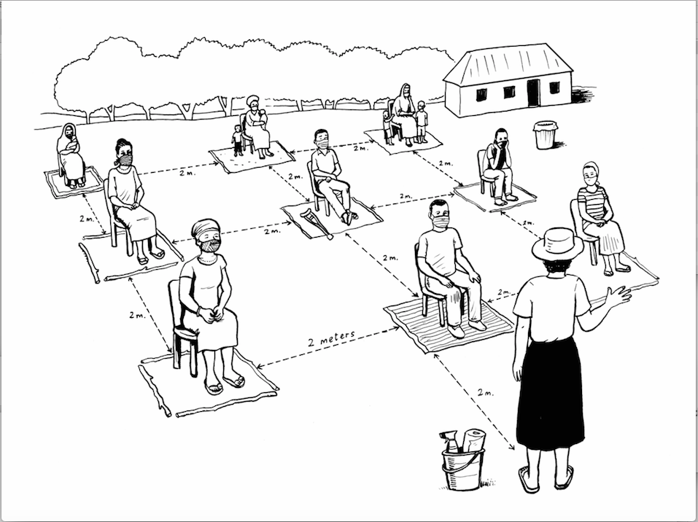

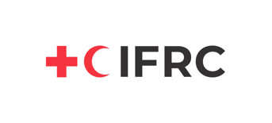

About This Guide

Some nations are gradually emerging into a “new normalcy” as they loosen public health and social measures (PHSMs), such as lockdowns, to control the spread of COVID-19. Response agencies continue to engage communities remotely when movement restrictions are mandated, but as countries open, more in-person, participatory community engagement activities are underway. This operational tool will help organizations plan safe in-person community meetings, with RCCE considerations to ensure prevention measures are maintained as PHSMs shift. It consists of the following content:
- Part 1: Tips for adapting RCCE during shifting lockdowns
- Part 2: Safety measures for conducting community meetings
- Part 3: Template to build a safe community engagement approach.
- Annex A: Scenarios with suggestions on RCCE during shifting lockdowns
- Annex B. Sample flyer and illustrations to adapt flyers for different contexts.

After reflecting on considerations in parts 1 and 2 and using the template in Part 3, organizations should have a plan to adapt their community engagement approaches as lockdowns and other public health measures change.
Audiences for this document include national and sub-national government, UN agency, and NGO level program managers who plan or adapt RCCE approaches for staff and volunteers during the COVID-19 pandemic.

Acknowledgements

This document is an initiative of the GOARN Risk Communication and Community Engagement (RCCE) Coordination Working Group co-led by UNICEF, the International Federation of the Red Cross (IFRC) and the World Health Organization (WHO). It was developed jointly by the READY Initiative [funded by USAID’s Office of Foreign Disaster Assistance (OFDA)], IFRC, Centers for Disease Control and Prevention (CDC), Save the Children, Johns Hopkins CCP, UNICEF, GOAL, United Nations High Commissioner for Refugees (UNHCR), World Food Programme (WFP), Translators Without Borders, CARE, and the CORE Group.

❚ Part 1. Tips for Adapting RCCE in Shifting Lockdown Scenarios

As some communities head to the streets after enforced isolation at home, RCCE needs to keep people alert and engaged in sustaining healthy protective measures to safeguard human lives. Below is a list of guiding tips to consider for adapting RCCE approaches when lockdowns and other public health measures are being lifted. Keep in mind that waves of COVID-19 resurgences have been predicted. With these waves, PHSMs will likely shift again.

1. Discuss New Norms and Collect and Address Feedback & Perceptions as PHSMs Shift
Especially as lockdowns are shifting, understand the broader community insights around the COVID-19 recommended measures. Connect with existing, trusted civil society organizations, community groups (e.g., women’s, youth, religious), networks (e.g., small businesses, market women, truck drivers), marginalized and vulnerable populations such as people with disabilities and the elderly, and discuss new norms with these groups. For example:
- How do they perceive heading into an easing of lockdown measures?
- What are their perceptions of risk of getting COVID-19 now? How do they perceive themselves as a risk to others?
- Did the community abide by the government’s public health and social measures? (Why/why not?)
- What high-risk activities might increase or are starting to increase (e.g., religious services, weddings) with these new measures?
- What are their main concerns (e.g., domestic violence, economic security)?
- What rumors and misinformation exist around the prevention measures?
- What are their care-seeking behaviors? How are or have these changed?
- What has their community been doing so far to keep safe?
- What safe community-based approaches can they suggest?
- Can they help us implement our activities?

COVID-19 affects all groups and in different ways, so consider whether new partners should be engaged. For example, in India, railway carriers developed isolation coaches to transport people who are ill with COVID while railway police were engaged to disseminate prevention messages to passengers. Continue to build capacity and work with these trusted key community stakeholders on how best to foster social and normative behavior change.
See an example from Ground Truth Solutions on perceptions from community leaders in Uganda, example perceptions survey, and example feedback form.

Create opportunities for decision-makers to listen to citizen feedback and respond to it, for example, through interactive radio shows or public debates on social media.

2. Be Aware of the Rising Topics in your Community
Actively listen to what community members are talking about—for example, through community health workers (CHWs), frontline workers, community leaders and groups and online forums. All regions and many countries have RCCE working groups where these data are compiled and shared. What are the main infodemic topics? For example, socio-economic impact, civil unrest, vaccines, testing. Think about identifying the risks and mitigations that these topics suggest and how to address them through RCCE activities—for example, by ensuring community engagement and ownership of the response.

3. Maintain Essential COVID-19 Prevention Measures

Lifting lockdown measures may be a cue for people to relax their hand-washing practices, stop wearing face coverings, and congregate in close quarters more often and in groups. See How might we use communications to encourage physical distancing in developing countries?, How can we improve hygiene behaviors?, the Hygiene hub, and WHO guidelines on facemasks to strengthen RCCE around these measures.

Provide clear information on policy shifts and address any rumors that may suggest that the lifting of lockdown measures means the disease is over. Support media to provide information on the importance of maintaining preventative behaviors during shifting PHSMs. Organise a media webinar on this topic. Provide clear information on how response processes work and why they help stop the spread of COVID-19 and ensure social mobilizers know how to answer questions and address concerns about public health measures. Make sure messages are updated regularly and social mobilisers actively cover the topic of policy shifts. Organize a media webinar on this topic.

Ensure Government departments in charge of communication and lock down decisions are aware of this confusion around the end of lockdowns and can address this in their public communication. Begin lobbying for expanding the scope for national response committees to include other civil society organizations (CSO) and faith-based organizations (FBO), who have valuable insights on the current situation.

4. Integrate COVID-19 Messaging Into Other Issues
Consider intensifying the integration of COVID-19 messages and activities into issues people care about (e.g., social protection, malaria, food security programming). For example, social protection messaging might stress how practicing frequent hand-washing with soap can protect from a range of illnesses, including COVID-19, which may affect the ability to work. It is important to pretest these messages on communities and adjust based on their feedback. See Sample Pretesting Template.

5. Enable Behavior Change as PHSMs Shift
Understand the barriers and enablers to behavior change. How easy or difficult are the behaviors to do? Are materials accessible/affordable to households? Remember that people are also influenced by people in their social circles, by what they believe they think about a behavior, how they see them actually behaving, and how their behaviors will be accepted within this context.

Create an enabling environment by establishing positive social norms around key behaviors. Leverage trusted community leaders, community groups, and other role models or use positive deviance to demonstrate recommended behaviors and/or local alternatives in their contexts. Highlight the effectiveness of practicing the behaviors and why they should practice them. Work with religious and community leaders to involve them in the response and ask if they can discuss these issues with their communities. Scripture references developed with senior religious leaders can support the messaging.

Work with community representatives to develop community-led solutions. This ensures interventions are more sustainable, appropriate and trusted. Communities’ fear and frustration can be reduced by providing the opportunity for people to play an active role. Make sure messages are updated regularly and social mobilizers actively cover the topic of policy shifts. Use a mix of channels and repeat core prevention messages and the benefits of these actions. See Synthesized Messaging for COVID-19 Document and Message Contextualization Tools. See low-literacy easy-to-read resources for COVID-19 and this repository of resources on disability inclusion..

6. Address Low Risk Perceptions
Risk perceptions of COVID-19 may be low for a variety of reasons: people may not see the severe effects of COVID-19 in their communities and may have more pressing concerns, such as hunger, poverty, or other more prevalent diseases such as malaria. They may have message fatigue. With the shifting PHSMs, they may assume the pandemic is over. Research conducted in 10 countries illustrated that appealing to altruistic and pro-social motives can be an important aspect of risk communication for COVID-19. Generally, for people to take actions, they should believe they or their loved ones are at risk of something dangerous, and that they can feasibly and effectively do something about it. A study on risk perceptions and COVID-19 suggested that direct experience with COVID-19 or receiving knowledge of the virus from family and friends increased risk perceptions in those countries. Further, it stated that those surveyed who think it is important to do things for the benefit of others even at some costs to them personally, perceived higher risk.

Consider the different risk perceptions and constraints to practicing optimal behaviors and work with communities to identify local solutions in each context. Emphasize the benefits of carrying out preventive actions, including the benefits to society, and the risks of doing nothing. Share stories of people who have recovered from COVID-19 through the media or at community level, to show the disease is real and that anyone can be affected. Work with case management technical working groups to develop key messages that explain the case fatality rate in the region and what this looks like in reality in a simple and clear way, as well as messages specifically for the most vulnerable, such as elderly.

7. Address Fears of Accessing Preventative Health Services
If people fear returning to health services that are re-opening, understand these concerns and encourage timely care-seeking. Consider working with partners to ensure health providers are adopting safety measures—for example, wearing personal protective equipment (PPE) and regular hand-washing with soap—and that patient flow is organized to minimize the risk of transmission. Recruit trusted community health workers, health providers, community leaders, existing community groups, media and radio stations to support the facilitation of timely care-seeking. Consider radio shows or spots highlighting health services and demonstrating optimal care-seeking behaviors. Medical experts should participate in radio shows, public debates to provide correct information, address rumours and answer communities’ questions. Hotlines can address people’s fears and concerns about care-seeking for essential and non-essential services.

8. Engage Youth as Agents of Change

Evidence shows that all people, including young groups and adolescents, can transmit the virus even if they have mild symptoms or are asymptomatic. Engaging youth in your RCCE activities is more relevant than ever. Explore how youth perceives the loosening of restrictions. How can they play an active role in influencing others towards sustaining PHSMs, including family and friends?

❚ Part 2. Safety Measures with Key Considerations for Conducting Community Meetings

Agencies and community leaders and groups who are organizing community meetings must maintain public health and social measures to minimize the risk of spread of COVID-19. This section includes six core measures that must be maintained during meetings, along with a set of key considerations to meet those measures, which should be adapted to the country and humanitarian context. For more information on community mitigation strategies, see the CDC’s Implementation of Mitigation Strategies for Communities with Local COVID-19 Transmission.

Measure 1. Ensure facilitators and community members are not ill or have been exposed to COVID-19

Key Considerations for Measure 1
BEFORE: | - Advise staff that they should not participate if they have been ill with COVID-19 symptoms (such as a cough, fever, or shortness of breath) in the past two weeks or were near anyone confirmed to have COVID-19 in the past two weeks.  - Ask community leaders to inform community members to not attend if they feel ill or were in close contact with someone who was ill with COVID-19 symptoms in the last two weeks.  - Create a simple referral procedure identifying whom to contact (e.g., a hotline or community health worker [CHW]) if anyone in the meeting shows symptoms of COVID-19.  - Create a plan to adapt or stop in-person community dialogues in the event of a resurgence of cases or additional public health measures.  - Plan to have dedicated isolation spaces for people to wait until support arrives if someone is ill during a community meeting.
DURING: | - Prohibit participant(s) who display symptoms of COVID-19 from attending. Advise them on how to avoid infecting other people within the household.  - Screen participants by asking them if they feel ill with symptoms of COVID-19, or if they’ve come into contact with someone who has symptoms or has been ill with COVID-19 within the past two weeks.
AFTER: | - Refer all suspected COVID-19 cases for investigation/testing if it is possible in that setting.

Measure 2. Maintain physical distancing of 2 meters

Key Considerations for Measure 2
BEFORE: | - Work with community leaders to select an accessible outdoor, spacious meeting site.  - If the meeting needs to be held indoors (e.g., in urban areas), ensure space is accessible (e.g., for people with disabilities) and ventilated (e.g., open windows); consider supplying and promoting facemasks or face coverings.  - Ensure directional flow (1-way flow) to meeting space if the meeting is indoors or in a semi-enclosed area.  - Provide barriers and use chairs, chalk, tape, sticks, mats or any other means to demarcate clear separation of participants by at least 2 meters.  - Restrict number of participants, based on national guidelines (e.g., between 5-10 participants and no more than 2 facilitators).  - Plan to conduct meetings in shifts so the same group of people are exposed only to each other.  - Limit duration of meetings to half the time it would normally take for a community meeting. Determine essential functions of meetings in advance, and limit meetings to these essential functions only.  - Limit the number of community meetings to not more than 2 per day.  - Plan to conduct part or all of the dialogues using remote options (e.g., interactive radio, WhatsApp discussion groups), where possible. Zoom with captioning/sign interpretation should be a considered approach to include people with disabilities.  - Avoid setting up meetings that require travel outside of a community/region.  - If staff and volunteers must travel with public transportation, have PPE—for example., gloves and masks—available to them.
DURING: | - Ensure people are at least 2 meters away from others at all times. Facilitators should also maintain a distance of 2 meters from participants and each other.  - Ensure individuals requiring caregivers, such as the elderly, people with disabilities, and children, stay with caregivers and are separated from other adults or children (e.g., using mats and supervising children so they do not roam).  - Limit the number of people who handle transfer of objects (e.g., food, products) to participants.  - Discourage private social gatherings (e.g., shared family meals, childcare services) connected to the community meetings.
AFTER: | - Practice physical distancing of at least 2 meters on the way home and encourage others to do so.

Measure 3. Avoid typical physical greetings

Key Considerations for Measure 3
DURING: | - Avoid typical physical greetings, such as handshakes, kisses on the cheeks or hugs. Do not touch others, even if socially expected.  - Engage community members to develop culturally and socially appropriate alternatives and practice new ways to greet people without touching (for example by a slight bow).

Measure 4. Ensure optimal hygiene practices

Note: Consider handmade sanitizers, tippy taps or other low-tech hand-washing equipment with buckets that collect run-off water.
Key Considerations for Measure 4
BEFORE: | - Identify priority cleaning supplies to disinfect materials that will be shared; identify who will be responsible for cleaning and ensure they have gloves.  - Have a plan to supply the following: hand sanitizer, tissues, soap, paper towels, bins for disposable hygiene products, and hand washing stations. Make sure you have enough supplies to cover all meeting participants including staff, volunteers, or any service providers (e.g., food preparation).  - Ensure hand-washing facilities and soap are near the meeting space; include physical distancing demarcations so people do not group near the stations.  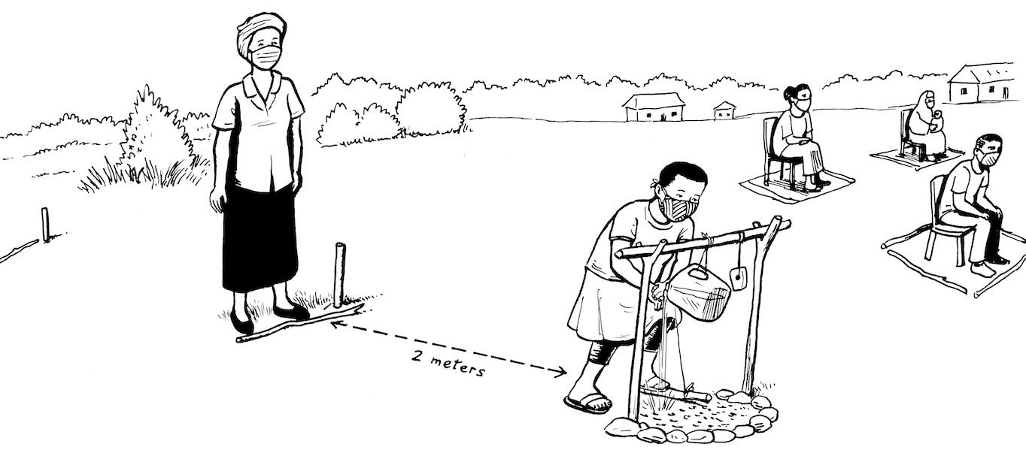  - Avoid serving food or beverages due to the risk of transmission through this service.  - Consider asking people to bring their own food from home if needed for children, OR  - Ensure people preparing and serving wash their hands with soap first, wear masks and gloves during food or beverage prep and service, and that single serve portions are handed out individually (rather than buffet-style) to reduce transmission.  - Ensure gloves are available for removing rubbish and other cleaning tasks.  - Procure signage and other notices related to hygiene procedures, adapted to local language and literacy levels. Ensure these are large format, inclusive and accessible. Consider “easy-go-read” COVID-19 guidelines for those with learning disabilities.  - Provide supplies to sanitize objects or surfaces when interacting with them.
DURING: | - Clean hands with soap and water or alcohol-based hand rubs after touching surfaces and encourage others to do the same.  - Start meetings with a demonstration of good hand-washing techniques as a way to reinforce positive behavior change.  - Display large format signage and posters on handwashing and hygiene etiquette.  If meals or snacks must be served, ensure people wash their hands with soap before distributing and eating, and that rubbish is disposed of safely - e.g., using gloves.  - Encourage others to wash hands with soap after they return home.
AFTER: | - Clean/disinfect all supplies and materials, pens, megaphone, clipboard, and other items with bleach mixed with water.  - Immediately wash your hands with soap or use alcohol-based hand sanitizer.  - Designate a space for removing and cleaning clothing at home

Measure 5. Practice and promote respiratory etiquette

Key Considerations for Measure 5
BEFORE: | - Learn global WHO, national and local guidelines for wearing facemasks in public; even if not mandatory, consider having something available should people elect to use them (e.g., extra fabric that can be used as masks, or locally produced offerings).  - Train staff, local partners and community leaders on COVID-19 transmission, signs/symptoms, public health and social measures (e.g., hand-washing, respiratory etiquette, physical distancing).  - If facemasks or face coverings will not be supplied, include a note in the meeting invitation that participants come to the meeting with their own.  - Consider whether you will have a policy on restrictions based on wearing facemasks, and if so, how this will be communicated.
DURING: | - If you are staff, wear facemasks. This will also help reduce fear that you are spreading the virus. Encourage participants to wear face coverings (or, ensure they are worn if mandated by the government).  - Demonstrate respiratory hygiene to reinforce positive behavior change. Cough into your elbow or into a tissue. If using a tissue, make sure to throw in a lined trash bin immediately.

Measure 6. During meetings, promote public health measures

Note: As indicated in Part 1, RCCE objectives may go beyond promoting PHSMs for COVID-19 to include protection, gender-based violence, parenting without violence, child protection, livelihoods, and other issues. See Part 1 and Risk Communication and Community Engagement Action Plan Guidance.

Key Considerations for Measure 6
BEFORE: | - Conduct a rapid assessment survey to understand the community’s knowledge, perceptions, rumors/misinformation, and concerns about the new public health and social measures. See Part 1. Tips for adapting RCCE in shifting lockdown scenarios.  - Pretest messages and materials to ensure messages are understood.  - Adapt messaging and materials to reflect latest measures, and to ensure people continue to practice essential protective behaviors. These practices will depend on the context. Work with national or regional RCCE working groups to ensure harmonization of any adapted messaging in your setting.  - Adapt materials (e.g., posters and banners) to large format to maintain distance.  - Work with community leaders to provide information on COVID-19 at-risk populations to all participants so they may make an informed decision on attendance due to personal risks.  - Collect community feedback on meetings and measures, and adapt to align with safety protocols and cultural, social norms.  - Make sure vulnerable populations understand the risks of becoming infected with COVID-19. Work with community leaders to provide information on COVID-19 to all participants so they may make an informed decision on attendance.
DURING: | - Orient participants on COVID-19, its risks and transmission routes, clinical signs and symptoms, vulnerable population groups and the steps to take to limit spread and transmission. For example, see body mapping and disease spread exercises in Community-Led Action (CLA) for COVID-19: A Field Manual for Community Mobilizers.  - Monitor rumors and address; include ongoing 2-way communication and feedback with communities.  - Engage the community to define challenges in maintaining or practicing behaviors.  - Explain the meaning of physical distancing during the event. See How might we use communications to encourage physical distancing in developing countries?  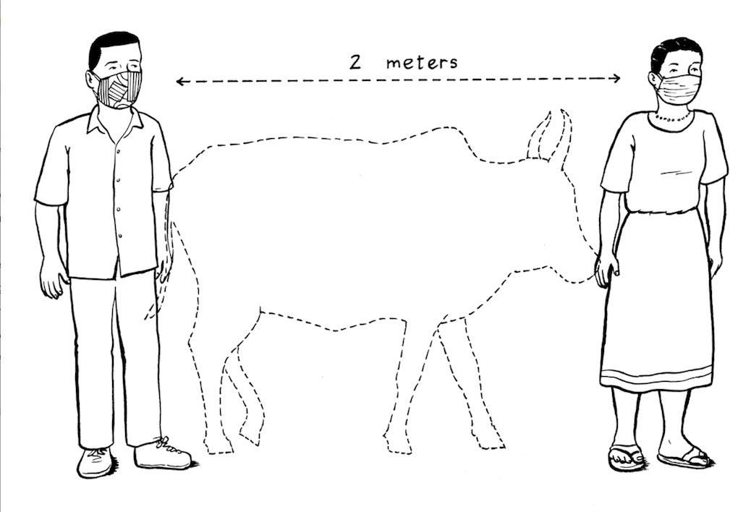  - Remind participants to follow safety guidelines throughout the meeting.  - Leave behind leaflets in local language, with graphics considering literacy levels.
AFTER: | - Share information on best practices on safety protocols for community dialogues with other implementers.

❚ Part 3. COVID-19 Safe Community Meeting Template
Why a planning template? Creating a community meeting plan in times of COVID-19 helps to understand the localized situation, government policies, protective measures, recommendations or restrictions, and what kind of resources, supplies and other safety elements we need to consider for conducting community engagement activities.
This planning tool will provide organizations’ staff and volunteers the necessary vision to reduce unexpected barriers when planning community-level engagement activities.
A. Context Analysis
- What is the host country/community where the activity will be held?
- What setting will your event be held in and what are the key considerations for that setting:
- Urban or peri urban environment:?
- Urban slum:
- Refugee/IDP camp or camp-like setting:
- Rural area:
- Other
B. Situation Analysis
- Will the activity take place in an area of the country without active local transmission (community spread)?
- Will the activity take place in an area adjacent to a community with local transmission (community spread)?
- What are the number of cases in the country and/or community where the activity will be held?
- Country:
- Community/Informal/Formal Settings:
- What are the public health and social measures in your country?
- Lockdowns/movement restrictions:
- Physical distancing:
- Wearing facemasks:
- Other:

- If people have to travel, will they have to quarantine for 14 days or be tested when they arrive in a new setting?
- What is the country's policy on domestic travel?
- What are the referral pathways in this setting for someone with COVID symptoms?
C. Risk Assessment

- Have you conducted a risk/vulnerability/protection assessment in the area you want to implement the activity?
- What is the organization allowed or required to do to ensure safety of staff and community members during activities (e.g., facemasks, hygiene, etc.)?
- What are some of the challenges to ensuring staff and community member safety in this setting?
- Are people attending from areas affected by COVID-19?
- Will there be participants who may be at risk (e.g., elderly persons, people with underlying conditions, health workers, etc.)?
- Are participants—including people with disabilities—and staff able to get to an accessible meeting space while practicing physical distancing of at least 2 meters (e.g., avoiding crowded public transportation)?
- Is there safe access to the community, free from the risk of hostility or physical attacks?
  - If not, what will you do to support people in getting to the meeting safely?
D. Meeting Area Specifications

- Can the meeting be held virtually instead of in-person?

- Will the meeting be held in an open space or outdoors?
- If indoors:
- Is it accessible for people with disabilities?
- Can you increase ventilation?
- Will masks be provided?
- Are handwashing stations already set up? If not, will you be setting these up?
- Will the room size be large enough for the number of participants to be physical distancing?
- Is it feasible to maintain at least a 2-meter distance between all participants and facilitators at all times during these community meetings, including when entering/exiting the space?
  - If not, can you limit the number of people who are attending?
- Are participants and staff able to get to the meeting space while practicing physical distancing of at least 2 meters (e.g., avoiding crowded public transportation)?
  - If not, what messaging can you provide or solutions can you offer?
- How will you engineer controls to mitigate risks in the space (e.g., Barriers between chairs? Chairs spaced 2 meters apart? Circles for people to sit on the ground 2 meters apart?)

E. Available Resources and Supplies

- Can the following supplies be made available during the activity?
- Hand sanitizer
- A hand-washing station [tippy taps] with soap and water (if one is not already available)
- Facemasks or face coverings for all participants, including staff, volunteers and any other service providers (e.g., food service staff)?
- If you cannot make supplies available, can you alert participants in advance to bring them or use them before and after the activity?
- Will there be food/beverages served?

F. Supervision and Compliance

- Will you create supervision roles and procedures to ensure staff and communities are following the guidance?
- Have you put in place daily health checks for staff supporting community meetings?
- Will you request staff and volunteers to undergo additional training on personal safety procedures (specifically those listed in this checklist)?
- What are the procedures on duty of care for all staff carrying out activities in affected communities?
- What PPE do staff and volunteers need? What access to PPE do they have?

G. Addressing Community Perceptions

- Does your organization have in place any feedback system to collect people’s doubts, concerns and suggestions around loosening lockdown measures?
- Have you conducted or are you planning any perception or feedback surveys to understand communities’ beliefs around public health and social measures?
- What are people’s perceptions about lockdown or post lockdown measures that you can address through your community engagement activities?

- Do you have procedures on using perception and feedback data for decision making?

- How will you address those perceptions and feedback?
- How will you articulate these plans back to the community?
H. Engagement and Participation

- Have you consulted community leaders, civil society organizations or any other networks on the planned activity?
- What other community groups or members are involved?
- Have you identified any community-based solutions on how to conduct a meeting safely based on their traditions and local expertise?

I. Protection and Inclusion

- Is the event inclusive of persons with disabilities?
  - If so, have you taken into consideration the physical distancing practices and/or how they can access hygiene supplies?
  - Have you planned how to communicate to different community groups (people with disabilities, illiterate, minority language speakers, children, women)?
    - For example, is sign language interpretation required?
    - Are multiple languages are required?
- Will the activity include a significant number of participants at higher risk of severe disease (e.g., elderly people and people with underlying health conditions)?
  - If so, have you worked with community leaders to ensure they understand the personal risks?
  - Have you taken into consideration modifications to the physical space to support them in being more protected?
  - Will they be provided supplies such as facemasks or face coverings, or hand sanitizer?
- If your event includes indigenous groups, have you considered translating and adapting COVID-19 protective measures and other required health information to languages and formats suitable to their specific indigenous roots?
- Are you taking into account existing gender and power dynamics and addressing them during your activity? (e.g. having diverse teams, respecting physical distancing or disposition of the event)
- If your event will include marginalized and vulnerable groups such as homeless, people deprived from liberty, people living with mental or health conditions, urban poor or slum dwellers, or indigenous groups, do you know if they are stigmatized and what kind of stigma they are facing?

❚ Annex A. Scenarios of Community Engagement in Different Contexts with Shifting PHSMs

The scenarios below illustrate how agencies can plan community engagement in different low-resource settings where lockdowns are being eased.

Scenario 1: Community Engagement in Urban Slum Areas with COVID-19 Hotspots
Urban Slum Profile
- High density of inhabitants who are highly mobile and have limited education, informal occupations, and low literacy levels.
- High rates of pre-existing conditions.
- High rates of social mixing between different age groups.
- Inadequate infrastructure with no or limited access to clean water and hygiene, and health services.
- May have lower education level which may be a challenge to understand more technical health information. May be illiterate.
- Misinformation, rumors and stigmatization about the disease is rampant.
- Focused more on making ends meet and can be hit hard economically by COVID-19. May not have time to actively look for official information about health emergencies. May not be eligible to benefit from social welfare systems and therefore may not receive health information.
- May not have/use technologies such as computers and smartphones.
- May prioritize basic needs over gathering information.
RCCE Considerations
- Consider conducting these meetings remotely to mitigate risks as much as possible. For example, encourage leaders to establish WhatsApp groups to discuss challenges and come up with solutions for their units/communities. Remote support can be provided by daily/weekly phone calls to the unit leaders to understand what the community is saying, what rumors or myths are circulating, challenges with accessing health services, etc. See Tips for Engaging People in Low-Resource Settings, Remotely and In-Person.

- If remote community engagement is not possible, consider the following:
  - Break the large community into smaller neighborhood units.
  - Identify unit leaders/champions who can build social cohesion and enroll households into actions.
  - If there is a case within a unit, work with local leaders and other unit leaders to ensure that it is only the unit that is locked down and not the entire slum. These leaders would need to ensure that the unit locked down can access life-saving supplies.
  - Target business owners to develop action plans to establish IPC plans to re-open and keep open public places (markets, restaurants etc.).
  - Work with transport owners and workers to ensure that infection, prevention and control (IPC) is being observed and that they know how to keep their passengers and drivers safe.
  - Use the units to deliver targeted life-saving services. See for adapting community health and nutritional interventions https://www.goalglobal.org/adapting-to-covid-19-resources-for-charities/.
- Adapt ongoing community engagement practices to recommended restrictions, e.g., numbers of people allowed in meetings, duration, spacing, any local recommendations on protective equipment use (e.g., masks). Given that meetings will most likely be held indoors, ensure space is accessible (e.g., for people with disabilities) and ventilated (e.g., open windows); consider supplying and promoting facemasks or face coverings. Ensure directional flow (1-way flow) to meeting space if the meeting is indoors or in a semi-enclosed area.
- Co-create messages with people from within the urban slum areas who are best placed to understand limitations and mobilize community networks. Health advice should be adapted to cultural realities. Making the advice more achievable encourages higher adherence rates.
- Work with organizations, religious and community leaders, and leaders from different branches of the informal sector, to leverage the value and belief systems within communities and create engaging messages.
- Encourage governments and civil society organizations (CSO) to establish confidential, communication models to encourage engagement (e.g. SMS; social network groups). See COVID-19: How to include marginalized and vulnerable people in risk communication and community engagement for information on perception surveys and strategy adaptations.
- Include questions about income sources, changes in income, wealth, access to basic resources (e.g., water, soap), and food security in a rapid survey. Include questions about the impacts of the pandemic—and the response—based on income, race/ethnicity, religion, gender, and other factors. Include questions as needed on people’s experiences with stigma and discrimination related to COVID-19. Refer to Socially Marginalized Groups and COVID-19.
- In contexts where children have higher literacy rates than their parents, children may support caregivers with information, so ensure that communication is tailored to children so they can understand and share content.

Scenario 2: Community Dialogues in Refugee Camps and Camp-like Settings with Increasing COVID-19 Case Numbers
Profile of Camp/Camp-Like Setting
- Lack of testing because of low prioritization with national health authorities
- Legal restrictions around access to the national health system
- Increased frustration linked to the livelihood restrictions and other economic impacts of COVID leading to some increasing protection concerns including violence in the home, SGBV, and petty criminality (examples from Cox’s Bazar)
- Mix of ethnicities and preferred means of communication
- Increased rumors and misinformation
- Tension with the host community, requiring engagement with the host community
RCCE Considerations
- Work through existing structures, leaders, and existing trusted channels including religious leaders. Ensure information is accessible via chosen channels to everyone including particularly vulnerable people. Review information from feedback systems and rumor management processes to understand pressing concerns. Be aware of the health measures in place including referrals for particularly acute cases. Be aware of the adaptations of the response, including any pivoting towards post-lockdown measures and any addressing longer term impacts.

- Ensure COVID-19 messages contain information on how life-saving services are going to be adjusted, such as changes on food distributions and health care services.
- Adapt ongoing community engagement practices to recommended restrictions, e.g., numbers of people allowed in meetings, duration, spacing, any local recommendations on protective equipment use (e.g., masks).

- Re-adapt approaches to the lifting of restrictions. Where face-to-face communication is preferred by affected people, revive practices with trained volunteers who exemplify distancing and other recommended restrictions. Continue to address rumors and misinformation with counter messages. Link up with other supportive COVID-19 programs including WASH to help maintain the focus on hand hygiene, and livelihoods/cash to help address concerns linked to economic impacts. Ensure continued information provision including information targeted towards maintaining protective practices and changing measures and restrictions.

❚ Annex B. Sample Flyer and Downloadable Illustrations
Download this sample flyer on How to Safely Engage Communities by IFRC. You can customize your own flyer by downloading some of the images on the following pages.
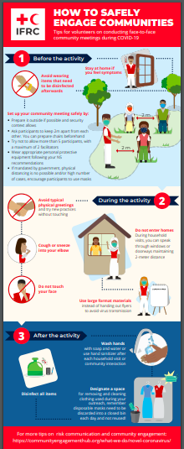

Download this image on physical distancing. High Res. Low Res.

Download this image on Safe Community Meetings. High Res. Low Res.

Download this image on Handwashing in Community Meetings. High Res. Low Res.

.

Just as PHSMs differ across countries—from curfews to quarantines and stay-at-home measures—countries are tailoring the lifting of those measures to their contexts. For example, Kenya and Senegal imposed dusk to dawn curfews—or partial lockdowns—and are staggering physical distancing measures.
See Step-by-step guide for engaging communities during COVID-19. And Community-Led Action for COVID-19 for Country Offices and Community Mobilizers for example approaches.
In some contexts--for example, urban slums or refugee camps--it may continue to be challenging if not impossible to maintain a physical distance of at least 2 meters. In this case, organizations have been promoting the isolation of individuals who are most at risk within households and communities, working with communities to ensure health and well-being.
Establishing broad acceptance of these measures might be accelerated when people are observing others practicing these behaviors and benefiting from them. Understand the barriers and enablers to behavior change to craft impactful messages and materials (see How to Write a Creative Brief) or community approaches (see Step by Step Engaging Communities during COVID-19).
See CDC guidance for large or extended families living in the same household and Synthesized Guidance for COVID-19 Messages.
Ibid.
Ibid
These were middle-to-high income countries: Japan, South Korea, Mexico, Sweden, UK, US, Australia, Germany, Spain, Italy.

