YES! Annual Report 2021
RCCE Collective Service - Youth Engagement Subgroup

Background  The Youth Engagement Working Group was created to enable collaboration and support a wide range of organisations with the development and rolling out of risk communication and community engagement (RCCE) specific interventions and strategies relevant to young people’s contexts and realities. The group is part of the RCCE Collective Service.  Youth Engagement Subgroup aims to mobilize young people and involve them in decision making processes that affect their life by advocating for the inclusion of young people and providing technical support and guidance.  The work of the Youth Engagement Sub- Group is co-led by UNFPA and UNICEF and has membership of WHO, WOSM, WAGGS, Duke of Edinburgh Award, YMCA, YWCA, IFRC , #MoreViralThanTheVirus.  Achievements in 2021  In 2021, after eleven group meetings, the subgroup was consolidated as a space for collaboration between member organizations. The group* facilitated the exchange of knowledge by stimulating the development of joint activities aimed at making visible and incorporating the vision and needs of young populations in the design and amplification of the use of RCCE resources as part of the COVID-19 response,  The achievements below respond to the objectives of YES! and the activities agreed by its membership during 2021. | Objectives of the Youth Engagement Sub-Group  Advocacy: Advocate for the inclusion of young people within global, regional and local RCCE strategies, policies and plans while ensuring the coordination of RCCE efforts towards young people.  Research: RCCE data generation and social research focused on young people to effectively guide field efforts.  Support: Provide technical support to RCCE efforts targeting at the country level and facilitating connections with youth groups active in RCCE.  Collaboration: Create linkages to other subgroups and support to include a youth lens in areas of work such as mental health, migrants, marginalised populations, people living with disabilities, indigenous, ethnically and racially diverse vulnerable young people and groups.

Identifying the main issues and needs to determine the challenges faced by Youth Networks

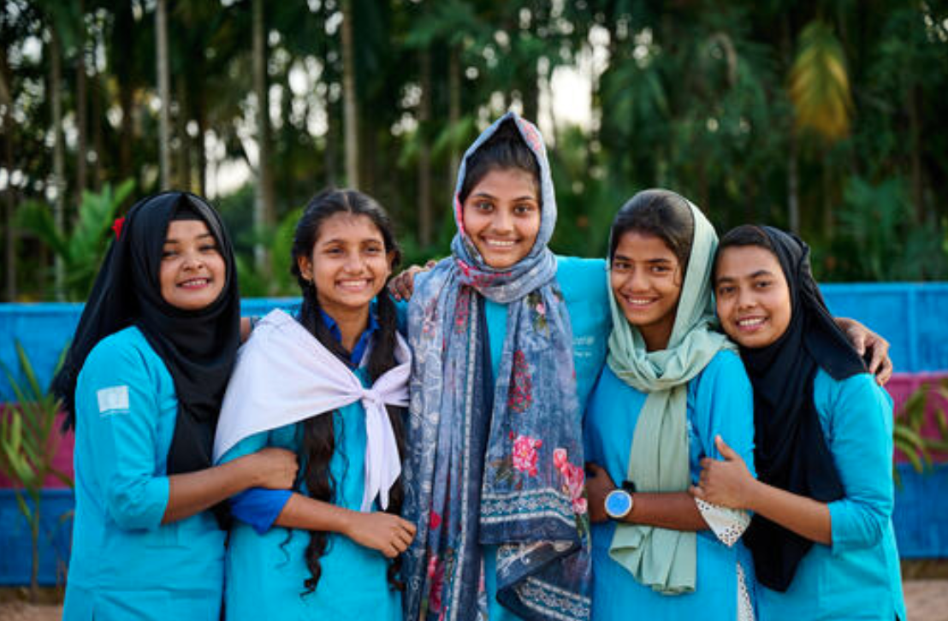
1. Survey on needs and priorities of Youth Networks
The YES! Survey on needs and priorities
This survey was conducted through over 40 Youth networks to identify challenges and priorities for youth networks such as tackling disinformation, myth busting, COVID-19 vaccines and support needed from the YES! partners.

Collecting relevant materials and guidance based on priorities
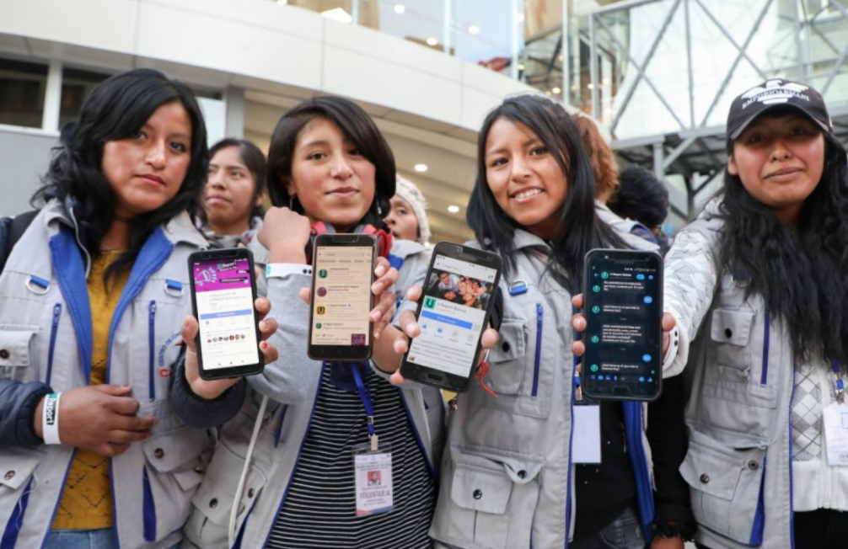
2.Youth Engagement Sub Group Online Space
An online space dedicated to the RCCE and Youth Engagement sub group was created on the website of the Collective Service for Risk Communication and Community Engagement, starting with key documents, members, resources, ToR, among others.

3.COVID-related Guidances for Youth-led Organisations on Collective Service RCCE website
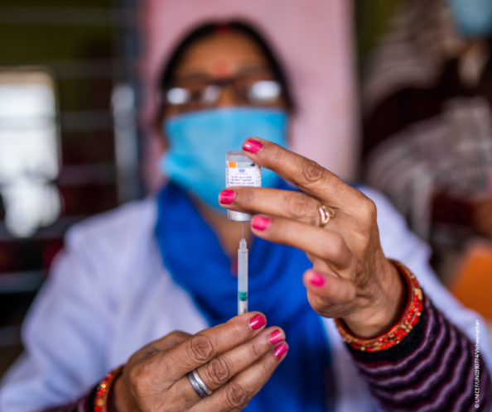
27 new resources were uploaded to the Collective Service for Risk Communication and Community Engagement (RCCE)’s youth subgroup online space that are focused on priority topics that were determined in the needs survey such as tackling disinformation, vaccines, myth-busting, health literacy, innovative approaches to service continuity with COVID restrictions, ensuring an intersectional feminist response to COVID and much more.

According to the results of the Youth Engagement Subgroup (YES!) survey on top needs and priorities of Youth networks, it was decided that COVID-related Guidances on various topics would be very useful for youth-led and youth-serving organisations. After the decision was made, a submission matrix was created by UNAIDS for YES! members to contribute and add resources to.

4.Risk Communication and Community Engagement for COVID-19: Interim Country Indicator Guidance

In this document the IFRC, UNICEF and WHO Collective Service for Risk Communication and Community Engagement provides interim indicator guidance for countries to monitor and evaluate Risk Communication and Community Engagement activities for COVID-19.

The interim indicator guidance will be rolled out to country and regional level partners during 2021. In 2022 the Collective Service will undertake an evaluation of the interim indicator guidance. The indicator guidance will be revised and full guidance published thereafter.

This guidance was originally created by RCCE Collective Service, Youth Engagement Subgroup members provided a perspective on youth, and youth-led and youth-serving organisations by adding feedback and comments on the final draft of the document.

Ongoing Projects

1.Adaptation of the Act-A demand for vaccination guidance for countries

The rollout of COVID-19 vaccines presents fresh challenges, such as working to rapid timelines and reaching older populations that normally would not be a major focus of vaccination.
Addressing the operational challenges that arise from these developments is vital to ensuring vaccines are valued, trusted, easily available, and actively sought out. This is particularly important to achieve among under-reached groups, including women and girls.

These tools were designed to respond to these challenges and support planning and implementation for COVID-19 vaccination. They offer practical guidance on a range of areas – from planning, to data gathering and evaluation, to specific strategies for community engagement and managing rumours and misinformation.

This initiative is led by UNICEF, UNAIDS and WHO. YES! partners are currently revising and providing their feedback on three guidance documents regarding the Act-A Demand for Vaccination Guidance for Countries:

- Acceptance and demand for COVID-19 vaccines
- Conducting community engagement for COVID-19 vaccines
- Young People and COVID-19 Behavioural Considerations for Promoting Safe Behaviours

​​2.Virtual Roundtables (GYM) (WHO, MVTTV, GYM, UNAIDS)

Global Youth Mobilisation (GYM) proposed to co-host the virtual roundtables with Big 6 Youth Organizations focusing on combating vaccine hesitancy and/or issue of equity in target countries / regions. GYM could facilitate / manage - including engaging the young people based on agreed targets.

The workshops will be delivered in key locations where vaccine hesitancy is relatively high, misinformation is a challenge and that members of the working group deem are a priority for the successful roll-out of the Covid-19 vaccine.

Youth Engagement Subgroup will aid in organizing the virtual roundtables, selecting the key locations and provide guidance on vaccine hesitancy.

3. 2022 YES! Retreat

YES! members will come together for a retreat where they will discuss the challenges & opportunities in 2021, the expansion of the YES and partners engagement strategy and determine a work plan for 2022.

YES! Retreat will take place on 7 February 2022.

- Retreat Agenda
- Slidedeck

Key YES! resources
For more information on the work of Youth Engagement Subgroup, please check out these resources:
YES! webpage (include objectives and TORs)
RCCE resources for youth
YES! Presentation (PPT)
Members list
Minutes of meetings
Documents on RCCE and Youth
Guidance: IASC Guidelines on Working with and for Young People in Humanitarian and Protracted Crises
Technical Brief: Invisible but not forgotten, RCCE with young people are left behind during COVID-19
Practical Tips: Risk Communication & Community Engagement:
Practical Tips on Engaging Adolescents and Youth in the COVID-19 Response

