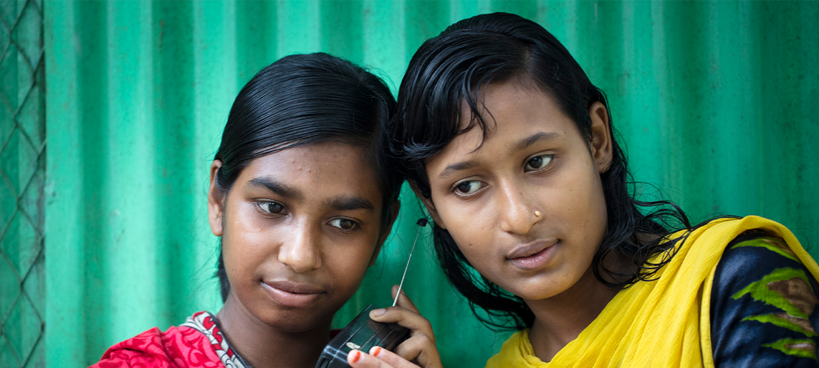

**TRAINING PACKAGE FOR USING SOCIAL SCIENCE IN COMMUNITY ENGAGEMENT AND/OR COMMUNICATIONS ACTIVITIES**

**SESSION 5.3:** How to communicate and present research outputs to different audiences

SESSION CONTENT

**Learning approach:** Real-time presentation, individual and group exercises, case examples

**Delivery mode:** Online and offline, 190 minutes approx.

**Summary:** This session covers how to effectively design research and transform social science data and evidence into findings that can be used to influence policy and practice.

**Learning outcomes:**

* Become familiar with different products and channels for communicating social science evidence
* Know how to understand and map different stakeholders, including intended users of the research findings and recommendations
* Be able to create an effective communications plan

FACILITATING THE SESSION

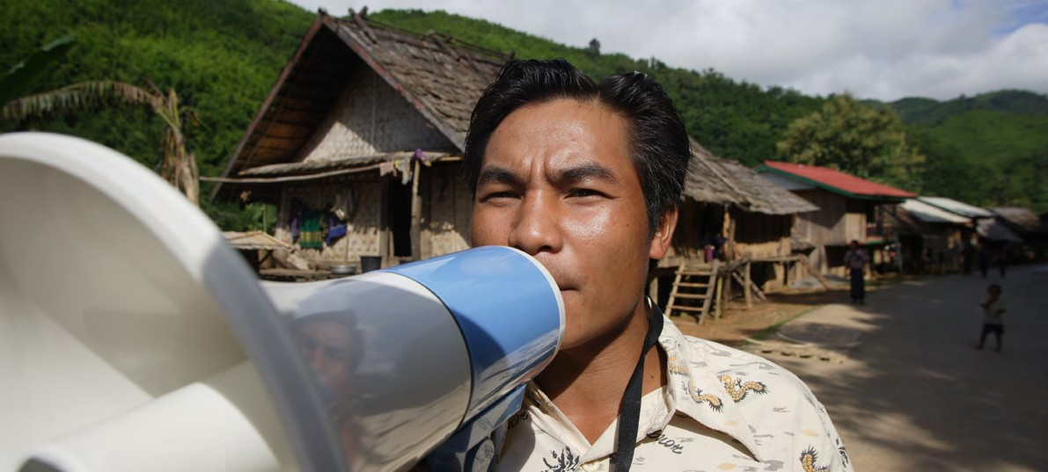

**TRAINING PACKAGE FOR USING SOCIAL SCIENCE IN COMMUNITY ENGAGEMENT AND/OR COMMUNICATIONS ACTIVITIES**

Introduction: (5 minutes total)

Talk through session summary and learning outcomes.

Position this session in the question flow. This session draws upon two stages in the research process: earlier on when considering who needs to use research evidence (2) and later in the research process when we consider how to feed research back to communities (6) and how to ensure the information is used (7).

1. How to ensure that this information goes back to communities? To inform community-level actions and decision-making of the broader response?
2. What methodology and tools should be used to collect and analyse this information?
3. How to track the information used to ensure that it effectively contributes to operational and strategic priorities?
4. Who can collect this information?
5. Does this information already exist? Is there a related needs assessment or study?
6. What information is needed?

**DATA TO ACTION:**

Key questions in social science research

1. Who needs this information?
2. How to ensure that the information is used to make operational and/or strategic decisions?

Communicating research outputs (15 minutes total)

|  |  |
| --- | --- |
|  | Question to participants (5 minutes):  Why is the communication of research such an important step to consider?  Online: Invite the participants to write the answers in the chat function and summarize  Offline: Ask two or three participants to share their thoughts |

When the findings and recommendations of social science research are effectively communicated to key actors in the response who are likely to use this information – including communities – this can significantly improve the way humanitarian response is designed and delivered. Surprisingly, this stage is often overlooked by some researchers, but it is a critical component of operational social science research.

|  |  |
| --- | --- |
|  | Question to participants (5 minutes):  What might be some of the challenges to communicating social science outputs in an emergency setting? What have you learned or observed from your own work?  Online: Invite the participants to write the answers in the chat function and summarize  Offline: Ask two or three participants to share their thoughts |

There are a number of challenges we face when trying to communicate social science information and knowledge.

* Social science often takes a broad perspective and produces complex information, e.g. about political, cultural and psychological factors. This can be difficult to communicate effectively, especially in an emergency situation where people’s time might be limited.
* Saving lives is at the core of most emergency and humanitarian work. A common misunderstanding or misconception among emergency response actors is that this sort of information – e.g. about political, cultural, psychological factors – is not going to save lives.
* Related to the previous point, in health emergencies, responders often focus on biomedical interventions and not the social context in which they are delivered. Sometimes it is necessary to persuade response actors that social factors are important to consider as part of the overall medical response (e.g. persons may not be interested in the health service provided).
* Another misunderstanding or misconception is that recommendations coming from social science research will slow the response down, especially if it highlights key issues that can challenge the direction of the work – e.g. the need to target a different group of people with different types of messaging than is currently planned for.

An effective communications plan can help overcome these challenges, which we will be focusing on next.

Products and channels (10 minutes total)

Products are what you produce, and channels are how you distribute them.

|  |  |
| --- | --- |
|  | Question to participants (5 minutes):  In your work, what have been some of the most effective communication products you have used? What are some of the most effective communication channels?  Online: Invite the participants to write the answers in the chat function and summarize  Offline: Hand out sticky notes and ask people to write and post as many answers as they can |

As you likely know from your work, there are a number of possible products and channels for communication purposes.

PRODUCTS:

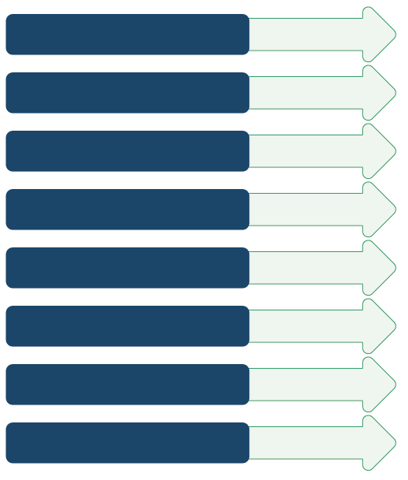

Policy brief

Academic journal article

Online blog/article

Research/evaluation report

PowerPoint slides

Manual/guideline document

Short video/animation

Infographics

CHANNELS:

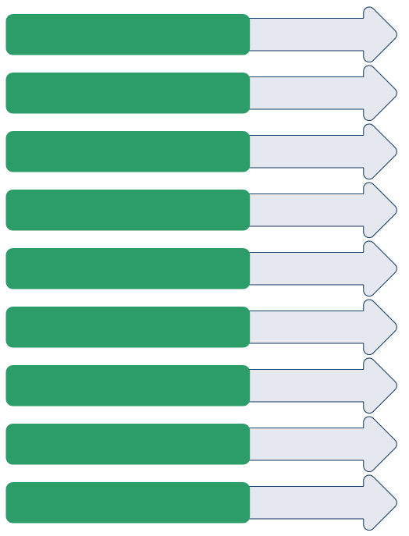

Working group/cluster/  
network meeting

Webinar

Conference

Social media

Policy review/policy   
development meeting

Public online resource collection

Informal meeting

Training sessions

Meeting/briefing with   
key stakeholders

All of these may be appropriate at different times and to different audiences. They need to be tailored to fit a well thought out communications plan.

Making your communications plan (70 minutes total)

Set SMART objectives

In order to create an effective communications plan, you need to start with strong objectives that are Specific, Measurable, Achievable, Relevant and Timely.

|  |  |
| --- | --- |
|  | Group exercise (5 minutes):  Discuss this objective: ‘I want to reduce cholera transmission in my community.’  How would you change this objective to make it SMART? Use your imagination about the context to make this objective SMART.  Online: Invite the participants to write the answers in the chat function and summarize  Offline: Ask two or three participants to share their thoughts  Reflect on whether these responses are SMART.  Example of a SMART objective: ‘I will increase handwashing practices in X community by 10% (based on baseline data from my report on hand-washing practices) by running 3 radio campaigns on World Health Day (in 2 weeks’ time).’ |

Identify users

Identifying users of research findings starts during the design phase (refer back to question flow diagram) and continues throughout the research process.

A good understanding of your target stakeholders is an important part of being able to communicating research findings effectively.

There are lots of ways to influence, create change and build relationships. It’s important to be specific and know who is influential (in a good or bad way), and interested (or not). You will need to prioritize your efforts and build engagement over time.

|  |  |
| --- | --- |
|  | Question to participants (5 minutes):  Think of your current context and who would benefit from hearing about the findings of social science research you support or produce. Come up with specific organizations or individuals that fit into the following categories of potential users of research findings:   * International agencies/multilateral organizations (e.g. UNICEF, WHO, WFP, UNHCR) * Working group/cluster members (e.g. WASH cluster) * Governments/ministries (e.g. Ministry of Health, Ministry of National Disaster Management) * Communities affected by a crisis * Local civil society organizations (CSOs) * Funders/donors (e.g. Gates Foundation) * Traditional media (e.g. radio, television, newspapers) * Social media (e.g. Twitter, WhatsApp) * Academia (e.g. local universities) * Any others?   Online: Invite the participants to write the answers in the chat function and summarize  Offline: Hand out sticky notes and ask people to write and post as many answers as they can  Briefly recap the actors and organizations and ask people to be more specific if necessary (for example, if someone has written UNICEF – ask who/which team at UNICEF?). |

Get to know your audience

When you know WHO to engage – you should next explore HOW you should engage them.

You need to learn about the following:

* Organizational/institutional interests and priorities
* Personality traits (for individuals)
* Values
* Opinions
* Political motivations and goals
* Blockages for action – concerns your audience may have – and how you should approach these – e.g. face them head-on, or approach these issues cautiously?
* Language – what terminology /jargon should be used and not used?

We need to understand what a successful outcome means to the person or group   
we are presenting to. The iceberg image captures this well as we also need to understand what might be going on under the surface. What organizational and/or personal issues might play a role in how well information is digested?

In order to achieve objectives, we particularly need to try and understand the information needs, interests and priorities and motivations of our key audiences that might affect how the research might be received.

To do so we need to get into the mindset of our audiences.

|  |  |
| --- | --- |
|  | Group exercise (15 minutes + 10 minutes discussion):  Working in pairs, look back at the list of potential users of research findings. Prioritize one, perhaps one you are currently most familiar with and who could most benefit from hearing about the findings of social science research you support or produce (or would like to support or produce).  Note: Session 5.4 is dedicated to communicating back with communities, so you might want to prioritize another type of user for this exercise.  Work through the Stakeholder Template (Handout 1, PowerPoint presentation) making notes on each section.  Pairs present back to the group |

All of these factors can guide what outputs or products you create and through what channels you choose to present them.

Identify appropriate products, channels and opportunities to engage

As we’ve said, we need to tailor the content of our products and choose appropriate channels to the intended ‘user’ of the product. *Link back to list of products and channels**.*

We also need to consider what opportunities we have to engage with intended users.

Plan ahead where you can – when is the right time/where is the right place to engage those people? For example, when we think about policy development and/or programme planning, look at the agenda and policy cycle to find meetings (i.e. what are the moments of planning and decisions that happen before key events?)

To be successful, we need to:

* Find the right time, and a fitting method to communicate, e.g. what fits the audience, the environment, the time available, etc.
* Learn, and speak the language of people we are communicating to – this will help make the information digestible. By using similar language to those we are aiming the information, we make it feel relevant to them.

|  |  |
| --- | --- |
|  | Group exercise (5 minutes + 5 minutes discussion):  Reconvene with your group, go back to your selected ‘user’ (identified prior) and focus in on ‘how do they get their information’. Come up with appropriate products, channels and opportunities to engage.  Feedback to the group |

Constructs a message that can turn research outputs into action, and disseminate using visually engaging outputs

In order to turn findings and recommendations into action and change, in our communications we need to:

* Show how this (whatever you have to communicate/your message) is vital to achieving priority goals – *‘These findings are crucial to the outcome of your activities’*
* Fit what you have to communicate/your message into the wider context of the response – ‘This will ultimately help curtail the spread of this disease’
* Keep what you have to communicate/your message solution-focused and actionable: ‘There is something actionable we can do about this’ and ‘This action will have impact’

For further discussion on transforming social science data into actionable findings, see Session 5.2. For more on turning research outputs into action, see Session 6.1.

*Who* needs to know *what* is always changing, especially in an emergency setting, and so we need to keep track and be ready to engage stakeholders at key moments. There is often a need to communicate information at the last minute (even if work isn’t ready completely ready!).

Finally, use visually appealing communication outputs to engage different audiences. Use a visual medium and a method that would be most engaging, user-friendly and accessible for your selected audience. Examples include: Microsoft PowerPoint, Adobe (various sub-apps), Google Slides, [SlidesGo](https://slidesgo.com/), [Slides Carniva](https://www.slidescarnival.com/)l, [Canva](https://www.canva.com/), [Visme](https://www.visme.co/), [Prezi](https://prezi.com/), [Picmonkey](https://www.picmonkey.com/), [Powtoon](https://www.powtoon.com/?locale=en), [Mindthegraph](https://mindthegraph.com/), and [DesignWizard](https://designwizard.com/).

Wrap-up/summary (5 minutes)

* When the findings and recommendations of social science research are effectively communicated to key actors in the response who are likely to use this information – including communities – this can significantly improve the way humanitarian response is designed and delivered.

* When making a communication plan it is important that the following steps are followed:
* Set SMART objectives
* Identify priority users of the research findings
* Get to know your audience – in terms of information needs, interests and priorities, and underlying motivations
* Identify appropriate products, channels and opportunities to engage your audience
* Construct a message that will help turn research findings into action.

ACKNOWLEDGEMENTS:

Alice Webb (IDS), Vivienne Benson (IDS) and Theresa Jones (Anthrologica) developed the content of this session. Jeni Stolow (Tulane University) contributed additional content. It was reviewed by Olivia Tulloch (Anthrologica).