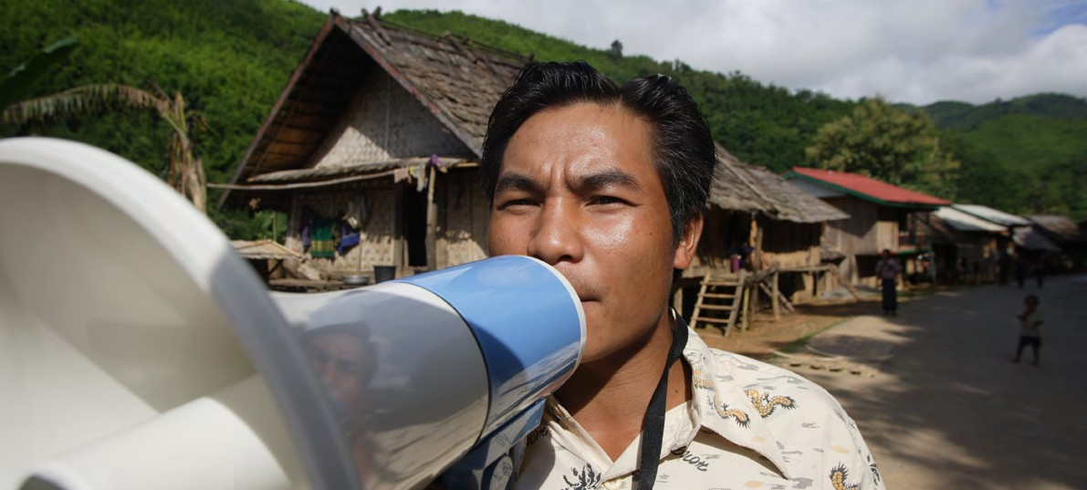

**TRAINING PACKAGE FOR USING SOCIAL SCIENCE IN COMMUNITY ENGAGEMENT AND/OR COMMUNICATIONS ACTIVITIES**

**SESSION 1.1:** Introduction to social science: Definition, approaches and role in humanitarian action

SESSION CONTENT

**Learning approach:** Real-time presentation, individual and group exercises, case examples

**Delivery mode:** Online and offline, 135 minutes approx.

**Summary:** This session discusses the value and the role of social science research in humanitarian action   
with a focus on community engagement and communications activities.

**Learning outcomes:**

* Understand why it is important to include social science as part of emergency response
* Understand how social sciences can support the design, delivery and continuous adjustment   
  of community engagement and/or communication activities and wider response action

FACILITATING THE SESSION



**TRAINING PACKAGE FOR USING SOCIAL SCIENCE IN COMMUNITY ENGAGEMENT AND/OR COMMUNICATIONS ACTIVITIES**

Introduction: (5 minutes total)

Talk through session summary and learning outcomes.

What is social science? (25 minutes total)

|  |  |
| --- | --- |
|  | Question to participants (5 minutes):  Define in your own words what ‘social science’ is.  Online: Invite the participants to share their answer verbally or write their answer in the chat function and summarize.  Offline: Ask two or three participants to give their definitions. |

**Social science** is the study of society and individuals, how individuals interact with each other, how people behave and the dynamics between different (population) groups. Social science is also the study of individuals and their environment. It works to understand how individuals influence their environment and how the environment influences individuals.

Social science tells us about the world beyond our immediate experience and can help us to explain how our own society works.

|  |  |
| --- | --- |
|  | Brainstorm (5 minutes):  What disciplines fall under the ‘social sciences’?  Online: Invite the participants to write as many answers as possible in the chat function  Offline: Ask the participants to write their answers down on a post-it and after few minutes invite  a few participants to share their responses. Note them down on the flipchart. |

**Disciplines** that fall under the broad category of social science include:

* Anthropology (cultural, social, medical)
* Archaeology
* Economics
* Geography
* History
* Law
* Linguistics
* Politics
* Psychology
* Sociology
* Etc.

Each discipline brings its own unique perspective and so social science practitioners often look through the viewpoint of many different disciplines to understand an issue.

For example, through a **psychological** lens we might understand why people might not take up public health or social guidance given to them by a local leader because they do not trust that leader. Through an **anthropological** lens we might understand the historical roots of marginalization in this community. Through a **political science** lens, we might understand local government practices and how power is shared, and shifts, in the area. These are four of the most common perspectives taken.

|  |  |
| --- | --- |
|  | Question to participants (5 minutes):  What is social science research?  Online: Invite the participants to share their answer verbally or write their answer in the chat function and summarize.  Offline: Ask two or three participants to give their definitions. |

Social science research is the activity of collecting, analysing and interpreting qualitative and quantitative data. We will talk more about these different types of data in later sessions.

Social science research focuses on both social and behavioural sciences. The social and behavioural sciences are often confused because they have many overlaps. Behavioural sciences also include anthropology, psychology and social and behaviour change theories – some of which we will hear about in later sessions.

Both the social and behavioural sciences collect and analyse data which can support decision-making processes and related action in humanitarian response, e.g. for communication strategies or other social and behaviour change strategies.

Social science research findings can be useful in different technical areas: social protection, economic development, health, education, etc.

The social sciences can be used to complement many other disciplines. Let’s take the example of epidemiology. Epidemiology makes it possible to estimate the risk of health-related events in a population, to describe it and to consider what might cause it. Social science allows us to question and explain how and why a social group would be more affected than another by a disease, for example because of historical marginalization of the group, or because of sociocultural practices that could favour the onset of a disease.

Why is social science important for public health and humanitarian emergencies?   
(25 minutes)

Social science provides a number of structured research approaches to understand and explore important issues which affect the effective design and delivery of public health services and humanitarian assistance.

**To consider** how systems responding to a crisis are organized (e.g. the health system) and which mechanisms (e.g. social protection) and structures (e.g. churches) already exist.

**Example:** Analysing which existing services are being used and by whom could help avoid establishing parallel systems and ensure uptake during an emergency response.

**To understand** people’s perceptions, values, priorities, beliefs and life experiences, and how these interact with the response to humanitarian needs.

**Example:** Rejection of cremation practices during the 2014–2016 West Africa Ebola outbreak led to an increase in ‘underground’ funeral practice which fuelled the spread of disease.

**To understand** how social, cultural, psychological, historical, political and economic factors influence people’s behaviour and/or the functioning of systems responding to the emergency. In particular, to understand people’s perceived risk and level of confidence to handle that risk, either through personal or external action..

**Example:** The decision to have a vaccination can be related to this act symbolizing your broader political affiliation (political), and whether others are doing the same (social).

**To understand** people’s perceptions, values, priorities, beliefs and life experiences, and how these interact with the response to humanitarian needs.

**Example:** Rejection of cremation practices during the 2014–2016 West Africa Ebola outbreak led to an increase in ‘underground’ funeral practice which fuelled the spread of disease.

**To understand** how social, cultural, psychological, historical, political and economic factors influence people’s behaviour and/or the functioning of systems responding to the emergency. In particular, to understand people’s perceived risk and level of confidence to handle that risk, either through personal or external action.

**Example:** The decision to have a vaccination can be related to this act symbolizing your broader political affiliation (political), and whether others are doing the same (social).

**To understand** local priorities for action, even where they contradict with the priorities of emergency response operations.

**To identify** potential gaps or tensions between how the response is being designed and delivered and how communities see and interpret it.

**Example:** During the Ebola response in the Democratic Republic of the Congo, community feedback data collected by Red Cross volunteers. This feedback highlighted strong mistrust of health authorities and a desire by affected communities to be consulted on how the response and services were rolled out. For example, communities requested to: have local health workers they know among the vaccinators (this request was linked to their fear, anxieties and mistrust in vaccination efforts); be able to enter households alongside Safe and Dignified Burial teams to see what they were doing (this request was linked to beliefs that bodies were being mistreated); have a say as to where Ebola treatment centres were constructed. This almost real-time data helped highlight people fears and specific requests made to responders to address those fears and adapt emergency services and actions based on community needs.

**To understand** local priorities for action, even where they contradict with the priorities of emergency response operations.

**To identify** local capacities, resources, resilience mechanisms and current actions.

**Example:** Some partners use the community score card approach (see an example [here](https://communityengagementhub.org/wp-content/uploads/sites/2/2020/04/Engaging-communities-in-Tanzania_-Case-Study.pdf)) to bring policy makers, community leaders, opinion leaders, service providers and diverse community groups to assess existing capacities, vulnerabilities and needs and roll out a participatory planning approach to share responsibilities for addressing needs.

**To use this information to adapt the design and delivery of services and the way response actors engage with communities throughout the response**

Taking a social science perspective acknowledges that affected individuals and communities are not passive receivers of externally designed programmes. Their values, priorities, beliefs and lived realities need to be included before, during and after an emergency. If you do this, there can be a narrowing of gaps between how responders see an emergency, and how communities see and interpret it.

If you listen to people’s concerns, you don’t only learn more about the situation but you can actually build trust with them, and work together to find solutions.

Social science helps us to achieve this. It helps us to tailor services, including communications and community engagement.

This enables humanitarian organizations to provide quality and accountable services.

|  |  |
| --- | --- |
|  | Question to participants (5 minutes):  What are ‘accountable’ services in an emergency setting?  Online: Invite the participants to share their answer verbally or write their answer in the chat function and summarize  Offline: Ask two or three participants to give their definitions. |

In short, being accountable is when people can explain, justify, and take responsibility for their actions. During an emergency response, this means putting people’s voices, priorities and feedback at the centre of decision-making. This requires two-way communication and feedback systems to understand people’s true needs and perceptions and then to have them guide what actions are taken. Social science can help emergency response actors be accountable by helping them to understand what positive and negative impacts their actions might have. It can help responders listen to communities and to become better at making and keeping commitments to the communities they work to support.

|  |  |
| --- | --- |
|  | Case example (15 minutes):  Ask participants to read through Case Study 1 & 2 (Handouts 1 & 2). |

**CASE EXAMPLE 1:**

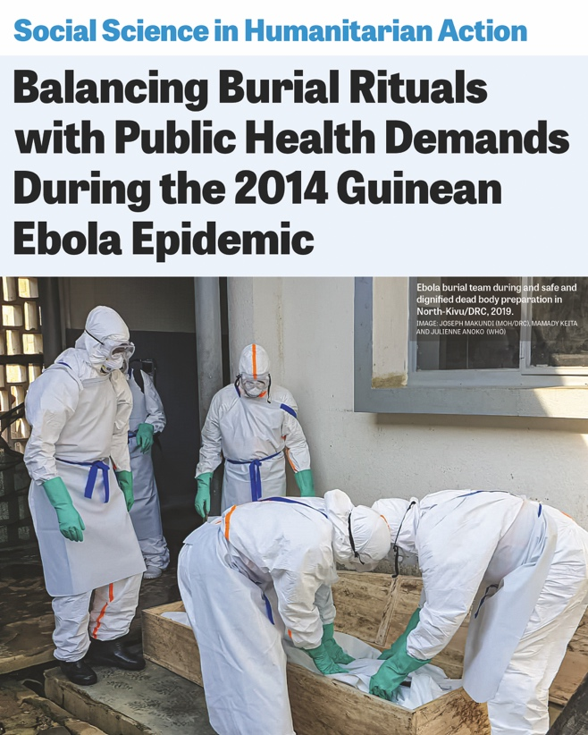

[**BURIAL RITUALS AND AN EBOLA EPIDEMIC**](https://www.socialscienceinaction.org/resources/balancing-burial-rituals-with-public-health-demands-during-the-2014-guinean-ebola-epidemic/)

In the West Africa 2014–2016 Ebola response, questions were raised over burial practices, local understandings of death and dying and how customary practices increased the risk of transmission.

This case study explains how an anthropologist negotiated a medically safe burial for a pregnant woman who had died of Ebola virus disease (EVD) in a Kissi community at the beginning of the 2014 Ebola epidemic in Guinea. The epidemiological protocol to organize a safe burial for a deceased pregnant woman with suspected EVD clashed with the local community’s need for a ritual burial following a post-mortem caesarean. A tense stand-off occurred. According to Kissi culture, when a pregnant woman dies the fetus should be removed before burial, to avoid a curse on the community.

The anthropologist engaged in a culturally sensitive rapid ethnographic investigation and carried out community-based participatory dialogue with family members, local authorities, and customary authorities and religious leaders.

As a result, an improvised ritual was devised, addressing the emotional and cultural needs of the mourning family and community, and meeting public health requirements. This case study shows the flexibility in funeral traditions in the face of a public health crisis and provides important insights for public health authorities in how to negotiate safe burials with affected communities that address local obligations   
and respect.

**CASE EXAMPLE 2:**

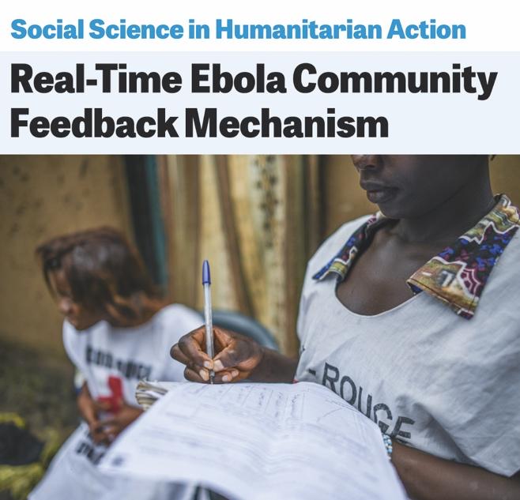

**REAL-TIME EBOLA COMMUNITY FEEDBACK MECHANISM**

During an Ebola outbreak in North Kivu, Democratic Republic of Congo (DRC) in 2020, the International Federation of Red Cross and Red Crescent Societies (IFRC), in close partnership with the US Centers for Disease Control and Prevention (CDC), supported the Red Cross of DRC to set up a rapid community feedback mechanism. A network of Red Cross volunteers living in the outbreak area collect rapid and regular perception data about Ebola and wider health issues of affected communities. Data informed responders about community concerns, perceptions, beliefs, priorities, and needs, and was used to tailor response mechanisms to make them more appropriate   
and effective.

Feedback such as suggestions, beliefs and concerns help local structures and responders to adjust interventions over time based on the perceptions of affected communities. For example, Red Cross Safe and Dignified Burial (SDB) team members use feedback data to inform changes in their approach. Adapted burial practices (e.g. use of transparent body bags so families can see their loved ones) led to a significant decrease   
in negative feedback on safe burials, and increased   
the number of alerts communities raised when someone died.

Ask participants: What may have been the consequences had social science research not been integrated into these response actions? Take two or three examples

A Unified Approach: The Behavioural Drivers Model (30 minutes total)

Ask participants: Have you heard of/have experience with either the SEM or BDM models?

Review the BDM model, paying particular attention to Level 1 and 2 drivers of behaviour

From a social science viewpoint, individual practices and behaviours do not stand alone. They are influenced by (and influence) the broader social and cultural setting, including individual and interpersonal influences among family, friendship groups and other social networks, community-based relations between organizations, institutions and social norms, and the policy and political environment. This is the foundation of the Social-Ecological Model (SEM) which has been used extensively in behaviour change programming by response organizations such as UNICEF.

SEM importantly considers not only individual behaviours, but the entire ecosystem in which those behaviours may occur due to the social or structural environment in which an individual lives. One example of application of SEM is mask use during the COVID-19 pandemic. This is influenced by perceived susceptibility, age and personal attitudes (of an individual), whether others in an individual’s social network wear a mask (family, community), public transportation and workplace requirements that request mask wearing (institutional) and public health recommendations and government mandates that enforce mask wearing (policy and politics).

However, a frequent gap in individual or social-ecological based models is lack of “an explanation of the specific mechanisms driving a behaviour” thereby “making the link between theory and selection of appropriate interventions” a more difficult undertaking. The [Behavioural Drivers Model](https://www.unicef.org/mena/reports/behavioural-drivers-model) (BDM) seeks to unify such models by incorporating their insights to answer not only the question of “Why do people do what they do?” but also “How can we influence it?”

The BDM was therefore developed to contribute to change the way people and organization understand social and behaviour change programming, invest resources, and use evidence.

The BDM has two **levels of depth**:

* Level 1 drivers: the higher-level or main drivers, referred to as ‘factors’
* Level 2 drivers: unpacking each ‘factor’ into its relevant ‘dimensions’ (e.g. cognitive biases, interest, attitude, self-efficacy, limited rationality, social influence, community dynamic, meta-norms, etc.)
* **Figure 1:** Three categories to classify behavioural drivers (Level 1 drivers)

PSYCHOLOGY

SOCIOLOGY

ENVIRONMENT

**What drives a behaviour?**

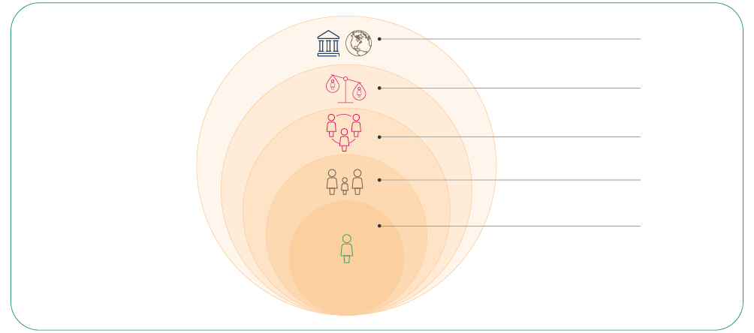**Figure 2:** The Behavioural Drivers Model ‘factors’ (Level 1 drivers) spread across the layers of the Socio-Ecological Model

POLICY AND SYSTEMS

INSTITUTIONAL AND SOCIETAL

COMMUNITY

FAMILY

INDIVIDUAL

**Figure 3:** Illustration of ‘dimensions’ as related to personal characteristics (Level 2 drivers)

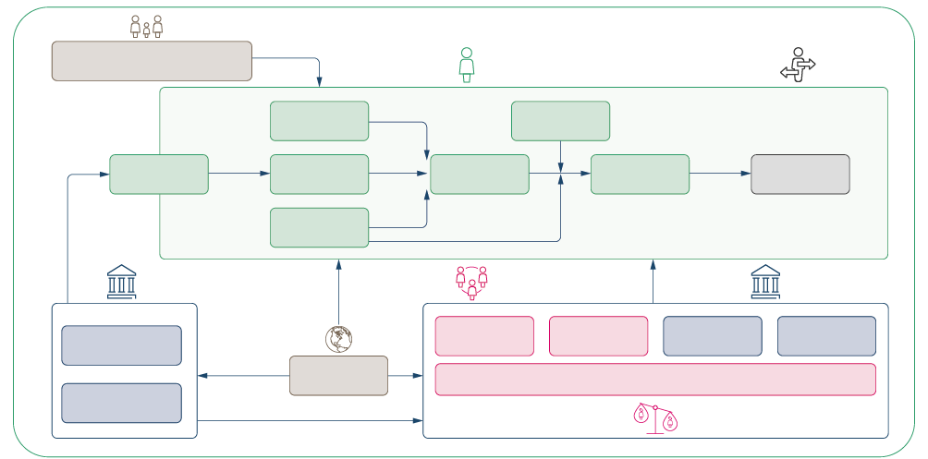

ACTION

INTENT

ATTITUDE

INTEREST

SELF-EFFICACY

COGNITIVE BASES

LIMITED RATIONALITY

BEHAVIOUR

CONTEXT

PERSONAL CHARACTERISTICS

COMMUNICATION ENVIRONMENT

EMERGING

ALTERNATIVES

GOVERNING ENTITIES

STRUCTURAL BARRIERS

SOCIAL INFLUENCE

COMMUNITY DYNAMIC

META-NORMS

Ask participants to review the BDM conceptual framework in-depth after the session/offline

We will revisit the BDM in later sessions.

|  |  |
| --- | --- |
|  | Written individual exercise (10 minutes):  Consider an issue in your own context right now; e.g. ANC non-attendance by pregnant women (it can be anything). Use this example to reflect on at least one of the Level 1 ‘factors’ and its related Level 2 ‘dimensions’ in the Behavioural Drivers Model. Take 10 minutes to write your answer.  Online: Invite the participants to write the answers in the chat function and share it with everyone  Offline: Ask two or three participants to give answers |

Why is social science research important when engaging communities, and how does   
it contribute to the design and delivery of community-led responses? (10 minutes)

Social science helps us place individuals and communities at the heart of a response and informs the design and delivery of appropriate strategies and approaches that support community-led responses. In line with core features important to community engagement and related communications fields, social science can support the following:

Social science evidence provides important information on the specific setting in question by drawing on existing data and/or by collecting and analysing new quantitative and qualitative data. Using this, social science can help to plan and adapt strategies and understand what actions would be acceptable by the local population and in line with their lives, abilities and social and cultural beliefs/practices.

Social science helps us to understand why people behave the way they do so programme activities and emergency responses can take this into account.

Social science research can pick apart ‘rumours’ to understand where they emerge from, how/why they circulate and why they persist.

* How do people prefer to get information and what are their information needs?
* Which languages do people speak and prefer to use with each other and response actors?
* What are people’s needs and priorities and how are they changing?
* Are systems (health, social) functioning, available and accessible?
* What is the degree of trust in services, policies (e.g. public health measures) and information.

Social science techniques provide a way to collect usable information on people’s needs and priorities, on how systems function, and on trust and willingness to engage in those systems and services to inform the design and adaptation of strategies.

Social science methods which use participatory approaches to define key issues, and strategies to address those issues, can assess and also build trust by meaningfully engaging with affected communities.

Social science approaches can build on solutions led by communities – and help provide locally appropriate support – by asking: What are communities already doing? What are the existing resources? How might they contribute to any external action and how do people want to be involved?

Social science research can identify people’s communication preferences, which ‘channels’ they usually communicate through, who uses which channels and which sources of information are trusted so that the response communicates in ways which are locally appropriate and trusted and the information is accurate and understandable.

* What capacity do individuals and communities have to respond to the crisis?

Social science helps to understand the vulnerabilities among affected populations and who is included or excluded in decision-making processes that affect their lives. It helps to understand who needs to be engaged so that strategies and approaches are inclusive and accountable and support community-led responses.

* What are people’s belief systems, sociocultural norms, and traditions?
* What knowledge and resources do individuals and communities have?
* What are people’s perceptions, attitudes, practices and behaviours?
* What ‘rumours’ or misinformation are circulating?
* What are the existing vulnerabilities and social inequalities?
* What are the existing social networks, informal and formal community leadership structures and social and power dynamics?

**Core questions for RCCE Role of Social Science**

Many of these issues are fluid and change continuously, and social science research should be seen as making an ongoing contribution to programming to allow for continuous adjustment of humanitarian responses.

|  |  |
| --- | --- |
|  | Question to participants (5 minutes):  Give an example of where you/your team/your organization/a partner has used social science as part of an emergency response.  Online: Invite the participants to write the answers in the chat function and share it with everyone  Offline: Ask two or three participants to share their answers. |

Examples of areas where social science contribution is important:

* Local explanations/interpretations of illness   
  and disease
* Health-seeking practices/multiple pathways of diagnostics and care
* Local funeral, burial and mourning practices
* Social networks, obligations and power dynamics (access to and control of resources)
* Political situation and local governance structures, local forms of public authority
* Conflicts and insecurity, negotiation and resolution practices
* Trusted channels of influence and communication preferences (languages   
  and formats)
* Ethnicity, clans and relations between   
  local communities
* Religious affiliations
* Livelihoods and economic situation
* Mobility patterns (in and out of affected areas, trade routes)
* Living environments, sanitation structures   
  and practices
* Food sourcing, preparation and allocation
* Gender (caring duties, vulnerabilities)

Throughout this training you will see examples of how social science has contributed to these different areas.

What do we mean by operational social science research? (25 minutes total)

|  |  |
| --- | --- |
|  | Question to participants (5 minutes):  What is operational research (OR)?  Online: Invite the participants to write the answers in the chat function and share it with everyone  Offline: Ask two or three participants to share their answers |

Operational’ social science is important as it generates data and findings that can be translated into action to improve humanitarian operations and strategies.

Social science research provides us with useful and usable information – to have an impact, it should be operationalized and presented effectively using the right languages and formats. It should be an ongoing process that allows for the continuous adjustment of programming.

**Research should be communicated:** Where the results/findings of a piece of research is effectively disseminated to key stakeholders and actors in the response – including communities – who are likely to use this information to improve the humanitarian response (the way it is designed and delivered).

**Research should be operationalized:** Where data is collected and transformed into information that can be used to improve the coverage, quality and effectiveness of the humanitarian response.

How can we ensure that social science research is operational?



**Useful**

**Used**

**Usable**

Research which addresses critical knowledge gaps (collects missing information) needed by a programme/response to solve a particular issue, improve acceptance of service, increase uptake of practices/behaviours, etc.

Research which generates useful information that can be easily translated into action and effectively communicated to influence/inform practice and policy.

We will build on this concept in session 1.2 and in 5.2 on transforming social science data to actionable findings.

|  |  |
| --- | --- |
|  | Written individual exercise (scenario )[1] (10 minutes):  You are a researcher supporting the organization ACTRelief which aims to assist conflict-affected population groups in the Northeast of Bagara.[2] The population faces several challenges including food insecurity, lack of water and sanitation infrastructure, high prevalence of diarrhoea and malaria, high rates of poverty and limited livelihood opportunities.  You were deployed to urgently conduct an analysis of the context and develop activities  for ACTRelief for them to communicate effectively with the affected population and engage communities and relevant stakeholders with the aim to reduce waterborne disease.  How could the use of social science research help you develop and implement community-led strategies? What sorts of issues could it help you answer? How could you connect this work to other NGOs and government actors with an interest in findings?  Take 5 minutes to write your answer.  Online/Offline: Ask two or three participants to share their answers |

Wrap-up/summary (5 minutes)

* The use of social science is of critical importance to humanitarian action, in order:
* To understand people’s perceptions, values, priorities, beliefs and life experiences, and how these interact with the response to humanitarian needs.
* To consider how systems responding to a crisis are organized (e.g. the health system) and which mechanisms (e.g. social protection) and structures (e.g. churches) already exist.
* To understand how social, cultural, psychological, historical, political, economic factors influence people’s behaviour and/or the functioning of systems responding to the emergency.
* To identify potential gaps or tensions between how the response is being designed and delivered and communities see and interpret it.
* To understand local priorities for action, even where they contradict with the priorities of emergency responses.
* To identify local capacities, resources and current actions.
* And to use this information to adapt the design and delivery of services during an emergency.
* The [Behavioural Drivers Model](https://www.unicef.org/mena/reports/behavioural-drivers-model) (BDM) is helpful for unpacking “Why do people do what they do?” and also “How can we influence it?” through RCCE activities.
* Social science is particularly important when activities involve engaging with affected communities, and social science approaches can support the design and delivery of community-led responses.
* Social science research should be ‘operational’ in that it produces findings and recommendations that are both usable and used.

ACKNOWLEDGEMENTS:

Gefra Fulane and Theresa Jones (Anthrologica) led the overall development of this session. Rania Elessawi, Anu Puri and Maria Fernanda Falero Cusano (UNICEF, Social Science   
for Community Engagement) contributed to the BDM section. Ombretta Baggio (IFRC) contributed examples of relevance to community feedback mechanisms during and   
Ebola outbreak in DRC. Kathryn Bertram (JHU), Alice Castillejo (Translators Without Borders),   
Eva Niederberger (Anthrologica) and Ginger Johnson (Collective Service) led the review process.

1. This is a written exercise to be assessed by the facilitator and discussed in the session of offline as needed.
2. Fictional place and organization – to be adapted