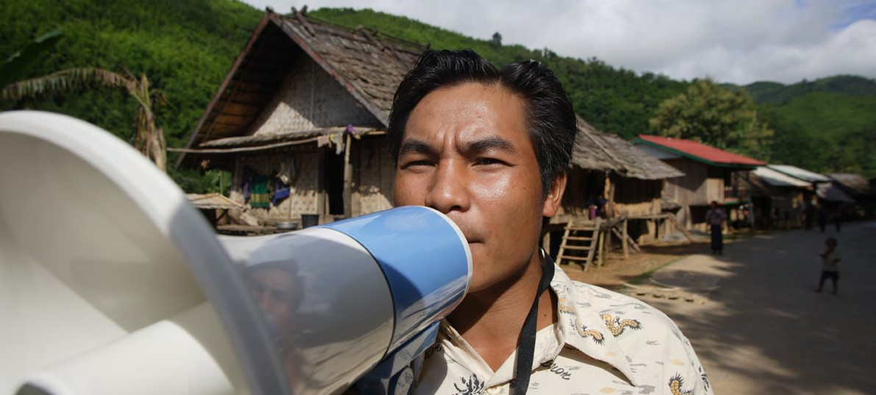

**TRAINING PACKAGE FOR USING SOCIAL SCIENCE IN COMMUNITY ENGAGEMENT AND/OR COMMUNICATIONS ACTIVITIES**

**SESSION 1.2:** Operational social science research   
in the humanitarian/emergency response cycle

SESSION CONTENT

**Learning approach:** Real-time presentation, individual and group exercises, case examples

**Delivery mode:** Online and offline, 80 minutes approx.

**Essential sessions to have completed before this session:** 1.1

**Summary:** This session defines operational social science and how it can be used in settings where research   
is time-sensitive. It also explains where it fits within the humanitarian/emergency response cycle.

**Learning outcomes:**

* Become familiar with the definition of operational social science and why it is important   
  when evidence is needed urgently
* Understand where the generation of quality operational social science research fits  
   in the humanitarian/emergency response cycle

FACILITATING THE SESSION



**TRAINING PACKAGE FOR USING SOCIAL SCIENCE IN COMMUNITY ENGAGEMENT AND/OR COMMUNICATIONS ACTIVITIES**

Introduction: (5 minutes total)

Talk through session summary and learning outcomes.

**Working in a time-sensitive context (10 minutes total)**

In session 1.1 we spoke about the role and value of social science research in a humanitarian emergency.

To recap, in line with core features of RCCE, social science can support the following:

**Core questions for RCCE Role of Social Science**

Social science evidence provides important information on the specific setting in question by drawing on existing data and/or by collecting and analysing new quantitative and qualitative data. Using this, social science can help to plan and adapt strategies and understand what actions would be acceptable by the local population and in line with their lives, abilities and social and cultural beliefs/practices.

Social science helps us to understand why people behave the way they do so programme activities and emergency responses can take this into account.

Social science research can pick apart ‘rumours’ to understand where they emerge from, how/why they circulate and why they persist.

* How do people prefer to get information and what are their information needs?
* Which languages do people speak and prefer to use with each other and response actors?
* What are people’s needs and priorities and how are they changing?
* Are systems (health, social) functioning, available and accessible?
* What is the degree of trust in services, policies (e.g. public health measures) and information.

Social science techniques provide a way to collect usable information on people’s needs and priorities, on how systems function, and on trust and willingness to engage in those systems and services to inform the design and adaptation of strategies.

Social science methods which use participatory approaches to define key issues, and strategies to address those issues, can assess and also build trust by meaningfully engaging with affected communities.

Social science approaches can build on solutions led by communities – and help provide locally appropriate support – by asking: What are communities already doing? What are the existing resources? How might they contribute to any external action and how do people want to be involved?

Social science research can identify people’s communication preferences, which ‘channels’ they usually communicate through, who uses which channels and which sources of information are trusted so that the response communicates in ways which are locally appropriate and trusted and the information is accurate and understandable.

* What capacity do individuals and communities have to respond to the crisis?

Social science helps to understand the vulnerabilities among affected populations and who is included or excluded in decision-making processes that affect their lives. It helps to understand who needs to be engaged so that strategies and approaches are inclusive and accountable and support community-led responses.

* What are people’s belief systems, sociocultural norms, and traditions?
* What knowledge and resources do individuals and communities have?
* What are people’s perceptions, attitudes, practices and behaviours?
* What ‘rumours’ or misinformation are circulating?
* What are the existing vulnerabilities and social inequalities?
* What are the existing social networks, informal and formal community leadership structures and social and power dynamics?

We define ‘operational’ social science research as the **generation of data and evidence relating to people’s socioeconomic experiences and behaviours that can then be used to inform actions which improve people’s lives. During humanitarian emergencies, operationalizing social science will therefore be the generation of evidence that feeds into humanitarian strategies and operations.** Table 1 below shows the difference between theoretical research and operational, or ‘applied’ research.

**Table 1.** The difference between theoretical and operational (applied) research

|  |  |
| --- | --- |
| Theoretical research | Operational (applied) research |
| * Gathers knowledge about a phenomenon * Ideas and knowledge oriented | * Tackles a ‘real world’ question and attempts  to solve a problem * Practical and solution orientated |

Humanitarian crises require rapid responses to support people who find themselves often in the most vulnerable moment of their lives. Response teams usually need information urgently, and the situation itself is often evolving and presenting new challenges. Although we do find both theoretical and applied research in crisis settings, in this training package we focus particularly on operational (applied) social science research.

Operational (applied) social science focuses on social science data and evidence that is:

* Relevant for operations and activities
* Timely
* Generated rapidly
* Easy and quick to digest and understand
* Shared with and acted on by key stakeholders as relevant

Why is social science important for public health and humanitarian emergencies?   
(25 minutes)

Social science provides a number of structured research approaches to understand and explore important issues which affect the effective design and delivery of public health services and humanitarian assistance.

**All** of the above social science activities must importantly consider ethical principles throughout the data cycle   
(see below and Module 3 for more on ethical principles).



**BENEFICENCE**(INTEND GOOD)

**RESPECT FOR AUTONOMY**



**NON-MALEFICENCE**(DO NO HARM)

**JUSTICE**(TREAT PEOPLE EQUITABLY)



**FOLLOW THROUGH**(ENSURE IMPACT)



**COLLABORATIVE**(CO-DESIGNED, OWNED)



**To understand** people’s perceptions, values, priorities, beliefs and life experiences, and how these interact with the response to humanitarian needs.

**Example:** Rejection of cremation practices during the 2014–2016 West Africa Ebola outbreak led to an increase in ‘underground’ funeral practice which fuelled the spread of disease.

**To understand** how social, cultural, psychological, historical, political and economic factors influence people’s behaviour and/or the functioning of systems responding to the emergency. In particular, to understand people’s perceived risk and level of confidence to handle that risk, either through personal or external action.

**Example:** The decision to have a vaccination can be related to this act symbolizing your broader political affiliation (political), and whether others are doing the same (social).

**To understand** local priorities for action, even where they contradict with the priorities of emergency response operations.

Finally, the field of operational social science has emphasized that conducting research rapidly does not mean sacrificing quality. The different modules of this training package demonstrate rapid, but also high-quality approaches to generating social science research in time-sensitive settings.

For more discussion on speed versus quality in social science research (specifically qualitative approaches), see the work of the [Rapid Research Evaluation and Appraisal Lab (RREAL)](https://www.rapidresearchandevaluation.com/).

Humanitarian/Emergency Response Cycle (55 minutes total)

|  |  |
| --- | --- |
|  | Question to participants (5 minutes):  Can you describe the different phases of a humanitarian/emergency response cycle?  Online: Invite the participants to individually draw the cycle and after a few minutes invite a few participants to share their responses.  Offline: Ask the participants to draw in pairs the cycle of a humanitarian/emergency response and after a few minutes invite a few participants to share their responses |

**WHO Guidance**

As stated within [WHO’s Guidance on Preparing for National Response to Health Emergencies and Disasters](https://www.who.int/publications/i/item/9789240037182), “emergencies often set back the gains countries had made previously and divert scarce resources from health and socioeconomic development.” The COVID-19 pandemic and its devastating impact on health systems around the world is a key example, as is the reality that countries regularly experience multiple crisis at the same time – natural, biological, technological and societal. WHO’s Guidance is therefore geared towards helping countries to develop comprehensive National Health Emergency Response Operations Plans that engage health sectors (and beyond) for a “whole-of-society approach” which is centred upon building upon existing national capacity development plans. Importantly, WHO’s Guidance captures key lessons learned from global COVID-19 response efforts.

This is of particular relevance to social science research given the importance of the core questions for communication and community engagement activities (presented above and in session 1.1). As noted by WHO’s Guidance, health emergencies and disasters do not occur in isolation. As noted by the social sciences, such events are connected to the social, cultural, psychological, historical, political, and economic factors which influence human behaviour.

A contextual country analysis, rooted in social science principles and methodology, seeks to understand social drivers and barriers; local perceptions, beliefs, attitudes and practices; trusted sources and channels of information; practical realities regarding access to health systems; and conflict and political histories which shape how both emergency responders and affected populations respond during a crisis. Insights include also community feedback data encompassing any type of information shared by communities such as questions, suggestions, observations, beliefs, perceptions, concerns, complaints and statements of appreciation to responders.

Social science and community feedback insights gained from analysis of a specific crisis (e.g. COVID-19) may be useful across multiple national crisis. For example, in contextualizing the lessons learned for COVID-19 based on DRC’s past experiences with Ebola, the Cellule d’analyse en Sciences Sociales (CASS, or “Social Sciences Analysis Cell”) produced their ‘[Humanitarian programme recommendations for COVID-19 based on social sciences evidence from the DRC Ebola outbreak response](https://www.unicef.org/drcongo/media/4131/file/CASS-Brief3-recommendations.pdf)’ report to help emergency responders use the insights from prior social science studies conducted in DRC, for the development of COVID-19 interventions and strategies.

**OCHA Mandate**

The [United Nations Office for the Coordination of Humanitarian Affairs (OCHA)](https://www.youtube.com/watch?v=6n_veh46IiM) has a mandate to contribute to principled and effective humanitarian response through coordination, advocacy, policy, information management and humanitarian financing tools and services. OCHA’s Service page on the [Humanitarian Programme Cycle](https://www.humanitarianresponse.info/en/programme-cycle/space) provides a collection of resources and examples aligned to the following five elements of a humanitarian response:

* **Needs assessment and analysis** – this can be before the crisis occurs or at the onset of the crisis. It is more common for it to take place at the onset of a crisis.
* **Strategic planning** – for crisis response activities. This can include the design of community engagement strategies and communication approaches (drawing on the analysis done in the previous stage).
* **Resource mobilisation** – mobilization of resources is an integral part of any response and involves, for example, the recruitment of community engagement experts, anthropologists, public health promotion field staff, funding for the response activities, procurement, and supply of material, etc.
* **Implementation and monitoring** – refers to the delivery of communication and community engagement strategies, including organizing training for private health-care providers on early case notification and referral, rehabilitation of water points and related hygiene promotion activities to promote the safe water chain, implementation of community-based protection monitoring, etc. This is underpinned by the regular monitoring of these response activities to determine whether the programme delivery is on track and in line with the objectives of the response.
* **Operational peer review and evaluation** – usually done to assess the outcome and impact of the work. This can include community-based learning workshops, feedback from response stakeholders including the coordination, the analysis and review of project documents etc.

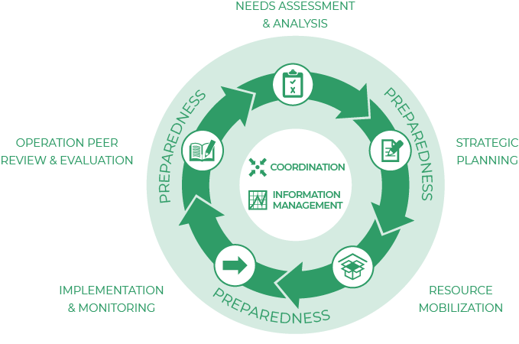

|  |  |
| --- | --- |
|  | Question to participants (10 minutes):  When do you think operational social science could and should be implemented within a humanitarian/emergency response? Think about the sorts of information covered above on the ‘role of social science’ (facilitator can go back to this slide). Which information would you collect at which stage to inform the design and delivery of RCCE strategies?  Online: Invite the participants to write the answers in the chat function and summarize  Offline: Ask two or three participants to share their thoughts |

The follow provides a brief overview of how social science activities and research may be applied to   
a humanitarian/emergency response:

1. Needs assessment and analysis:

At this preparedness/early onset phase of a crisis, operational social science research can improve the understanding of humanitarian responders in relation to:

* Existing vulnerabilities and how these have changed
* Historical leadership structures and social structures
* Social influencers, formal and informal stakeholders
* Community organization and structures, existing outreach networks, past and current community initiatives
* Gender roles
* Knowledge of specific issues (e.g., understanding of disease transmission)
* Sociocultural norms, values, traditions
* Perceptions, practices and behaviours (e.g., health-seeking behaviour, perception on public health system, hand-washing practice)
* The range of languages and preferred languages
* Information preferences, needs and access
* Access to public services
* Features and arrangements of government structures (e.g., health services including public health/ water supply/education)
* Population (e.g., numbers and profile), average household size
* Priority needs of affected population
* What does a successful response look like for the crisis-affected communities?

(More detail on context analyses and assessing vulnerability can be found in Module 2).

This information can be gathered/collected during the preparedness phase to be rapidly updated when a crisis occurs (e.g. the example presented above from CASS drew upon an existing repository of 57 field studies conducted as part of Ebola outbreak response efforts).

|  |  |
| --- | --- |
|  | “NGOs come here, gather information, and don’t come back. People are frustrated.  Other organizations follow in their steps, and people are no longer willing to engage  in conversations.” *Village woman Sri Lanka*  Question to participants (5 minutes):  What would you do to avoid such a situation? |

It is important to keep in mind that relevant data may already exist and that a secondary data analysis could help prevent survey fatigue and save time and resources.

The collection of assessment data can be the first contact between responders and the crisis-affected communities. As such, the approach and behaviour of the response team sets a foundation for future relationships with the local population. Community involvement in the analysis of the assessment findings and feedback on how the findings were used can create greater buy-in and trust in for future response actions and related services. See session 4.1 on localized research for more discussion on this.

The results from the analysis should be able to inform operational and strategic planning process. This is a critical stage to conduct operational social science research to ensure that all resources and capacity are available for the sort of response activities that are envisioned. Module 6 discusses in more detail how we can make sure that social science evidence translates into action.

This stage could involve the deployment of social scientists such as anthropologists or sociologists, with experts from other relevant disciplines (e.g., epidemiologists, virologists) to support the initial learning process and/or to conduct rapid formative research to deepen the understanding of response actors of a specific topic. Formative public health *research ‘is the process by which researchers or public health practitioners define a community of interest, determine how to access that community, and describe the attributes of the community that are relevant to a specific public health issue.’* **[1]**

1. Strategic planning:

During this phase, initial assessment data triangulated with existing information (see above secondary data analysis) is used to inform the design and delivery of RCCE strategies and other related wider response activities.

For example, the assessment findings will help to decide how to set up and maintain two-way communication to ensure that affected communities have access to the information they need to make informed choices. It will also help to understand how to involve trusted information sources in the local response.

Assessment data is critical to understand how best to (continuously) support community-led action and response. It will be important, for example, to identify what *level of engagement* (e.g., consultation, information, demonstrating acceptance, planning and acting together, negotiation, taking decisions)**[2]** might be practical or appropriate at the different stages of the response – and in view of the local context. Assessment findings will also inform the appropriate *methods* to meaningfully involve a diverse community in decisions that affect them. This will further help the design of locally appropriate community feedback mechanisms and ways to coordinate externally in relation to community engagement.

Developing a robust monitoring and evaluation (M&E) framework is an integral part of the planning stage. This framework should allow programmatic changes to be measured based on feedback from monitoring data. M&E indicators are typically used to measure changes throughout an emergency response cycle as relevant to various activities, outputs, or outcomes. For example, as part of the COVID-19 response effort, the Collective Service developed a set of indicators that measures the social and behavioural aspects of RCCE for COVID-19.

Analysis of assessment results should also highlight knowledge gaps and areas for continuous formative research/in-depth research.

1. Resource mobilisation:

Poorly and ineffectively coordinated RCCE platforms can lead to inefficient use of resources and duplication of research activities. The phase will need to determine staffing, material, technical support and budgetary needs to support social science research activities, and should be coordinated across emergency response actors. As evidenced by the example presented earlier, resource mobilization coordinated through existing coordination platforms can help prevent community survey fatigue, in addition to saving time and resources.

1. Implementation and monitoring:

This phase provides the opportunity to start in-depth research/continue formative research and deepen connections with the local community. During this phase, the collection of almost real-time community feedback data is key to inform responders of the concerns, suggestions, questions and priorities of affected communities in order to prioritize community needs within implementation and monitoring plans. Community engagement approaches should be an iterative process which changes and evolves with the community’s changing perceptions and needs.

Important questions for guiding the data collection or evidence reviews which are relevant for the delivery of communication and community engagement strategies (and response efforts overall) could include:

1. Do people access accurate trustworthy information in their local language and through trusted information sources?

* Who are the trusted information sources   
  (by population / risk group)?
* Do they access the information sources they trust?
* Do the information sources represent the diversity of the communities?

1. Do people feel that they are meaningfully engaged in the response?

* Are high-risk groups including marginalized and vulnerable population groups meaningfully represented in decision-making processes and able to influence decisions that affect them?
* What can be barriers or enabling factors to promote, strengthen and ensure the involvement of the local population in response activities?
* Do people know how to provide feedback and do they believe their views are taken into consideration when decisions are made around the support they receive?

1. Which factors influence people’s behaviours and practices (preventive and responsive?):

* The information they receive
* Socioeconomic and structural factors
* Their experiences of the crisis, for example of a disease outbreak
* Cultural and social dynamics

1. What is the impact of the response on individuals and the community as a whole?

* On family dynamics, inter- and intra-community dynamics
* Protection
* Health
* Socioeconomic situation
* Sociocultural norms and local beliefs

It is important to note that there are questions that typically emerge over the course of a response, as well as novel questions that may be unique to the situation.

**Taking action and closing the loop** - We need to ensure that social data, including community feedback, are shared and discussed with key response stakeholders (including affected communities) and acted upon.

It is essential to close the feedback loop and communicate back to communities what has been done in response to their feedback. This involves explaining and discussing how the information they shared was considered, what was feasible to do (or not), the rationale behind decisions made, and what this means for the future.

The response team should also seek (with the help of a social science expert where necessary) to **systematically integrate findings with other data sources** (triangulation). For example, programmatic (monitoring) data on emergency water supply in refugee camps alongside the construction of communal toilet facilities and hygiene promotion activities should be regularly triangulated with community feedback data, local health service data, data on protection issues related to WASH activities and broader aspects. Such data should also integrate gender dynamics in managing WASH-related aspects, for example including data on community behaviours and practices in relation to water management, the use of communal toilets, the practice of menstrual hygiene, data on health-care workers and service provision as well as other WASH service providers (availability, risks, changes), events and timeline, markets, prices, movements and the overall context. See session 4.8 for more discussion on triangulating data and session 5.1 on synthesizing evidence.

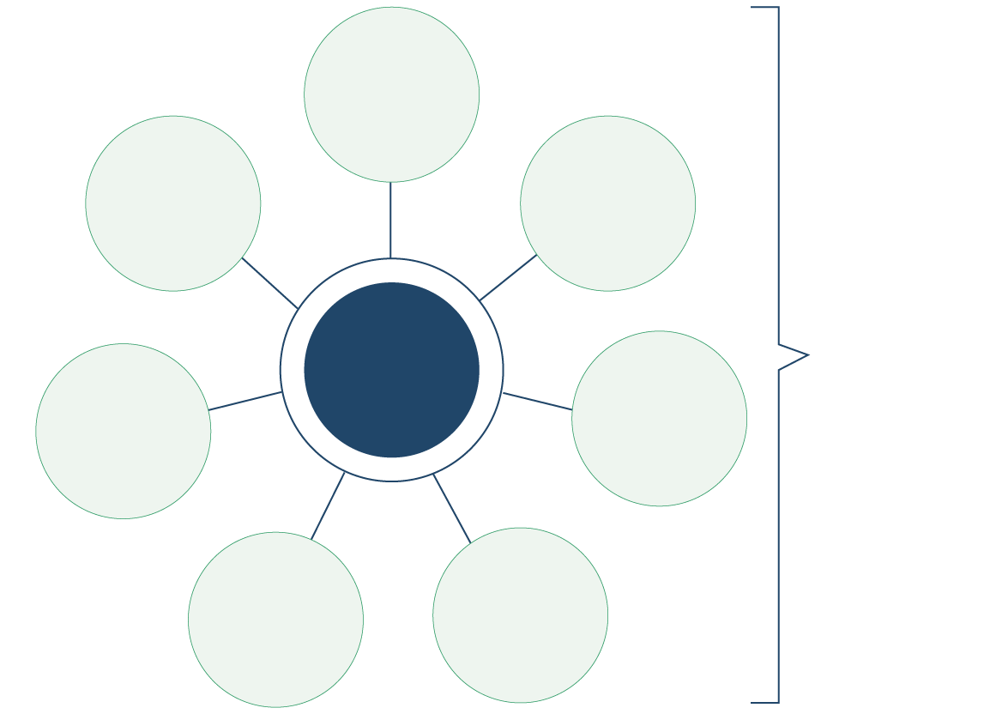

Transdisciplinary sciences wich are integrated and analysed together

Transdisciplinary sciences wich are integrated and analysed together

Health services data (DHIS2 or direct collection

Outbreak response data, VACC, surveillance, WASH-IPC

Context: conflict,gender, traditions,culture

Markets, prices, movements

Events, timelines (policies, political,restrictions) & response strategies

HWC and services provision (availability, risks, changes

Evidence which is used and usable

Track evidence use by location, analysis over time

Source: [Integrated Outbreak Analytics – approach can be applied to broader humanitarian action](https://drive.google.com/drive/folders/1AVZskCsCzkM7K4ZOTROGylLNqGaRhZqa)

|  |  |
| --- | --- |
|  | Question to participants (10 minutes total):  What do you think is the connection between social science research and monitoring RCCE activities?  Online: Invite the participants to write the answers in the chat function and summarize  Offline: Ask two or three participants to share their thoughts  As a key objective, both social science research and M&E in crisis settings should value putting people at the centre of the response, support healthy behaviour change, ensure that people’s priorities and perspectives are influencing operational and strategic decision-making, and meet programme/project objectives.    Applying **social science** in RCCE helps us to understand which would be the best strategy and approach for community-led responses. Socio-behavioural sciences are vital:   * To establish a robust contextual understanding (social norms, belief, existing vulnerabilities, social inequalities, etc.) * To help RCCE practitioners to continuously update their contextual knowledge given that the situation is evolving * To provide an understanding of socio-behavioural factors at any given time of the response, as well as improving the knowledge of RCCE practitioners and the wider response about the underlying drivers and barriers influencing communities’ ability to protect themselves against the disease risk     To get a deeper understanding of what drives people’s perceptions, practices and behaviours and to explain relevant social dynamics, social science in RCCE triangulates the information with other data sources – for example epidemiological data, access to treatment/vaccines, school dropout rates, socioeconomic data, etc.    **M&E** helps us to understand how to measure the effectiveness and impact of RCCE strategies and related approaches. It can further inform areas for operational social science research, for example to understand underlying socio-behavioural drivers. M&E could also evaluate the impact of specific social science research as such.    **Both M&E and social** science draw at times on similar data collection tools and sources (e.g. KAP surveys). However, social science methods tend to include additional methods and tools such as rapid ethnographic assessments, in-depth interviews, focus group discussions, and observation-based data collection activities. |

1. Operational peer review and evaluation:

The evaluation of response activities assesses the relevance and level of achievement of project objectives, its effectiveness, efficiency, impact and sustainability. Evaluation data can help us to understand the quality of the community engagement and communication approaches used and the impact they had, for example regarding communities’ response to vaccination programmes, antenatal and postnatal care, livelihood programmes, etc.

Key questions could include:

1. Did the community receive the support they needed? (e.g., Was the provision of cash transfers useful? Did the expansion of school feeding programmes help to prevent early marriage and pregnancy?)
2. Was the support provided in an effective and appropriate way?
3. Did the response activities contribute to individual and community-level behaviour change?
4. What should be done differently?
5. How can the programme exit be safely managed?

More information on different research methods for data collection and analysis can be found in Module 4, alongside guidance on which methods are better suited to which questions. For further learning, please visit OCHA’s Service page on the [Humanitarian Programme Cycle](https://www.humanitarianresponse.info/en/programme-cycle/space) which provides a collection of resources and examples dedicated to broader response activities.

Key questions in social science research (5 minutes total)

The following key questions in social science research form the foundation for how all subsequent sessions in this training package are presented. These questions should be considered as part of any response operation which seeks to incorporate social science knowledge and insights, and as most relevant and applicable to the humanitarian/emergency response cycle. See Guidance Note for additional details on how these questions frame this training package, and which modules help address each question.

1. How to ensure that this information goes back to communities? To inform community-level actions and decision-making of the broader response?
2. What methodology and tools should be used to collect and analyse this information?
3. How to track the information used to ensure that it effectively contributes to operational and strategic priorities?
4. Who can collect this information?
5. Does this information already exist? Is there a related needs assessment or study?
6. What information is needed?

**DATA TO ACTION:**

Key questions in social science research

1. Who needs this information?
2. How to ensure that the information is used to make operational and/or strategic decisions?

Wrap-up/summary (5 minutes)

* Crisis settings require research to be conducted in a rapid and timely fashion. Social science approaches have adapted to be able to do this, without sacrificing quality.
* There are critical elements in a humanitarian/emergency response cycle. As defined by OCHA these elements include: needs assessment and analysis, strategic planning, resource mobilisation, implementation and monitoring, and operational review and evaluation.
* All elements of a response operation provide an important opportunity to advocate for and/or implement operational social science research. The objective of all social science activities should be informing the design or adaptation of RCCE approaches that can contribute to the design of effective response actions and strategies, and meaningfully support communities.

ACKNOWLEDGEMENTS:

Eva Niederberger (Anthrologica) developed the session content. Content was informed by the UNICEF WCAR social science training conducted in 2021, by the work of the Integrated Outbreak Analytics (IOA) team, and with contributions from Rania Elessawi, Maria Fernanda Falero Cusano, and Anu Puri (UNICEF, Social Science for Community Engagement). It was reviewed by Theresa Jones and Olivia Tulloch (Anthrologica), Ombretta Baggion (IFRC), and Ginger Johnson (Collective Service).

1. See Centers for Disease Control <https://www.cdc.gov/hiv/pdf/statistics/systems/nhbs/nhbs-msm4-formativeresearchmanual.pdf>
2. See Oxfam Manual: *An Introduction to community Engagement in WASH* (2019) <https://www.oxfamwash.org/en/communities/community-engagement>