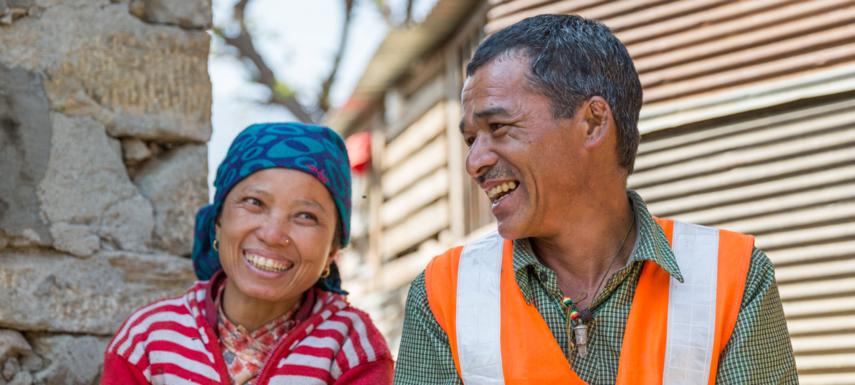

**TRAINING PACKAGE FOR USING SOCIAL SCIENCE IN COMMUNITY ENGAGEMENT AND/OR COMMUNICATIONS ACTIVITIES**

**SESSION 2.2:** Understanding behaviour in humanitarian/emergency response: Models and theories

SESSION CONTENT

**Learning approach:** Real-time presentation, individual and group exercises, case examples

**Delivery mode:** Online and offline, 105 minutes approx.

**Essential sessions to have completed before this session:** 2.1

**Summary:** This session discusses how to understand and identify the drivers and barriers to the uptake of behaviours critical to the response to humanitarian action.

**Learning outcomes:**

* Become familiar with decision-making and behavioural theories/models, e.g. Behavioural Drivers Model

FACILITATING THE SESSION

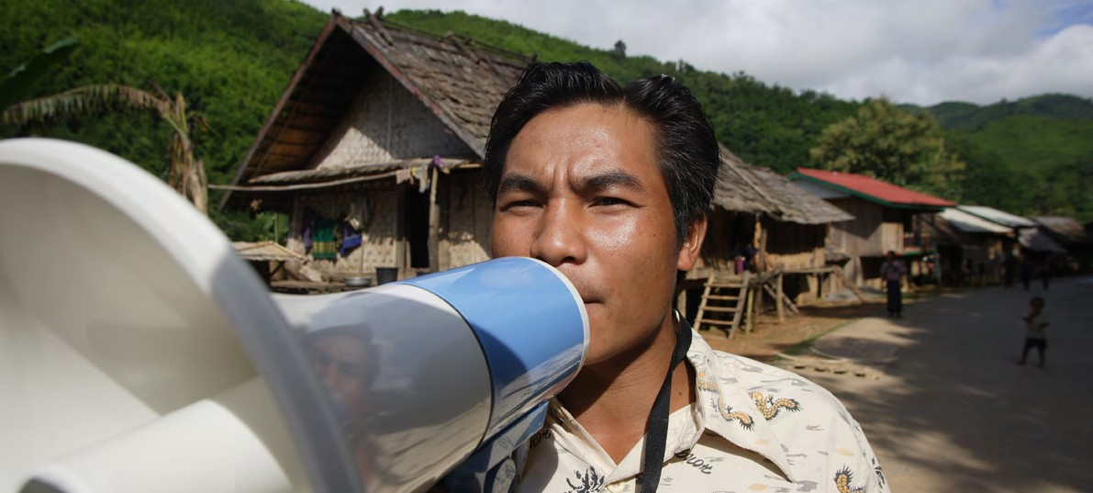

**TRAINING PACKAGE FOR USING SOCIAL SCIENCE IN COMMUNITY ENGAGEMENT AND/OR COMMUNICATIONS ACTIVITIES**

Introduction: (5 minutes total)

Talk through session summary and learning outcomes.

Position this session in the question flow below.

1. How to ensure that this information goes back to communities? To inform community-level actions and decision-making of the broader response?
2. What methodology and tools should be used to collect and analyse this information?
3. How to track the information used to ensure that it effectively contributes to operational and strategic priorities?
4. Who can collect this information?
5. Does this information already exist? Is there a related needs assessment or study?
6. What information is needed?

**DATA TO ACTION:**

Key questions in social science research

1. Who needs this information?
2. How to ensure that the information is used to make operational and/or strategic decisions?

What is the role of behaviour in a health emergency or humanitarian crisis? What frameworks do we have to understand individual behaviour? (30 minutes total)

|  |  |
| --- | --- |
|  | Question to participants (5 minutes):  Define in your own words what ‘behaviour’ is and how it plays a role in a health emergency or humanitarian crisis.  What sort of ‘behaviours’ might we be interested in changing in our work?  Online: Invite the participants to write the answers in the chat function and summarize  Offline: Ask two or three participants to share their thoughts on each question |

**Behaviour** related to health or well-being includes actions taken by individuals that may be intentional   
or unintentional and that can promote or lessen the health or well-being of the individual or others (Short   
& Mollborn, 2015). Examples of behaviours a public health emergency response might be interested in changing during an emergency might include wearing a face mask, washing hands, treating water with chlorine, seeking treatment at the local health facility level, etc. Understanding behaviour is therefore of critical importance during a humanitarian/emergency response.

There are a number of models or theories that social science uses to try understand behaviour.

|  |  |
| --- | --- |
|  | Question to participants (5 minutes):  Have you heard of or used any models or theories related to behaviour and decision-making? Describe. Potential responses might include: Communication for Social Change Model, Health Belief Model, Social Ecological Model, Behavioural economic theories, Social Network Theory and orbits of influence, Transtheoretical Model, and Behavioural Drivers Model. |

Models and theories offer frameworks to explore and better understand a variety of motives for behaviours – e.g. why do people do the things they do?

**Let’s revisit the Social Ecological Model briefly introduced in Session 1.1**

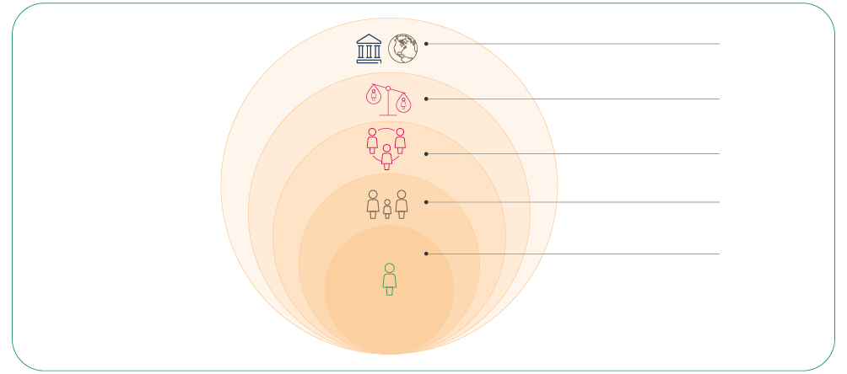

POLICY/ENABLING ENVIRONMENT

(national, state, local laws)

ORGANIZATIONAL

(organizations and social institutions)

COMMUNITY

(relationships between organizations)

INTERPERSONAL (families, friends, social networks)

INDIVIDUAL   
(knowledge, attitudes, behaviours)

The Social Ecological Model (SEM) is a theory-based framework for understanding the different levels of personal and environmental factors that determine behaviours, and for identifying behavioural and organizational entry points for action.

There are five nested, hierarchical levels of the SEM: Individual, interpersonal, community, organizational, and policy/enabling environment. The image provides a brief description of each of the SEM levels. The most effective approach to public health prevention and control uses a combination of interventions at all levels of the model.

|  |  |
| --- | --- |
|  | Case example (5 minutes):  [Effect of Knowledge and Perceptions of Risks on Ebola-Preventative Behaviours in Ghana](https://academic.oup.com/inthealth/article/10/3/202/4916041?login=false) (Handout 1).  This study looked at knowledge about Ebola and changes in risk perception in Ghana during the 2014–16 West Africa Ebola epidemic. The authors found that there were significant changes in risk perception over time. Communities that expressed worry about a potential Ebola outbreak were more likely to engage in Ebola-preventative behaviours.  What does this mean? As the Social Ecological Model (SEM) and Behavioural Drivers Model (BDM) emphasises, we need to understand more than individual behaviour – we need to understand context as well. |

How is individual behaviour influenced by the larger context? (30 minutes total)

In the previous session we defined context as ‘the different aspects of a setting that are important for it to be fully understood, for example geography and infrastructure, language, livelihoods, religion and dominant ideas etc.’

Over the past 20 years, there has been growing awareness of how individual behaviour is influenced by the larger context. There is more recognition of how individual characteristics (wealth, education, income) relate to the wider social and physical context (family, school, workplace, community) in which that individual was born, learned, and grew up. This includes other broader structural factors that can act as barriers or enablers to behaviour change, for example national laws or government policies.

|  |  |
| --- | --- |
|  | Written individual exercise (scenario)[1] (10 minutes)  There is a disease outbreak set in broader humanitarian crisis marked by conflict and displacement in Absa, District 1**[2]** in sub-Saharan Africa. You are part of the response team and have been deployed to urgently put in place a communication and community engagement plan to motivate individual and collective behaviour change, particularly to engage affected populations in effective health and hygiene behaviours such as hand washing, using communal toilet facilities in Internally Displaced Population (IDP) camps and treating water with chlorine tablets. What aspects of the context might affect preventative behaviour? What do you need to better understand to design your communication and community engagement plan?  Feedback in plenary – take one or two answers  Notes for facilitator: it is important to understand factors including:  • Who is displaced (age, gender, ethnical background)  • Who is most at risk from the disease outbreak and why  • What is the relationship of the internally displaced population and host population  • What assistance does the government provide to both population groups, etc. |

|  |  |
| --- | --- |
|  | Brainstorm (5 minutes):  If we think of the individual level as including knowledge, beliefs, attitudes, self-efficacy, interests and actions, how does the wider context influence these processes? |

We’ve learned about aspects of context. This might influence behaviour in the following ways:

* Community or society’s attitudes and norms that can have social pressure or influence
* A person’s ‘network’, including family and peers (friends, co-workers, students, etc.), who can have influence over a person
* Influence by power holders/gatekeepers – e.g., how in some places people might use violence to control a person’s behaviour
* Social identity and how complying with norms can be driven by an individual’s desire to belong to a certain group
* Stigma and discrimination – negative views/beliefs regarding certain groups of people might alter an individual’s behaviour or practices
* Broader context – gender roles and norms, and power dynamics (power is the ability to control and access resources, opportunities, and decision-making processes)

An individual’s behaviour is situated in a wider context, which is important to understand for public health emergencies and humanitarian crises.

However, the linkages between context and behaviour are *complex, relational* (depend on relationships with other people/networks) *and may shift over time*.

|  |  |
| --- | --- |
|  | Question to participants (5 minutes):  Can you share from your own work supporting communities in responding to a humanitarian/ emergency crisis where contextual factors have influenced behaviour?  Online: Invite the participants to write the answers in the chat function and summarize  Offline: Ask two or three participants to share their thoughts on each question |

**Let’s revisit the Behavioural Drivers Model (introduced in Session 1.1 as a ‘unified’ approach)**

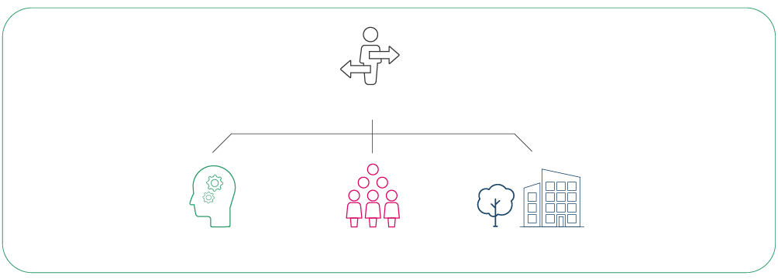

PSYCHOLOGY

SOCIOLOGY

ENVIRONMENT

**What drives a behaviour?**

The Behavioural Drivers Model for Social and Behaviour Change (30 minutes total)

As discussed in Session 1.1, the Behavioural Drivers Model (BDM) seeks to integrate key aspects of multiple behaviour change models which you may be familiar with. The BDM was developed by UNICEF as a conceptual framework that draws on other frameworks and provides guidance on how to operationalize social and behaviour theory to practice while also assessing and influencing a wide range of drivers. Read more in the [full report](https://www.unicef.org/mena/reports/behavioural-drivers-model) (Petit et al., 2019).

What do we mean by behavioural drivers? These are simply the factors that influence a person’s or a group’s behaviour. BDM describes main **behavioural factors** that include: cognitive biases, interest, attitudes, self-efficacy and intent. The next level of influence includes **sociological factors**: social influence, community dynamic, and meta-norms. Lastly, the model looks at the **environment**: communication, emerging alternatives, governing bodies and structural barriers.

Application of a model – Context analysis

In order to apply a behavioural model, you can first conduct a context analysis using a social science research tool. Here we present one tool, the **Rapid Remote Context Analysis Tool (RR-CAT)** (Ripoll et al., 2020), which provides an example of assessing the context of an infectious disease outbreak. This [tool is available](https://www.socialscienceinaction.org/resources/rapid-remote-context-analysis-tool-rr-cat-in-epidemics/) from the Social Science in Humanitarian Action Platform (SSHAP).

As described by RR-CAT, the following methods can be used to assess key contextual realities relevant to the spread of epidemics:

* Desk review of academic and grey literature of affected areas/populations to understand knowledge gaps and themes in the literature
* Interviews or use of a brief scoping questionnaire with local social scientists, public health authorities, local associations, responding agencies, or other key stakeholders in the area
* *Note:* Area experts can provide ongoing insights to programmes, analysis, or understanding context.
* Remote interviews (e.g. via Zoom or WhatsApp) with stakeholders in affected communities.
* This can also be complemented with social media analysis.

The RR-CAT has 10 modules which can be used to understand the context. We discuss this further in Session 2.3. As a practitioner, you can choose which research questions to focus on by, for example, using the Behavioural Drivers Model as a guide. For example, to understand community dynamics, one might ask: are there any particular social groups in the area that could be scapegoated or stigmatized in the context of an emergency?

Still within the Behavioural Drivers Model, once you better understand the context, you can use that information to choose what drivers to focus on for a programme. Think of the specific behaviour you want to influence: what key aspects of the context might influence this behaviour?

You should then ensure that you continue monitoring beliefs, attitudes and behaviours to understand how and when these might change.

Understanding socio-behavioural drivers and barriers is an *ever-changing process* that relates to a context that changes over time.

To use the BDM in your work, you may need the support of someone with a technical background in social science research

|  |  |
| --- | --- |
|  | Group exercise (scenario) and case example (20 minutes):  Split the room into groups of 3. Create breakout rooms if online  During the Ebola epidemic of West Africa, it became clear that a substantial amount of transmission was occurring during the burial rites of people who had died from the disease. These rites involved the touching and washing of corpses by family and loved ones, and persisted even when public health responders recommended (and in some cases forced) alternative ‘medical burials’ involving burial by specialized teams trained in infection prevention. It became clear that to influence change in people’s behaviour to adopt safer modes of burial, an understanding of context and the behavioural drivers behind the persistent practice of non-medical (or traditional) burials was needed.   1. What might be some root causes of families continuing with their traditional burial practices? 2. What might be the key drivers to focus on?   Take 5 minutes to read through the short expert on this topic from the What Anthropologists Do book series (Handout 2).  Take 5 minutes to discuss.  Feedback in plenary from one or two participants |

Give case example to follow up on your discussion

Researchers Lee-Kwan and colleagues (2017), who undertook rapid qualitative research in areas of Sierra Leone impacted by the epidemic, came to understand a number of individual and sociological factors driving the persistence of traditional burial practices. These included concerns among communities that the ‘safe and dignified’ medical burials promoted by the response would break cultural traditions, and cause stigmatization of families who followed them. There were also fears that bodies would be improperly handled, and that family members would not be able to view the burials. The research also suggested that communities would be more likely to accept safe and dignified burials if given opportunities to participate in them, rather than this being left to formal teams who were often outsiders to the communities in which the burials occurred.

Through this understanding of the context and behavioural drivers, responders were able to work with communities to co-develop more acceptable safe and dignified protocols for burial which helped to turn the epidemic around.

|  |  |
| --- | --- |
|  | Optional individual exercise (10 minutes)  Read the recent SSHAP briefing on health-seeking behaviour and its context in Équateur Province [here](https://www.socialscienceinaction.org/resources/key-considerations-health-seeking-behaviours-equateur-province-drc/) for another example of the context of behaviour.  Final thoughts/reflections? How could this be helpful for your own work in engaging communities? |

Wrap-up/summary (5 minutes)

* Behaviour can promote or lessen the health or well-being of an individual or others, for example by wearing a face mask, washing hands, treating water with chlorine, seeking treatment at the local health facility level, etc. Understanding behaviour is therefore of critical importance during a humanitarian/emergency response.
* There are a number of models or theories that social science uses to explore and better understand a variety of motives for behaviours – i.e., why do people do the things they do?
* Recognizing the influence of the wider social context, the Social Ecological Model is a theory-based framework for understanding the different levels of personal and environmental factors that determine behaviours, and for identifying behavioural and organizational entry points for action.
* The Behavioural Drivers Model is a conceptual framework that draws on other frameworks to create a ‘unified approach’ which assess a wide range of behavioural drivers – including behavioural, sociological and environmental – and to provide guidance on how to operationalize social and behaviour theory to practice.

**References**

Baum, A., Newman, S., Weinman, J., West, R., & McManus, C. (1997). *Cambridge Handbook of Psychology, Health and Medicine.* Cambridge University Press.

Carpenter, C. J. (2010). A meta-analysis of the effectiveness of health belief model variables in predicting behavior. *Health Communication*, 25(8), 661–669.

Lee-Kwan, S. H., DeLuca, N., Bunnell, R., Clayton, H. B., Turay, A. S., & Mansaray, Y. (2017). Facilitators and barriers to community acceptance of safe, dignified medical burials in the context of an Ebola epidemic, Sierra Leone, 2014. *Journal of health communication, 22*(sup1), 24–30.

Petit, V. (2019). *The Behavioural Drivers Model: A Conceptual Framework for Social and Behaviour Change Programming.* UNICEF.

Ripoll, S., Gercama, I., & Jones, T. (2020) *Rapid Remote Context Analysis Tool (RR-CAT) in Epidemics*, SSHAP Practical Approaches brief 3, UNICEF, IDS and Anthrologica.

Short, S. E., & Mollborn, S. (2015). Social Determinants and Health Behaviors: Conceptual Frames and Empirical Advances. *Current Opinion in Psychology*, 5, 78–84. [https://doi.org/10.1016/j.copsyc.2015.05.002](https://www.sciencedirect.com/science/article/pii/S2352250X15001530?via%3Dihub)

Tenkorang, E. Y. (2018). Effect of knowledge and perceptions of risks on Ebola-preventive behaviours in Ghana. *International Health*, 10(3), 202–210. [https://doi.org/10.1093/inthealth/ihy009](https://academic.oup.com/inthealth/article/10/3/202/4916041)

ACKNOWLEDGEMENTS:

Megan Schmidt-Sane and Tabitha Hrynick (IDS) developed the content of this module. Ginger Johnson (Collective Service) contributed a case study. This session was reviewed by Theresa Jones and Eva Niederberger (Anthrologica) and Ginger Johnson (Collective Service).

1. This is a written exercise to be assessed by the facilitator and discussed in the session for offline sessions.
2. Fictionalized – to be adapted