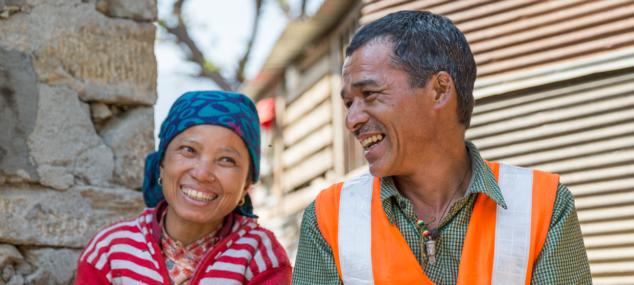

**TRAINING PACKAGE FOR USING SOCIAL SCIENCE IN COMMUNITY ENGAGEMENT AND/OR COMMUNICATIONS ACTIVITIES**

**SESSION 2.3:** Rapid strategies to understand the political, sociocultural and economic factors that increase vulnerability

SESSION CONTENT

**Learning approach:** Real-time presentation, case examples, group exercises

**Delivery mode:** Online and offline, 90 minutes approx.

**Essential sessions to have completed before this session:** 2.1

**Summary:** This session discusses rapid strategies to establish and deepen participants’ understanding of social determinants, risk perceptions, historical, political, sociocultural and economic context to overcome vulnerabilities of specific population groups.

**Learning outcomes:**

* Gain familiarity with additional social science tools (e.g. Rapid Remote Context Analysis Tool, Rapid Anthropological Assessment in the Field) that can be used and adapted to identify inequalities and vulnerabilities
* Be able to initiate a rapid context analysis to identify inequalities and vulnerable groups within a specific community
* Gain familiarity with approaches to vulnerability assessment
* Know how to conduct a power analysis

FACILITATING THE SESSION

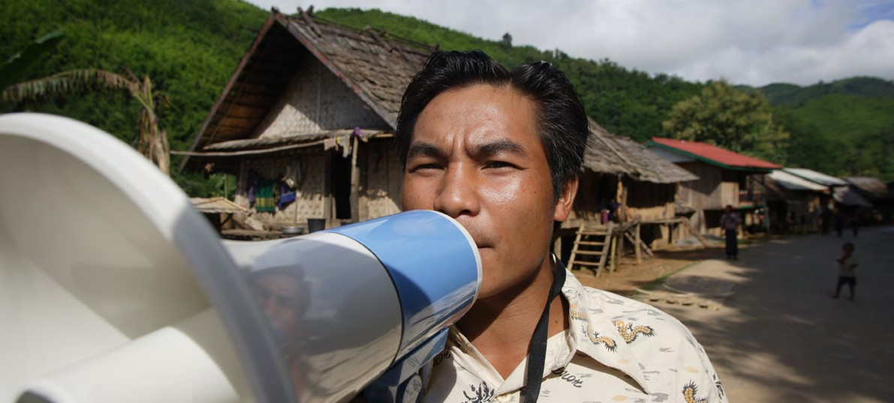

**TRAINING PACKAGE FOR USING SOCIAL SCIENCE IN COMMUNITY ENGAGEMENT AND/OR COMMUNICATIONS ACTIVITIES**

Introduction: (5 minutes total)

Talk through session summary and learning outcomes.

Position this session in the question flow below.

1. How to ensure that this information goes back to communities? To inform community-level actions and decision-making of the broader response?
2. What methodology and tools should be used to collect and analyse this information?
3. How to track the information used to ensure that it effectively contributes to operational and strategic priorities?
4. Who can collect this information?
5. Does this information already exist? Is there a related needs assessment or study?
6. What information is needed?

**DATA TO ACTION:**

Key questions in social science research

1. Who needs this information?
2. How to ensure that the information is used to make operational and/or strategic decisions?

Recapping concepts (15 minutes total)

|  |  |
| --- | --- |
|  | Question to participants (10 minutes):  Recapping the previous session:   * What does vulnerability mean in the context of a crisis? * What does community resilience mean? * What do we mean by context?   Online: Invite the participants to write the answers in the chat function and summarize  Offline: Ask two or three participants to share their thoughts on each question |

**Vulnerability:** the primarily socially and contextually determined characteristics of individuals, households or groups that put them at risk of physical or mental harm, and/or of being unable to meet their basic needs.

**Community resilience:** this term has long been used in disaster management and humanitarian response to refer to communities’ capacities and resources to prepare for and respond effectively to crises.

**Context:** the different aspects of a setting that are important for it to be fully understood, for example geography and infrastructure, language, livelihoods, religion and dominant ideas, etc.

The previous two modules focused on vulnerability, resilience, and the context of behaviour, and this module will focus on social science approaches and tools that can be used to identify and act on them.

|  |  |
| --- | --- |
|  | Question to participants (5 minutes):  Why is it important for people who engage communities during humanitarian crises  to be familiar with these concepts?  To be familiar with these tools?  Ask two or three participants to share their thoughts |

Context analysis (15 minutes total)

Existing knowledge – both formal, published and ‘lay’ knowledge – on social, cultural, economic and political factors is important to an emergency response. This knowledge can be brought together to provide an overview of the context in which a crisis is occurring.

|  |  |
| --- | --- |
|  | Question to participants (5 minutes):  What kinds of contextual information do you/would you find useful as someone engaging communities during humanitarian crises?  Online: Invite the participants to write the answers in the chat function and summarize  Offline: Ask two or three participants to share their thoughts on each question |

Context analyses ask **where**, **why** and **how** people do things which contribute to resilience and vulnerability and either facilitate or impede participation in interventions.

Trained social scientists, or others with training, through online searches and conversations with experts, can conduct rapid reviews of this knowledge, and bring it together and present it in a way that is usable and useful   
to responders, who can in turn design or adapt response activities in appropriate ways.

Two tools, developed in collaboration with the Social Science in Humanitarian Action Platform, are the **Rapid Remote Context Analysis Tool (RR-CAT)** and the **Rapid Anthropological Assessments in the Field (RAA)** tools. The documents outlining these tools can be downloaded from the SSHAP website ([RR-CAT](https://opendocs.ids.ac.uk/opendocs/bitstream/handle/20.500.12413/15428/PracApproach%203.pdf?sequence=3&isAllowed=y) / [RAA](https://opendocs.ids.ac.uk/opendocs/bitstream/handle/20.500.12413/15429/PracApproach%204.pdf?sequence=3&isAllowed=y), or refer to Handouts 1 & 2). The RR-CAT Tool can be used to structure a context analysis rapidly and remotely, to respond to a crisis like an epidemic. The tool includes ‘question modules’ which researchers can use to structure their searches, ensuring they cover key aspects of a context, from basics like geography and infrastructure to more social aspects including the political situation and trust, local livelihoods, religion and dominant beliefs, social organization (e.g. how kin groups or communities are structured and function) and much more. This tool might be most useful, for example, when needing to conduct an analysis of a setting that is hard to reach due to conflict or due to policies which restrict populations movement (e.g. ‘lockdowns’ during the COVID-19 pandemic).

The Rapid Anthropological Assessment in the Field (RAA) Tool can be used to structure contextual assessments **rapidly and in the field**, also in response to a crisis like an epidemic. The tool includes three types of rapid ‘assessments’ – with suggested questions to ask – to correspond to the stage of the emergency and what is known (or not) at the time based on available data. The three types of rapid assessments contained within the RRA Tool are: 1) Contextual Assessments (e.g. to use during the acute phase of an emergency to identify programming/knowledge gaps), 2) Risk and Health Consequences Assessment (e.g. to use to create an action plan to address identified risks), and 3) Intervention Assessment (e.g. to use once an action plan/intervention has begun in order to identify/evaluate positive and negative benefits). The RRA Tool additionally includes suggested data collection methods and includes references to social scientists who have been especially involved in the creation and piloting of these types of assessments for many decades. This type of tool would be most useful, for example, in situations where social scientists are on the ground where the emergency is occurring.

Tools can and should be adapted to a context and to the situation at hand. Responders and researchers – who may be remotely located – can agree together what key areas are important to know about. For instance, responders might want to know more about what is known about health seeking among a particular population. Do people tend to visit alternative or traditional healers more than biomedical or public health services? This kind of knowledge would have important implications for how a response is designed and implemented.

|  |  |
| --- | --- |
|  | Brainstorm (5 minutes):  Select one of the question modules or assessments that are most relevant to the work of the group.  What kinds of questions might be asked/adapted under that ‘question module’ or ‘assessment’? |

|  |
| --- |
| To use these tools you may need the support of someone with a technical background in social science research |

Rapid ethnographic methods (10 minutes total)

|  |  |
| --- | --- |
|  | Question to participants (5 minutes):  Does anyone have experiences of using ethnographic methods? Or working with data produced through ethnographic methods? How useful was it to your work?  Online: Invite the participants to write the answers in the chat function and summarize  Offline: Ask two or three participants to share their thoughts on each question |

Another way of rapidly gathering contextual information, particularly at a local level, are rapid ethnographic methods. ‘Ethnography’ is an approach most closely associated with the social science discipline of anthropology. It generally entails spending time and paying close attention to social life and processes in a particular setting in which a researcher is embedded. All data is valid data – from observations, to informal conversations, to formal interviews and participatory exercises conducted with members of a community – and can be put together to form a ‘thick description’. This can include descriptions of who is locally influential, who people trust (or don’t trust), what kinds of social networks exist and how they work, who might be more vulnerable in a community and why, where people go for help, how people perceive the response, and many more insights that are useful for emergency responders. While traditional ethnographies often take months or years, ethnographic researchers in an emergency setting can work intensively (over a period of days or weeks), and provide insights in real time to responders if they engage in productive collaborative relationships.

The broad steps of a rapid ethnography include:

1. Identify research questions, tailor them to be specific, and involve stakeholder audiences (think about dissemination from the outset)
2. Understand time and resources needed (e.g., ethics approval)
3. Study design (sampling, data collection tools)
4. Implement with a team of local researchers
5. Rapidly disseminate findings using 1-2 page briefings, PowerPoint slides, short videos, or other formats

We will discuss the design, roll-out and analysis of qualitative methods further in session 4.4.

Vulnerability assessments (20 minutes total)

While broader context analysis methods (such as identified by RR-CAT and RRA Tools) may help highlight issues around vulnerability and resilience in a country or context in a broad sense, and rapid ethnographies may help to better understand social life and process in a particular setting where an emergency is occurring, vulnerability can shift and change dramatically under crisis conditions. For example, in the context of COVID-19 ‘lockdown’ regulations, older people living alone can become more vulnerable. While existing inequalities may deepen, heightening risk for already vulnerable people, crises can also create new vulnerabilities – for example, younger people living alone may become newly vulnerable. Crises can also trigger responses within communities that it is important for responders to know about. For example, locally driven material and psychosocial support to people in quarantine.

It is critical that responders understand all of these dynamics as they are playing out on the ground in order to ensure equitable response and resource distribution. It is important for people who engage communities during humanitarian crises in particular to understand these dynamics.

**Rapid Assessment of Vulnerable Populations: A ‘Barefoot’ Manual**

This tool was developed specifically for understanding the dynamics of vulnerability, and for building capacity in local communities impacted by crisis scenarios for immediate action, as well as long-term change. It is a ‘barefoot’ manual in that its use does not depend on large-scale funding or complex data collection and analysis. The tool can be downloaded from the Sonar Global [website](https://www.sonar-global.eu/vulnerability-assessment/the-rapid-assessment-of-vulnerable-populations/), or refer to Handout 3).

This manual focuses on three key areas:

1. Knowledge of existing external (formal) responses
2. Knowledge about local community responses
3. Vulnerability identification on the ground

* ***Knowledge of existing external responses*** includes a stocktaking of what forms of formal support are already available to assist vulnerable people, as well as whether and how people may know about, understand and perceive them. The sudden arrival of SUVs (as frequently used by humanitarian response agencies), for instance, may be associated with oppressive military forces, rather than beneficial assistance, and can mean that vulnerable people do not engage with a response and get the assistance they need.
* ***Knowledge about local community responses*** includes understanding community structures and networks, and local modes of cooperation and resilience which may shift in both negative and positive ways in the midst of a crisis. This knowledge is important so that formal responses do not damage positive community-based responses, or exacerbate exclusion by cooperating with corrupted or co-opted community structures. An example might be establishing orphanages in an area where extended family would usually take in orphaned children. Rather, responses should identify, build upon and support positive and inclusive community initiatives to enhance relief efforts, and to support post-crisis recovery and resilience.
* ***Vulnerability identification on the ground*** can occur after understanding about formal and community responses is established, as it now allows for a more informed investigation of who may be ‘falling through the cracks’. It is important for researchers/responders to recognize that generic categories of vulnerable groups can only be a starting point, and that local qualitative investigation, as enabled by this manual, will yield more accurate and specific understanding of just who is more/most vulnerable in a given local context.

The manual provides three sets of suggested questions (see Table 1) that a user might (adapt and) ask to gain insight into these areas in the specific context and situation in which they are working.

**Table 1.**

|  |  |  |
| --- | --- | --- |
| External response | Community response | Assessing vulnerability |
| * Nature of assistance received (and from which government agencies, UN agencies, international NGOs, local NGOs)? * Period (when)? * Temporary or long-term? * Type (kind of assistance provided?) * Needs met? * Can everyone access? Specific criteria established for those who are elibible? | * Nature of community cooperation (presence or absence?) * Temporary or long-term? * New forms of community response? * Can everyone access? * Sustainability (will they continue and/or grow?) * How to best work with them to enhance sustainability, or replace them if they are harmful? | * Identifying the vulnerable (who suffered most?) * Type of vulnerability? * Coping patterns? * Kind of adjustment? Stable or unstable? * Temporary or long-term? |

|  |  |
| --- | --- |
|  | Group Exercise (15 minutes)  Divide participants into three groups and assign them each one of the three key areas shown in Table 1.  In your group, choose a crisis that one or more of you are currently supporting. Consider a specific setting (geographic location) and spend 10 minutes answering the questions in Table 1, flagging those you need to know more about.  Feedback in plenary |

|  |
| --- |
| To use this tool you may need the support of someone with a technical background in social science research |

Power analysis (20 minutes total)

|  |  |
| --- | --- |
|  | Question to participants (5 minutes):  Why is it important to understand power in the context of your work?  Online: Invite the participants to write the answers in the chat function and summarize  Offline: Ask two or three participants to share their thoughts on each question |

To improve any kind of crisis, whether it’s an epidemic or humanitarian crisis, it is important to understand how power is created, maintained, or resisted in a specific context. We need to understand what structures we need to change to improve equity and access, or to achieve fairness and justice. These are underlying issues that affect how different groups are able to manage and recover from a crisis.

A power analysis is a participatory process that involves people with a stake in a particular situation to analyse for themselves how power relations affect them and might be changed for the better. It uses a structured approach and needs to be reassessed over time.

Power analysis uses participatory group discussions and mapping techniques. There is no one specific framework, but tools can be adapted to fit the context and problem being addressed. This may address governance and health, resilience, gender, conflict, policy/advocacy.

Power mapping specifically identifies different stakeholders in a situation – understanding who has the power to change things and who influences who (and how) – to identify targets for influence, things or people who are blocking change, and possible ways to work with them (see Handout 2).

Online: Give out Handout 4 – give 5 minutes to read

*Offline: Provide link to Handout 4 – give 5 minutes to read*

|  |  |
| --- | --- |
|  | Case example (5 minutes):  Stakeholders involved in a specific issue (e.g. access to health care in a drought/famine setting) can be facilitated to use flipchart paper to outline key stakeholders/actors involved in health services delivery in that particular community/catchment area. Stakeholders can be asked to put actors in a big circle if they have a lot of power and smaller ones if they don’t have so much power. Once these actors have been listed, they can be asked about actors that have not been named (for example, chiefs, politicians, civil society, etc.) and why they haven’t been named, e.g. maybe they don’t play an active role in this issue. Ask the participants to discuss which stakeholders are most trusted and those least trusted. Draw lines between actors with direct power influences: thickness of the line can mean degree of influence (i.e. thicker line = more influence). The direction of the arrow can show who influences who. Dotted lines can show informal power, dashed lines can show hidden power and solid lines can show visible power. Different colours of lines can be used to indicate different types of power (resource, positional, personal, knowledge).  Or more simply: write on the arrowed line the specific mechanism/s the actor uses to exert influence over the primary stakeholder or other actors (e.g. law or custom or informal relationship) and describe the nature of that relationship. See the example of Figure 1 below. |

**Figure 1:** Example power map

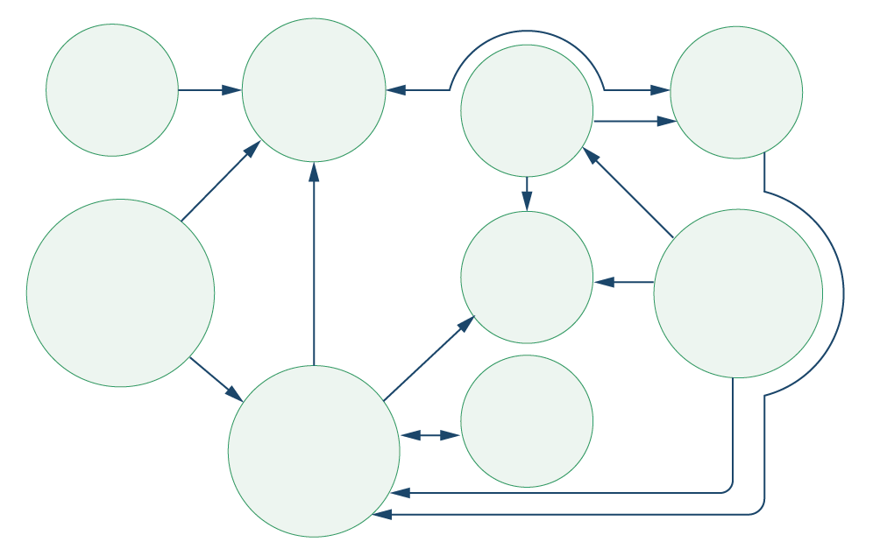

INGO

CHIEFS

COMMUNITY

DHO

RELIGIOUS  
LEADERS

MINISTRY OF  
HEALTH

SOCIAL  
MEDIA

PHUs

CHWs

Any thoughts/reflections?

|  |
| --- |
| To conduct a power analysis you may need the support of someone with a technical background in social science research |

Wrap-up/summary (5 minutes)

* **Context analyses** ask *where, why* and *how* people do things which contribute to resilience and vulnerability and either facilitate or impede participation in interventions
* Trained social scientists (or others with similar training) through online searches and conversations with experts, can conduct rapid reviews of this knowledge, and bring it together and present it in a way that is usable and useful to responders, who can in turn design or adapt response activities in appropriate ways;
* Two tools to assist with this are the **Rapid Remote Context Analysis Tool (RR-CAT)** and the **Rapid Anthropological Assessments in the Field (RAA)** tools.
* **Rapid ethnographic methods** are another way of rapidly gathering contextual information, particularly at a local level. This method generally involves spending time and paying close attention to social life and processes in a particular setting in which a researcher is embedded.
* **Vulnerability assessments** like the **Rapid Assessment of Vulnerable Populations: A ‘Barefoot’ Manual** appreciate that vulnerability can shift and change dramatically under crisis conditions. This tool was developed specifically for understanding the dynamics of vulnerability, and for building on capacity in local communities impacted by crisis scenarios for immediate action, as well as long-term change.
* In a humanitarian emergency, it is important to understand how power is created, maintained or resisted in a specific context. A **power analysis** or **power mapping** is a participatory process that involves people with a stake in a particular situation analysing how power relations affect them and might be changed for the better.

ACKNOWLEDGEMENTS:

Megan Schmidt-Sane and Tabitha Hrynick (IDS) led the development of this session. Theresa Jones and Eva Niederberger (Anthrologica) and Ginger Johnson (Collective Service) led the review process.