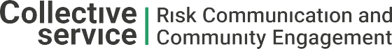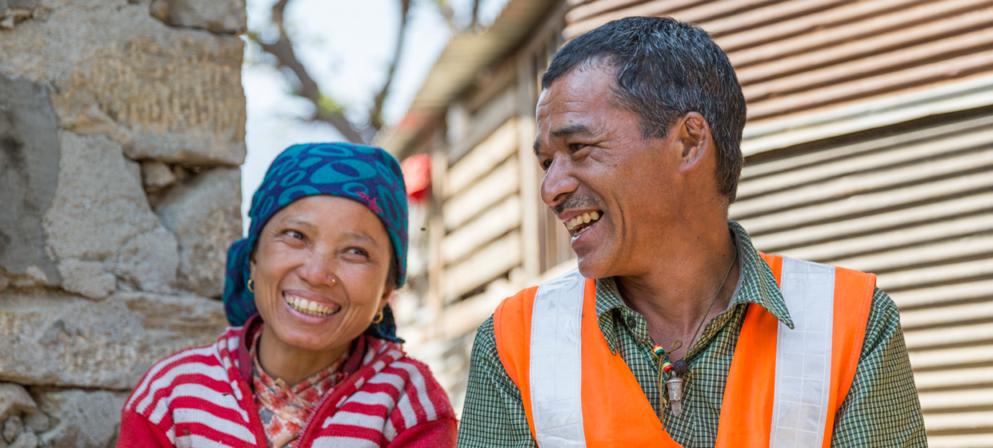

**TRAINING PACKAGE FOR USING SOCIAL SCIENCE IN COMMUNITY ENGAGEMENT AND/OR COMMUNICATIONS ACTIVITIES**

**SESSION 2.4:** Understanding the importance of language   
in social science research

SESSION CONTENT

**Learning approach:** Real-time presentation, individual and group exercises, case examples

**Delivery mode:** Online and offline, 90 minutes approx.

**Essential sessions to have completed before this session:** 2.1

**Summary:** This session discusses the significance of language in social science research in humanitarian action with a focus on community engagement and/or communications activities.

**Learning outcomes:**

* Become familiar with the basic language challenges in social science research
* Understand the risks of conducting social science research which is not language-sensitive
* Understand how social sciences can support community engagement and/or communications activities through language-sensitive research

FACILITATING THE SESSION

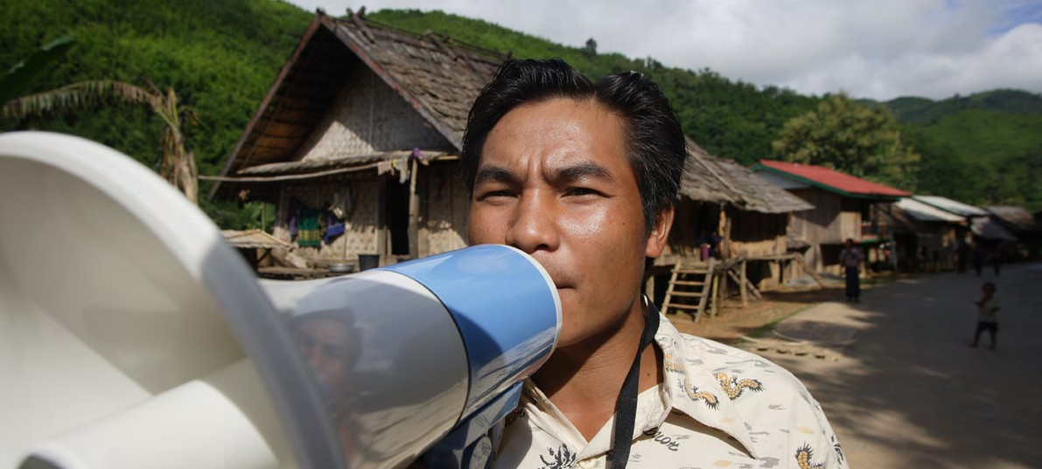

**TRAINING PACKAGE FOR USING SOCIAL SCIENCE IN COMMUNITY ENGAGEMENT AND/OR COMMUNICATIONS ACTIVITIES**

Introduction: (5 minutes total)

Talk through session summary and learning outcomes.

Position this session in the question flow below, highlighting that language is an important consideration   
across the whole process.

1. How to ensure that this information goes back to communities? To inform community-level actions and decision-making of the broader response?
2. What methodology and tools should be used to collect and analyse this information?
3. How to track the information used to ensure that it effectively contributes to operational and strategic priorities?
4. Who can collect this information?
5. Does this information already exist? Is there a related needs assessment or study?
6. What information is needed?

**DATA TO ACTION:**

Key questions in social science research

1. Who needs this information?
2. How to ensure that the information is used to make operational and/or strategic decisions?

What are the language challenges for community engagement/communications approaches? (15 minutes total)

It is critically important for emergency response teams to be able to communicate with affected communities in the language that they are most comfortable with. However, this is not always the case.

|  |  |
| --- | --- |
|  | Question to participants (10 minutes):  Where would you go to find a map of languages spoken in the community where the majority of your activities take place?  Online: Invite the participants to write the answers in the chat function and share it with everyone  Offline: Ask two or three participants to make suggestions |

**Lack of language data:** One of the most significant challenges for community engagement and/or communications approaches in humanitarian organizations is the lack of data available on what languages are spoken, by whom, and where. Very few countries collect language data in their census. In the rare cases that they do, it is often outdated, isn’t combined with data on literacy, and doesn’t take account of population movements in a crisis. Because of this, humanitarian organizations often lack the basic information they need to develop a communications strategy. Humanitarian responses should prioritize finding out what languages people speak, who can read in which languages, and what are the preferred channels of communication. In reality this basic data is rarely collected and can have an impact on the quality of research, and of wider humanitarian response, if it is not addressed.

|  |  |
| --- | --- |
|  | Question to participants (5 minutes):  When carrying out research, what could you do to make sure you are using the correct language(s)?  Online: Invite the participants to write the answers in the chat function and share it with everyone  Offline: Ask the participants in groups of 2-3 to write down as many ideas as possible and after a few minutes invite a few participants to share their responses. Note them down on the flipchart |

You could make sure to:

* Ask community-based organizations or local research focal persons (e.g. local leaders) for guidance
* Know the preferred languages of the sample populations of the research so that research tools are developed in the correct languages
* Understand which groups may speak a language which is often overlooked or not incorporated, and dedicate specific data collection activities with those groups
* Make sure to ask people living with disabilities about their language preferences, which may be different, e.g. sign language. Be prepared to adapt your tools
* Do not assume that people will prefer to read the same language they prefer to speak
* Prepare material in a variety of languages if necessary

It is essential to carry out research in the language that people feel most comfortable speaking. Recruit researchers who speak the preferred languages of research participants, checking with local people that their dialect and accent are readily understood and accepted.

Language is also a major consideration for conducting ethical research and for gaining ethical approval – see sessions 3.1 and 3.2 for more on ethical principles and ethical approvals.

Why does language matter in research? (20 minutes)

It is important to recognize that emergency responders often use their own ‘language’. This can be called ‘jargon’ and it is sometimes confusing for people who are not used to communicating in specialized language. Even different sectors of a response have their own language (e.g. ‘RCCE’, ‘SBCC’, ‘C4D’, ‘AAP’).

|  |  |
| --- | --- |
|  | Brainstorm (5 minutes):  As a group, list several examples of words which are often misunderstood from your areas of expertise, e.g. to ‘engage’ communities, to ‘adopt preventive behaviours’.  Online and offline: Take several answers from the group, including through the chat function |

Choose one or two examples and ask: What are some of the different understandings of these terms? Why are these terms difficult to explain?

Even within a single language, there can be many different understandings of the same term. Think how quickly this multiplies when you are working in a multilingual context. The term ‘access’, for example, may mean something different to someone working in land rights than to someone working in the protection field. In some languages ‘rape’ may only apply to sexual violence committed by a man to a woman. Making sure that you clarify terms at the start of your discussions will mean that:

1. You collect information on the topics you intend to
2. You don’t cause offence or embarrassment
3. You may discover crucial differences in understanding which enrich your findings and inform approaches to your work

For example: Research participants may not consider it to be ‘sexual exploitation’ when an aid worker has sex with a member of the affected community in exchange for gifts or priority access to aid. If they do not consider this as exploitation, a communications campaign based on this term is unlikely to stop this type of behaviour. Asking people: ‘what words would you use to describe this situation?’ will mean that your research questions are better understood, and you can design a more effective campaign to address this type of transactional sexual relationship. This relationship with language also, importantly, applies to humanitarian workers as well who may use terms such as ‘beneficiary population’ to obscure their rights and obligations to crisis affected populations.

For a relevant example of the importance of understanding terminology during a public health emergency (e.g. ‘sexual exploitation’ ; ‘beneficiary population’, please see the [Final Report of the Independent Commission on the Review of Sexual Abuse and Exploitation During the Response to the 10th Ebola Virus Disease Epidemic in DRC](https://www.who.int/publications/m/item/final-report-of-the-independent-commission-on-the-review-of-sexual-abuse-and-exploitation-ebola-drc).

For additional links of importance to Protection against Sexual Exploitation and Abuse (PSEA) during an emergency response, please see [IASC Six Core Principles](https://psea.interagencystandingcommittee.org/update/iasc-six-core-principles) and a [2021 IASC External Review of PSEA](https://psea.interagencystandingcommittee.org/resources/2021-iasc-external-review-pseash). Take 10 minutes to read through this content on your own, also noting down where you think agency ‘jargon’ may might need to be translated for those who are not familiar with this sector of humanitarian response operations.

What more can language tell us? (15 minutes total)

Speaking a marginalized language can further contribute to a group’s marginalized status and leave people at greater risk during a humanitarian emergency, e.g. if they do not understand the safety information being played on the radio, or information about where they can seek services that is written on posters. Understanding and using people’s preferred languages is one way to directly address the types of vulnerabilities and inequalities we spoke about in the previous three sessions (2.1-2.3). Being sensitive to language in social science research can help ensure this.

|  |  |
| --- | --- |
|  | Group Exercise (15 minutes)  In groups of 4 or 5, answer the following question:  Addressing marginalization through being sensitive to language in research: How will you know you have done this?  Online: Put participants into breakout rooms and provide an online note function for them to take notes of their discussion  Offline: Ask the participants in groups of 2-3 to note down as many ideas as possible  After 10 minutes, take another 5 minutes to ask a few groups to share their responses. Note them down on the flipchart |

Questions you could ask yourself after research:

* Did speakers of marginalized languages participate meaningfully in the research? How do you know if they could express their views freely and openly? Could they be fully understood?
* Did speakers of marginalized languages raise issues not expressed by others, or consistently have different opinions? What conclusions might you draw from this?
* Were there any marginalized language groups that were not able to participate in the research because their language could not be spoken or understood by the research team?

You can also check the following processes after research by asking the following questions:

* How did our work address differences in understanding and expressing key concepts? Did we have multiple language options? Did we ensure that important concepts and terms were easy to understand?
* Were speakers of marginalized languages as involved in our work as speakers of other, more common, languages?
* What can we feed back to the humanitarian community or health authorities about differences in understanding and communicating important concepts?
* What are the important differences between the languages of the response, other major languages, and marginalized languages? How should we respond to these differences?
* Can we be sure that speakers of marginalized languages feel as able to engage in humanitarian and public health response as others

Why is language important in public health campaigns? (25 minutes)

|  |  |
| --- | --- |
|  | Case example (25 minutes):  Ask participants to read through the summary below. See Handout 1 for additional information.  5 minutes reading, 15 minutes group discussion, 5 minutes feedback |

The response to the 10th outbreak of Ebola in the Democratic Republic of the Congo (DRC) was marked by affected populations’ high levels of distrust in health workers. Responders faced unprecedented levels of violence: WHO recorded more than 300 attacks on Ebola health workers in 2019, several of them fatal.

In a study published in the Lancet based on a 2018 survey of 941 people in Nord Kivu, just 349 (36%) said they trusted local authorities. And while 91% said they had received information on how to protect themselves from Ebola, 25.5% also said they believed Ebola did not exist, 32.6% said they thought Ebola was fabricated for financial gain, and 36.4% said they thought Ebola was fabricated to destabilize the region.

Responders’ failure to gain acceptance from target groups, a problem referred to as ‘community resistance’ or ‘community refusal’, severely impeded their access in the affected area. The difficulties in engaging with communities then exacerbated the trust issues responders faced.

In a 2018 review of findings by NGOs and others published in the journal *Health Communications*, the WHO noted that one of the most important considerations for risk communication is ‘tailoring’ content to specific local populations, gender, circumstances and language.

But at the outset of the 10th Ebola response in DRC, official health communication was mainly conducted in French, the official language. As the response built its community engagement capacity, and actors placed greater emphasis on communicating with communities, the Ministry of Health and responders recognized the importance of Swahili as the most widely spoken language in the region. Subsequently, responders began to make information available in Swahili, historically the lingua franca of East Africa. However, the form of Swahili used in the Ebola response was often a formal, international Swahili not understood by communities, many of whom spoke local dialects of the language or did not speak Swahili at all. As late as September 2019, Translators Without Borders (TWB) research found that the response was still generating risk communication materials largely in French or Swahili.

A TWB assessment in Goma showed that many people did not understand the risk communication materials they had received (see Handout 1). For example, most focus group participants did not understand apparently simple French words used in risk communication, such as *sanglant* (bloody), *sperme* (sperm) or *gencives* (gums).

TWB also tested comprehension of the first page of the informed-consent form for vaccination for adults in Swahili. TWB assessed the Swahili form as being written in a mix of high-register Congolese Swahili and standard Swahili; it also contained words in French and English. All participants had difficulty understanding the form, especially where it contained technical or unfamiliar words in standard Swahili, French or English. They highlighted words they did not know.

Seemingly basic words such as fomu (form) or vital concepts such as *ridhaa* (consent) or *chanjo* (vaccine) in standard Swahili caused confusion. In particular, women over 35 did not understand *chanjo*. They said that *ndui*, which refers specifically to prenatal or preschool vaccines, was more familiar to them. Conversely, half the men were unfamiliar with the term ndui. Respondents recommended translating the form into local languages.

Collect any immediate reflections.

Ask participants: In another localized major disease outbreak, what social science research could be done at the outset to support practitioners in developing successful risk communication?

Wrap-up/summary (5 minutes)

Social science research should:

* Collect data on the languages spoken and language preferences of different groups.
* Collect data on preferred communication channels and formats of different groups.
* Understand the meaning of terms specific to the response, e.g. ‘vaccine’ – testing terminology and comprehension by different groups

|  |
| --- |
| **Additional resources:**   * <https://translatorswithoutborders.org/language-questions> * <https://translatorswithoutborders.org/language-data-by-country/> * <https://safeguardingsupporthub.org/documents/how-consider-language-when-researching-sexual-exploitation-abuse-and-sexual-harassment> |

* Find out from communities which terms related to disease and treatment are widely understood and accepted.
* Conduct a language sensitivity evaluation that aims at understanding ethnic/conflict tensions that are affecting communication or communicators.

ACKNOWLEDGEMENTS:

Christine Fricke and Alice Castillejo (Translators Without Borders) developed the   
module content. It was reviewed by Theresa Jones and Olivia Tulloch (Anthrologica)   
and Ginger Johnson (Collective Service).