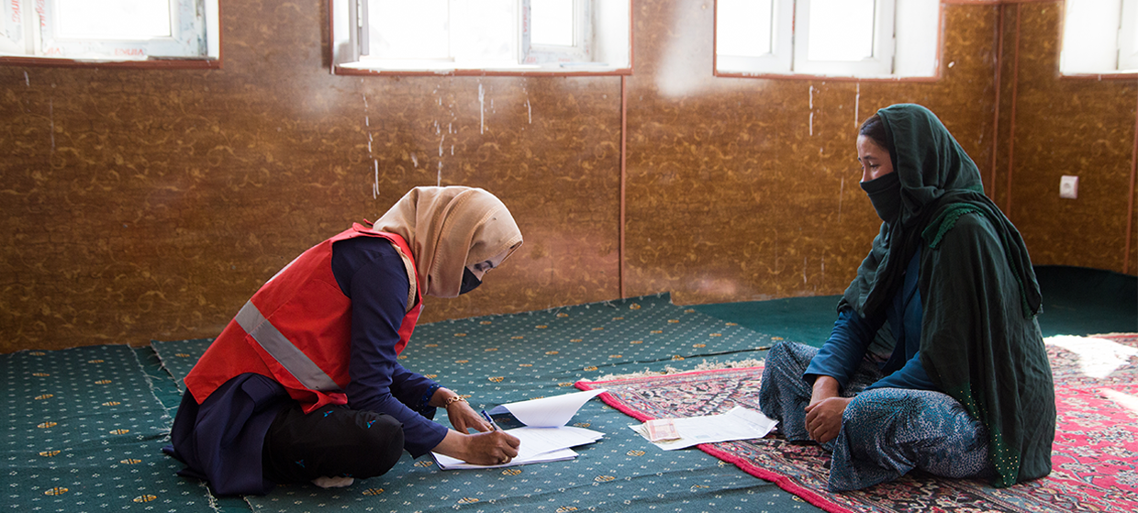

**TRAINING PACKAGE FOR USING SOCIAL SCIENCE IN COMMUNITY ENGAGEMENT AND/OR COMMUNICATIONS ACTIVITIES**

**SESSION 4.1:** Localised research: Designing operational social science research that is responsive to communities

SESSION CONTENT

**Learning approach:** Real-time presentation, individual and group exercises, case examples

**Delivery mode:** Online and offline, 110 minutes approx.

**Summary:** This session covers how to plan and roll-out social science research that brings in local knowledge and expertise and puts communities’ knowledge, capacities and needs at the centre.

**Learning outcomes:**

* Know how to plan and design social science research that is responsive to communities
* Understand the roles that affected communities should play in the different stages of social science research

FACILITATING THE SESSION

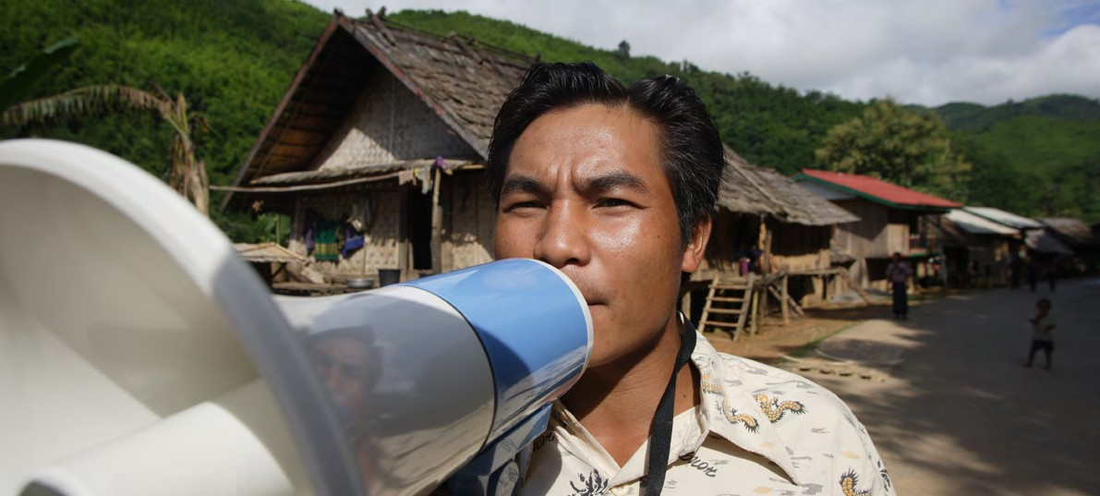

**TRAINING PACKAGE FOR USING SOCIAL SCIENCE IN COMMUNITY ENGAGEMENT AND/OR COMMUNICATIONS ACTIVITIES**

Introduction: (5 minutes total)

Talk through session summary and learning outcomes.

Position this session in the question flow, nothing that localizing research is an important consideration across the whole process.

1. How to ensure that this information goes back to communities? To inform community-level actions and decision-making of the broader response?
2. What methodology and tools should be used to collect and analyse this information?
3. How to track the information used to ensure that it effectively contributes to operational and strategic priorities?
4. Who can collect this information?
5. Does this information already exist? Is there a related needs assessment or study?
6. What information is needed?

**DATA TO ACTION:**

Key questions in social science research

1. Who needs this information?
2. How to ensure that the information is used to make operational and/or strategic decisions?

Localized Research (15 minutes total)

|  |  |
| --- | --- |
|  | Question to participants (5 minutes):  What do we mean by ‘localized research’?  Online: Invite the participants to give answers or write their answers in the chat function  Offline: Ask two or three participants to share their thoughts |

Localized research puts the needs of communities affected by a crisis first. It brings in and builds on existing local knowledge, skills and other resources.

Localized research:

* Listens first
* Understands and then prioritizes the needs of communities affected by an emergency
* Understands and builds on local knowledge and expertise
* Involves and engages people in the design, roll-out and evaluation of activities
* Supports communities to take their own action
* Creates and maintains trust
* Sets up two-way communication and exchange of information between emergency responders and those affected by a crisis
* Builds local capacity

|  |  |
| --- | --- |
|  | Question to participants (5 minutes):  Why is it important to make sure that communities affected by a crisis are at the centre of social science research?  Online: Invite the participants to give answers or write their answers in the chat function  Offline: Ask two or three participants to share their thoughts |

Communities affected by a crisis should play a central role in research in order to:

* Select a research topic that is truly relevant to that setting
* Build on local expertise and knowledge to make sure the research is addressing the most important questions, in the best possible way
* Turn findings into actions that are realistic and acceptable to affected communities – so they can actually work
* Establish buy-in for any action or change that may result from the research – for example, being actively involved in the research process may improve understanding of prevention measures for disease
* Ensure the research informs and supports community-level action which can address the emergency but also benefit the longer-term development of the area
* Promote the active rather than passive role of communities, which can also positively contribute to more resilient communities

For additional details on how to stimulate quality research using a bottom-up approach , please see the [Advancing Research in CSO Partnerships: Localization as a Way Forward](https://wncb.org/report-advancing-research-in-development-partnerships/) guide. This guide offers principles for advancing research through localization, pathways for change, and conversation starters to explore opportunities and ways forward together. See also **Handout 1**.

When? (20 minutes total)

|  |  |
| --- | --- |
|  | Question to participants (5 minutes):  In the context of an emergency, at what point in the research process should affected communities play a role?  Online: Invite the participants to give answers or write their answers in the chat function  Offline: Ask two or three participants to share their thoughts |

Communities need to be involved **in all stages of the research process.** This will be critical to put communities’ knowledge, capacities and needs at the centre, to ensure that research is collaborative and draws on local expertise and to support community-led action.

The description below provides additional details related to the key questions outlined in the question flow diagram (presented above):

1. Defining information needs

Most often, research is designed to answer questions which are defined and prioritized by emergency response actors. Affected communities *should* be engaged in this process to make sure that these questions are relevant and in line with their needs and priorities.

For example, communities in Mava district**[1]** have been throwing rocks at burial teams conducting burials for Ebola patients. Response actors may want to ask: *‘Why don’t the communities support the burial protocol? How can we conduct burials in a more acceptable way?’* Consultation with community members corrects the assumption that there is an issue with the way burials are performed. They suggest instead that the real question is: *‘Why do communities not support response workers? How can this be resolved so that “safe and dignified” burials can be supported?’*

1. Identifying who needs this information

As noted above, if response actors define the questions, then it can be assumed that they should be the ones receiving the answers (the research findings).

If the information produced from research is relevant to affected communities AND it is made accessible to them then this can trigger:

1. Helpful feedback to inform the design of locally appropriate and accountable response actions
2. Direct community-level action that is also supportive of the response

This can build acceptance and trust in the response and other services, and improve the quality and effectiveness of the response.

For example, a recommendation from the research is that burial workers should be recruited and trained from within Mava district.**[2]** If this information is shared with the affected communities, they can suggest solutions which are locally relevant and acceptable. In practice this could mean giving advice on the team composition of Ebola ‘Safe and Dignified Burial’ teams (gender, age, etc.) and suggesting candidates from the local population. This should also help to improve the trust in the service and increase the likelihood of response protocols being followed.

Communities are diverse – made up of people from different social and ethnic backgrounds, of different genders, and with different educational backgrounds and economic resources – and it is important to understand exactly *who* needs to know *what.* This question can be asked when research needs are being defined (see question 1). We will talk about communities and diversity shortly.

1. Checking whether this information already exists

Communities may participate in multiple research projects, studies and evaluations and may be a better source of information than a literature review (especially for work that does not get published) so it is helpful to ask whether other similar research initiatives have been carried out.

1. Deciding who can collect this information

Wherever possible, local social scientists should lead research projects. Where there is a lack of local social scientists, then it is important to advocate with research institutions and donors for longer-term capacity strengthening (see Session 1.3 on advocacy).

With appropriate training and support, members of a crisis-affected community can themselves collect social science data. In later sessions we speak more on training for data collection.

**BOX 1 COMMUNITY-LED ETHNOGRAPHY IN SIERRA LEONE**

An exploratory study was conducted in Sierra Leone’s Kambia District where a small group of community health workers were trained in introductory social science research and ethnographic research methods. These trainees were then supported to conduct research, analyse findings and propose adaptations to current public health strategies, including their own practice. This network of community researchers first explored vaccine confidence in border communities, contributing to the adaptation of community engagement and vaccine deployment strategies at district level. The community researchers then recorded their communities’ experiences and perceptions of COVID-19, which formed the basis of weekly social science reports to the District COVID-19 Response.

Collecting data from your own community related to a recent crisis can be distressing – especially if it requires repeatedly discussing upsetting aspects of the crisis and/or if fellow community members have expectations from you as part of the research team. Strong training and supervision processes are important to mitigate or minimize this. Good community understanding of the research can reduce extra pressures on the research team around expectations, etc. In addition, research coordinators should familiarize themselves with local services where research team members can be referred for additional psychosocial/psychological support.

1. Selecting methodology and tools to collect and analyse this information

Methodology should be realistic and acceptable in the local setting. For example, giving participants cameras to document their use of hand-washing facilities may not work in a rural area where poor connectivity may prevent this data being transferred.

Tools should be translated to the relevant local language(s). They should be in plain language and understood by all members of the research team. This can be ensured by asking community members who are part of the team to check the questions and their phrasing, and do a general terminology check.

Members of affected communities can be involved in both collecting and then analysing the data produced, for example by reading transcripts and flagging important themes. This is discussed in a later session on qualitative data analysis.

The more participatory and engaging the methods for data collection and analysis, the more likely they will tap local expertise and knowledge. For example, simple check-box surveys asking: ‘*What do you feed children under 2 years?*’ can restrict the amount of information given. By giving community members a food diary to complete over the course of two weeks and then bringing the participants together in a group discussion, information can be shared on why certain foods are given and how infants respond, etc.

Participatory methods can also be more likely to inform and trigger local action, due to active participation in the research process.

1. Communicating information back to communities so it informs community decision-making   
   and action

Research findings should address the priority needs of the communities – not only the priorities voiced by emergency responders.

Community members can be asked which of the findings are of priority relevance and important to them, for example through a ranking exercise (see [example tool](https://www.who.int/publications/i/item/WHO-EOS-98.3)). This can help them identify which findings can inform the sort of action that is important to them. For example, responders might be interested in what the research says about how to engage young men. Community representatives might be specifically interested in why young men don’t seem to take the advice given to them by local leadership, so that this can be addressed at a local level.

If the previous steps have been followed, this should not be the first time affected communities hear about the research.

When research has also been designed around a community’s priorities, then it should be simpler to ensure it supports that community’s own decision-making and action. Session 5.4 is dedicated to different approaches to feeding research back to communities so that it can inform their own decision-making and action.

1. Converting information so it can support operational and strategic decisions

Affected communities should also be involved in developing recommendations for the emergency response. They should be invited to review research findings and give feedback on response plans, e.g. by being asked: ‘Will this work in this setting?’ As noted above, this can produce locally appropriate and accountable response actions, which can build acceptance and trust in the response and other services, and improve the quality and effectiveness of the response. The final research findings and results should be shared with communities in their own language and in a format they can understand.

1. Tracking information use to ensure that it contributes effectively

Knowing exactly how the information is being used and how it has addressed priority issues at the community level is of crucial importance. As well as quality programming, this is part of accountable programming.

Social science research should be able to start, or contribute to, a dialogue/conversation between responders and a crisis-affected community. This is why it is important to establish two-way communication channels and feedback loops using the languages of the community *from the start of* the research process. These loops and channels can also help to track information use. We will talk about this further below. These channels can also then be used to inform new and important information needs (linking back to question 1).

**NOTE:** Certain participatory methodologies such as Participatory Action Research (PAR) place those affected by an issue as researchers themselves rather than as the subject of research. They are also the primary implementers of any resulting change. As such, methodologies such as PAR should produce truly localized research at all stages of this question flow. We discuss these methodologies in the session on qualitative methods.

How? (40 minutes total)

|  |  |
| --- | --- |
|  | Brainstorm (5 minutes):  What are some practical ways to involve affected community members in the design of social science research? How do we do this? Draw on your experience of involving communities in your activities.  Online: Invite the participants to write their answers in the chat function  Offline: Collect as many answers as possible from the room |

There are a number of practical ways for research to collaborate with affected communities, to draw on local expertise and to bring in communities’ knowledge and capacities.

1. Aim to include the communities that the outcomes of the research will impact, **from the earliest planning phases**.
2. Establish a ‘**steering committee’ / community advisory board** or similar with representation from all key stakeholders and a range of community members. These should be established at the beginning of the research process and have defined terms of reference as to their purpose – e.g., to develop research questions, to comment on research protocol, to give feedback on findings, etc. They should meet regularly, be available to speakers of all identified languages and give input at every stage of the research.
3. Form **research teams** which include a range of community members. Professional social scientists and local researchers in particular can help localize the research in the ways described. But also, and as noted, with adequate training and support it is possible for community members to collect social science data.

|  |  |
| --- | --- |
|  | Group exercise (20 minutes)  Communities are diverse – they are made up of people from different social and ethnic backgrounds, of different genders, and with different educational backgrounds and economic resources.   1. What do we mean by engaging a ‘diverse’ range of community members? Draw on your own experience. You have 5 minutes to discuss.   Online: Breakaway rooms  Offline: Small working groups or discussion in pairs  Reconvene in plenary, note down answers on flipchart paper     1. Can someone describe a community in which they are currently working?   Take one example  Let’s look at the context of [X], and think of who is in the community.  What might be the different population groups in this community?  Online and offline: Use circles and colours to represent the different population groups they mention which can range from different age and gender, socioeconomic and sociocultural groups, etc.  Who do you think are most vulnerable (because of the crisis or before)? Draw an asterisk on the circle  Who might be marginalized because of structural factors? Draw an asterisk on the circle. |

1. Create **two-way communication channels and feedback loops** in the language of the community – bearing in mind that social science research can begin or contribute to a dialogue/conversation with communities around an emergency. These channels or loops may take the form of regularly scheduled community meetings or radio phone-in shows, etc.
2. As we have already discussed, building the social science capacity of the local area in the longer term can mean future research benefits from local expertise and can inform community action. This might include direct training during the research process (see Box 1 above) or investing in community-based social science research training as part of preparedness activities (see **Handout 1**). This is not the direct responsibility of community engagement/ communications actors, but you should advocate with research institutions and research arms of humanitarian organizations to prioritize this.

|  |  |
| --- | --- |
|  | Question to participants (5 minutes):  Think about your current work – which community structures and networks exist that could contribute to the design and roll-out of social science research? How would you ensure the involvement of local research teams (e.g., universities etc.)?  Online: Invite the participants to give answer verbally or write the answers in the chat function and summarize  Offline: Ask two or three participants to share their thoughts |

To ensure the design and implementation of localized research which supports emergency response action and strategies, response teams could start off by:

* Mapping all of the community structures and networks at the local level.
* This should include both formal and informal structures and making sure that vulnerable and marginalized population groups are represented.
* This can help to understand who should be involved in defining local priorities and research questions, who should and could support the research implementation, data collection and analysis, and who will need to know about and provide feedback on the research findings.
* Mapping existing research institutions at the subnational and national level (e.g., anthropology and sociology departments and contacts of local universities).

|  |  |  |  |  |  |  |  |  |  |  |  |  |  |  |  |  |  |  |  |
| --- | --- | --- | --- | --- | --- | --- | --- | --- | --- | --- | --- | --- | --- | --- | --- | --- | --- | --- | --- |
|  | Group exercise (20 minutes)  Break the group into groups of three.  Scenario: You are working for the NGO WaterAction in Bangara in South Africa in the middle of a cholera outbreak. You are starting a research project to understand how to reduce open defecation among children and adults in a rural area. The research will help the design of a community engagement strategy to increase the use of latrines and to slow down cholera transmission risks. As a group discuss the eight stages in Table 1 below and what you might do in each stage to ensure that research is collaborative, draws on local expertise, prioritizes communities’ knowledge, capacities, and needs, and contributes to local action.    **Table 1:**     |  |  | | --- | --- | |  | Example answer (do not share) | | Defining information needs | Take research questions to a **community consultation** to ensure they reflect local priorities. If not, collect local priorities. | | Identifying who needs to know this information | During consultation find out who at the community level would benefit from knowing research findings. Consider the diversity of the community. | | Checking whether this information already exists | Ask community members whether information has already been collected on this issue. | | Deciding who can collect this information | Assess whether research knowledge or expertise already exists within the community. **Include community members in the research team.** | | Selecting methodology and tools to collect and analyse this information | Conduct **participatory data-collection workshops** to understand latrine use. Make sure research tools are translated into the languages’ community members speak. Involve community members in analysing the qualitative data. | | Communicating information back to communities so it informs community-level decision-making and action | Feed findings back in a **community meeting** which is attended by those identified prior.Members rank which findings are most useful to them. Brainstorm what local change can occur as a result of these findings. | | Ensuring information can support operational and/or strategic decisions | During the meeting collect recommendations and suggestions for the response to improve latrine use. Collect feedback on response plans – will this work? | | Tracking information use to ensure that it contributes effectively | During initial consultation form a **community advisory committee** for the research. Link back with them after 6 months to see what has changed. | |
|  | In plenary ask two groups to share their answers (online and offline) |

Wrap-up/summary (5 minutes)

* Localized research puts the needs of communities affected by a crisis first. It brings in and builds on existing local knowledge, skills and other resources.
* Communities should be involved in all stages of the research process, including:
* Defining information needs
* Identifying who needs this information
* Checking whether this information already exists
* Deciding who can collect this information
* Selecting methodology and tools to collect and analyse this information
* Communicating information back to communities so it informs community decision-making and action
* Converting information so it can support operational and strategic decisions
* Tracking information use to ensure that it contributes effectively to the research.
* This can be achieved through:
* Including the communities that the outcomes of the research will impact, from the earliest planning phases
* Establishing a ‘steering committee’ / ‘community advisory board’ or similar
* Forming research teams which include a range of community members from affected communities
* Creating two-way communication channels and feedback loops
* Building the social science capacity of the local area.

ACKNOWLEDGEMENTS:

Theresa Jones (Anthrologica) developed the content of this session. It was reviewed by Megan Schmidt-Sane (IDS), Tabitha Hrynick (IDS), Christine Fricke (Translators Without Borders), Alice Castillejo (Translators Without Borders), Eva Niederberger (Anthrologica), and Ginger Johnson (Collective Service).

1. Fictitious – to be adapted to context
2. Fictitious – to be adapted to context