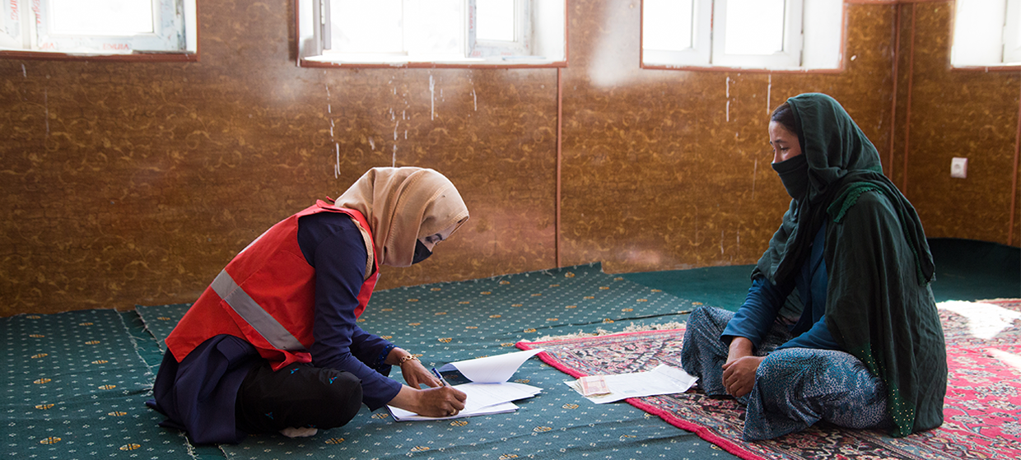

**TRAINING PACKAGE FOR USING SOCIAL SCIENCE IN COMMUNITY ENGAGEMENT AND/OR COMMUNICATIONS ACTIVITIES**

**SESSION 4.2:** Quantitative and qualitative approaches to generate data in operational social science research

SESSION CONTENT

**Learning approach:** Real-time presentation, individual and group exercises, case examples

**Delivery mode:** Online and offline, 90 minutes approx.

**Essential sessions to have completed before this session:** 4.1

**Summary:** This session lays out the differences between quantitative and qualitative approaches to collecting and analysing socio-behavioural data and the strengths and weaknesses of both of these approaches. It guides participants on when to apply these types of methods, including to which sorts of research questions.

**Learning outcomes:**

* Know the difference between qualitative and quantitative data collection approaches to social science research
* Know when to apply these different approaches, including to which types of research questions

FACILITATING THE SESSION

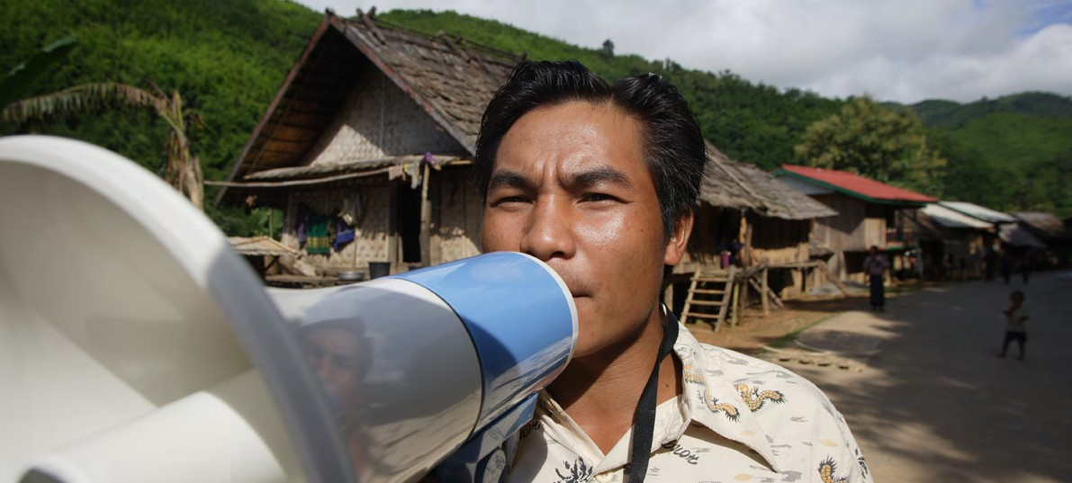

**TRAINING PACKAGE FOR USING SOCIAL SCIENCE IN COMMUNITY ENGAGEMENT AND/OR COMMUNICATIONS ACTIVITIES**

Introduction: (5 minutes total)

Talk through session summary and learning outcomes.

Position this session in the question flow.

1. How to ensure that this information goes back to communities? To inform community-level actions and decision-making of the broader response?
2. What methodology and tools should be used to collect and analyse this information?
3. How to track the information used to ensure that it effectively contributes to operational and strategic priorities?
4. Who can collect this information?
5. Does this information already exist? Is there a related needs assessment or study?
6. What information is needed?

**DATA TO ACTION:**

Key questions in social science research

1. Who needs this information?
2. How to ensure that the information is used to make operational and/or strategic decisions?

Quantitative vs qualitative

|  |  |
| --- | --- |
|  | Question to participants (5 minutes):  How are quantitative research methods different to qualitative research methods?  Online: Invite the participants to write the answers in the chat function and summarize  Offline: Ask two or three participants to share their thoughts  Quantitative approaches differ from qualitative approaches in several ways. |

**Quantitative approaches**

Use quantitative methods when you want to know ‘how many’ and/or ‘how often’

* Work with numbers – the instrument used in quantitative research poses questions in which response options are assigned numbers
* Generally use surveying of a large group of people (usually several hundred) and a structured questionnaire that contains predominantly closed-ended, or forced choice, questions
* Can test theories you have about a situation: e.g. pregnant women are less likely to use water chlorination tablets than non-pregnant women (although not all quantitative research is designed to do this)
* Can establish causal relationships – e.g. X causes Y: trust in health system contributes to greater vaccine uptake
* Analysis often uses statistical methods to interpret the significance of the findings
* The more representative the sample is – when it has characteristics of the whole population including vulnerable and marginalized population groups such as ethnic minorities, people living with disabilities etc. – the more likely it can be generalized to a wider population

|  |  |
| --- | --- |
|  | Question to participants (5 minutes):  What might be some of the strengths of quantitative methods? What might be some of the weaknesses of quantitative methods?  Online: Invite the participants to write the answers in the chat function and summarize  Offline: Divide the room into two groups, half of the room to give strengths, half to give weaknesses |



**STRENGTHS**

* Number-based estimates
* Opportunity for relatively uncomplicated data analysis
* The accuracy of the data can be checked
* Can compare data between different communities within different locations
* Data does not require individual judgement beyond consideration of how information will be presented

**WEAKNESSES**

* Often leaves gaps in information - including around 'why' and 'how'
* Close-ended questions and tools limit outcomes, and response options are based on the selection of the researcher. So results might not always represent the actual situation
* A labour intensive and resource-heavy data collection process
* Usually, there is limited participation by affected persons in the development of questions and in the way the information collection process flows
* Method least likely to lead to relationship-building for community engagement

**Qualitative approaches**

Use qualitative methods when you want to know how people feel and what they think – You don’t need to know how many people think or feel this way

* Not based on numbers
* Generally use interviews, focus groups discussions and observations
* Exploratory: looking at factors such as cultural expectations, gender roles, ethnic and religious implications and individual feelings
* Usually uses a smaller sample size than quantitative approaches
* Methods provide results that are usually rich and detailed, offering many ideas and concepts to inform your programme
* Are used to understand ‘the why and the how’ – why do people behave in a certain way, how do they perceive the situation and how are their priorities and capacities evolving

|  |  |
| --- | --- |
|  | Question to participants (5 minutes):  What might be some of the strengths of qualitative methods? What might be some of the weaknesses of qualitative methods?  Online: Invite the participants to write the answers in the chat function and summarize  Offline: Divide the room into two groups, half of the room to give strengths, half to give weaknesses |



* Rich and detailed information about affected populations and the impact of the emergency
* Perspectives of specific social and cultural contexts (i.e. the human voice of the disaster)
* Opportunity for more active participation in the research process and community engagement
* Flexible and open tools means that the focus of research can be adjusted if appropriate
* A data collection process which requires limited numbers of respondents
* A data collection process which can be carried out with limited resources.
* Results in data which the accuracy of the data cannot be objectively checked
* May require a more labour intensive analysis process (categorisation, recoding, etc.)
* Needs skilled interviewers to successfully carry out the primary data collection activities.
* Requires a detailed dissemination and visualisation plan (data is text and words not percentages and graphs)
* Data does not as easily translate (as numbers) into PowerPoint presentation
* Potentially more time intensive for recipients of this information to take in detailed findings
* (see Session 5.3 for information on presenting and communicating evidence)

**STRENGTHS**

**WEAKNESSES**



Table 1 illustrates the main differences between quantitative and qualitative approaches in social science research.

**Table 1:** Differences between quantitative and qualitative methods in social science research. See also **Handout 1**.

|  |  |  |
| --- | --- | --- |
|  | Quantitative | Qualitative |
| **Type of questions the approach is best suited  to answer** | What? How many? How often?  Answers a controlled sequence of questions with predetermined possible answers. Because responses are pre-defined, they can be counted. | How? Why?  No preformed answers, just captures what respondents say (words are the ‘data’). |
| **Participatory** | Less likely. Participants have limited to no control over question sequence and responses. Pilot testing mandatory to ensure responses are relevant and relatable.  Researchers define the line of inquiry, the questions and their sequence, and the universe of response options. It is a structured method where participants just respond to questions in the sequence that is presented and within the parameters provided. Every participant experiences the same structure. | More likely. Participants have more control of the discussion through responding to more open-ended questions. Strong interviewer skills required to facilitate discussion which is relevant to participant but also covers all areas of questionnaire.  Researchers define the line of inquiry and provide open-ended questions for use in a conversational context where the researcher and participants INTERACT responsively to one another. Sequence and spontaneity are allowed for both the researcher and participant. Semi-structured, organic process. Participants do not experience the same set of questions or interactions because the researcher is empowered to listen and probe the participant in ways that achieve the aims of the inquiry. |
| **Research design, data collection and sampling** | Tools and procedures established beforehand. Fixed formats that are consistently applied is key to quality and the ability to compare groups or assess trends over time. | Flexible and open tools and adjustable procedures. Flexible formats that allow for exploration and characterization of important (deep) contextual information that does not need to be compared across populations, places, or over time. |
| Survey-based with close-ended questions. The unit of analysis is at the individual level of respondents or counts of respondent universe. | Case-based: open-ended questions, semi-structured or unstructured interviews, focus group discussions. The unit of analysis depends on the method employed but usually represents the conversation between the researcher and participants. The transcript of an interview or a focus group discussion is analysed as a whole data unit regardless of the number of individual participants. |
| Surveys (e.g. face-to-face interviews, telephone interviews, self-administered via mail, internet)  Population movement tracking  Registration  Structured interviews | Individual interviews  Key informant interviews  Semi-structured interviews  Focus group discussions  Observations |
| Greater number of subjects with characteristics of the whole population. | Few subjects with characteristics of specific populations (e.g. purposive sampling). |
| A specific number of participants is statistically defined. | Number of subjects is often defined in the field with data collection stopping when ‘saturation’ is reached – that is, researchers get answers from new respondents that are similar to what they have heard from earlier respondents without any new ideas or insights. |
| **Data analysis, interpretation and findings** | Statistical analysis: statistical programs, charts, deductive methods, descriptive statistics, inferential statistics,  univariate or multivariate analysis. | Interpretation: thematic analysis, content analysis, inductive reasoning, iterative process of reading, categorizing the data into codes that are defined, and describing patterns and making interpretations of those patterns to represent the perspectives of research participants. |
| Establishment of association among results. | Researchers interpret the categorized/coded data. |
| **Presentation and dissemination** | Mainly numerical and categorical values. Can display findings through tables, charts, and pictures with or without a discussion. | Mainly textual (words, pictures, audio, video). Narrative synthesis with descriptions and quotations, and detailed discussion/debriefing session required. |

|  |  |
| --- | --- |
|  | Group exercise (10 minutes)  Break the group into four groups.  What is the best approach to produce social and behavioural evidence relevant to your work in community engagement/communications in an emergency setting: quantitative or qualitative?  Assign groups the role of advocating for either quantitative or qualitative methods  Online: Invite the participants to write the answers in the chat function and summarize both sides of the debate  Offline: Ask two or three participants from each ‘side’ to give their view. |

Why are **qualitative methods** so important to community engagement and/or communications activities during an emergency?

They:

* Allow an understanding of why and how affected people and communities cope with and are impacted by an emergency

* Give us an opportunity to listen to people
* Help to start a dialogue/conversation with people affected by an emergency situation
* Can help to build relationships, acceptance and trust among the crisis-affected population
* Help to identify local resilience mechanisms for responding to crisis which can be supported (i.e. building on existing structures, not creating new and unsustainable ones)

Why are **quantitative methods** so important to community engagement and/or communications activities during an emergency?

They:

* Can provide findings which are widely applicable
* Allow for the comparison of data between different communities within different locations

* If the instruments are used at different points in time, they can also show trends in phenomena over time
* Communications and community engagement work often tries to change knowledge, attitudes, beliefs, perceptions and practices so having repeated measures in a community, offers a feedback loop
* If repeated measures are done with the same group of people over time (e.g., a cohort), can detect changes in individuals which could help address service delivery issues people may be encountering, as well as changes in perceptions and experiences

Oftentimes people choose to mix quantitative and qualitative approaches to get the benefits of both. We talk more about this in Session 4.7.

|  |  |
| --- | --- |
|  | Group exercise (20 minutes total)  Break the group into groups of three.  You are working for ReliefOrg in Bogoria**[1]** that has been recently hit by a cyclone. You have been requested to lead a 3-week, in-depth assessment to ensure that migrants and other vulnerable populations in the most affected districts are included in the main community engagement activities. See **Handout 2** for further information. Ask yourself:   * What information do we want to collect? * What is the most appropriate research approach to do this? (Do not give it as an option, but participants may use a mix of approaches)   Ask one group to feed back their work  Ask others to comment if they had any very different ideas (take two or three answers). |

Wrap-up/summary (5 minutes)

* Qualitative and quantitative methods are both helpful. They allow us to address different sorts of questions
* Use quantitative methods when you want to know ‘how many’ and/or ‘how often’
* Use qualitative methods when you want to know how people feel and what they think
* **Qualitative methods** are important during an emergency because they:
* Allow an understanding of why and how affected people and communities cope with and are impacted by an emergency
* Give us an opportunity to listen to people
* Help to start a dialogue/conversation with people affected by an emergency situation
* **Quantitative methods** are important during an emergency because they:
* Can provide findings which are widely applicable
* Allow for the comparison of data between locations
* If the instruments are used at different points in time, they can also show trends in phenomena over time
* Communications and community engagement work often tries to change knowledge, attitudes, beliefs, perceptions and practices so having repeated measures in a community, offers a feedback loop
* If repeated measures are done with the same group of people over time, would be able to detect changes in individuals which could help address any service delivery issues people may be encountering, as well as changes in perceptions and experiences

ACKNOWLEDGEMENTS:

Gefra Fulane and Theresa Jones (Anthrologica) developed the session content. It was reviewed by Ginger Johnson (Collective Service) and Christine Prue (CDC).

1. Fictional org and country – to be adapted/contextualized