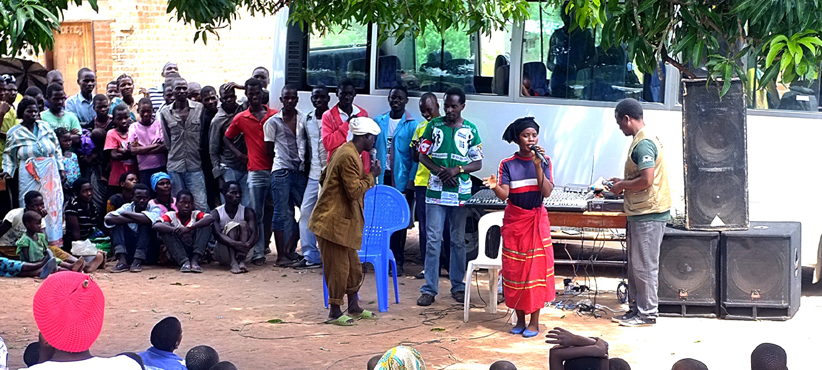

**TRAINING PACKAGE FOR USING SOCIAL SCIENCE IN COMMUNITY ENGAGEMENT AND/OR COMMUNICATIONS ACTIVITIES**

**SESSION 4.9:** Community feedback mechanism:   
Design and data collection

SESSION CONTENT

**Learning approach:** Real-time presentation, individual and group exercises, case examples

**Delivery mode:** Online and offline, 150 minutes approx.

**Essential sessions to have completed before this session:** 1.1, 4.1, 4.4, 4.6

**Summary:** This session focuses on the application of qualitative approaches to design and manage a community feedback mechanism. It introduces community feedback and explains its role in a response, and describes how to set up and collect community feedback data using examples from the Red Cross. This session links the IFRC Community Feedback Kit to the social science operational research context.

**Learning outcomes:**

* Become familiar with community feedback data and its role in public health emergency responses
* Be able to describe or set up a simple feedback system
* Become familiar with methods to collect community feedback

FACILITATING THE SESSION



**TRAINING PACKAGE FOR USING SOCIAL SCIENCE IN COMMUNITY ENGAGEMENT AND/OR COMMUNICATIONS ACTIVITIES**

Introduction: (5 minutes total)

Talk through session summary and learning outcomes.

Position this session in the question flow. Explain that this module mainly addresses question area 4 and 5,   
but we will touch on 1, 2, 3 and 6.

1. How to ensure that this information goes back to communities? To inform community-level actions and decision-making of the broader response?
2. What methodology and tools should be used to collect and analyse this information?
3. How to track the information used to ensure that it effectively contributes to operational and strategic priorities?
4. Who can collect this information?
5. Does this information already exist? Is there a related needs assessment or study?
6. What information is needed?

**DATA TO ACTION:**

Key questions in social science research

1. Who needs this information?
2. How to ensure that the information is used to make operational and/or strategic decisions?

Introduction to community feedback & feedback mechanisms (20 minutes total)

**REVIEW SESSION 4.4**



In session 4.4 we talked about community feedback as a qualitative research methodology –

Community feedback: Using the example of IFRC’s community feedback process, Red Cross volunteers collect the comments and questions that come to them during their routine community engagement activities. These are then transcribed in batches. Qualitative thematic analysis is applied to each batch. This is coded, usually in a standardized way, to enable changes in the information collected to be tracked over time. You can read more in the case study [here](https://opendocs.ids.ac.uk/opendocs/handle/20.500.12413/15423) or refer to **Handout 2** from Session 1.1. Baggio, O. (2020) Real-Time Ebola Community Feedback Mechanism, SSHAP Case Study 10, UNICEF, IDS and Anthrologica.

We base this section partly on the IFRC Community Feedback Kit. For further reading see the “further resources” section at the end of this document.

|  |  |
| --- | --- |
|  | Question to participants (5 minutes):  What do we mean by community feedback?  Online: Invite the participants to write the answers in the chat function and summarize  Offline: Ask two or three participants to share their answers |

Community feedback is simply any information shared by members of the community we are working for and interacting with.

* Community members may share insights that include questions, suggestions, observations, beliefs, perceptions, concerns and statements of thanks.
* These insights could be shared in different ways: formally or informally, in a structured or unstructured way, directly or indirectly.
* Feedback could be proactively collected, or reactively received when community members wish to share.
* Feedback could be positive, neutral or negative.
* Feedback could be about anything, but we are usually interested in community members’ experiences with the activities we are conducting, the current situation of the community, or other topics relevant to our work, such as health beliefs.
* It is communities’ right to share their feedback with us, and our responsibility to manage and handle it appropriately.

A community feedback mechanism is a way to systematically and regularly listen to and act on what community members share with us, especially while they are receiving support. A community feedback mechanism is organized in a cycle of collecting, making sense of, acknowledging and acting on what’s shared by community members. The system includes different ways (channels) for collecting/receiving feedback, tools for managing, analysing and sharing feedback, and processes to act on the data and inform communities about actions taken.

Community feedback is an essential part of all response operations, including risk communication, community engagement and emergency response operations. By recognising, respecting and valuing local knowledge, community feedback mechanisms are an opportunity to build and maintain trust with communities and accountability to them. Organizations have an obligation to listen to community members and respect their right to give feedback. More specifically, community feedback can be used to answer both operational and theoretical social science research questions or as a monitoring and evaluation tool. It’s a source of information to triangulate or combine with other sources in the response. Community feedback can complement other methods to validate their findings, explain further, or offer a divergent perspective. Community feedback is often used in cross-analysis with other social sciences.

|  |  |
| --- | --- |
|  | **Case example: Understanding community perceptions  on COVID-19 in Ukraine**  During the COVID-19 response, the Ukrainian Red Cross (URCS) set up a new feedback mechanism to better understand the perceptions of community members on COVID-19. Communities were asked to share the main observations, beliefs, questions, concerns or suggestions they hear in their communities about COVID-19, as well as to share the feedback on the URCS response to COVID-19. The feedback was collected through several channels, including face-to-face surveys, focus group discussions, phone calls, and community meetings. The feedback was used to improve the way the Red Cross supported the COVID-19 response, including updating communication plans, finding new ways to engage communities, working with media to better reach communities and make sure they receive the information they need, coordination with key health actors and sharing feedback findings with them. You can access reports relevant to this work [here](https://communityengagementhub.org/wp-content/uploads/sites/2/2021/04/UPD-Com-Feedback-report-URCS-Dec-2020.pdf) and [here](https://communityengagementhub.org/wp-content/uploads/sites/2/2021/11/URCS_COVID-19_Survey_-Highlights_Final_EN-2.pdf). The Ukrainian Red Cross has since developed its own feedback policy which ensures a systematic and consistent approach to how community feedback is handled, shared and responded to across the National Society.  Reference: IFRC Feedback Kit, Module 3 (Feedback Essentials), Section 1.6. |

Figure 1 below visualizes the 6 stages of the Community Feedback cycle. In this session, we will cover stage 1 and 2: Design and data collection. In Session 4.10 we will learn about consolidation, prioritisation, and analysis. Session 7.2 covers sharing, taking action and closing the loop.

Figure 1: The Community Feedback Cycle

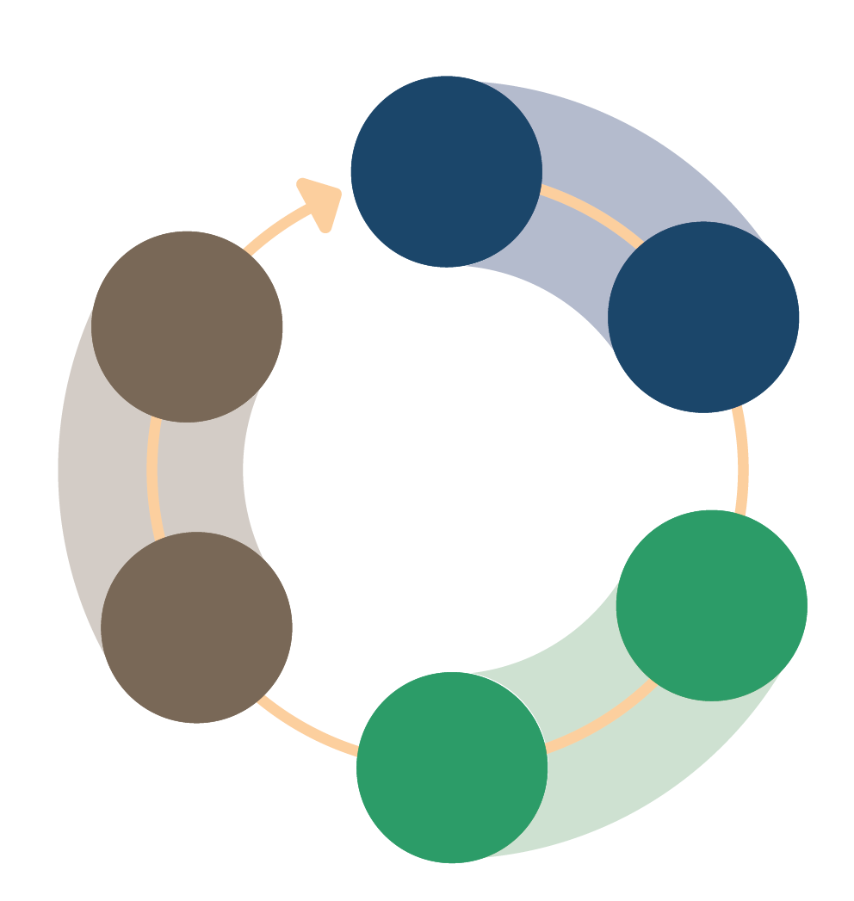

1.

Design

2.

Data collection & initial response

3.

Consolidation &

prioritisation

4.

Analysis

5.

Sharing   
&  
taking action

6.

Closing   
the loop

Key considerations of community feedback mechanisms

Community feedback mechanisms take a participatory, collaborative approach. This means involving community members in the design, collection, prioritization, analysis, sharing, action and final outcome of the feedback provided. Rather than an “us and them” mentality, community feedback involves diverse perspectives, with affected communities and responders working together.

Community feedback mechanisms play a role, whether formal or informal, in public health and emergency responses. Sometimes this role involves social science research. When feedback mechanisms are applied to answer social science operational research questions, community members are part of the research team. Community feedback data are owned by community members and feedback is ultimately addressed by the community, in that it triggers actions by and within the community. At its core, community feedback involves respectfully listening to community members and supporting them to make changes.

Community feedback analyses take a qualitative or mixed methods approach. Open unstructured feedback is best analysed using a qualitative method. Perception surveys, which have a mix of quantitative survey questions and open answer options, need both analysis methods (qualitative and quantitative) to make sense of the data.

Community feedback is a two-way street:

* When feedback mechanisms are in place, we need to act on what we receive, which includes both the positive and negative.
* Acting on feedback means discussing what is going well, what isn’t going well, and what this means for our ways of working.
* These discussions should include the community, as well as others who are in the position to act on the feedback.
* Once it is clear what needs to happen, this needs to be shared and discussed with those who first contributed the feedback.
* If certain changes can’t be made, make sure the community knows why not. This is to manage their expectations and allow them to plan accordingly.

Functioning feedback mechanisms are:

* Owned by the community: The mechanism is designed, implemented, monitored and evaluated together with the community to ensure it increases accountability.
* Effective: Clear procedures are in place to adequately, in a timely manner, and efficiently, handle the different types of information and ensure feedback is shared and discussed with those who are best placed to act.
* Accessible and inclusive: Regardless of who you are and which channels of communication you are using, you can access the mechanism, share information and expect a response.
* Safe: Feedback data are collected, stored, analysed, shared and acted upon ensuring the safety of the persons sharing the information at all times.
* Confidential: The confidentiality of the person sharing feedback, as well as other relevant parties, is respected at all times.
* Complementary and collaborative: Community feedback mechanisms avoid duplication of other systems and feedback mechanisms which are already in place and working. They make sure to build on, tap into and strengthen already existing structures and activities.
* Transparent: Information about the mechanism and its processes, and how feedback was addressed (or not) is easily visible, accessible, available in multiple formats and frequently communicated.

Community feedback mechanisms, community engagement and the emergency response (40 minutes total)

|  |  |
| --- | --- |
|  | Question to participants (5 minutes):  Why are community feedback mechanisms important to community engagement and/or communications activities?  Online: Invite the participants to write the answers in the chat function and summarize  Offline: Ask two or three participants to share their answers  Review Box 1 (below) and Session 1.2 for additional information. |

Here are some ways that community feedback mechanisms support communication and community engagement during an emergency response:

* Increase accountability to the community
* Provide information on how to mitigate or prevent harm
* Improve quality of programming
* Give opportunities to involve local community members and build capacity
* Monitor activities and react to real-time issues
* Assess needs of communities to build relevant programs that respond to local needs
* Reach out to those who are vulnerable and need the most support
* Understand the context and broader situation
* Evaluate programs and operations to learn for future responses/events, and how to work with communities better

**BOX 1**



**Core questions for community engagement and/or communication activities that community feedback can help answer. Note: Refer to Session 1.2 for additional details.**

* What are people’s needs and priorities and how are they changing?
* Are systems (health, social) functioning, available and accessible?
* What is the degree of trust in services, policies (e.g. public health measures) and information?
* What capacity do individuals and communities have to respond to the crisis?
* What are people’s belief systems, sociocultural norms, and traditions?
* What knowledge and resources do individuals and communities have?
* What are people’s perceptions, attitudes, practices and behaviours?
* What ‘rumours’ or misinformation are circulating?
* What are the existing vulnerabilities and social inequalities?
* What are the existing social networks, informal and formal community leadership structures and social   
  and power dynamics?

Feedback mechanisms can also help answer:

* What are communities’ suggestions on how to improve the response?
* What are existing solutions led by the community?
* What are people’s concerns and questions, and how are they changing?

Feedback mechanisms need information on these RCCE questions in order to succeed:

* How do people prefer to get information and what are their information needs?
* Which languages do people speak and prefer to use with each other and response actors?

***Note:*** These are not the only questions we need to answer before setting up a feedback mechanism. Other important questions may include: Do people feel comfortable to share feedback? What are their suggestions to share feedback? How do they want to be involved in the process? More to come later in this session.

|  |  |
| --- | --- |
|  | Question to participants (5 minutes):  Why are community feedback mechanisms important to emergency responses, humanitarian and public health programming?  Online: Invite the participants to write the answers in the chat function and summarize  Offline: Ask two or three participants to share their answers |

Here are some ways that community feedback mechanisms support emergency responses, public health programs and the humanitarian sector:

* Course-correcting actions
* Providing a continuous iterative improvement process
* Improve quality and effectiveness of programmes and response work
* Ensure that services are responding to needs

Here are some links with public health and humanitarian emergency response issues (Session 1.1):

* To identify potential gaps or tensions between how the response is being designed and delivered and how communities see and interpret it.
* To understand local priorities for action, even where they contradict with the priorities of emergency response operations.
* To identify local capacities, resources, resilience and current actions.
* And ultimately, to use this information to adapt the design and delivery of services and the way response actors engage with communities throughout the response.

Community feedback and the Humanitarian Programme Cycle

Community feedback mechanisms can inform all five elements of a humanitarian response, depicted in the figure below.

Figure 2: The Humanitarian Programme Cycle

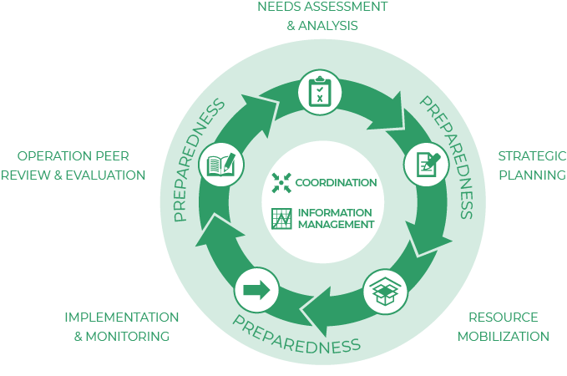

|  |  |
| --- | --- |
|  | Question to participants (5 minutes):  Where and how can we collect community feedback data? What are some examples you’re familiar with?  Online: Invite the participants to write the answers in the chat function and summarize  Offline: Ask two or three participants to share their answers |

Examples of where and how to collect community feedback include:

* Community engagement activities (e.g. door to door awareness raising, radio talk shows or community events)
* Social media monitoring
* Perception surveys
* Feedback boxes
* Observation notes (see Session 4.4)
* Questions to WhatsApp groups or radio shows
* An informal conversation with a staff member
* Via a phone call to a call centre
* In the form of responses to structured surveys

Feedback channels: People communicate in different ways

The ways we collect insights and experiences shared by community members are called feedback channels. Feedback channels need to be diverse to make sure everyone has a fair chance to be heard.

Channels can include:

* Face to face interactions, e.g. via a helpdesk, during community meetings or focus group discussions, in-person surveys or interviews.
* Phone calls, e.g. via a hotline, phone surveys or interviews, radio show with call-in, or interactive voice response.
* Voice recorder, where the deviceis placed in a safe place for community members to use it independently.
* Written or visual communication, which can beonline, e.g. e-mails, social media, chat bots or other online messaging applications; or offline, e.g. letters, feedback boxes, SMS messages.

We can collect feedback reactively (waiting for people to come give their feedback) or proactively (asking or actively soliciting feedback). It’s best to have a mix of both.

|  |  |
| --- | --- |
|  | Group exercise (10 minutes):  Split the participants into two groups  Group 1: What are some examples of reactive (unsolicited) ways to collect feedback? What are their advantages and disadvantages?  Group 2: What are some examples of proactive (solicited) ways to collect feedback? What are their advantages and disadvantages?  Online: Invite the participants to write the answers in the chat function and summarize  Offline: Ask two participants from each group to share their answers  Reactive (unsolicited) feedback channels  People contact us when they have feedback to share  Example channels:   * Hotline * Helpdesk * Suggestion box   Advantages:   * Available when people need to use it * Can capture feedback on anything   Disadvantages:   * If people don’t use the system, you don’t get any feedback * Needs to be advertised   Purposes best suited for:   * Fixing issues timely (e.g., issues with cash transfers) * Providing needed information * Confidential handling of sensitive feedback   Proactive (solicited) feedback channels  We actively solicit feedback by asking questions  *Example channels:*   * Focus group discussions * Perception surveys * Key informant interviews   Advantages:   * Can collect feedback on specific topics * People might not come forward to share feedback otherwise   Disadvantages:   * By asking specific questions, you might miss feedback on other topics * People might not be able to report issues when they need to   Purposes best suited for:   * Understanding the community * Meaningful two-way dialogue * Monitoring key metrics   Most feedback channels can be used for both ways of collecting feedback. For example, call centres can receive calls but also conduct phone-based surveys; household visits can be used for asking specific questions, but also for recording unsolicited feedback.  *Refer to* ***Handout 1*** *for additional details.* |

Stage 1: Set up and design your community feedback mechanism (70 minutes total)

Next we will go through the community feedback cycle.

The figure below visualizes the different steps of designing and setting up a community feedback mechanism.

Explain the steps in red squares in the figure below, that lead up to the Community Feedback Cycle. Refer to **Handout 2**.

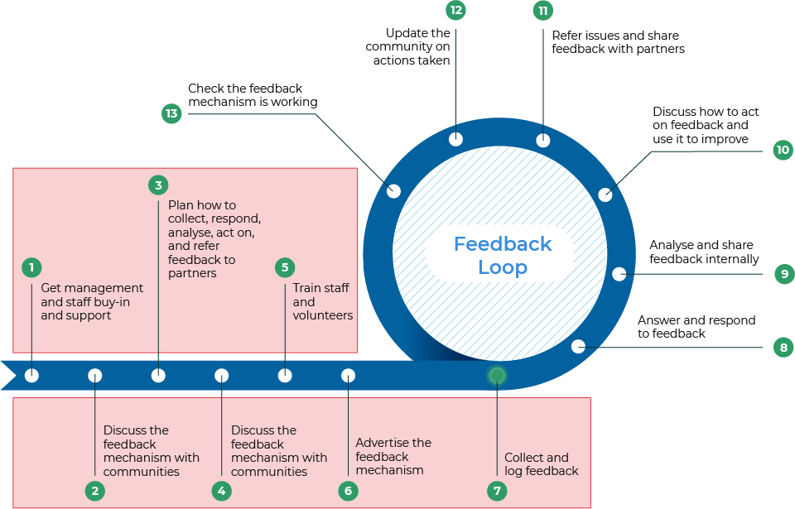Figure 3: Setting up and running a [Community Feedback Mechanism](https://communityengagementhub.org/wp-content/uploads/sites/2/2019/06/20211020_CEAGuidelines_NEW1.pdf).

Design of a Feedback Mechanism:Get buy-in from the community, management and key teams. Determine what kind of information is already received by the community, what additional channels might be required (based on the context and the community preference) and plan the feedback process together with the community. Clearly identify the processes to collect, manage, and share the community feedback and the roles and responsibilities of everyone involved.

Steps for setting up and designing your feedback system

1. Get buy-in – You will need staff time, funding and commitment to make changes

* Management
* Key (internal) teams:
* Programme and operations who will act on feedback
* Information management who will manage, analyze and visualize data
* Information technology and logistics for equipment and resources
* Program monitoring and evaluation for coordination
* Protection, Gender and Inclusion (PGI) teams for handling sensitive feedback and Human Resources/Legal Department for investigations
* The community who will be giving feedback:
* Share the plans and involve them
* Relevant partners who may also be collecting feedback, operational social science research, or have an interest

1. Be clear about the scale of the feedback mechanism – Aim for one central mechanism

* Feedback mechanisms must be local-level. They can also be district/branch-level, organizational-level or regional-level.
* Key questions to ask the community and your team:

1. What is the purpose or goal of the feedback mechanism (beyond ensuring accountability)?
2. Where will we be collecting data?
3. Who needs to see what information within my team, organisation, and among external stakeholders?
4. What resources do we need to set this up? What resources are available?
5. What are the long-term needs related to feedback for the community and the local teams?

Figure 4: Visualisation of a community feedback mechanism at the local, branch/district, organizational/operational, and inter-agency or regional scales.

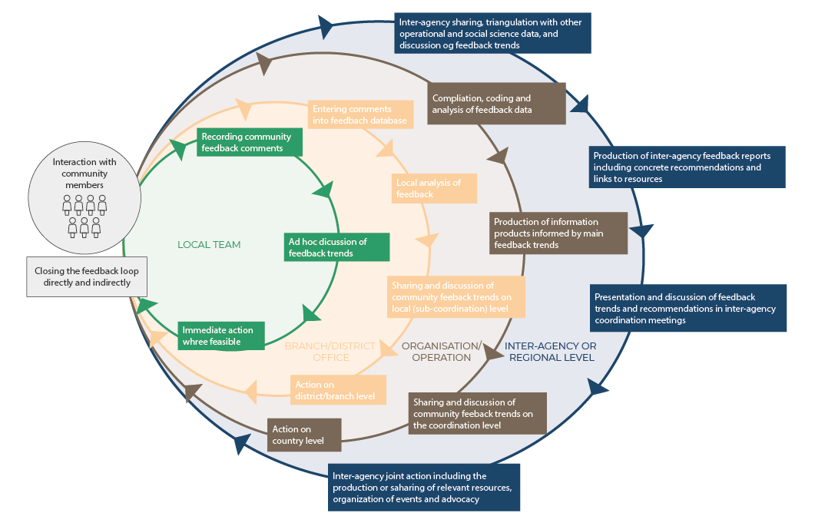

1. Define your communication channels based on what already exists and what’s preferred by your target audience. You will need to think through information provision channels, channels through which to collect feedback, and channels to respond to the feedback.

|  |  |  |
| --- | --- | --- |
| Information Provision Channels | Feedback Channels | Response Channels |
| Are channels through which we can share information about our organisation, partners, programs, and response plans with the communityin the areas where we work. These channels can be used to advertise the feedback mechanism, as well as share requested information. | Are channels through which we collect insights from communities about our work and services, and anything else of importance to the community. This can include broad information about cultural and contextual conditions for the target population. | Are the channels through which we respond to community feedback, usually during our process of “closing the loop.” It is important to remember that channels for collecting feedback are not always the appropriate channels to respond to the feedback. |

Refer to Session 2.4 and 5.2 for choice of communications channels depending on the community and stakeholders.

1. Map and design information flows

* Vital for the success of the system. Otherwise communities are set up for disappointment (refer to do no harm principle in Session 3.1).
* Identify gaps where information is getting lost or stuck.
* Closing the loop – Regardless of how the feedback is managed internally, the outcome is always relayed back to the community or the individual who raised the feedback.
* Sensitivity and criticality – The information flow is dependent on the kind of feedback you are receiving from the community. There will be different processes for handling sensitive, critical, project/operational, and ‘big picture’ feedback.

1. Agree on roles, responsibilities and timeframes

* Go through each step of the feedback cycle and consider:
* Who is already doing this work?
* Who has the capacity to fill gaps and/or reinforce what is already happening?
* Who can play an enabling or supporting role?

Decision-making should be carried out by community members as much as possible, so that decisions are made locally and quickly.

The table below lists key roles and responsibilities within a community feedback mechanism. Keep in mind that one person can carry out multiple roles and responsibilities. Community members may also be operations staff, for example.

|  |  |  |
| --- | --- | --- |
| Feedback collectors | Feedback manager | Leadership |
| * Document feedback * Respond as soon as possible, even immediately * Often recruited from the community (local staff and volunteers) * May have a dual role in programmes/operations | * Day-to-day management of database * Quality assurance, data analysis, systematic sharing of findings * Ensuring follow-up | * Support widespread feedback use and adaptations * Amplify community voices and advocate |
|  |  |  |
| Programme or operations staff | Human Resources and Prevention of Sexual Exploitation and Abuse | Security |
| * Adapt programs based on community feedback * Answer community questions and give updates * Support staffing * May play a role in data collection | * Oversee safe and appropriate handling of sensitive feedback * Support staffing | * Handle and advise on security concerns raised in feedback |
|  |  |  |
| Information management, Performance measurement, monitoring and evaluation | Data management support | Community |
| * Set up data collection, analysis and presentation of results * Make links with other data | * Data entry into Excel or another database * Cleaning data and quality assurance * Coding data * Important for larger-scale feedback systems | * Share feedback * Discuss findings and answers to questions or actions taken * Make decisions together to adapt programmes * May play a role in data collection |

In general, routine feedback should be responded to within two weeks, or ideally within a few days. Sensitive and critical feedback should be acted on immediately (within a day). This includes acknowledging the person who submitted the feedback and explaining the next steps to them. For more on sensitive and critical feedback, see Session 4.10.

1. Identify resources you will need based on the roles and responsibilities identified. Think through:

* How many people will be needed on the team? Who might be available? (Human resources)
* Keep protection factors and the diversity of your team in mind. By ensuring that your team is diverse, for example gender-balanced and inclusive of minority language speakers, it’s more likely that the community will be able to communicate with and trust in your team. The feedback mechanism will become more accessible. Diversity will also strengthen the quality of your data and the interpretation of your results.

Tip/lesson learned: Dedicate at least one staff member to drive and manage all steps of the process

* Consider the skillsets of your team as well (social science research)
* What materials or tools are needed? How could they be obtained? (Material support)
* What expertise and training will the team need? (Technical support)
* What budgets will be needed to obtain additional resources? (Financial support)
* Build a budget for the feedback mechanism

1. Design data collection tools and processes

Keep ethics at the forefront of your design (see Session 3.1 for additional details). Reminder:

* Do no harm – assess the risks and benefits of your feedback mechanism for community members, and explain these to community members.
* Respect for persons – community members have a right to give feedback, a right to withdraw from giving feedback at any time, and a right to privacy and confidentiality.
* Justice – select participants equitably and ensure many perspectives are represented.

To apply these ethical principles, incorporate informed verbal consent into your feedback mechanism: explain why any information is recorded or written, and explain what feedback is and why it’s being collected to any community members who are involved.

Keep your data collection tools and processes simple and small-scale to start. Start with 1-2 channels and a few feedback collectors. You can monitor how things go and decide when to scale up the mechanism when things are running smoothly.

Plan for experienced volunteers and staff to become trainers (capacity-building). Then once the mechanism is running smoothly, start to scale up. Constantly evaluate which channels are most comfortable for the community since they can change at any time. Think about when you will have enough feedback data for a meaningful analysis, and when you will have more than you could analyze or use. An effective, ethical feedback mechanism will stay within these bounds.

The methods you’ll use to analyse your community feedback will be primarily qualitative (see Session 4.4 and 4.6).

The channels you use to collect feedback will influence what type of feedback data you receive: open feedback or structured feedback. These are described in the table below:

|  |  |  |
| --- | --- | --- |
|  | Open feedback | Structured feedback |
| General description: | Listening to feedback from communities about community priorities | Actively soliciting feedback from communities about specific topics |
| Feedback shared: | Formally and informally | Formally |
| Channels and activities for collecting this kind of feedback: | Community meetings, interactive radio shows, hotlines, discussions after community events, informal conversations during daily activities, etc. | Perception or Knowledge, Attitude and Practices (KAP) surveys, focus group discussions, key informant interviews, social media polls, etc. |
| Topics covered: | Any topic the community wants to comment on | Topics pre-determined by aid organization |
| Timing: | Open and varied, whenever community members want to share | Specific times pre-determined by aid organization |
| Type of data generated by feedback: | Qualitative data | Qualitative data and/or quantitative data |
| Useful for: | Understanding the thoughts and priorities of communities in real-time | Answering specific questions that can help to design programs, activities, and strategies |

For an example of a Community Feedback Form, please refer to **Handout 3**.

Understanding the sample of feedback you will analyse

Sessions 4.3 and 4.4 discuss quantitative and qualitative sampling methods. In social science research, because we can’t realistically ask every single person to participate in our research, we use sampling to conduct research with a smaller group of people, and then we apply those findings (generalize) to a subset of the community.

Community feedback is slightly different, because community feedback is collected alongside response operations and activities. The sample is partly determined by who your organisation interacts with and serves. It’s important for data collection to be independent enough from programmatic activities, to be able to be scaled up or down as needed.

Monitoring and understanding how different groups within your community are represented in the feedback is important. This way, you can ensure that you are hearing from all layers and perspectives of the community. For example, hearing from community members across age groups, genders, geographic areas or language groups may shed light on very different impacts of an event or emergency. If you find that you are not hearing from one group, especially those who are more vulnerable or marginalized due to the power structures in your context, you could proactively adjust your data collection strategy to reach them.

Key questions to ask your team when setting up data management tools and processes:

* How will you document the feedback collected from different channels?]
* E.g. Mobile devices, paper forms, direct entry into a database
* How will informed consent be ensured? (Refer back to Session 3.2)
* What tool will be used to document the feedback?
* Mock up a simple form, create a database, or set up the required software
* How will you decide how much feedback to collect, and when there is enough or too much to analyse?
* This applies to proactive feedback collection
* It’s called a sampling strategy
* How will sensitive feedback be handled?
* It should be stored and addressed separately to protect privacy and confidentiality
* Sensitive feedback can be more time-sensitive and should be prioritized (see Session 4.10)

These questions translate to the following steps:

* Create data management and collection tools
* Test these tools with your data collectors and with community members. Ask how easy these tools are to use and understand.
* Develop your sampling strategy
* Document standard operating procedures that give instructions for each of the data collection and management tools, including roles, responsibilities, and timeframes
* Test your processes for handling sensitive data

|  |  |
| --- | --- |
|  | Individual exercise (10 minutes):  Explore the following community feedback data collection and management tools. Refer to **Handout 3, Worksheet 1,** and **Worksheet 2.**  In case you will be collecting the feedback using paper forms, this example form can be useful: [Example form for recording open community feedback on paper](https://docs.google.com/document/d/1qY61yuvN4qjHPyu8sniWmkMDeB9a6mdT/edit?usp=sharing&ouid=109473232721131860036&rtpof=true&sd=true) (**Handout 3**).  If you will be using mobile devices to record the data, the following KoBo form may be of use: [Example form for recording open community feedback using a KoBo survey](https://docs.google.com/spreadsheets/d/1cNpWl0Eraev-FJy0QHakl2qh9VqUYXFw/edit?usp=sharing&ouid=109473232721131860036&rtpof=true&sd=true) (**Worksheet 1**).  For consolidating the data in an Excel file, or directly entering the data in a logbook, you can use and adapt the following Excel logbook:  [Example Excel logbook for community feedback](https://docs.google.com/spreadsheets/d/14VSl2D5XWvmeH3ZXahMbQvWIO1szyPp1/edit?usp=sharing&ouid=109473232721131860036&rtpof=true&sd=true) (**Worksheet 2**).  Online: Invite the participants to share their reflections in the chat function and summarize  Offline: Collect answers from the group and discuss |

You can find additional data collection tools for open, unstructured feedback and for perception surveys in the [IFRC Feedback Kit.](https://docs.google.com/document/d/1PJNUfW8Cr2u8Ew8pK_1fKYJOtqGlxrLZRso9DpyiZ8w/edit?usp=sharing)

1. Train and brief your team

Everyone involved in the feedback mechanism needs to know how it works and their role in the mechanism. This way, they can more accurately explain it to the community. Feedback is meant to improve the organization, and not to criticize anyone’s individual work.

Training should include:

* Listening and communication skills
* Qualitative data collection
* Protection and prevention of sexual exploitation and abuse
* (If applicable) data entry and computer skills
* Analysis and presentation skills
* The overall functioning of the feedback mechanism
* Essential information on the context you are working in (e.g. public health measures if you’re working in a health emergency)
* Practice sessions on answering the community’s questions or saying “I don’t know”
* When and how to flag critical or sensitive feedback

Plan refresher trainings as the emergency (and your feedback mechanism) evolves. Plan to debrief with data collection teams to learn how your processes can improve. Offer psychosocial support, should they need it, since community feedback can include emotionally and morally difficult topics.

*Refer to module 4.4, “Key informant interviews” section for best practices for collection of open community feedback.*

1. Promote the feedback mechanism within the community and your organization

This is essential for communities to be able to give feedback. Use communications channels commonly used by the community.

Key messages can include:

* Communities have a right to give feedback
* Positive, neutral and negative feedback are welcome since they help organizations improve
* There will be no foreseen negative consequences if people complain
* (Based on the design of your feedback mechanism) where responses will be shared, and the timeframe for sharing responses (closing the loop)
* Sensitive or serious complaints will be handled safety and confidentially

Brief all staff and volunteers in your organization on the functioning and purpose of the feedback mechanism, and why it’s important. Include information on how community members can access the feedback mechanism.

Stage 2. Collecting community feedback (5 minutes total)

Feedback Collection: Feedback from the community can come through a formal channel (like a hotline or suggestion box) or through informal channels (like conversations with staff during other activities). No matter what form of feedback, it needs to be collected, recorded, and processed. This also means recording information about when and where it was collected and some information about who the feedback came from.

Once your feedback system is set up, and data collection is underway, remember these key principles:

Listen to and acknowledge community members

* Refer to the active listening tips in Session 4.4 and review **Handout 4** – Important skills for effective listening
* Communicate with community members using their preferred language and in a setting where they feel safe
* Acknowledge the feedback by thanking the person, addressing the feedback if possible, and letting them know how and when they can expect a follow-up

Ensure informed consent before collecting any information (including writing or recording)

* Explain what feedback collection is, what information you’ll be recording (and what you’ll be leaving out), how the data will be used and let the person know they can choose not to give feedback or to anonymously give feedback
* Check that the person understands and ask if they have any questions

Use the tools you developed for Steps 1-9

Give an initial response to feedback, where possible

* Ask for contact information for follow-up, if appropriate
* To help feedback collectors respond, consider developing the following tools:
* A repository of key information including answers to frequently asked questions
* A list of services and activities
* A referral framework
* “I don’t know” is an acceptable response as well, and is much preferred over giving a false or misleading answer

Completing the community feedback cycle (5 minutes total)

The next stages of the community feedback cycle are covered in sessions 4.10 (Stages 3-4) and 7.2 (Stages 5-6).

Consolidation & prioritisation: Some feedback comments might be addressed immediately; others might have to be escalated to program teams or leadership. Once feedback has been recorded, you need to sort and treat the different types of feedback according to the nature of the feedback (level of sensitivity or criticality).

**Analysis:** Feedback needs to be analysed for immediate action and understanding longer-term trends. You group the feedback comments to identify the main topics that community members shared with you and see if there are differences in the feedback shared by specific groups of people or changes over time. You also compare the findings with other information sources to understand the bigger picture.

Sharing & taking action:The most essential step of the feedback cycle is gathering together to discuss what you have been hearing, what it means, and what you can do to address it. To facilitate this process, you need to share and discuss the findings with those who are in the position to act on the feedback. This includes internal discussions, external discussions (with peers and others) and, importantly, meetings with the community.

Closing the Loop:To close the feedback cycle, you document the agreed action points and provide updates on what has been done with the feedback to the community.

FURTHER RESOURCES

|  |  |
| --- | --- |
| **Step 1-9** | **Resource** |
| 1 | [Tips for creating leadership buy-in](https://docs.google.com/document/d/1HVU8jd1XH9ttTW-ANSlKn6w0383M4w8V/edit?usp=sharing&ouid=109473232721131860036&rtpof=true&sd=true) |
| 2 | [Community feedback – Why bother?](https://docs.google.com/document/d/14Xt91CRTGniZXr2S5dYP-F8KUMsE0JzT/edit?usp=sharing&ouid=109473232721131860036&rtpof=true&sd=true) |
| 2 | [Do you want people to trust you? Start by listening](https://communityengagementhub.org/wp-content/uploads/sites/2/2020/06/EN-Listening-Zine-FINAL.pdf) |
| 3 | [Communications methods matrix](https://communityengagementhub.org/wp-content/uploads/sites/2/2020/03/TOOL-19.-Communications-methods-matrix.docx) |
| 3 | [Defining communication channels for feedback mechanisms](https://docs.google.com/document/d/1Hp2nQTRcTAXDyhVeKvyxqlCmjVxY3xq4/edit?usp=sharing&ouid=109473232721131860036&rtpof=true&sd=true) |
| 4 | [Mapping the information flow](https://docs.google.com/document/d/1Hi34vhZYczoT0HCxMcFvOsudXRv18vGS/edit?usp=sharing&ouid=109473232721131860036&rtpof=true&sd=true) |
| 4 | [Quick guide: Steps to take when receiving sensitive feedback](https://docs.google.com/document/d/1PNuZiUtqbqoouimoXG9lS2oUpJs9-QYK/edit?usp=sharing&ouid=109473232721131860036&rtpof=true&sd=true) |
| 6 | [Template budget for feedback mechanisms](https://docs.google.com/spreadsheets/d/1HvyrqLmb_4zQX3bhjLZS3uN_DtLPrTbJ?rtpof=true&authuser=evaelisabeth.erlach%40gmail.com&usp=drive_fs) |
| 7 | [How to listen and respond to open community feedback](https://docs.google.com/document/d/1PpQqnYVy-5Lc10A6qh8e2Lp3YfQIlLZZ/edit?usp=sharing&ouid=109473232721131860036&rtpof=true&sd=true) |
| 7 | [Deciding on how to document your feedback data](https://docs.google.com/document/d/1FFn4PdHyS2f8wjbaAl38prRaIq52ttaY/edit?usp=sharing&ouid=116662936400076330863&rtpof=true&sd=true) |

**FOR MORE DETAILED INFORMATION ON COMMUNITY FEEDBACK (IN GENERAL) –**

* [Using Community Feedback to Guide the COVID-19 Response in Sub-Saharan Africa: Red Cross and Red Crescent Approach and Lessons Learned from Ebola](https://www.liebertpub.com/doi/10.1089/hs.2020.0195?url_ver=Z39.88-2003&rfr_id=ori:rid:crossref.org&rfr_dat=cr_pub%20%200pubmed)
* [New Mixed Methods Approach for Monitoring Community Perceptions of Ebola and Response Efforts in the Democratic Republic of the Congo](https://www.ghspjournal.org/content/9/2/332)
* [A Red Cross Red Crescent Guide to Community Engagement and Accountability](https://communityengagementhub.org/wp-content/uploads/sites/2/2019/06/20211020_CEAGuidelines_NEW1.pdf)
* IFRC’s [COVID-19 Community Feedback Kit](https://communityengagementhub.org/resource/covid-19-community-feedback-kit/), which is a list of tools and guidance actors need to set up mechanisms for systematically listening and responding to communities
* [IFRC Feedback Kit](https://docs.google.com/document/d/1PJNUfW8Cr2u8Ew8pK_1fKYJOtqGlxrLZRso9DpyiZ8w/edit?usp=sharing) (Overview)

Wrap-up/summary (5 minutes)

Community feedback is simply any information shared by members of the community you are working for and interacting with. A community feedback mechanism is a way to systematically and regularly listen to and act on this feedback.

Community feedback mechanisms function in a cycle. The six steps in the cycle are:

1. Design
2. Collection and initial response
3. Consolidation and prioritisation
4. Analysis
5. Sharing and taking action
6. Closing the loop

Functioning feedback mechanisms are:

* Owned by the community
* Effective
* Accessible and inclusive
* Safe
* Confidential
* Complementary and collaborative
* Transparent

The phases (A-I) to set up your community feedback mechanism are:

1. Get buy-in
2. Scale the feedback mechanism
3. Define your communication channels
4. Map and design information flows
5. Agree on roles, responsibilities and timeframes
6. Identify resources
7. Design data collection tools and processes
8. Train and brief your team
9. Promote the feedback mechanism within the community and your organization

ACKNOWLEDGEMENTS:

This session was developed by Vivienne Walz (IFRC), Ombretta Baggio (IFRC) and Eva Erlach (IFRC) and is based on materials developed by CDA Collaborative Learning and IFRC. It was reviewed by Elisabeth Ganter Restrepo (IFRC) and Ginger Johnson (Collective Service).