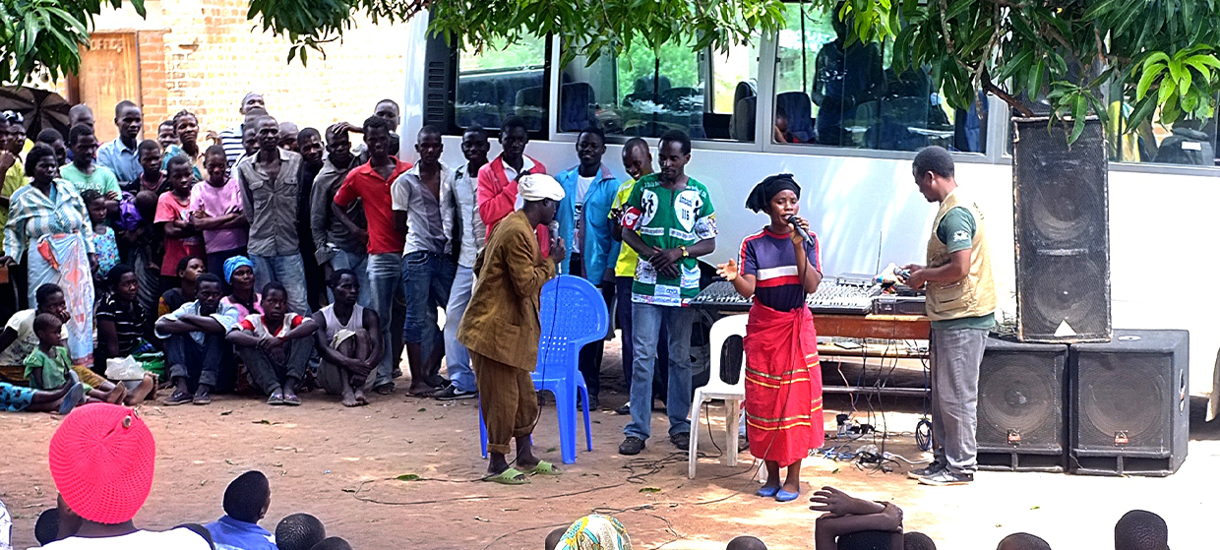

**TRAINING PACKAGE FOR USING SOCIAL SCIENCE IN COMMUNITY ENGAGEMENT AND/OR COMMUNICATIONS ACTIVITIES**

**SESSION 4.8:** Triangulation of data: why is it important and how does it work?

SESSION CONTENT

**Learning approach:** Real-time presentation, individual and group exercises, case examples

**Delivery mode:** Online and offline, 80 minutes approx.

**Essential sessions to have completed before this session:** 4.2

**Summary:** This session teaches how to triangulate social science data with other types of data to generate evidence relevant to community engagement and/or communications activities.

**Learning outcomes:**

* Know the importance of data triangulation
* Understand the steps of triangulating different forms and sources of data

FACILITATING THE SESSION



**TRAINING PACKAGE FOR USING SOCIAL SCIENCE IN COMMUNITY ENGAGEMENT AND/OR COMMUNICATIONS ACTIVITIES**

Introduction: (5 minutes total)

Talk through session summary and learning outcomes.

Position this session in the question flow. The process of triangulation comes into the collection and analysis of data, but existing information can also be used for purposes of triangulation – this session is relevant to both questions 3 and 5.

1. How to ensure that this information goes back to communities? To inform community-level actions and decision-making of the broader response?
2. What methodology and tools should be used to collect and analyse this information?
3. How to track the information used to ensure that it effectively contributes to operational and strategic priorities?
4. Who can collect this information?
5. Does this information already exist? Is there a related needs assessment or study?
6. What information is needed?

**DATA TO ACTION:**

Key questions in social science research

1. Who needs this information?
2. How to ensure that the information is used to make operational and/or strategic decisions?

Defining triangulation (20 minutes total)

In this session we will give a basic overview of triangulation. Further resources will be given at the end of the session for those wanting to know more.

|  |  |
| --- | --- |
|  | Question to participants (5 minutes):  What do we mean by triangulation in research?  Online: Invite the participants to write the answers in the chat function and summarize  Offline: Ask two or three participants to share their thoughts |

Triangulation in research is ‘the practice of using multiple sources of data or multiple approaches to analysing data to enhance the credibility of a research study’. <https://methods.sagepub.com/reference/encyc-of-research-design/n469.xml>

The common types of triangulation in research include:

* Triangulation of investigator: combining different researchers from different sociocultural backgrounds (e.g. researchers from the affected area versus researchers from other countries) who separately analyse the data, and comparing results/findings
* Triangulation of theories/models: approaching data with multiple approaches or disciplines (e.g. anthropology versus political science) and comparing results/findings

Note for facilitator: these first two types can somewhat overlap as investigators often come with their own perspectives and preferred theoretical models (e.g. Behavioural Drivers Model, Health Belief Model, Socio-Ecological Model).

* Multi-site, cross-cultural or cross-country triangulation:combining data from the same topic from different locations, e.g. data on Ebola in Guinea applying to data on Ebola in DRC
* Triangulation of data: combining several formsandsources of existing data sources – for example combining data produced through a social science research project with the latest epidemiological data when conducting an evidence review or synthesis

As noted in Session 1.1, epidemiology makes it possible to estimate the risk of health-related events in a population, to describe it and to consider what might cause it. Epidemiological data and hypotheses can be checked, compared and complemented with social science data. Social science allows us to question and explain how and why different population groups would be more affected than others by a disease, for example because of historical marginalization of the group, or because of sociocultural practices that could favour the onset of a disease.

Triangulation of data might mean combining quantitative data (e.g. surveys) with qualitative data (e.g. FGDs, interviews or observations).

|  |  |
| --- | --- |
|  | Question to participants (5 minutes):  Why might triangulation be important to inform community engagement and/or communications activities in an emergency setting?  Online: Invite the participants to write the answers in the chat function and summarize  Offline: Ask two or three participants to share their thoughts |

During an emergency a lot of different information can be produced, which can seem overwhelming. You probably all have experience of this.

Triangulating this information can help us get to a broader and deeper understanding of a particular issue that does not rely too heavily on one methodological approach, theoretical perspective, researcher’s viewpoint or data source. This is important to:

* Capture different aspects of the same topic to give a more detailed and balanced picture
* Increase the accuracy and trustworthiness of the results

These broader and deeper insights can more effectively guide the design of community engagement and/or communications strategies and actions.

One additional point to note here is that although lots of data is produced during an emergency, it is not always shared. As this session highlights, the sharing of data is a good thing – as long as it is done in a responsible way by anonymizing data (e.g. removing any personally identifying information of a participant) – as it strengthens the overall body of knowledge. Those completing this training should see themselves as a person who can produce and then share their findings with others.

|  |  |
| --- | --- |
|  | Question to participants (5 minutes):  How might we best share data so it can be used by others? Consider your own work setting and what has/has not worked well.  Online: Invite the participants to write the answers in the chat function and summarize  Offline: Ask two or three participants to share their thoughts  Session 5.3 is dedicated to communicating and presenting research findings. |

Data triangulation (15 minutes total)

In this session we will be talking specifically about triangulation of data.

This can include different *forms* and *sources* of data

|  |  |
| --- | --- |
|  | Question to participants (5 minutes):  What type of data might be triangulated in a community engagement/communications setting? You can draw on your own experience.  Online: Blackboard function or invite the participants to write the answers in the chat function and summarize  Offline: Use post-it notes; start with the ones already described |

Facilitator can group the post-its/chat comments into these two categories

* Different forms of data may include:
* Quantitative and qualitative data, e.g. numerical data generated from surveys (quantitative) and textual data generated from focus group discussions, interviews and observations (qualitative)
* Primary and secondary data, e.g. data collected directly on the topic area (primary) versus data which already exists on the topic area (secondary)
* Data on a specific issue gained from speaking with people versus data gained from observing people or measuring people – e.g. what people do vs. what people say they do (which may not always be in alignment)
* Social media posts
* Etc.
* Different sources of data may include:
* Government data
* Data from NGOs, CSOs
* Data collected from affected populations
* Media reports
* Social media
* Academic journals (less likely to offer primary data in an emergency, but can be helpful for secondary data)
* Etc.

For example:

The [Social Science in Humanitarian Action Platform](https://www.socialscienceinaction.org/) worked on an evidence brief around RCCE interventions and health-seeking behaviours in the Rohingya context. See [Handout 1](../Handout/Module4.8_Handout_1.pdf) for a full overview. The different forms and sources of triangulated included:

These different types of data were analysed and then presented together.

In which ways might these different types of data be analysed and presented?

Mava district in Bogoya[1] is reporting a low uptake of the measles vaccination.

1. Different data sets can enrich one another by explaining different aspects of an issue.   
   For example, you have a number of data sets related to attitudes towards vaccination in Mava District and they may highlight different population groups’ beliefs and experiences.
2. One set of data can shed further light by explaining unexpected findings generated in another.   
   For example, one survey data set might find that women in Mava District are reluctant to vaccinate their children and another qualitative data set might be able to explain why this is.
3. They can support or confirmthe findings of the other data sets.   
   For example, your different sets of data might all agree that general mistrust of health systems is related to reluctance to vaccinate.
4. Certain data sets may also disagree with or contradict the findings of the others, which should be looked into more deeply and explored further to figure out reasons for disagreement.For example, one NGO survey might relate this mistrust to health workers asking for money for ‘free’ services, which contradicts another survey published by the local district health team which shows health worker–community relationships to be positive.

Certain types of data may be especially important to triangulate depending on the specific setting. As noted, triangulation of social science data with epidemiological data (including prevalence data) is especially important in health emergencies.

|  |  |
| --- | --- |
|  | Question to participants (5 minutes):  Please give examples of when you have triangulated data in your work. What type of data have you triangulated? What were the different forms, sources, etc., used? Any difficulties?  *Online: Invite the participants to write the answers in the chat function and summarize*  *Offline: Ask two or three participants to share their thoughts* |

Practical steps to triangulate data (10 minutes total)

The process of data triangulation, which is a common type of triangulation used for applied social science, involves the following key steps:

* Identify the relevant sources of data for your area of interest/research question
* Bring together the data sets and organize them in a clearly labelled electronic filing system with folders and sub-folders; initially this might be according to type of data (survey, qualitative etc.) and/or the theme or research question
* Read through the findings of each
* Pull out the findings that relate to your research question and save them in a new document, e.g. a matrix
* Look across the different types of data (cross-check) and ask yourself the following questions:
* Do the data sets enrich each other by explaining different aspects of an issue? Note down how
* Do the different data sets complement each other and shed further light? For example, can one data set explain unexpected findings generated in another? Note down how
* Do the data sets support or confirmthe findings of the others? Note down how
* Do certain data sets disagree with or contradictthe findings of the others? Note down how
* Ask yourself why certain data sets may bring different aspects of a topic to light:
* Who and/or what is the source? (e.g. government data may refute findings generated by a CSO for political reasons). What are the methods and how robust are they?
* What might be strengths and limits of the forms of data? (e.g. observational data show you what people *actually do* whereas interview data may be affected by how people want to present themselves)

|  |  |
| --- | --- |
|  | Question to participants (5 minutes):  Do you have anything to add to this from your own experiences? When two different sources of data have contradicted each other? When one has supported the other?  Online: Invite the participants to write the answers in the chat function and summarize  Offline: Ask two or three participants to share their thoughts |

Finally, when you are reporting, make it clear where the different data sets have come from

Depend on your research, it can also be important to consider the reliability and the quality of each of the types of data you are using (see Session 5.1 for more on quality appraisal).

*When triangulating data in practice, especially more complex data sets, it is advisable to get the input of someone with a technical background in social science research*

In-depth triangulation of quantitative data may additionally include comparing trends across data sets and considering explanatory causes.

The further resources given at the end of this session go further into these steps of triangulation.

The systematic triangulation of data (20 minutes total)

|  |  |
| --- | --- |
|  | Case example  COVID-19 in Pakistan  Read [Handout 2](../Handout/Module4.8_Handout_2.pdf) (10 minutes) |

Summary: In this example, social and behavioural data was collected to monitor the changing situation of people’s knowledge, attitudes and norms around COVID-19. UNICEF established an adaptable mechanism to generate, synthesize and use behavioural and social data to guide the COVID-19 response of the government and partners.

UNICEF, using existing expertise in doing qualitative research, generated data through local and globally developed tools, and triangulated the data with additional quantitative and qualitative information, for example triangulating self-reported responses with observational studies.

Figure 1 shows the different forms and sources of data that were triangulated.

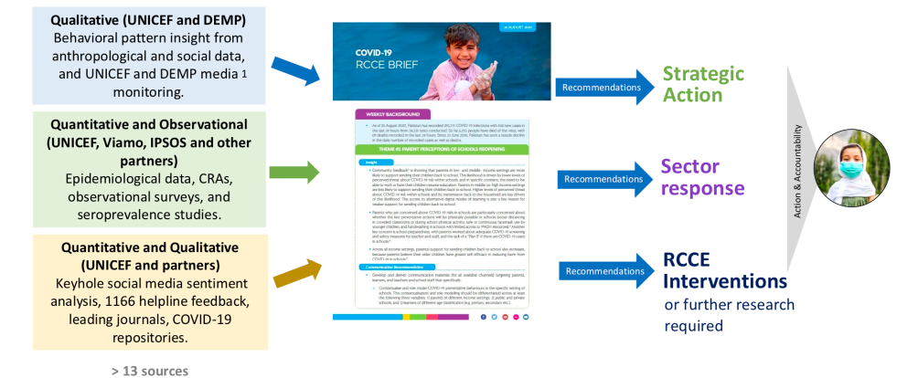Figure 1: Worklow of data sources and translation into action

Quantitative and qualitative data was collected by UNICEF, the Government of Pakistan, NGO partners and other independent agencies and private research companies through surveys, qualitative studies, hotlines such as the Polio Call Centre (now the Polio and COVID-19 Call Centre), social media monitoring, media monitoring, helplines and journals. The types of data expanded over time as the response to COVID-19 evolved.

|  |  |
| --- | --- |
|  | Case example  RREAL RAP (Rapid Assessment Procedure) Sheets  (Re)view [Handout 3](../Handout/Module4.6_Handout_3.pdf) from session 4.6 (5 minutes) |

Findings from UNICEF’s primary qualitative data collection (discussed in above Case example) were recorded in RAP (Rapid Assessment Process) sheets (see Figure 2).

A short video on use of RREAL RAP sheets by the Rapid Research Evaluation and Appraisal Lab (RREAL) can be found [here](https://www.rapidresearchandevaluation.com/resource).

Figure 2: RREAL RAP sheet overview (session 4.6 speaks more on qualitative analysis and RAP sheets)

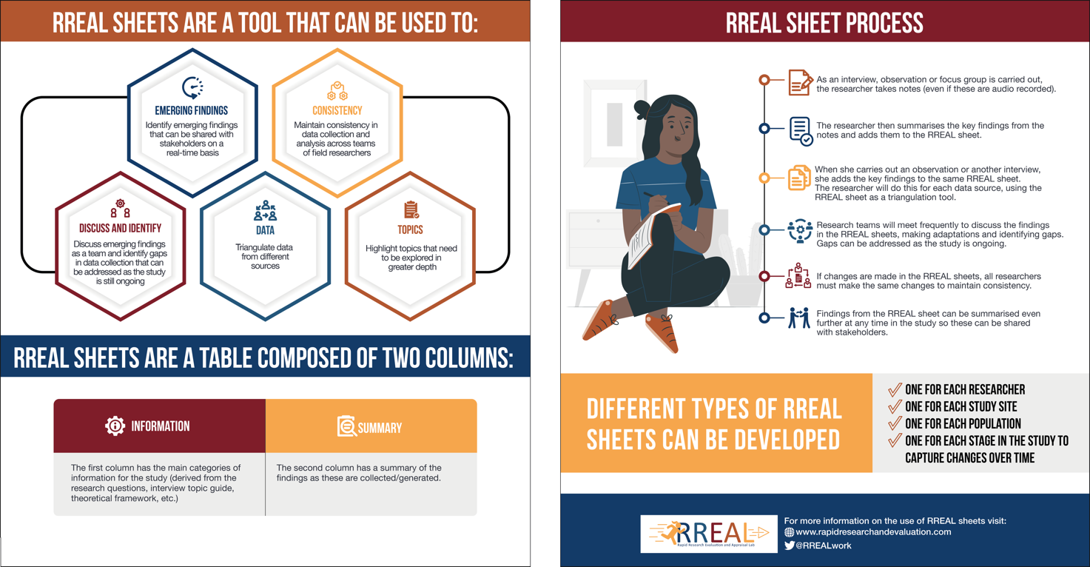

Findings were triangulated across the RAP sheets of each data collector. Findings from these qualitative data collection activities were then triangulated with the other different sources of data to look more deeply into issues such as: differences between reported use of wearing masks vs. observed (much lower) rates, why vaccination rates among women in some locations were significantly lower than for men, and the impact of COVID-19 ‘lockdowns’ on family dynamics and an increase in interpersonal violence.

Ask participants: What were the benefits of triangulating data in this case study?

For the facilitator: Quantitative data based on self-reporting indicated that between 80 and 90% of people were practising actions to prevent the spread of COVID-19, such as mask-wearing and social distancing. The qualitative data suggested that this was not the case, and that compliance was episodic or low overall. Self-reported quantitative data may have overestimated adherence to measures due to participants wanting to seem like they are following socially desirable behaviours when they are not. Later findings from a direct observational study conducted by UNICEF (to further explore these contradictory data sources) confirmed qualitative assessments in by highlighting that people were not always behaving as reported – e.g. 90% had reported wearing masks, but 88% of people were observed not wearing masks. This highlighted the importance of observational studies in triangulating self-reported data with other forms of data collection.

Other follow-up questions/reflection points*?*

Wrap-up/summary (5 minutes)

* Triangulation in research is ‘the practice of using multiple sources of data or multiple approaches to analysing data to enhance the credibility of a research study’.
* During an emergency, a lot of different information can be produced, which can seem overwhelming.
* Triangulating this information can help us capture different aspects of the same topic to give a more detailed and balanced picture and increase the accuracy and trustworthiness of the results.
* We can consider different *forms* and *sources* of data.

**FURTHER RESOURCES WHICH GO INTO THE STEPS OF TRIANGULATION IN MORE DETAIL**



[UNAIDS – An Introduction to Triangulation](https://www.unaids.org/sites/default/files/sub_landing/files/10_4-Intro-to-triangulation-MEF.pdf)

[CDC/WHO – Data Triangulation for Improved Decision-making in Immunization Programmes](https://bidinitiative.org/wp-content/uploads/Data-Triangulation-Overview_BID-Webinar_26May2020.pdf)

Torrance H. Triangulation, Respondent Validation, and Democratic Participation in Mixed Methods Research. *Journal of Mixed Methods Research.* 2012;6(2):111-123. doi:[10.1177/1558689812437185](https://journals.sagepub.com/doi/10.1177/1558689812437185)

* Practical steps to triangulate data include:
* Identify the relevant sources of data for your area of interest/research question
* Bring together the data sets and organize them
* Read through the findings of each
* Pull out the findings that relate to your research question
* Look across the different types of data (cross-check) and ask yourself:
* Do the data sets enrich each other by explaining different aspects of an issue?
* Do the different data sets complement each other and shed further light? For example, can one data set explain unexpected findings generated in another?
* Do the data sets support or confirm the findings of the others?
* Do certain data sets disagree with or contradict the findings of the others?
* Ask yourself why certain data sets may bring different aspects of a topic to light?

ACKNOWLEDGEMENTS:

Theresa Jones and Gefra Fulane (Anthrologica) developed the session content. Ginger Johnson (Collective Service) contributed a case example from UNICEF Pakistan. It was reviewed by Olivia Tulloch (Anthrologica) and Santiago Ripoll (IDS).

1. Fictitious location – to be contextualized