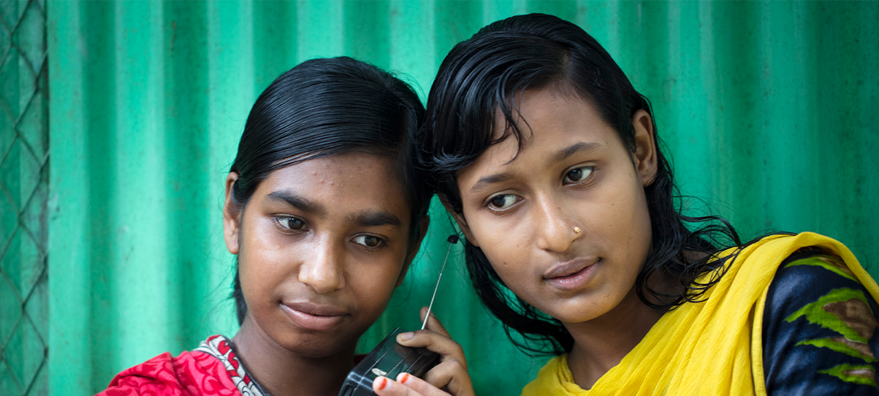

**TRAINING PACKAGE FOR USING SOCIAL SCIENCE IN COMMUNITY ENGAGEMENT AND/OR COMMUNICATIONS ACTIVITIES**

**SESSION 5.2:** How to transform social science data   
and evidence into actionable findings

SESSION CONTENT

**Learning approach:** Real-time presentation, individual and group exercises, case examples

**Delivery mode:** Online and offline, 190 minutes approx.

**Summary:** This session covers how to effectively design research and transform social science data and evidence into findings that can be used to influence policy and practice.

**Learning outcomes:**

* Be able to design research that lays the foundation for actionable findings
* Know how to draw out what research findings actually mean in a way that is helpful to community engagement and/or communications activities
* Be able to transform data into useful knowledge and actionable recommendations

FACILITATING THE SESSION

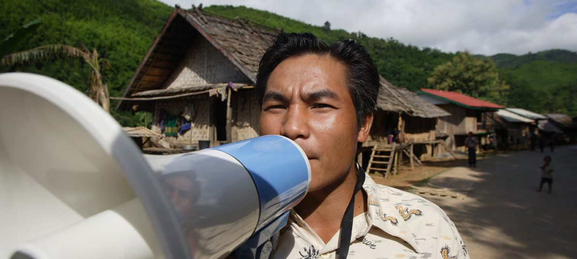

**TRAINING PACKAGE FOR USING SOCIAL SCIENCE IN COMMUNITY ENGAGEMENT AND/OR COMMUNICATIONS ACTIVITIES**

Introduction: (5 minutes total)

Talk through session summary and learning outcomes.

Position this session in the question flow. This session draws upon multiple questions in the research process: earlier on in the research process when considering what information is needed (1) and who needs this information (2); and later in the research process when we consider how the information is used (7). Depending on where the information will be used, it may also have relevance to the question on ensuring community-level action and decision-making (6).

1. How to ensure that this information goes back to communities? To inform community-level actions and decision-making of the broader response?
2. What methodology and tools should be used to collect and analyse this information?
3. How to track the information used to ensure that it effectively contributes to operational and strategic priorities?
4. Who can collect this information?
5. Does this information already exist? Is there a related needs assessment or study?
6. What information is needed?

**DATA TO ACTION:**

Key questions in social science research

1. Who needs this information?
2. How to ensure that the information is used to make operational and/or strategic decisions?

What are actionable findings? (15 minutes)

|  |  |
| --- | --- |
|  | Question to participants (5 minutes):  What are your thoughts on if/how research results are actually used at implementation level? Please share any positive or negative experiences.  Online: Invite the participants to write the answers in the chat function and summarize  Offline: Ask two or three participants to share their thoughts and summarize |

Social science research should produce findings which can be used to improve the coverage, quality and effectiveness of response activities.

Actionable findings are both useful and usable

Useful in that they address critical information gaps (missing information) that a programme/response needs to solve a particular issue, such as to improve acceptance of a service, increase uptake of practices and behaviours, etc.

Usable in that they generate useful information that can be easily transformed and effectively communicated to influence and inform policy and practice.



**Useful**

**Used**

**Usable**

In this way, data can be actively used to inform response practices and/or policies at the individual household, community, services or structural and policy level.

Why do we need to transform data? (20 minutes total)

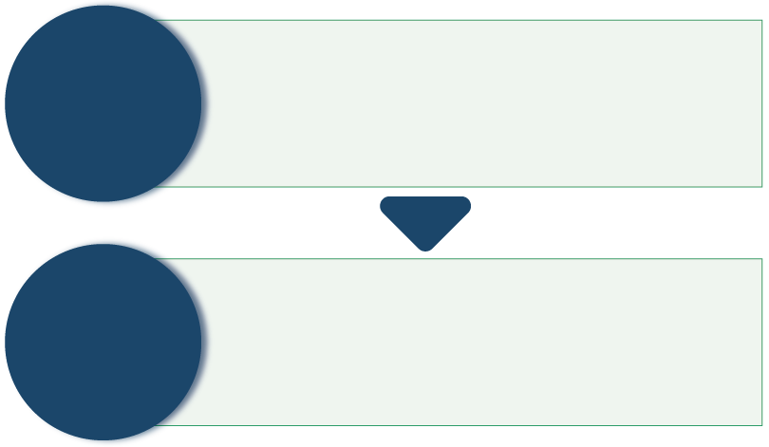

* Raw material that has not yet been analysed and has minimal meaning beyond what is stated
* That which is known about a certain topic/subject
* Data that has been collected and transformed in a way that increases understanding of a certain topic/subject
* Focused down on what is crucial in understanding that topic/subject

**DATA**

**INFORMATION**

|  |  |
| --- | --- |
|  | Question to participants (5 minutes):  What is the difference between data and information?  Online: Invite the participants to write the answers in the chat function and summarize  Offline: Ask two or three participants to share their thoughts |

We need to actively work with the data that we collect to transform it into information that can be used.

|  |  |
| --- | --- |
|  | Question to participants (5 minutes):  What might be some of the challenges to transforming social science data into actionable findings?  Online: Invite the participants to write the answers in the chat function and summarize  Offline: Ask two or three participants to share their thoughts |

Some challenges in transforming social science data into actionable findings include:

A disconnect between researchers and practitioners/humanitarian responders. This occurs when social scientists do not know the critical knowledge gaps needed by a programme or response to solve a particular issue, and therefore data cannot be transformed in a way that is most helpful. Researchers often use other routes to identify knowledge gaps. For example, a researcher may have identified through literature review that a key gap in knowledge is a headteachers’ perceptions of mask-wearing in school initiatives to prevent COVID-19 transmission. Community engagement actors may be instead focused on producing an engagement strategy with parents, and so would benefit instead from more up-to-date information from this group.

Social science approaches recognize the complexity of a problem, reporting from multiple viewpoints. A large amount of multi-layered data can therefore be generated, e.g., looking at response-related issues, social and cultural factors, political and historical factors. Producing short, focused summaries and practical, targeted recommendations and solutions is not always straightforward.

Connected to this, social science research often reveals problems that are political and structural, which can be harder to generate actionable recommendations for. One example is when failures in vaccination campaigns are found to be related to historical marginalization of certain ethnic groups and a resulting mistrust of health system actors.

Response strategies and approaches must be tailored to the local context. As such, considering that some social science research can often produce findings based on a small sample of community members, this can limit how far this data can create ‘action’ for a broader geographic scope. For example, if responders want to create a communications strategy with messaging for an entire district, but the research findings are focused on the preferences of a single sub-group of a single community, then more information would be needed to fill the gaps and inform that strategy.

Steps to transforming data (30 minutes total)

There are a number of key steps that must be considered in order to successfully transform data into actionable findings. These occur at different stages of the research process – even at the earliest stages.

A key takeaway: Think about how your research findings will actually be used **before, during and after data collection!**

1. Begin at the research design stage

* Identify existing knowledge gaps and informational priorities that impact the quality and reach of community engagement and/or communication strategies and activities.

|  |  |
| --- | --- |
|  | Question to participants (5 minutes):  What steps would you take to determine informational priorities for the research that would be useful for your strategies and activities? At what point in the research process would this be important?  Online: Invite the participants to write the answers in the chat function and summarize  Offline: Ask two or three participants to share their thoughts  Facilitator can follow up with the explanation: Although this prioritization step takes place at the beginning of the response, it is important to revisit and reassess these priorities as the research and the crisis response unfolds. Consider current and emerging priorities when analysing the data and framing the findings.  Do not consider research as a ‘one and done’ type of process. Feedback loops of study findings can be built in at key points in the process for real-time decision-making about response strategy and/or activities during an emergency. Or research can be conducted to fill a purpose at a specific time, learn about a new gap, go back and collect additional data to fill that gap, etc. |

In this first research design step, in order to be able to create actionable findings, it is also important to:

* Identify intended usersandensure that those who are designing and implementing community engagement and/or communications strategies, and those working in other important areas of the emergency response, are an active part of the research design and implementation – for example, very often field teams are not involved in the analysis, which can create a gap and lack of ownership of research.
* Understand and communicate with potential users how social science research can help to address the identified gaps (see Module 1).
* Agree on the research questions and map the anticipated changes that the research could influenceat different levels of the emergency response (e.g., individual, community, health services, political/structural).
* Identify resources available to implement recommendations, which may include financial resources, human resources and knowledge/skills of personnel.
* Identify in-country research capacity by mapping existing research and academic networks and institutions, including universities, who can provide further information about in-country research capacity.
* Build your research plan and protocol, study tools and timeline, with clear roles and responsibilities for who will carry it out.
* Get expert support if needed to conduct the research – ideally the research should be done by local and national personnel with additional expertise as needed.

1. Frame actionable research

* Objectives
* These should address operational priorities and cover the complexity of the issue.
* Methodology
* Certain methods may be more effective than others, for example mixing quantitative and qualitative research methodologies so that ‘how many’ and ‘how often’ can be addressed alongside why and how’ respectively (see sessions 4.2 and 4.7).
* Ask action-oriented questions, for example in the context of vaccine uptake:
* Do you intend to be vaccinated?
* What specific concerns do you have over the safety of vaccines?
* What information do you need/want? From whom?
* Is the vaccine available in your area? Where?
* Where would you like to get the vaccine?
* Who would you trust to tell you honest information about vaccines?
* Collect data that can be separated out for different contexts, genders, and age groups, and that it includes those who are more vulnerable and marginalized (i.e. data which can be disaggregated – or split up – to show these differences).
* Analysis
* Make sure you can group data into categories that could include demographics (e.g., age, sex, residency) and thematic areas related to your research questions.
* Narrow your focus on the data that is crucial to understanding the specific subject/situation. For example, if your research is on mask-wearing, focus on the data that is central to this issue only, regardless of whether interesting findings emerged in other areas.
* Consider if a framework and/or related theory can help to analyse the findings in a structured way (see session 2.2 for more information). You may need the help of a social science expert to do this.
* RAP sheets may be useful for quick analysis of qualitative data (see session 4.6 for more information).

*As noted above, you may need the support of someone with a technical background in (operational) social science research at different stages of this process.*

What is the purpose of an evidence synthesis? (10 minutes total)

The purpose often depends on what you want to achieve from the evidence synthesis.

An important first step in the evidence synthesis is establishing a clear aim. The aim can help the review team determine the scope of the synthesis and the best approach to select and review the existing evidence. The scope of a review is normally decided through the development of questions that guide the development of the synthesis. If the evidence synthesis will be used to generate findings that can be translated into changes in policy or practice, it is good practice to involve all relevant stakeholders in the process of defining the research questions.

During a humanitarian crisis an important consideration will be how quickly you can collect the information that you need to synthesize so that it can inform response activities. Your approach should be tailored to the needs and urgency of the situation.

1. Transform analysed data into actionable findings

* Compile and integrate your data with other relevant data (see session 4.8 on triangulation and sessions 6.1 and 7.1 for a case example of Integrated Outbreak Analytics).
* Pull out discrete pieces of information directly related to the priority research questions. For example, ‘parents think X, Y and Z about their children wearing a mask while at school.’ Bullet points can be helpful for clearly organizing this information.
* Draw out why this is important and the *‘so what?’*for the field priorities identified at the outset.
* *‘Why is this important?’* For example, it is important to know how much parents are influenced by the attitudes of other parents because this could help encourage mask-wearing in schools
* *‘What do we do next?’* For example*,* to change the practice, we recommend mobilizing certain parents as ‘Champions’ to promote mask-wearing during their interactions with other parents.
* Wherever possible, discuss these findings with affected communities, or get their input and feedback. See sessions 4.1 and 5.4 for more detailed discussion on this.

1. Transform those findings into actionable recommendations

* Link each key finding to a 🡪 recommendation(s) related to its 🡪 potential impact
* For example, ‘Parents are influenced by the attitudes of other parents towards mask-wearing.’ Parents who are particularly positive about mask-wearing should be engaged as “Champions” to promote mask use. This could help increase uptake of mask-wearing practices.’
* Help the intended users understand:
* ‘This finding is crucial to the outcome of this work’
* ‘There is something actionable we can do about this’
* ‘That action will have impact’
* Make concrete recommendations, and give practical examples or suggestions, for example “Champion” parents can be identified through asking the parents and teachers for recommendations.
* Make the recommendations fit the context and resources available– which you mapped in step 1.

|  |  |
| --- | --- |
|  | Question to participants (5 minutes):  Share examples/experiences/thoughts about giving or receiving concrete recommendations that fit the context and resources available. Why is this important to your work?  Online: Invite the participants to write the answers in the chat function and summarize  Offline: Ask two or three participants to share their thoughts  It can also be frustrating as a programmer to receive recommendations that are out of the scope of programming capacity. This can further alienate research from practice.  Community engagement and/or communications work is often based around community-action and so community-based resources should be central to any recommendations that emerge. |

* Separate recommendations that are easily actionable and can happen in the short term from the recommendations that may take more time and resources to achieve.
* Clearly target each recommendation to a specific user – e.g. which recommendations are for fellow community engagement and/or communications actors, which are for government actors, which are for communities and so on.
* Wherever possible, develop these recommendations jointly with affected communities, or get their input and feedback. See sessions 4.1 and 5.4 for more detailed discussion on this.

1. Communicate them effectively to different audiences

* Session 5.3 covers the effective communication of social science findings in greater detail.

Exercise (20 minutes total)

|  |  |
| --- | --- |
|  | Case example (building on scenario from 1.1)  Ask participants to read through the summary of the research (including the research focus and the intended users of the findings) and the data set summary.  Ask them to transform the data into four or five actionable recommendations (15 minutes)  Summary of the research  You are a researcher supporting the organization/programme ACTRelief, which aims to assist conflict affected population groups in the northeast of Bagara.[1] The population faces several challenges including food insecurity, lack of water and sanitation infrastructure, high prevalence of diarrhoea and malaria, high rates of poverty and limited livelihood opportunities. You were deployed to urgently develop activities for ACTRelief, and other partner NGOs and government actors for them to effectively communicate with the affected population and engage communities and relevant stakeholders with the aim to reduce waterborne disease.  The key research questions included:   * What are the key messages to be delivered to help reduce the spread of waterborne diseases? * What are the key communication channels that service providers should use? * Who are the key influencers that should be involved?   Data set summary:  Key themes and sub-themes to emerge from qualitative assessment (key informant interviews and focus group discussions with community members)  Waterborne diseases:   * Perception that cholera does not exist in the country, that something else is causing the disease and deaths, including a divine sign from God * Shame and stigmatization of the people who had cholera, including rejection by their own communities, sometimes leading to violent attacks on the affected persons * Misunderstanding about the purpose and use of household chlorine as medicines that could be used to prevent or treat cholera   Priorities of the community members interviewed:   * Lack of livelihood opportunities was perceived by male participants as the most important issue * Female participants raised the concern that men who were not working were drinking excessive amounts of alcohol   Trust in service providers:   * NGO actors are generally trusted * ACTRelief had a recent incident whereby promised food relief was delivered late, and this had not been communicated to all community members, so there is some dissatisfaction with these services * Government actors are perceived as doing little to support, but when information is given it is generally believed   Key influencers at community level:   * Local leadership were reported to be influential, although not always the most trusted * For the Christian majority, church leaders and other figures from a local Baptist Church network are both influential and trusted * For the Muslim minority, Imams are the most influential and trusted community members   Preferred communication channels for information from service providers:   * Women – radio, face-to-face/door-to-door * Men – radio, market announcements * Older population groups – radio, market announcements * Youth – market announcements * Marginalized Tia ethnic group – face-to-face/door-to-door   Hygiene KAP survey results:   * Relatively high coverage of latrines (approx. 70%) * Low coverage and use of improved latrines; the majority do not have hand-washing facilities * Low prevalence of hand-washing with soap in adults and children * Drinking water sources not protected * Water from water vendors not clean * Water is not stored or drawn safely at home * Children’s faeces (excrement) are not seen as dangerous * Leftover food not reheated thoroughly, and fruits are not washed before eating * Fruit juices and ice-lollies use contaminated water * Generally poor hygiene among food sellers/cooks * Food is not prepared hygienically for communal gatherings * Failure to wash hands with soap following the preparation of a cholera victim’s corpse (for burial) leads to further transmission * People are scared to disclose sickness or death because of associated stigma * Indiscriminate refuse/trash disposal creates breeding grounds for flies * Delay in seeking treatment for cholera for various reasons   In plenary ask two or three people to share their findings  Facilitator should refer back to step 4 to see if these different components are covered |

Wrap-up/summary (5 minutes)

* Social science research should produce findings which can be used to improve the coverage, quality and effectiveness of response activities. Actionable findings are both *useful* and *usable*.
* We need to actively work with the data that we collect and transform it into information that can be used.
* There are some challenges to this, including:
* A disconnect between researchers and practitioners/humanitarian responders. This occurs when social scientists do not know the critical knowledge gaps needed by a programme or response to solve a particular issue, and therefore data cannot be transformed in a way that is most helpful.
* Social science approaches recognize the complexity of a problem. Producing short, focused summaries and practical, targeted recommendations and solutions is not always straightforward.
* Social science research often reveals problems that are political and structural, which can be harder to generate actionable recommendations for.
* Social science research can often produce findings based on a small sample of community members. This can limit how far this data can create ‘action’ for a broader geographic scope.
* Key steps for transforming data into actionable findings include:
* Begin at the research design stage
* Frame actionable research
* Transform analysed data into actionable findings
* Transform those findings into actionable recommendations
* Communicate them effectively to different audiences

ACKNOWLEDGEMENTS:

Theresa Jones and Gefra Fulane (Anthrologica) developed the session content. It was reviewed by Ginger Johnson (Collective Service) and Kathryn Bertram (JHU).

1. Fictional place and organization – to be adapted