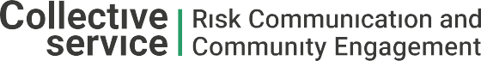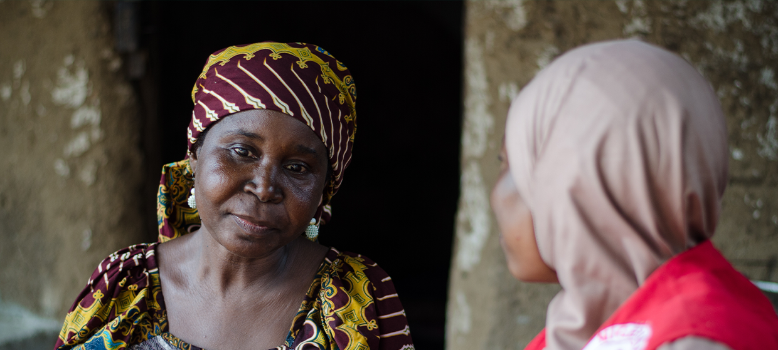

**TRAINING PACKAGE FOR USING SOCIAL SCIENCE IN COMMUNITY ENGAGEMENT AND/OR COMMUNICATIONS ACTIVITIES**

**SESSION 6.1:** Translating social science research into action

SESSION CONTENT

**Learning approach:** Real-time presentation, discussion, case examples

**Delivery mode:** Online and offline, 120 minutes approx.

**Essential sessions to have completed before this session:** 1.1

**Summary:** This session explores how social science evidence can translate to actual change in the planning and roll-out of community engagement and/or communications activities. It discusses key considerations, challenges and practical steps needed to translate social science evidence to action.

**Learning outcomes:**

* Understand what it means to translate social science research into action
* Understand the key challenges and opportunities to effectively translate knowledge to inform programming and/or policy
* Become familiar with practical steps needed to translate evidence to inform action

FACILITATING THE SESSION

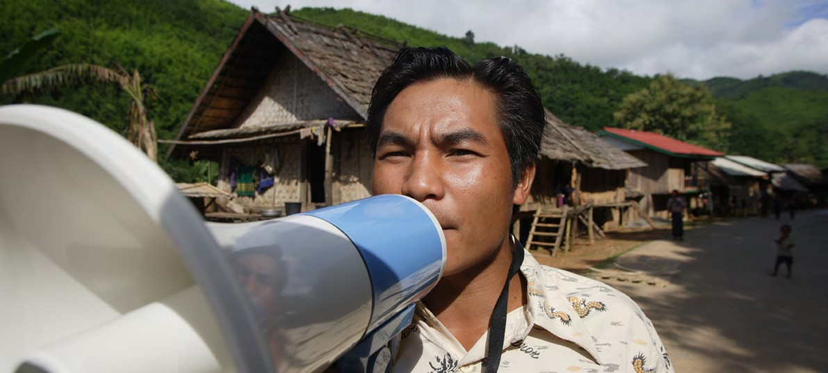

**TRAINING PACKAGE FOR USING SOCIAL SCIENCE IN COMMUNITY ENGAGEMENT AND/OR COMMUNICATIONS ACTIVITIES**

Introduction: (5 minutes total)

Talk through session summary and learning outcomes.

Position this module in the question flow.

1. How to ensure that this information goes back to communities? To inform community-level actions and decision-making of the broader response?
2. What methodology and tools should be used to collect and analyse this information?
3. How to track the information used to ensure that it effectively contributes to operational and strategic priorities?
4. Who can collect this information?
5. Does this information already exist? Is there a related needs assessment or study?
6. What information is needed?

**DATA TO ACTION:**

Key questions in social science research

1. Who needs this information?
2. How to ensure that the information is used to make operational and/or strategic decisions?

How does social science support community engagement and communications activities? – recap (10 minutes total)

|  |  |
| --- | --- |
|  | Question to participants (5 minutes):  In the first module we spoke about how social science research can support the design and delivery of community engagement and communications activities. Can you tell us what you remember?  Online: Note the answers from the chat and read them out loud  Offline: Write the participants’ answers down on flipchart paper |

**To understand** people’s perceptions, values, priorities, beliefs and life experiences, and how these interact with the response to humanitarian needs.

**Example:** Rejection of cremation practices during the 2014–2016 West Africa Ebola outbreak led to an increase in ‘underground’ funeral practice which fuelled the spread of disease.

**To consider** how systems responding to a crisis are organized (e.g. the health system) and which mechanisms (e.g. social protection) and structures (e.g. churches) already exist.

**Example:** Analysing which existing services are being used and by whom could help avoid establishing parallel systems and ensure uptake during an emergency response.

**To understand** how social, cultural, psychological, historical, political and economic factors influence people’s behaviour and/or the functioning of systems responding to the emergency. In particular, to understand people’s perceived risk and level of confidence to handle that risk, either through personal or external action..

**Example:** The decision to have a vaccination can be related to this act symbolizing your broader political affiliation (political), and whether others are doing the same (social).

**To identify** potential gaps or tensions between how the response is being designed and delivered and how communities see and interpret it.

**Example:** During the Ebola response in the Democratic Republic of the Congo, community feedback data collected by Red Cross volunteers. This feedback highlighted strong mistrust of health authorities and a desire by affected communities to be consulted on how the response and services were rolled out. For example, communities requested to: have local health workers they know among the vaccinators (this request was linked to their fear, anxieties and mistrust in vaccination efforts); be able to enter households alongside Safe and Dignified Burial teams to see what they were doing (this request was linked to beliefs that bodies were being mistreated); have a say as to where Ebola treatment centres were constructed. This almost real-time data helped highlight people fears and specific requests made to responders to address those fears and adapt emergency services and actions based on community needs.

**To understand** local priorities for action, even where they contradict with the priorities of emergency response operations.

**To identify** local capacities, resources, resilience mechanisms and current actions.

**Example:** Some partners use the community score card approach (see an example [here](https://communityengagementhub.org/wp-content/uploads/sites/2/2020/04/Engaging-communities-in-Tanzania_-Case-Study.pdf)) to bring policy makers, community leaders, opinion leaders, service providers and diverse community groups to assess existing capacities, vulnerabilities and needs and roll out a participatory planning approach to share responsibilities for addressing needs.

**To use this information to adapt the design and delivery of services and the way response actors engage with communities throughout the response**

In this session we will explore how social science evidence can translate to actual change in the planning and roll-out of emergency response action. This is a step of research that can often be the most challenging. We will discuss key considerations, challenges and practical steps needed to translate social science evidence to action.

What sort of change can social science create? (15 minutes total)

|  |  |
| --- | --- |
|  | Question to participants (10 minutes):  Can you share an example from your work where social science research has been used to inform and adapt the design and delivery of strategies and/or approaches? You can also share examples that you have heard about – either in or outside of this training (e.g. communication around COVID-19 vaccinations in response to data on people’s key reservations).  Online: Note the answers from the chat and read them out loud  Offline: Take two or three examples from the room |

There are different types of change that research can bring about in humanitarian action. These changes can include:

Improved knowledge among policymakers and humanitarian responders, for example about the local context, the impact of the response, whether the response is meeting the needs and matching the priorities of the local population, whether vulnerable and marginalized population groups are included (receiving humanitarian assistance, part of response teams, have a say in decision-making processes etc.)

Strengthened networks or community of practice around a specific research area (e.g. Anthropology Network formed during the West African Ebola response).

Operational change in programming, such as including representatives from the Water and Sanitation Department and from the Health Department in community meetings for cholera prevention.

Strategic change in programming and in policy, such as widening the focus of cholera prevention activities to broader water safety as a result of data collected through observations and focus groups.

We will mainly focus on operational and strategic change in this session. Although community engagement/communications activities will be the focus of the ‘change’, this type of information is also vital to inform other response pillars and technical clusters and/or sectors (WASH, health, food security, protection etc.)

Where can change happen? (5 minutes total)

Change as a result of (operational) social science research can come at different levels:

Change can occur in community engagement/communications-related operations and strategy

* At the local level, the findings can be used to understand who are the trusted information sources among a diverse community who can motivate others to take action. For example, in order to ensure equal access to newly constructed water sources, to share information on eligibility for cash assistance, to encourage timely referral of patients with cholera symptoms to formal health care structures, etc.
* At the national level, social science research can be used to change standing operating procedures or protocols for community engagement/communications and beyond.
* At the global level, operational social science research can be used to inform the content of global guidelines and tools for community engagement, for example in the context of conflict and displacement.

Change can occur across sectors

Social science research applied in community engagement and/or communications activities can create change in the sector in which it is ‘housed’. For example, during the Ebola outbreak in North Kivu, DRC (2018-2020) formative research was used to inform community engagement for the vaccination roll-out. Participatory methods helped to understand public perception of Ebola vaccines among women and other population groups and the results led to the inclusion of pregnant and lactating women within the Ebola vaccination roll-out.

Information for community engagement and/or communications pillars is also vital for operational and strategic thinking in other areas of an emergency response, for example WASH, nutrition, health, shelter etc. Social science research takes a broad perspective, so even when community engagement/communications activities are ‘housed’ for example in the health sector (e.g. for the COVID-19 outbreak), issues relevant to other sectors may be revealed (e.g. increases in domestic violence during national lockdowns).

Change can occur within local systems and networks

Humanitarian disasters affect social and political dynamics at the local level. For example, they can trigger distrust in existing structures, which can result in a range of community-led initiatives and the emergence of new networks. Operational social science research is critical to understand where and why these changes occur, how this affects people’s trust and acceptance of the response and related services, and what can be strengthened and/or altered for positive outcomes.

|  |  |
| --- | --- |
|  | Case example  A participatory research project looking at reproductive health in the wake of a hurricane in a Southern Africa country identified that poor communication between women and health workers, and ‘peer pressure’ from other young women to avoid these appointments was a key barrier for attendance at antenatal appointments. As a result of this research, pregnant women who were involved in the project held meetings with other young women in their community to discuss common points of tension and how to better interact with health workers. |

Useful and Usable (10 minutes total)

So how can this change occur? From evidence that is actionable.

What do we mean by actionable? Actionable evidence must be both useful and usable.

|  |  |
| --- | --- |
|  | Question to participants (5 minutes):  What do you remember from Module 1 on useful and usable information?  Online: Note the answers from the chat and read them out loud  Offline: Examples from the room |

What do we mean by this?



**Useful**

**Used**

**Usable**

Useful: addresses critical knowledge gaps (collects missing information) needed by a programme/response to solve a particular issue, improve acceptance of service, increase uptake of practices/behaviours etc.

Usable: generates useful information that can be easily transformed and effectively communicated to influence/inform practice and policy.

In order to be ‘used’, social science research should produce:

1. Useful information: Evidence that responds to the operational and strategic priorities of those affected by and responding to the humanitarian crisis. This includes evidence in relation to gaps in humanitarian assistance, for example in rural areas.
2. Usable information: Research findings and recommendations that can easily inform practice and policy. They should consider what resources are available to implement any recommendations made, which may include financial resources, human resources, and knowledge/skills of personnel.

These aspects need to be understood and considered from the start of a research project.

Challenges to translating research to action (20 minutes total)

|  |  |
| --- | --- |
|  | Brainstorm (10 minutes):  What are some of the challenges to translating social science research findings into action (broadly define, as above)? Try to think of an experience where social science research has failed to inform and improve humanitarian assistance.  Offline: Small working groups or discussion in pairs  Online: Organize break-out rooms  Reconvene in plenary, note down answers on flipchart paper |

There are a number of challenges to translating social science evidence into action during an emergency response.

1. Producing data and findings in real time. In an emergency there is a need for data to inform decision-making in the here and now. Social science research, particularly certain types of qualitative research, can be a slower and longer-term activity. In our other sessions we have covered social science research approaches that can be rapidly applied in time-sensitive settings; however, this remains a key challenge to turning evidence into action.
2. Standardization versus contextualization. Humanitarian responses should adhere to a set of existing standards and principles (for example, the [Sphere Standards](https://spherestandards.org/humanitarian-standards/)). These standards and principles are often adapted into organizational and/or response-related Standard Operating Procedures (and/or guidelines) that are assumed to be applied across contexts (although it is often a real challenge to adhere to those standards). Social science, on the other hand, acknowledges that each context is unique, and that response strategies and approaches must be tailored to the local context. Operational social science research can produce findings that are only applicable to a specific situation and context, and can therefore be limited in how far they can create broader ‘action’.
3. Priority misalignment – disconnect between researchers and practitioners/humanitarian responders. What is of theoretical interest to a researcher may not match what will best inform the programming and policy decisions of those supporting communities in responding to the crisis. For example, a researcher may have identified through literature review that a key gap in knowledge is headteachers’ perceptions of mask-wearing initiatives to prevent COVID-19 transmission. However, responding actors may be focused on developing an engagement strategy with parents, and so would benefit from more up-to-date information from this group instead of headteachers.
4. Transforming and communicating findings. Social science research outputs can often take the form of lengthy, complex and theoretical reports which may not be digestible and practical for humanitarian responders who have to make rapid decisions. We have covered approaches to transforming and communicating findings (Sessions 5.2 and 5.3), but again this remains a key challenge to turning evidence into action.
5. Rigid programmes. Changing the direction of an ongoing response is challenging as this might, for example, require allocating a budget differently (with implications for different sectors, as evidence could indicate the need for fewer investments in WASH and more funding for shelter), to change the targeting of humanitarian assistance (e.g. increased focus on remote areas), to buy different materials, to invest more in the training and technical support of staff and/or community groups, etc. These challenges are often grounded in already developed response plans and architecture and related commitments to donors. While community engagement and/or communications strategies should respond to people’s evolving needs and priorities as well as changes in the response and context, rigid logframes and lack of flexibility among decision-makers, including donors, can be a major barrier to creating change.
6. Revealing issues or problems that are political and structural, which can be harder to solve. For example, when failures in vaccination campaigns are found to be related to historical marginalization of certain ethnic groups which results in their mistrust of health system actors. Such issues may be things that you can have little control over, even when working through other sectors.
7. Identifying problems and weaknesses which can cause certain audiences to become defensive. This can lead certain ‘users’ of evidence to reject findings and prevent any action being generated. For example, if poor uptake of water chlorination tablets is found to be related to community health workers (CHWs) not having enough fuel to get to remote communities, this may be perceived as a criticism by local health teams, who then reject rather than use this finding.
8. Poor understanding and low perceived value of social science research. Qualitative research in particular may be seen as less trustworthy, while quantitative research (numbers) is often considered as ‘harder’ evidence. Also, some do not know what questions can be addressed through operational social science research. This can lead to resistance to taking up findings. There may also be a false perception of the role of social science, and a belief that social scientists are recruited to make people adhere or ‘convince people to do things’ – which can lead to pushback when this does not happen.
9. Resources to act on findings and recommendations. The ability to integrate findings from research requires resources such as funding and appropriate knowledge and skills. This is why producing recommendations that are actually realistic to the setting and that involve those who are affected by and responding to the crisis is so important.

Practical steps to turning evidence into action (30 minutes total)

|  |  |
| --- | --- |
|  | Brainstorm (10 minutes):  What might be some practical steps to turn social science evidence into action? Try to think of an experience where social science research did inform and improve humanitarian assistance.  Offline: Small working groups or discussion in pairs  Online: Organize break- out rooms  Reconvene in plenary, note down answers on flipchart paper |

A key takeaway is: Think about how the data and research findings will be used before, during and after data collection!!!

Effective research design, framing actionable research through objectives, methodology and analysis, transforming findings into actionable recommendations and then communicating these effectively are all key to translating knowledge to action. We have already discussed steps 1, 2, 3 and 4 in detail in Session 5.3 on transforming social science evidence, and step 5 in Session 5.4 on communicating findings. Now we present the entire process, including the need for an enabling environment which allows findings to inform operational and strategic change.

1. Begin at the research design stage

* Identify existing knowledge gaps and informational priorities that impact the quality and reach of the community engagement and/or communications strategies and activities.
* Identify intended users and ensure that those who are designing and implementing community engagement and/or communications activities, and those working in other important areas of the emergency response, are an active part of the research design and implementation – for example, very often field teams are not involved in the analysis, which can create a gap and lack of ownership of research.
* Understand and communicate with potential users of the findings how social science research can help to address the identified gaps (see Module 1).
* Agree on the research questions and map the anticipated changes that the research could influence at different levels of the emergency response (e.g., individual, community, health services, political/structural).
* Identify resources available to implement recommendations, which may include financial resources, human resources and knowledge/skills of personnel.
* Identify in-country research capacity by mapping existing research and academic networks and institutions, including universities, that can provide further information about in-country research capacity.
* Build your research plan and protocol, study tools and timeline, with clear roles and responsibilities for who will carry it out.
* Get expert support if needed to conduct the research – ideally the research should be done by local and national personnel with additional expertise as needed.

1. Frame actionable research

* Objectives should address operational priorities and cover the complexity of the issue.
* Methodology
* Certain methods may be more effective than others, for example mixing quantitative and qualitative research methodologies so that ‘how many’ and ‘how often’ can be addressed alongside ‘why and how’ respectively (see Sessions 4.2 and 4.7).
* Ask action-oriented questions, for example in the context of vaccine uptake:
* Do you intend to be vaccinated?
* What specific concerns do you have over the safety of vaccines?
* What information do you need/want? From whom?
* Is the vaccine available in your area? Where?
* Where would you like to get the vaccine?
* Who would you trust to tell you honest information about vaccines?
* Collect data that can be separated out for different contexts, genders and age groups, and that includes those who are more vulnerable and marginalized (i.e. data which can be disaggregated, or split up, to show these differences).
* Analysis
* Make sure you cangroup data into categories that could include demographics (e.g., age, sex, residency) and thematic areas related to your research questions.
* Narrow your focuson the data that is crucial to understanding the specific subject/situation. For example, if your research is on mask-wearing, focus on the data that is central to this issue only, regardless of whether other interesting findings emerged.
* Consider if a framework and/or related theory can help to analyse the findings in a structured way (see Session 2.2 for more information). You may need the help of a social science expert to do this.
* RAP sheets may be useful for quick analysis of qualitative data (see Session 4.6 for more information).

*You may need the support of someone with a technical background in (operational) social science research at different stages of this process.*

1. Transform analysed data into actionable findings

* Compile and integrate your data with other relevant data (see Session 4.8 on triangulation).
* Pull out discrete pieces of information directly related to the priority research questions. For example, ‘parents think X, Y and Z about mask-wearing during class time’. Bullet points can be helpful for clearly organizing this information.
* Draw out why this is important and the **‘so what?’** for the field priorities identified at the outset
* ‘Why is this important?’ For example, it is important to know how much parents are influenced by the attitudes of other parents because this could help encourage mask-wearing in schools.
* ‘What do we do next?’ For example, to change the practice, we recommend mobilizing certain parents as ‘champions’ to promote mask-wearing during their interactions with other parents.
* Wherever possible, discuss these findings with affected communities, or get their input and feedback. See Sessions 4.1 and 5.4 for more detailed discussion on this.

1. Transform those findings into actionable recommendations

* Link each key finding to a 🡪 recommendation(s) to its 🡪 potential impact. For example, ‘Parents are influenced by the attitudes of other parents towards mask-wearing. Parents who are particularly positive about mask-wearing should be engaged as “champions” to promote mask use. This could help increase uptake of mask-wearing practices.’
* Help the intended users understand:
* ‘This finding is crucial to the outcome of this work’
* ‘There is something actionable we can do about this’
* ‘That action will have impact’
* Make concrete recommendations and give practical examples or suggestions. For example: ‘“Champion” parents can be identified through asking the parents and teachers for recommendations.’
* Make the recommendations fit the context and resources available– which you mapped in step 1.
* Separate recommendations that are easily actionable and can happen in the short term from the recommendations that may take more time and resources to achieve.
* Clearly target each recommendationto a specific user – e.g. which recommendations are for fellow community engagement and/or communications actors, which are for government actors, which are for communities and so on.
* Wherever possible, develop these recommendations jointly with affected communities, or get their input and feedback. See Sessions 4.1 and 5.4 for more detailed discussion on this.

1. Communicate findings effectively to different audiences

* Identify the intended users of the findings and recommendations (many of which have hopefully been involved in the research process from the beginning – see research design phase above).
* Consider user information needs, priorities and motivations when shaping research findings.
* Select appropriate products and channels for communication, and key opportunities to engage these actors.

1. Enabling environments

Features of the systems you work in, including institutions and actors, are also central to ensuring that evidence is taken up and used. Enabling environments are discussed further in the next session, 6.2, but key features of them include having:

* Existing knowledge and capacity for the generation and operationalization of social science research.
* Supportive structuressuch as community engagement/communications coordination mechanisms and social science working groups at the local, national and international levels are important to facilitate these key steps, for example to keep users informed of the research process, as a setting for feedback loops. These should be as multi-sectoral as possible to ensure maximum action can result from the evidence generated.
* Actors familiar with social science research methodsin terms of what they are, which questions they seek to address, and their importance to success. This knowledge transfer works both ways**.** Social scientists themselves require more knowledge relating to epidemiology, public health, emergency response and human architecture. If you understand the context then you know what can be changed.
* Personal relationships and trust between social scientists, communities, and members of different technical pillars. Ensure that social scientists are seen as good partners, who can offer important and, if necessary, critical but constructive insight.

How has social science research been used to influence response action? (20 minutes total)

|  |  |
| --- | --- |
|  | Case example  The Integrated Outbreak Analytics (IOA) approach was developed by the Social Science Analysis Cell (CASS) of UNICEF and this video shows its application in the Democratic Republic of Congo.  Show video: <https://www.youtube.com/watch?v=7Sl7e24iKk4&t=3s> (min. 0.0-20)  Facilitator can edit the video as preferred  Session 7.1 provides a more detailed overview of the MONITO tracking tool. |

The main takeaways from IOA to ensure that social science evidence turns into action are:

1. Include key stakeholders in survey design and study questions, including:

* Commissions and clusters
* Epidemiology and health data analysts
* Users of the data (community, local, national, international)

1. Prioritize questions/information required by decision-makers, asking:

* Are they checking that we get data that can be used?
* Are we checking how, and what, will this data inform?

1. Triangulate and integrate data, using:

* Existing complementary and contradictory data sources
* The stronger and more integrated the evidence, the better it is for use

1. Coordinate data well

* Working effectively with different sources of data including tracking expected dates for results and continually engaging with different partners who are providing the data.

Effective mechanisms for use have included:

1. Discussing results with different researchers and analysts before presenting, checking:

* Is the data good enough? What does it say? What does it mean? Does it reflect what was seen and heard in the field?
* Identify and acknowledge limitations – where are the weakness in the analyses? Can the data gaps be filled? How/what is needed?

1. Systematically presenting results in:

* Multiple forum cluster meetings, commissions, individual organizations/actors
* Multiple presentations each tailored to the audience (focusing on different, most relevant aspects of results)
* MoH leadership (coordinating a response) provide first validation and feedback (typically present results in full)

1. Organizing discussions with influencers and decision-makers

* Bring government ministries, commissions, NGOs and donors together to look at the problems and solutions at different levels of intervention (direction of funds vs. adaptation of activity or strategy)

**RECOMMENDED RESOURCE**



‘[How to maximise the use of social science evidence for public health emergencies in humanitarian settings](http://www.socialscienceinaction.org/wp-content/uploads/2020/09/2020-09-Analytics-for-Operations-Maximizing-the-use-of-Evidence-guidance-brief-ENG.pdf)’ – Analytics for Operations Working Group

Wrap-up/summary (5 minutes)

* There are different types of change that research can bring about in humanitarian action, including improved knowledge, strengthened networks, strategic change and operational change.
* Research can bring about change in community engagement/communications-related operations and strategy. Change can also occur across sectors and within local systems and networks.
* Challenges to translating social science evidence into action during an emergency include:
* Producing data/findings in real time
* Priority misalignment – disconnect between researchers and practitioners/humanitarian responders
* Transforming and communicating complex findings in a simple and digestible way
* Rigid programmes
* Revealing issues that are political and structural, which can be harder to solve
* Identifying problems and weaknesses which can cause certain audiences to become defensive
* Poor understanding and low perceived value of social science research
* Lack of resources to act on findings and recommendations
* Key steps for transforming social science evidence into action include:
* Begin at the research design stage
* Frame actionable research
* Transform analysed data into actionable findings
* Transform those findings into actionable recommendations
* Communicate findings effectively to different audiences
* Enabling environments
* Features of the systems you work in, including institutions and actors, are also central to ensuring that evidence is taken up and used.

ACKNOWLEDGEMENTS:

Theresa Jones (Anthrologica) developed the session content. It was reviewed by Luisa Enria (LSHTM) and Eva Niederberger (Anthrologica). Simone Carter and Isabel Scott Moncrieff (CASS) contributed a case example.