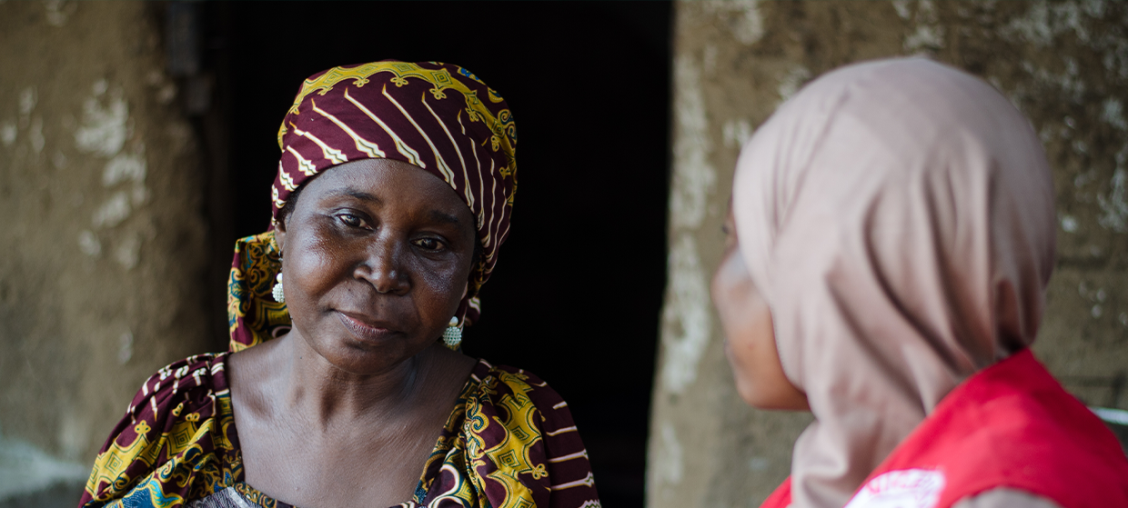

**TRAINING PACKAGE FOR USING SOCIAL SCIENCE IN COMMUNITY ENGAGEMENT AND/OR COMMUNICATIONS ACTIVITIES**

**SESSION 6.2:** Enabling environments for the uptake of social science evidence in emergency response

SESSION CONTENT

**Learning approach:** Real-time presentation, individual and group exercises, case examples

**Delivery mode:** Online and offline, 100 minutes approx.

**Essential sessions to have completed before this session:** 1.2, 6.1

**Summary:** This session aims to explore what an enabling environment looks like so that social science can inform different phases of an emergency response and how it can best be promoted.

**Learning outcomes:**

* Be able to identify opportunities to create an enabling environment for uptake of social science findings within response pillars, by technical clusters and by sectors
* Be able to identify opportunities to embed operational social science across different phases of a community-centred response
* Understand what an enabling environment looks like at the community level to ensure that research can inform local action

FACILITATING THE SESSION

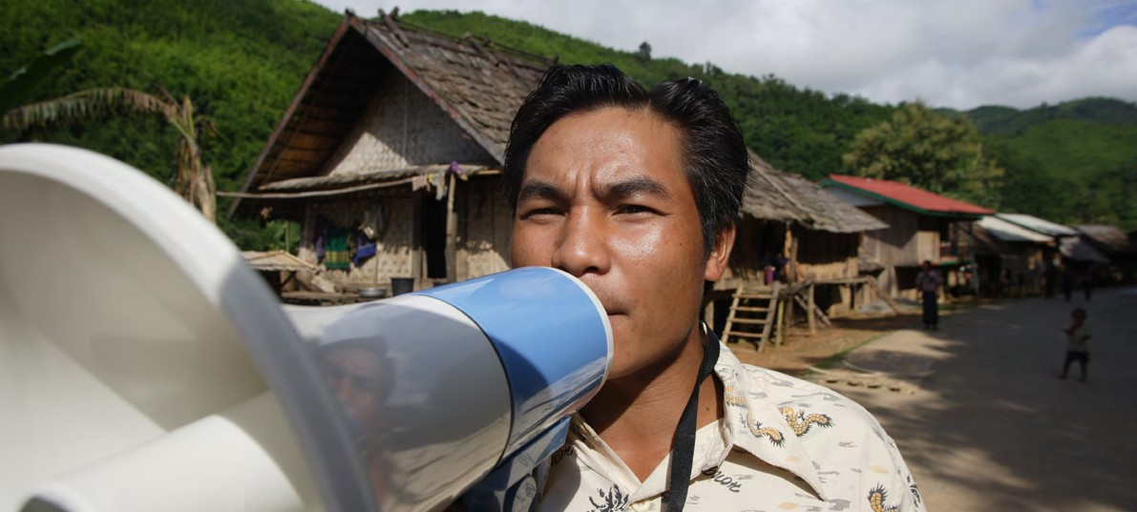

**TRAINING PACKAGE FOR USING SOCIAL SCIENCE IN COMMUNITY ENGAGEMENT AND/OR COMMUNICATIONS ACTIVITIES**

Introduction: (5 minutes total)

Talk through session summary and learning outcomes.

Position this module in the question flow.

1. How to ensure that this information goes back to communities? To inform community-level actions and decision-making of the broader response?
2. What methodology and tools should be used to collect and analyse this information?
3. How to track the information used to ensure that it effectively contributes to operational and strategic priorities?
4. Who can collect this information?
5. Does this information already exist? Is there a related needs assessment or study?
6. What information is needed?

**DATA TO ACTION:**

Key questions in social science research

1. Who needs this information?
2. How to ensure that the information is used to make operational and/or strategic decisions?

What is an enabling environment? (60 minutes total)

The ‘environment’ (for this work) are the systems, institutions and actors that make up the emergency response operation(s) that our social science research intends to influence. This includes a host of response pillars, technical clusters and sectors, and communities affected by the crisis.

Overview of the cluster approach

The cluster approach is a key concept in humanitarian work.

This concept has been developed since the [2005 Humanitarian Reform](https://interagencystandingcommittee.org/iasc-transformative-agenda) with the aim of improving coordination of humanitarian actors following the Indian Ocean Tsunami of 2004, when there was  “[an ambition to organize global humanitarian governance with the United Nations as its linchpin](https://espace-mondial-atlas.sciencespo.fr/en/topic-regulatory-efforts/focus-6F09-EN-the-un-s-2005-reform-of-humanitarian-coordination.html).”

The ‘cluster system’ groups together humanitarian actors who work in the same sector. This includes the government, UN agencies, Red Cross/Red Crescent, NGOs, the private sector, CSOs, etc.

Clusters are groups of humanitarian organizations (UN and non-UN) working in the same sector: food security, camp management, education, shelter, emergency telecommunications, health, logistics, nutrition, protection and WASH.

There are global and country-level clusters. Global clusters are always active, even when not engaged in a specific emergency response.

At country level, the cluster approach is activated when government mechanisms are overwhelmed or inadequate. This means in most countries, most of the time, the cluster system is not usually activated, but all countries have clusters which can be activated.

UN OCHA leads the coordination in situations where there are no refugees involved in the crisis. In refugee situations, UNHCR takes the lead.

Country-level cluster activities include:

* Supporting service delivery by coordinating the Humanitarian Response Plan
* Informing strategic decisions – including preparing needs assessments and analysis of gaps and undertaking information management
* Planning and implementing cluster strategies and plans, including funding requirements and proposals
* Monitoring and evaluating progress
* Building national capacity in preparing for future emergencies and contingency planning
* Carrying out advocacy activities

The cluster lead agencies at country-level are the same as at global level unless the government and cluster leadership designate otherwise.

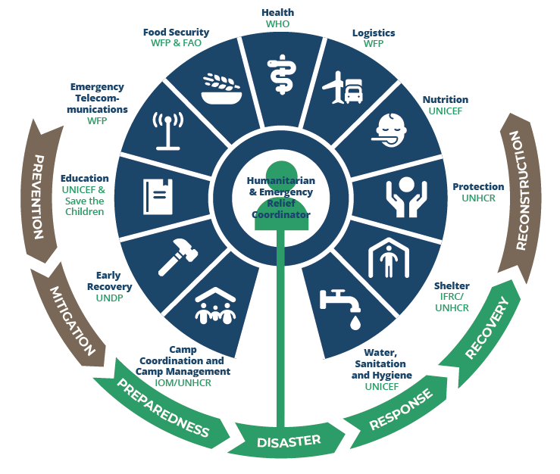

The figure above illustrates the cluster approach and also highlights the roles of the different UN agencies. We will discuss later where social science might ‘sit’ in this system.

|  |  |
| --- | --- |
|  | Question to participants (5 minutes):  What might need to exist within the emergency response environment to make sure the findings of social science research are actually used?  Online: Invite the participants to write the answers in the chat function and summarize  Offline: Ask two or three participants to share their thoughts and summarize |

There is no single formula for creating an enabling environment – much will depend on the setting and the nature of the emergency response. In each context, however, we can pay attention to the following factors in order to map opportunities to generate the right kind of environment to ensure more effective uptake of operational social science research.

1. Existing knowledge and capacity

* The ability to build an enabling environment for social science to inform different phases of a response response will also depend on what social science expertise already exists at the beginning of a response.
* The first step should always be to map existing social science knowledge and operational capacity that exists in local academia and civil society.
* If further training needs are identified – specifically for developing social science evidence which can be used for emergency response – an enabling environment can be facilitated by delivering targeted trainings for rapid data collection and analysis tailored to the environment. This may include opportunities for developing participatory research design, implementation and analysis techniques to involve affected communities in the process (see Session 4.1 on localized research). Mapping may identify gaps at different levels (e.g. national and/or subnational) or specific social science expertise required to support different technical pillars (e.g. to conduct KAPs or to do ethnographic research for clinical trials).
* Establishing a long-term and sustainable enabling environment requires investment in social science expertise**.** This might bethrough university-level training and sustained operational social science training as well as ongoing research projects. Local social science expertise also has to be accompanied by sustained engagement with key public health and civil society actors to generate demand for social science insights and to develop frameworks for integrated initiatives. These can be seen to contribute to emergency preparedness.

1. Structural factors

Where social science ‘sits’ within the response infrastructure

* We need to determine where social science belongs in relation to the various response pillars and technical clusters that have been organized for a specific emergency response. The introduction section gave some detail on the tasks and responsibilities of different pillars and clusters.
* Social science research can, for example, be embedded in community engagement/  
  communications operations by identifying emerging issues to be addressed by community engagement actors, advising on how activities can best adapt to a changing social context, and offering regular feedback on ongoing programming.
* Social science research can also effectively be embedded in other pillars, a potential that remains too often unexplored. For example, social science can be embedded in clinical research operations to support the development of medical protocols that are informed by local knowledge, experience and priorities; or, in the co-production of community surveillance mechanisms that take into account social pathways of transmission and community expertise.
* Social science research can also stand alone as a separate pillar of the response.
* All of these questions can also be asked in relation to the appropriate level where social science can be embedded. For example, social scientists working in the national coordination body may have different goals from those embedded within subnational or community-level structures.
* For each of these positions, there will be compromises. For example, while being embedded within operations may strengthen uptake, being independent may make it easier to build trust in affected communities.

|  |  |
| --- | --- |
|  | Individual exercise (10 minutes):  Write some notes about what you see as the pros and cons of the different options for where social science can sit:   1. Embedded in community engagement/communication sector 2. Cross-cutting across operations 3. Stand-alone, independent social science pillar   Online: Invite the participants to write the answers in the chat function and summarize  Offline: Ask two or three participants to share their thoughts for each question and summarize |

1. Collaboration readiness – speaking the same ‘language’

|  |  |
| --- | --- |
|  | Question to participants (5 minutes):  Have you had experiences where people from a social science background had challenges communicating with those from a different discipline? What happened and what were the consequences?  Online: Invite the participants to write the answers in the chat function and summarize  Offline: Ask two or three participants to share their thoughts and summarize |

* Emergency responses are often made up of a wide range of people coming from very different academic and professional backgrounds. An enabling environment for effective social science uptake requires the establishment of effective mechanisms for communicating social science evidence across disciplinary boundaries.
* This may mean identifying existing understanding of social science methods across technical pillars, the value placed on social science expertise and potential philosophical barriers to effective collaboration (e.g., if partners have different understandings of what counts as ‘valid’ evidence).
* There may be different kinds of challenges for different kinds of evidence. For example, quantitative research has traditionally been more widely accepted, particularly in public health, while qualitative research has been (wrongly) dismissed as being ‘anecdotal’ or not rigorous.
* It may be therefore be necessary to create opportunities to discuss the role and value of different kinds of social science evidence, giving concrete examples of areas of complementarity to generate demand (see Session 1.4 on advocating for social science methods and further discussion in the brief: ‘[How to maximise the use of social sciences evidence for public health emergencies in humanitarian settings](https://www.unicef.org/drcongo/media/5406/file/COD-CASS-maximizing-use-evidence.pdf)’ developed by the Analytics for Operations Working Group (2020).
* Knowledge transfer works both ways. Social scientists themselves may require more knowledge relating to epidemiology, public health, emergency response and human architecture. If you understand the context, then you know what can/should be changed.

|  |  |
| --- | --- |
|  | Question to participants (5 minutes):  Giving examples specific to your field of expertise (or to a specific emergency response), how would you explain the value of social science evidence?  Online: Invite the participants to write the answers in the chat function and summarize  Offline: Ask two or three participants to share their accounts |

1. Relationships and trust

* Strong relationships and the establishment of **trust** between social scientists, communities and members of different technical pillars is essential to develop an enabling environment.
* Preparedness planning should include efforts to lay the groundwork, and build relationships and effective communication mechanisms to integrate social science evidence in different types of operations.
* Building trust in social science requires good interpersonal relationships but it is also gained and strengthened through how social scientists position themselves and their evidence during operations. Social scientists need to be seen as good partners, who can offer important and if necessary critical but constructive insights.
* Trust must also be built with affected communities, whether the researchers are ‘insiders’ or not. This means ensuring that research is carried out with integrity, that principles of confidentiality are respected (see ethics Sessions 3.1 and 3.2) and that community members who take part in social science research feel they are listened to and that their insights are fed back into programming.
* Identifying opportunities for building good rapport with other pillars and in affected communities will also influence decisions about where social science is best placed in a given emergency response and in a specific context. Independent research, for example, may make it easier to gain trust in affected communities but may make it harder to directly influence operations.

|  |  |
| --- | --- |
|  | Question to participants (5 minutes):  How important might personal relationships be to an enabling environment? Include an example from your own experience in your answer.  Online: Invite the participants to write the answers in the chat function and summarize  Offline: Ask two or three participants to share their thoughts |

1. Flexibility and adaptability in response action

* An enabling environment for effective uptake of social science expertise also requires a degree of flexibility and adaptability in response actions so that the course can be reset in light of social science research findings.
* This requires an analysis and mapping of which changes can happen at which levelat the project design phase, as outlined in Session 6.1 on translating social science evidence into action.

1. Economic factors

* An enabling environment for effective uptake of social science expertise also requires having the adequate resources to:
* Fund a sustained programme of social science research that can be effectively integrated with other pillars and coordination structures
* Fund the implementation of recommendations made
* These require an understanding of what financial and human resources are available to implement any recommendations made at the project design phase, as outlined in Session 6.1 on translating social science evidence into action.

|  |  |
| --- | --- |
|  | Case example (working in enabling environments) (5 minutes total)  Longer-term engagement – relationship and reputation building in Sierra Leone  During the 2014-16 Ebola outbreak in Sierra Leone, a team of social scientists was established to work in the Ebola vaccine trials. Their research focused on community experiences of the Ebola outbreak and engagements with medical research in Northern Sierra Leone. Working as social scientists within a vaccine trial during and in the aftermath of an epidemic, they learned important lessons. Working within an interdisciplinary team was occasionally challenging, particularly in terms of communicating the significance of qualitative data and establishing a shared understanding of how to interpret ethnographic data. One strategy that they implemented to overcome these challenges was building strong relationships over time with clinicians, laboratory staff and others involved in the trial. They presented their findings regularly so as to give insights into their analysis and created opportunities for regular feedback to the trial team (including community engagement colleagues) to try to identify how research findings could be effectively operationalized. A key example of this related to widespread fears about blood taking that surrounded the trial, which were picked up by the social science team. The team then brought these anxieties to the broader team, and placed them in context, explained their significance as commentaries of mistrust, and facilitated conversations about strategies to stimulate dialogue about these concerns. Being able to identify critical issues, contextualize and interpret them and offer dynamic recommendations to adapt operations, allowed the team to build trust with clinicians and other triallists over time and facilitate the integration of social science findings into trial operations.  Similarly, their work with the Ebola vaccine trials over a long period of time also allowed the team to develop durable relationships with local health partners, including the district-level representation of the Ministry of Health, the District Health Management Team (DHMT). This relationship over a long period of time set the foundations for further collaborations. Through their engagements, they identified collective priorities. For example, discussions with the social mobilization team highlighted a lack of data on the factors affecting vaccine confidence in border communities. They therefore designed a research project together to train community health care workers in social science research methods to understand these factors and engage communities to design and evaluate novel community engagement strategies that directly responded to ongoing realities. This close collaboration and co-production of both research and action meant that as the COVID-19 pandemic hit, there was appetite within the DHMT for social science work to continue to support their operations. The community health worker project shifted to support the COVID-19 response by identifying unfolding social, political and economic experiences and perspectives, and recommending strategies to address them.  These experiences highlighted the importance of building relationships, and how over a period of time generating trust through collaborative work could create an enabling environment for dialogue between social scientists and public health officers involved in epidemic preparedness and response. Of course, challenges remained, particularly in relation to the translation of findings into practice, partly because of resource constraints (to tackle structural issues), difficulties in changing long-standing operational practices, and some inertia in the types of data that tend to be privileged during emergencies. |

Which aspects are important in different phases of a response? (20 minutes total)

|  |  |
| --- | --- |
|  | Group exercise (15 minutes):  What aspects of an enabling environment are critical to promote at different stages of an emergency response?  Divide into groups. In your group, discuss each point described above (existing knowledge and capacity, structural factors, human relationships, speaking the same language, flexibility and adaptability in response action, and economic factors) in relation to:   1. Preparedness 2. Response 3. Recovery   Give 10 minutes to discuss. Ask two or three groups to share their thoughts  Facilitator summarizes and then goes through any of the points below that have not been mentioned in the discussion, using flipchart paper or an online scribing/mapping tool. |

Preparedness

* Establish social science expertise by:
* Funding long-term operational social science expertise through university-level and professional accreditation
* Supporting opportunities for community-centred, participatory research as standard practice to support ongoing community engagements/communications activities and other programming
* Lay the groundwork for interdisciplinary/inter-agency collaborations by:
* Generating demand for social science evidence, drawing on examples of effective integration
* Advocating for integration of social science expertise and for sustained collaboration across different technical pillars
* Creating opportunities to discuss the value of different types of social science expertise and how it can complement other kinds of data to strengthen community-centred operations
* Developing tailored trainings on social science methods and on evidence translation to strengthen competency for uptake in key agencies and pillars at international, national and subnational level
* Build relationships and trust by:
* Investing in effective working relationships that can be rapidly activated during an emergency, through sustained, long-term social science research
* Advocate for flexible and adaptable programming

Response

* Map existing social science operational capacity at different levels of a response:
* If there is existing operational expertise, mobilize this to identify avenues for collaboration
* If additional training needs are identified, mobilize existing resources for rapid training and for translating social science evidence into action
* Map existing understanding and demand for social science evidence. If there are gaps, initiate discussions and discuss opportunities for collaboration.
* Map thefinancial and human resources that are available to implement any recommendations made.
* Co-produce research questions and designs with other response pillars and affected communities.
* Map contextual factors that will determine where social science is best placed within a response – e.g. understanding operational environment, community dynamics, and social science evidence needs.
* Design programmes that are flexible and adaptable and make sure programme management allows for course correction.
* Establish effective mechanisms for regularly feeding back social science research findings, being sure to offer recommendations and evaluating their implementation.

Recovery

* Evaluate the integration of social science evidence in the response.
* Identify how any challenges to collaboration might be addressed in future emergencies.
* Identify strategic relationships that have been built that need to be maintained to maximize the momentum built for future emergencies.
* Identify new areas of expertise built during the response that can be expanded on for long-term preparedness planning.

An enabling environment at the community level (10 minutes total)

To ensure that social science evidence supports community-level action, it is important to understand what an enabling environment looks like at the community level.

|  |  |
| --- | --- |
|  | Question to participants (5 minutes):  What might be some of the aspects of an enabling environment at the community level?  Online: Invite the participants to write the answers in the chat function and summarize  Offline: Ask two or three participants to share their thoughts and summarize |

Many of the features may actually be quite similar, including:

* Involvement in the research –Session 4.1 speaks further about localized research, and specifically what role community members play in generating and using social science evidence. If affected communities have been actively involved during the research process, and the research is addressing an issue they prioritize, it is more likely the findings will support community-level action.
* Supportive structures – It is important to understand and connect with important community structures. If the research is able to directly feed into institutions and actors who make decisions, or who are otherwise influential, it is more likely that social science findings can make change at the local level.
* Human factors, relationships –Individuals and communities will most likely need to trust the research process in order to use the findings.The nature of trust may be different considering a possible history of exploitation with research. One of the benefits of social science research is that the methods used (often face-to-face and qualitative) and the specific focus (understanding people’s needs, perceptions, preferences) can themselves help to build trust.
* Familiarity with social science –It is important to understand whether communities know what input from social science researchers means and how it can help inform community-level action.
* Openness to input – Linked to the above points, it is also important to understand whether communities actually *want* input from social science research. If not, it is unlikely any findings will be taken up.
* Resources –Just as resources are often required within response systems to implement the recommendations of social science research, resources may also be required to act at community level. Community resources may include people, time, expertise, money etc. Recommendations may need to be tailored to match the resources a community actually has in order for findings to be taken up.

Certain participatory methods such as [Participatory Action Research](https://equinetafrica.org/sites/default/files/uploads/documents/PAR_Methods_Reader2014_for_web.pdf) place those affected by an issue in the driving seat of research. This means that they contribute to the design of research that answers their priorities and needs, and generate evidence which can inform actions affected populations want to take. These sorts of methods inherently create an enabling environment for findings to be translated to action.

Wrap-up/summary (5 minutes total)

* The ‘environment’ (for this work) are the systems, institutions and actors that make up the emergency response that our social science research intends to influence. This includes a host of response pillars, technical clusters and sectors, and the communities affected by the crisis.
* There is no single formula for creating an enabling environment: much will depend on the setting and the nature of the emergency. In each context, however, we can pay attention to the following factors in order to map opportunities to generate the right kind of environment to ensure effective uptake of operational social science research:
* Existing knowledge and capacity
* Structural factors, including where social science ‘sits’ in the humanitarian response infrastructure
* How ready responders are to collaborate on social science, in terms of speaking the same ‘language’
* Strong relationships and the establishment of trust between social scientists, communities and members of different technical pillars
* Flexibility and adaptability in response action
* Economic factors, including what financial and human resources are available to implement any recommendations made
* These factors are of differing importance depending on the phase of the response: preparedness, response or recovery.
* To ensure that social science evidence supports community-level action, it is important to understand what an enabling environment looks like at the community level. Many of the factors are the same, in terms of community involvement in the research – engagement of important structures and decision-makers, strong relationships and trust with key community-level personnel, familiarity with social science within the community, being open to input from social science research, and having adequate community-level resources to implement any recommendations of the research.

ACKNOWLEDGEMENTS:

Luisa Enria (LSHTM) and Theresa Jones (Anthrologica) developed the session content. The session was reviewed by Olivia Tulloch (Anthrologica) and Ginger Johnson (Collective Service).