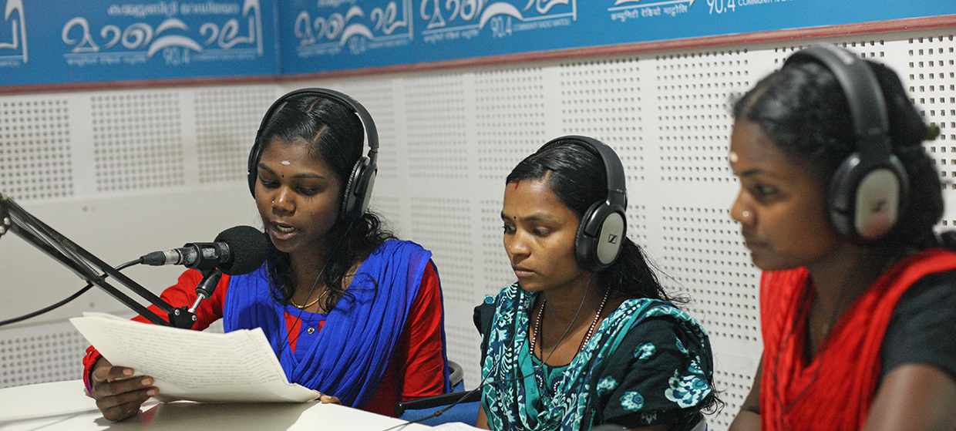

**TRAINING PACKAGE FOR USING SOCIAL SCIENCE IN COMMUNITY ENGAGEMENT AND/OR COMMUNICATIONS ACTIVITIES**

**SESSION 7.1:** Tracking the use or ‘application’ of integrated operational social science outputs: Integrated Outbreak Analytics and MONITO

SESSION CONTENT

**Learning approach:** Real-time and video presentation, case examples, discussion, recorded videos

**Delivery mode:** Online and offline, 50 minutes approx.

**Summary:** This session discusses tools and approaches for monitoring the use of integrated evidence by emergency response actors to better inform operational decision-making. It is based on examples from the Democratic Republic of the Congo (DRC).

Content delivered through real-time presentation, and pre-recorded videos to explain in detail the theory behind the concepts covered, and to stimulate discussion based on the examples provided.

**Learning outcomes:**

* Understand the Integrated Outbreak Analytics approach and its application in emergency response
* Know different methods for ensuring the use of evidence for decision-making
* Learn what is needed to set up and manage a tool for monitoring the use of evidence

FACILITATING THE SESSION

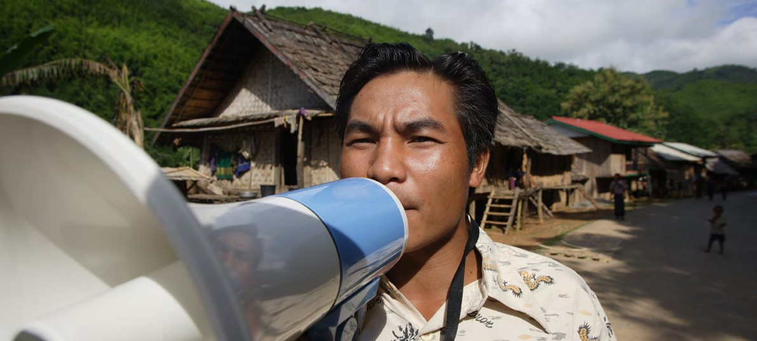

**TRAINING PACKAGE FOR USING SOCIAL SCIENCE IN COMMUNITY ENGAGEMENT AND/OR COMMUNICATIONS ACTIVITIES**

Introduction: (5 minutes total)

Talk through session summary and learning outcomes.

Position this module in the question flow.

1. How to ensure that this information goes back to communities? To inform community-level actions and decision-making of the broader response?
2. What methodology and tools should be used to collect and analyse this information?
3. How to track the information used to ensure that it effectively contributes to operational and strategic priorities?
4. Who can collect this information?
5. Does this information already exist? Is there a related needs assessment or study?
6. What information is needed?

**DATA TO ACTION:**

Key questions in social science research

1. Who needs this information?
2. How to ensure that the information is used to make operational and/or strategic decisions?

What is Integrated Outbreak Analytics? (30 minutes total)

|  |  |
| --- | --- |
|  | Question to participants (5 minutes):  Define what the concept of ‘integrated outbreak analytics’ means to you. (Re: General ideas based on their understanding of the words).  Online: Invite the participants to share their answer verbally or write their answer in the chat function and summarize  Offline: Ask two or three participants to give their definitions |

Explanation of the concept of Integrated Outbreak Analytics (IOA)

IOA is an approach developed by the Social Science Analytics Cell (CASS) of UNICEF which brings together and analyses different data sources to generate a solid, reliable evidence base with which to inform operational decision-making for emergency response.

This approach increases the reliability, viability and strength of evidence, so that it can be more confidently shared with response stakeholders. IOA provides a better reflection of the real situation on the ground than if individual data sources were considered in isolation.

|  |  |
| --- | --- |
|  | Brainstorm (5 minutes):  What are examples of different types of data that might be included in the IOA process?  Online: Invite the participants to write as many answers as possible in the chat function  Offline: Ask the participants to write their answers down on a post it and after a few minutes invite a few participants to share their responses. Note them down on a flipchart |

Different data sources and types could include:

* Qualitative data from interviews, focus groups, observations
* Household or health care worker surveys
* DHIS2 – Data Health Information Systems (government-reported health facility data)
* Timelines of events (e.g. how do these correspond with things we see in epidemiological/other health data?)
* Infection Prevention and Control (IPC) reports
* Programme data from response actors

Each data source contributes to a more complete overall understanding of the dynamics of a particular emergency. Think of it like a jigsaw puzzle where, with every piece, you have a clearer image of what the complete picture should be showing.

Examples of IOA for public health emergencies could include:

* Big outbreaks (e.g. Ebola)
* Endemic outbreaks (e.g. Cholera, Plague)
* Broader impacts, such as a pandemic (e.g. COVID-19)
* Long-term health (e.g. malnutrition)

|  |  |
| --- | --- |
|  | Case example (10 minutes):  This [YouTube video](https://www.youtube.com/watch?v=-3EOn1yil1w) provides an explanation of the IOA approach applied by CASS: Min. 0 - 5.36  This [YouTube video](https://www.youtube.com/watch?v=7Sl7e24iKk4&t=3s) describes use of IOA in the Democratic Republic of Congo (DRC) 2018-2020: Min. 11.5-15  Invite questions or immediate reflections. [Note: IMOA is now known as IOA]. |

Ensuring the use of research evidence (10 minutes total)

As discussed in Sessions 1.1 and 1.2, there is no point in conducting applied research or generating evidence unless it is going to be used. This evidence needs to be *operational.* There are different ways that we might go about ensuring evidence is used, and these are discussed in depth in Session 6.1.

|  |  |
| --- | --- |
|  | Question to participants (5 minutes):  What measures should be taken to encourage the use of evidence for decision-making?  Online: Invite the participants to share their answer verbally or write their answer in the chat function and summarize  Offline: Ask two or three participants to give their definitions |

The work of the CASS on research during outbreaks has shown that stakeholder engagement is key to ensuring that research evidence is used. There is a need to involve those who will be using the data/evidence, at every stage of the research process to make sure that the data will be both usable and used (see Session 6.1 for more discussion on this). Note: The example of how CASS uses an Integrated Outbreak Analytics (IOA) approach is specific to responding to public health emergencies (such as an outbreak of Ebola, cholera, polio, etc.) but may be adapted for other crises. Please see Session 7.2 for detailed discussion of how IFRC uses community feedback to track the uptake of evidence.

The CASS team emphasize the need to ensure that research:

1. Includes the relevant stakeholders in survey design and study questions, including:

* Health commissions and sector clusters
* Epidemiologists and health data analysts
* Users of the data (community, local, national, international)

1. Prioritizes questions/information required by decision-makers, asking:

* Are they checking that we get data that can be used?
* Are we checking how, and what, will this data inform?

1. Triangulates and integrates data, using:

* Existing complementary and contradictory data sources
* The stronger and more integrated the evidence, the better it is for use (IOA approach)

1. Coordinates data, by:

* Working effectively with different sources of data including tracking expected dates for results, etc.

CASS identified the following effective mechanisms for the use of evidence in outbreak response (but also relevant to other sectors):

1. Discussing results with different researchers and analysts before presenting, checking:

* Is the data good enough? What do the results say and mean? Do the results reflect what was seen and heard in the field?
* Identifying and acknowledging limitations – where are the weakness in the analyses? Can the data gaps be filled? How/ what is needed?

1. Systematically presenting results, via:

* In multiple forum cluster meetings, commissions, and to individual organizations/actors
* Through multiple presentations each tailored to the audience (focusing on different, most relevant aspects of results)
* To the Ministry of Health leadership (coordinating a response) for validation and feedback

1. Organizing discussions with influencers and decision-makers, such as:

* Bringing Ministry of Health, commissions, NGOs and donors together to look at the problems and solutions at different levels of intervention (direction of funds vs. adaptation of activity or strategy)

Co-development is avital step, but it is rarely considered. Research reports typically provide recommendations based on the evidence presented but lack a system for monitoring who may have read the recommendations, let alone outlining a road map, or strategy for implementation.

When we talk about co-development, we mean that those conducting the research (producing and presenting the evidence) sit down with operational partners (e.g. government, NGOs etc.) and together make a plan for how they can use the evidence to develop/improve their programmes, strategies or advocacy.

The idea is that the more involved they are, the more invested the response actors will be in using the data to influence decision-making.

The process should ask: *After the development of actions, what should come next, to make sure that they are implemented?*

As noted above, see Session 6.1 for more discussion on translating evidence to action.

**OPTIONAL** videos to show to participants (or make available for offline):

1. <https://www.youtube.com/watch?v=-3EOn1yil1w> (roughly, min. 5.36 – 9.20)
2. <https://www.youtube.com/watch?v=7Sl7e24iKk4&t=3s> (roughly, min 15.00 – 24.00) – covers a bit of MONITO
3. <https://www.youtube.com/watch?v=4zwyihBmAf8&t=298s> (roughly, min 2.49 – 10)

Tracking the implementation of research recommendations using a dedicated monitoring tool (50 minutes total)

**“**

We’re doing social science but no one is using our data.

**”**

Quote from a social science researchers during the West African Ebola outbreak.

Part of making sure that evidence is used is then actively tracking or monitoring if and how the evidence has been taken up.

|  |  |
| --- | --- |
|  | Question to participants (5 minutes):  Please think about any experiences from your work of when you had to track that recommendations made for a project were actually taken up. What did you do? If no answers, ask for ideas of how you might do this.  Online: Invite the participants to share their answer verbally or write their answer in the chat function and summarize  Offline: Ask two or three participants to give their suggestions |

We will now share with you one tool (MONITO) that has been developed by the CASS for monitoring the use of integrated evidence by emergency response actors to better inform operational decision-making.

What is a MONITO?

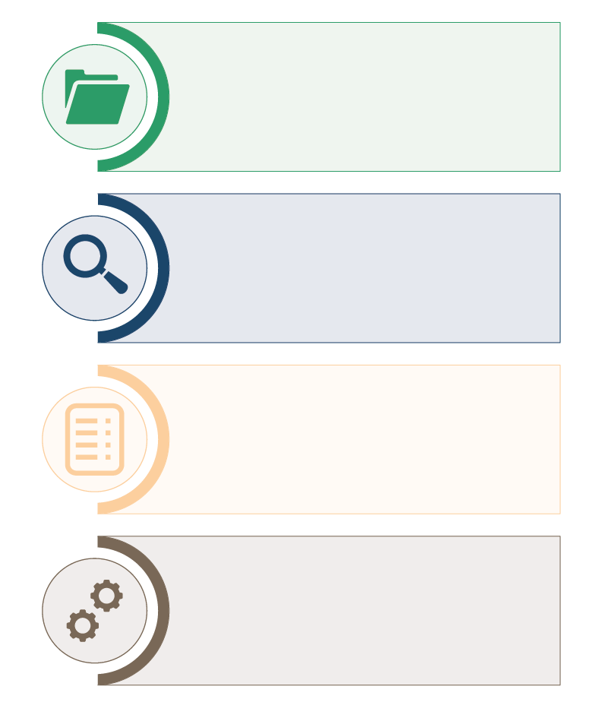

Compiles recommendations co-developed

Follow up the consideration and implementation of the recommendations by the partners concerned

Documents the work of   
the CASS with partners (when, who, where, what)

Contribute to meassuring   
the impact of social science research on response interventions

A tool (database) to document and monitor the use of evidence generated through operational research. Agreed actions are recorded in the MONITO, and their implementation tracked over time.

A MONITO can help response actors do what they say they will do, when they say they will do it. So, in a way, it holds them accountable, while ensuring that the monitoring process does not become like top-down ‘policing’.

Ethically, operational research is not possible to justify without a MONITO. Not only does it help show whether research evidence actually gets used, but it allows researchers to evaluate their own performance and effectiveness, and the relevance of data generated.

|  |  |
| --- | --- |
|  | Question to participants (5 minutes):  What could this tool look like to make it work for you? What is needed to ensure it works?  Online: Invite the participants to share their answer verbally or write their answer in the chat function and summarize  Offline: Ask two or three participants to give their suggestions |

Facilitator can add to the discussion some important considerations for the use of MONITO to add to the answers generated.

It is important to think about:

* Who will manage the tool: a team or one person?
* What kind of indicators do we want to be able to produce with the tool? (progress status per area, per actor, number of recommendations per actor, etc.)?
* Do we want to group the recommendations into major themes? If so, which ones?
* How can we avoid duplication of counting when the same recommendation has several responsible actors, or is applicable across different areas?

|  |  |
| --- | --- |
|  | Case example (35minutes):  Videos on how the CASS MONITO tool was developed in the DRC, and how it is used to track the implementation of actions:   1. <https://www.youtube.com/watch?v=-3EOn1yil1w> (min. 9.20 – 36) OR 2. <https://www.youtube.com/watch?v=4zwyihBmAf8&t=298s> (min. 10.39 - 40)   Facilitator should review and select most appropriate video for context  Invite questions or immediate reflections |

**ADDITIONAL RESOURCE**

Further video with examples of IOA, and ways to push actioning of evidence:

<https://www.youtube.com/watch?v=7Sl7e24iKk4&t=3s> (min. 24.3 – 39.00) – IOA to support better understanding of vaccine engagement

Wrap-up/summary (5 minutes total)

* Integrated Outbreak Analytics (IOA) is an approach developed by the Social Science Analytics Cell (CASS) of UNICEF which brings together and analyses different data sources to generate a solid, reliable evidence base with which to inform operational decision-making for emergency response.
* A crucial component of this approach is to involve those who will be using the data/evidence, at every stage of the research process, to make sure that the data will be both usable and used.
* Part of making sure that evidence is used is then actively tracking or monitoring if and howthe evidence has been taken up.
* MONITO is one example of a tool (database) used by CASS to document and monitor the use of evidence generated through operational research*.* Agreed actions are recorded in the MONITO, and their implementation tracked over time.
* A MONITO can help response actors do what they say they will do, when they say they will do it. So, in a way, it holds them accountable, while ensuring that the monitoring process does not become like top-down ‘policing’.

ACKNOWLEDGEMENTS:

Isabel Moncrieff and Simone Carter (CASS, UNICEF) developed the session content.   
The session was reviewed by Theresa Jones and Olivia Tulloch (Anthrologica) and Ginger Johnson (Collective Service).