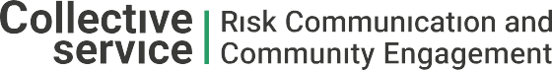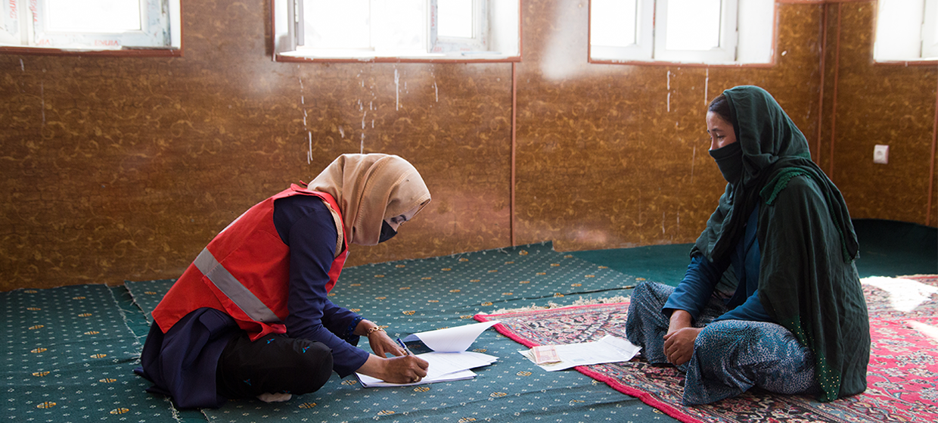

**TRAINING PACKAGE FOR USING SOCIAL SCIENCE IN COMMUNITY ENGAGEMENT AND/OR COMMUNICATIONS ACTIVITIES**

**SESSION 4.3:** Quantitative data collection methods: Rapid needs assessment (RNA) surveys, and knowledge, attitudes and practice/perceptions (KAP) surveys

SESSION CONTENT

**Learning approach:** Real-time presentation, individual and group exercises, case examples

**Delivery mode:** Online and offline, 100 minutes approx.

**Essential sessions to have completed before this session:** 4.1

**Summary:** This module gives an overview of how to apply quantitative approaches, specifically knowledge, attitudes, practice/perceptions (KAP) surveys to collect data for community engagement and/or communications activities and wider humanitarian response actions.

**Learning outcomes:**

* Be familiar with different quantitative data collection survey methods used by social scientists and relevant to community engagement and/or communications activities
* Understand the key steps for the use of knowledge, attitudes, practice/perception (KAP) surveys

FACILITATING THE SESSION

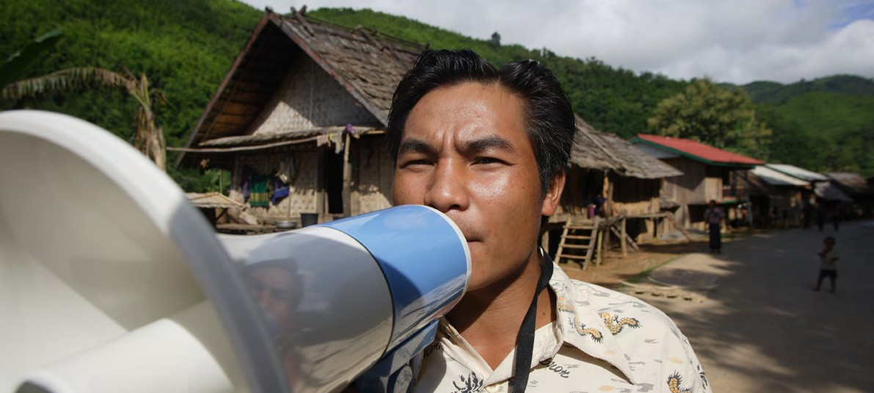

**TRAINING PACKAGE FOR USING SOCIAL SCIENCE IN COMMUNITY ENGAGEMENT AND/OR COMMUNICATIONS ACTIVITIES**

Introduction: (5 minutes total)

Talk through session summary and learning outcomes.

Position this session in the question flow, explaining that this module mainly addresses question area 5, but also touches upon 1, 2, 3 and 4.

1. How to ensure that this information goes back to communities? To inform community-level actions and decision-making of the broader response?
2. What methodology and tools should be used to collect and analyse this information?
3. How to track the information used to ensure that it effectively contributes to operational and strategic priorities?
4. Who can collect this information?
5. Does this information already exist? Is there a related needs assessment or study?
6. What information is needed?

**DATA TO ACTION:**

Key questions in social science research

1. Who needs this information?
2. How to ensure that the information is used to make operational and/or strategic decisions?

**Quantitative Methods (15 minutes total)**

We use quantitative methods when we want to know ‘how many’ and/or ‘how often’.

Other key features of quantitative methods are that they:

* Work with numbers– the instrument used in quantitative research poses questions in which response options are assigned numbers
* Generally use surveying of a large group of people (usually several hundred) and a structured questionnaire that contains predominantly closed-ended, or forced choice, questions
* Can test theories you have about a situation: e.g. pregnant women are less likely to use water chlorination tablets than non-pregnant women (although not all quantitative research is designed to do this)
* Can establish causal relationships – e.g. X causes Y: trust in health system contributes to greater vaccine uptake
* Analysis often uses statistical methods to interpret the significance of the findings
* The more representative the sample is – when it has characteristics of the whole population including vulnerable and marginalized population groups such as ethnic minorities, people living with disabilities etc. – the more likely it can be generalized to a wider population

|  |  |
| --- | --- |
|  | Question to participants (5 minutes):  Why should we apply quantitative social science research methods to inform community engagement and/or communications activities?  Online: Invite the participants to write the answers in the chat function and summarize  Offline: Ask two or three participants to share their thoughts |

Rapid (needs) assessments and structured surveys (5 minutes total)

Social scientists working in emergency settings are particularly interested in the local context, and in the knowledge, attitudes, perceptions and behaviours of different groups of people. As we have already discussed in this training (see Module 1), this information is very important to help us to develop and/or adapt strategies and activities to communicate and engage with crisis affected communities.

There are many different quantitative methods and tools that can provide information about the context of a situation and about knowledge, attitudes, perceptions and behaviours. We discuss two below, with a focus on KAP surveys:

1. Rapid needs assessment (RNA) survey

These are short surveys which are often conducted in the early phase of a response to inform response efforts. They can be sector specific (e.g., WASH, health, nutrition) or multi-sectoral. They often build on the review of existing/secondary data and information, for example, existing demographic data and/or information provided by local health authorities and/or similar assessments conducted by other researchers or organizations. RNAs:

* Intend to answer a few important/urgent questions and are very focused/streamlined
* Use a convenience sampling approach – often by conducting the survey in appropriate places to reach key audiences (e.g., clinics, schools, churches, marketplaces) especially impacted by the emergency
* Use rapid analysis that includes engaging the data with communities to INTERPRET the findings together and to develop actions based on data
* Usually ask close-ended survey (quantitative) questions but can also selectively incorporate some open-ended questions (i.e. open-ended questions can help to provide explanatory information to survey responses)

These assessments generally use a standardised data collection method and put emphasis on disaggregation – or being able to split apart data by groups of interest (e.g., by geography, gender, age).

1. Knowledge, attitude, practices/perception (KAP) surveys

KAP surveys provide information on what people know and do. They also help to reveal important (mis)conceptions or (mis)understandings which influence people’s ability and motivation to adapt and maintain, for example, recommended health/hygiene behaviours. They may provide information about barriers to the activities that responders are proposing to implement. They can also assess communication processes and sources that are key to defining effective activities and messages. One downside of KAP surveys is that there may be a gap between what people say they do, and what they actually (e.g. observably) do. This is called the “KAP Gap”, also sometimes knows as the “value-action gap”, “attitude-behaviour gap”, or “intention-behaviour gap” (see Figure 1). This gap can be large or small depending on economic, political, cultural and cognitive factors. Studies that observe behaviours directly (e.g., for behaviours that are publicly observable, like mask wearing or social distancing) or that involve the use of services (e.g., interactions at health facility), can offer other sources of information about behaviours that don’t require people to report their own performance. Observational studies and other qualitative methods of data collection that additionally ask individuals or small groups of people about ‘why’ they think, feel, or behave the way they do offer helpful insights for explaining KAP survey findings (see Session 4.4).

**Figure 1.** The KAP Gap (excerpted from Unit 5 of [WHO’s SocialNet](https://openwho.org/courses/empowering-communities) training series).

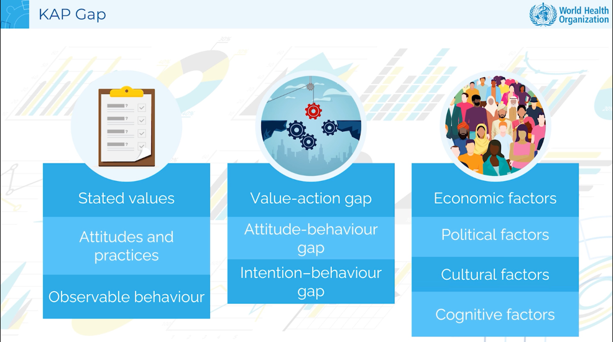

KAP surveys include predefined questions formatted as standardised questionnaires. These might be designed to allow the collection of quantitative and qualitative information, although it is usually mostly quantitative. Sometimes, a quantitative question with pre-defined response options that are assigned numeric values may be followed by an open-ended question to have the participant explain why they gave the response that they did. For example, a person who says “not at all concerned” or “very concerned” (two survey/quantitative response options on a question asking, “How concerned are you about becoming infected with Ebola virus?”) may be followed up with a qualitative question asking the participant to explain why are they “not concerned at all” or why they are “very concerned”. This is an appropriate way to both understand how many people believe or think a certain way, but also WHY they think that way.

Surveys can be given door-to-door, online or via text message. There are also a number of free, online tools for making surveys including [Survey Monkey](https://www.surveymonkey.com/) and [Google Survey](https://support.google.com/surveys/answer/2372144?hl=en).

KAP surveys (70 minutes total)

|  |  |
| --- | --- |
|  | Question to participants (5 minutes):  Has anyone been involved in designing, delivering or using the findings from a KAP survey? Please share your experiences.  Online: Invite the participants to write the answers in the chat function and summarize  Offline: Ask two or three participants to share their experiences |

KAP surveys are often used throughout a response to inform the design of communication and engagement strategies and activities, as well as to monitor how the situation evolve. They can:

1. Measure the extent of a known situation, e.g. how many people have lost access to safe drinking water following an earthquake.
2. Confirm or disprove a hypothesis/theory, e.g. women are less likely to use water chlorination tables if pregnant.
3. Provide new insights in a given situation, e.g. that pregnant women are in fact more likely to promote the use of water chlorination tablets to others.
4. Reveal detailed information about knowledge, attitudes, and practices/perceptions related to specific themes, e.g. what people know about water safety, whether they feel at risk from dirty drinking water and what practices they use to purify their water sources.
5. Identify more broadly what is known and done about various emergency-related subjects, e.g. where do people get information about other services available to them post-earthquake.
6. Establish the baseline for use in future assessments and help measure the effectiveness of activities, e.g. does access to safe drinking water increase? Do people have access to the information they need? Are people able to translate the information available into practical solutions?
7. Inform the design/adaptation of an operational strategy that reflects specific local circumstances and the cultural factors that influence them, e.g. how best to promote the use of water chlorination tablets in female-headed households.
8. Help plan activities that are suited to the respective population involved, e.g. who needs to be involved in the creation and delivery of messaging and wider community action

**Key considerations for the use of KAP surveys**

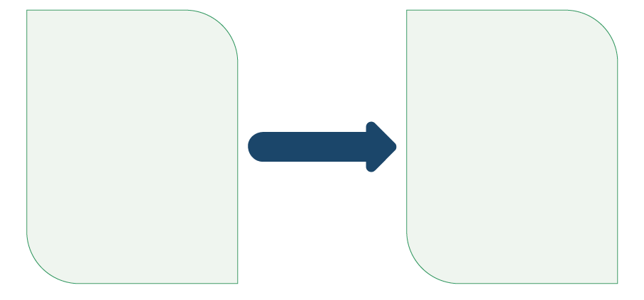

**Develop and conduct KAP surveys**

* Team/personnel, timeline, budget
* Draft the surveys, adapt survey modules
* Translate
* Pilot and validate by testing with locals
* Ethical considerations
* Select the sample
* Recruit and train data collectors
* Data collection plan

**Define social science needs**

* What you need to know and   
  why it is important
* Is a KAP survey the best tool?

See **Handout 1**: U.S. Centers for Disease Control and Prevention, National Center for Emerging and Zoonotic Disease, “A Guide to Adapting and Using Knowledge, Attitudes, and Practices (KAP) Surveys During an Ebola Response” May 2022.

1. Define social science needs

Before choosing to implement a KAP survey, you should have made a list of your priority information needs. Think back to our question list and ask yourself: What information is needed? Who needs this information? Does this information already exist? Consider conducting a desk review of project documents and existing materials.

You then need to identify which of those needs would be best met through a KAP survey, considering the different questions KAP surveys can address that we have already described.

Consider who to involve in defining these information needs. Involving the intended users of findings at this stage can increase the chance that findings will be useful and used by the intended user (this is discussed more in Module 6).

1. Select team/personnel to design and use the KAP survey

You will need to identify people to contribute to the design and use of KAP surveys, including: the project lead, response teams, local/governmental structures, technical team, statisticians and behavioural scientists, field coordinator, data collectors, data collector supervisors, etc.

|  |  |
| --- | --- |
|  | Question to participants (5 minutes):  Who do you think should play a role in the development of a KAP survey? Why?  Online: Invite the participants to write the answers in the chat function and summarize  Offline: Ask two or three participants to share their answers |

1. Define a timeline

This should consider the time required to create, apply, analyse and report the findings of a survey. A KAP survey usually takes between six and twelve weeks to implement and analyse data (although this is highly dependent upon financial and human resource availability).

See **Handout 1** (pgs. 3-4) for a sample KAP timeline as an example.

1. Create a budget

Make sure that you have adequate budget to develop and implement the survey and to hire and train local KAP survey data collectors, as well as for any materials

or services not provided by your group/organization.

See **Handout 1** (pgs. 5-6) for a sample budget as an example.

1. Ethical considerations

In an emergency context, resources are often scarce and there is likely to be increased community tension and suspicion, increased demands on community resources, strangers entering the community, and the potential for violence. This makes the adherence to high ethical standards particularly important. Factors such as informed consent, confidentiality and right to withdraw are of particular relevance to KAP surveys. Remember, data collection done within a community in a crisis is for the purpose of helping the community! Refer to Module 3 for more information on ethical standards.

1. Draft survey

Consider the information needs that you have already defined. Develop simple answer patterns that are easy to follow and organize questions by category or theme. Surveys usually start with broad questions, then proceed to more specific, targeted questions. It is important to keep the survey as concise/short as possible so we don’t ask too much of participants.

As both RNA and KAP survey methods highlight, the timing of when a survey is conducted is critical not only for ensuring that findings can be communicated timely to inform response operations, but also due to the

types of questions which should be prioritized at the beginning of a response operation, versus once a response has been in operation for weeks/months and it is therefore more important to understand how affected populations perceive the response and response actors.

See **Handout 2** (Ebola KAP survey 1) and **Handout 3** (Ebola KAP survey 2) for questionnaire examples provided by the CDC Ebola KAP survey.

**Handout 2** focuses on KAP questions which are of greatest interest early in an outbreak response (e.g. sources of and trust in health information, main health concerns, etc). **Handout 3** focuses on KAP questions which are most useful later in an outbreak response (e.g. experiences with Ebola Treatment Centers, contact tracing, vaccination, etc.) to help emergency responders understand what persons in Ebola-affected communities are experiencing and how these experiences might influence their attitudes about emergency responders.

1. Translate survey to local languages

To obtain the most accurate and consistent information, KAP surveys need to be administered in respondents’ preferred language. See Session 2.4 for more information on the importance of language and translation. Test the survey questions with data collectors in the language that they were written, and

then again in other languages.

As an example, **Handout 4** as provided by the CDC Ebola KAP survey, are surveys 1 & 2 translated into the three languages most commonly spoken in Ebola-affected regions of the Democratic Republic of Congo (DRC) – Kiswahili, Kinande, and Lingala.[1] For reference, DRC has experienced more outbreaks of Ebola than any other country.

Collectively , these surveys (**Handout 2**, **Handout 3** & **Handout 4**) provide good examples of how quantitative social science data can be collected during a health emergency.  The fact that these surveys are in participants’ first language (e.g. **Handout 4**) is also important both from the standpoint of respect for affected populations, and because it likely to result in more accurate and complete data.

.

1. Assess the survey instrument for clarity among potential respondents (i.e. “pilot testing”)

The aim is to make sure that respondents understand and interpret the questions as you intend them to and that they don’t find them confusing or difficult to understand. It also ensures that response options make sense. Survey questions can then be improved to make the questions and responses clearer/simpler for respondents. This step greatly improves the quality of the KAP survey.

“Pilot testing” of a survey is usually done to test the flow or sequence of the survey especially when technology is used (e.g., tablets or computer assisted technologies). Testing should be done with people from the group from which the data will be collected (e.g., affected communities).

Also share the draft with your team and any available colleagues with survey experience to get their feedback.

|  |  |
| --- | --- |
|  | Question to participants (5 minutes):  What experiences have you had in getting feedback on a draft survey instrument from potential respondents BEFORE the survey was finalised and rolled out?  Online: Invite the participants to write the answers in the chat function and summarize  Offline: Ask two or three participants to share their answers |

It is important to encourage honesty and openness in feedback so that you get the most from the process.

1. Select and sample of participants

It is important to take into account the following questions:

* Who is in the population of interest (e.g., adults or also children, women or also men)?
* Are you interested in collecting answers for the entire sample (e.g. adults and children), or is it more important to keep groups separate to compare them?
* What about other subsets of the population such as ethnic or religious groups might you also need to consult?

**Sampling methods**

You will need to decide on how to select and recruit respondents. Ideally, selecting participants is done by obtaining a list of everyone in the population of interest and then randomly selecting participants from this list, but this is not always possible.

***Probability sampling methods*** ensure that each element in the population has an equal and known chance of being represented in the sample group. For example, if you have a target population of 100 people, each person will have a 1/100 chance of being selected as a respondent in the study. The four main types of probability sampling methods are: simple random sampling, systematic sampling, stratified random sampling, and cluster sampling. You can read more about these sampling techniques [here](https://www.qualtrics.com/uk/experience-management/research/sampling-methods/).

***Non-probability sampling methods*** do not give all respondents an equal chance of being selected in the sample group. They rely instead on judgment, convenience, and/or logic for sample selection. For example, researchers may choose to survey people who are easily and conveniently available to them. The four main types of non-probability sampling methods are: quota sampling, snowball sampling, purposive sampling, and convenience sampling.

In places where emergencies or outbreaks are occurring, some sort of disruptive event frequently affects sampling plans. For example, for Zika virus outbreak in Puerto Rico, the CDC found that over 90% of pregnant women received services for the Woman, Infant, and Children’s (WIC) program. With that very high coverage, CDC researchers were able to randomly select pregnant women to call from this “universe” of pregnant women. In Ebola outbreaks, health zones and/or health areas affected by the outbreak are selected and a “spin the bottle” method (i.e. a type of random selection method) are sometimes used to select the households that are visited by interviewers. The key point to make is that effort is taken to be inclusive of members of the population, and to reduce any systematic bias in who you are inviting to respond to your survey. For example, you don’t want interviewers to just interview people they know or who they feel comfortable interviewing (friends and family).

You now need to calculate the survey **sample size**. This requires considering the number of participants necessary to give us confidence in the findings. [Here](https://stattrek.com/survey-sampling/sample-size-calculator.aspx) is an example of a sample size calculator that could help. This [wikiHow](https://www.wikihow.com/Calculate-Sample-Size) also helps to explains how to calculate sample size, in addition to details provided in **Handout 1**.

If you do not have this experience, you will need the input of someone who is familiar with different sampling methods   
to support you.

1. Recruit survey data collectors

Data collectors are not always included from the start of survey development, particularly if the sample size has not yet been defined.

* The number of data collectors will be determined based on the geographic spread and number of units/households to be visited.
* Data collectors often come from the communities to be surveyed. This can maximise the cultural appropriateness of their interactions and can strengthen their rapport with participants during interviews. However, it is important to know that this can place some extra pressure on the data collector, especially if the wider community have certain expectations on what may arise from the research. Good communication around the purpose of the research with participants and the wider community, and strong informed consent procedures, can help address this (see Module 3 for additional details). This is also discussed further in session 4.1 on localised research. Including data collectors from affected communities may also potentially increase a risk of bias (see Box 1 below). Good training and supervision can help address this.
* They should have experience conducting surveys.
* They should speak the local languages and be able to communicate with the wider survey team (which could be through translation if required).

1. Train data collectors

Even if a survey has been thoughtfully developed and validated, if it is poorly administered by a data collector who has not been well trained, you will end up with invalid data – by which we mean information which is false, incomplete, or unrelated to the subject being studied.

When training data collectors it is important to use a language which is fluently understood by all participants (preferably the language in which the survey will be administered). The training should contain the following elements:

1. Purpose of the survey
2. Protocol for recruiting respondents
3. Building rapport and interpersonal skills, including managing conflict
4. Ethical considerations
5. Handling and recording refusals - what to do when people do not want to participate
6. Review of the survey questions
7. Communication skills
8. Avoiding bias while asking questions
9. Saving and transmitting data
10. Role play of the survey implementation
11. Survey team structure (e.g. who is supervising their work)

**BOX 1**



***What do we mean by bias?***

In research, bias refers to when observations or interpretations of data are no longer an accurate description of a phenomenon.

Bias can occur in all research stages: in selection of the problem and the formulation of a research question, research design, data collection, data analysis, reporting and use of the findings. During data collection, this can mean when questions are asked in such a way that the answers are affected or influenced, sometimes in line with what the questioner believes about the question area.

For example, an interviewer expressing their opinions about an issue that they are asking about could influence how the person responds to questions. For example, if an interviewer says that they think vaccination is a good idea and that they personally got vaccinated, and then they ask the respondent whether they think vaccination is a good thing to do, then the person may be more likely to make a favourable statement. The opposite could be true as well. Many people want approval or to please others, so providing answers that do not produce conflict is consistent with human nature. Interviewers must NOT express their own opinions and must stress the need for respondents to give their own opinions or beliefs and not worry about what others may think.

Also, interviewers body language should be neutral. Receiving responses without any indication of agreement (smiles or positive head nodding) or disagreement (frowns or disgust or negative head nodding) is important as well. Interviewers must interact in ways that demonstrate that they are not JUDGING the respondent by their responses.

|  |  |
| --- | --- |
|  | Group exercise (10 minutes)  Split the participants into two groups  Group 1: What are some tips for good communication skills for data collectors?  Group 2: How can bias while asking questions be avoided?  Online: Invite the participants to write the answers in the chat function and summarize  Offline: Ask two participants from each group to share their answers  **Explain:**  Good communication skills   * Introduce yourself clearly * Help the person feel comfortable * Speak slowly and calmly; do not rush the participant to answer * Follow any relevant local practices around seating position, eye contact etc. * Invite the participant to ask any of their own questions and answer them as best you can – be honest when you don’t know the answer   Avoiding bias   * Be aware of your beliefs or prejudices around a question area from the start (e.g. you assume pregnant women do not use water chlorination tablets), so you know when you might be leading participants in one direction * Ask the questions as they are written * Be clear with participants (and data collectors!) that there is no favourable or preferred answer to any of the questions – we are looking for honest answers. |

1. Make a data collection plan

* To plan for daily data collection, a daily schedule should be developed for each team.
* Data collection should follow a detailed plan to ensure adequate quality and quantity of data. This plan defines daily movements of the entire team so that data collection remains organized, and supervisors can closely support data collectors.
* The plan should include time at the end of the day to debrief about accomplishments, challenges faced, modifications that could improve the process, discussion of observations/impressions, and feedback and support. This is hard work and people need to be both encouraged and equipped to succeed.

1. Coordinate data collection process

* Data collection should be overseen by a team of field supervisors.
* Every day, after the data collectors return from the field, their completed questionnaires can be reviewed, challenges, mistakes and unclear information identified and relevant feedback provided.

|  |  |
| --- | --- |
|  | Question to participants (5 minutes):  How else might we make sure that the survey data collected is of high quality?  Online: Invite the participants to write the answers in the chat function and summarize  Offline: Ask two or three participants to share their answers |

Facilitator should summarize and can add the following answers to potential participant questions:

* Supervisors can observe a portion of the interviews conducted.
* Supervisors can review every data collection form from start to finish to make sure the form is complete (all questions are answered and skip patterns are followed). This is important early in the process so that issues with forms and/or technology and/or interviewer practices can be corrected quickly.
* You can create an open forum for data collectors to raise any questions or concerns.
* Feedback can be sought from a number of the participants about their experiences during data collection.

**FURTHER RESOURCES**



Please refer to [IndiKit](https://www.indikit.net/) for guidance and resources for developing surveys and M&E indicators related to Nutrition, Food Security, Maternal & Child Health, etc.

M&E indicators are typically used to measure changes throughout an emergency response cycle as relevant to various activities, outputs, or outcomes. Developing a robust monitoring and evaluation (M&E) framework is an integral part of the planning stage (see Session 1.2 for additional details).

The [RCCE Collective Service](https://www.rcce-collective.net/resource/risk-communication-and-community-engagement-indicator-guidance-for-covid-19/) additionally has a set of indicators that specifically measures the social and behavioural aspects of RCCE for COVID-19.

Wrap-up/summary (5 minutes)

* There are many different quantitative methods and tools that can provide information about the context of a situation and about knowledge, attitudes, practices/perceptions. These include Rapid needs assessment (RNA) surveys, and Knowledge, Attitude, Practices/Perception (KAP) surveys.
* The steps to roll out a KAP survey include:

1. Define social science needs
2. Select team/personnel to design   
   and use the KAP survey
3. Define a timeline
4. Create a budget
5. Ethical considerations
6. Draft survey
7. Translate survey to local languages
8. Assess the survey instrument for clarity among potential respondents (i.e. “pilot testing”)
9. Select and sample participants
10. Recruit survey data collectors
11. Train data collectors
12. Make a data collection plan
13. Coordinate data collection process

ACKNOWLEDGEMENTS:

Soha Karem and Barbara Muzzolini (Anthrologica) developed the session content.   
It was reviewed by Eva Niederberger (Anthrologica), Ginger Johnson (Collective Service)   
and Christine Prue (CDC). The CDC Ebola KAP survey guide and questionnaires were created by the National Center for Emerging and Zoonotic Disease Social and Behavioral team – Giulia Earle-Richardson, Ciara Nestor, Henriette Bulambo and Christine Prue.

1. **Handout 4** combines Ebola KAP surveys 1 & 2 for all three languages. For reference, Kiswahili survey 1 begins on pg. 1; survey 2 on pg. 17. Kinande survey 1 begins on pg. 32; survey 2 on pg. 47. Lingala survey 1 begins on pg. 63; survey 2 on pg. 78.